Welcome to
Faith Lutheran

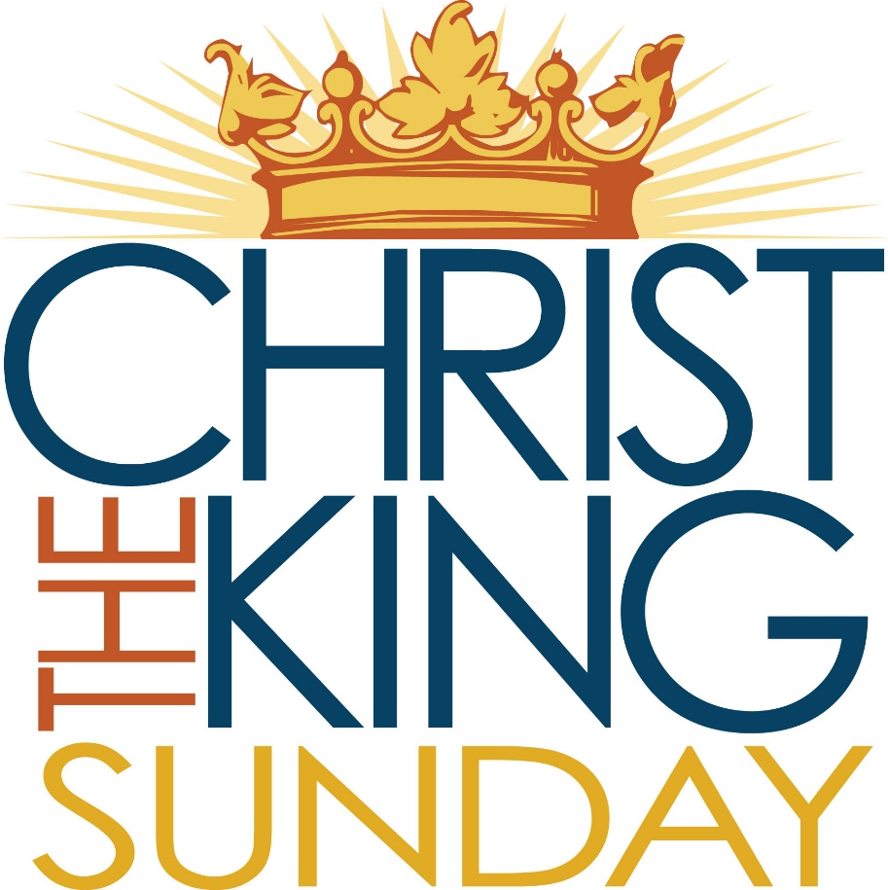
November 20th, 2016
4515 Dobie Road
Okemos MI 48864-2203
517-349-0620
Pastor Ellen Schoepf
prellen@faithlutheranokemos.org

The Cross as Hinge
We end the church year in an unconventional fashion: at the cross. Today’s gospel seems a strange capstone to the liturgical calendar, and that is intentional. This is because Christ the King Sunday is not a capstone at all, but rather a hinge that opens into the new year. We end at the cross because that is where we see most fully the great, culminating example of where God is willing to go to show love for humanity. We end at the cross because in the crucifixion we see Christ’s enthronement as the one that nothing, not even death, can destroy.
Christ’s kingship lies not in his exultation in glory but in his being raised upon the instrument of death from which God causes life to spring. The cross of Christ is the tree of life. But this life is hidden in what appears to be anything but life. Christ is not king because he conquers all in self-preserving might and force but because he conquers all in self-giving grace, and in doing so proves that he cannot be conquered even by violence.
Now we stand ready to step again onto Advent soil where new life, hope, and possibility is germinating. We must remember as we prepare to hear once again in the story of Jesus’ birth and life that God’s glory is not found in power and might but in humility and sacrifice, in one willing to give his life for his friends, his enemies, and the criminal hanging beside him. That is the kingdom of God: that place where the friend, the enemy, and even the one rightly condemned receives the grace and forgiveness of Christ. For that, we praise Christ as king!

Sunday, November 20, 2016
Christ the King
ELW Holy Communion Setting Four

Introduction to the day
Jeremiah’s promise of the execution of “justice and righteousness in the land” finds ironic fulfillment in the execution of Jesus of Nazareth, the King of the Jews. It appears so utterly contradictory that the king should be crucified with the criminal. This victory appears for all the world as ignominious defeat. Yet through the gate of death our Lord opens the door to paradise.

If hearing assistance is needed, please ask an usher for a personal PA receiver.

The ushers also have large print copies of today’s worship folder available.

If it will be difficult for you to stand along with the congregation during
any part of the worship service, please feel free to remain seated.

There is a nursery available during the worship service for those who wish
to use it. It is located at the end of the hall beyond the coat racks.

WELCOME AND ANNOUNCEMENTS

We cordially greet all who have come to worship today.
Please register your attendance and join us in fellowship after the service.

Prayer Requests

PRELUDE

The pre-service music signals the beginning of the worship service. Silence during the
pre-service music enables worshipers to prepare for worship through quiet meditation.

Faith Bells “Praise, My Soul, the King of Heaven” (Dobrinski)

Gathering
The Holy Spirit calls us together as the people of God.
The assembly stands.

Thanksgiving for Baptism

All may make the sign of the cross, the sign marked at baptism, as the presiding minister begins.
In the name of the Father,
and of the ☩ Son,
and of the Holy Spirit.
Amen.
Joined to Christ in the waters of baptism,
we are clothed with God's mercy and forgiveness.
Let us give thanks for the gift of baptism.

We give you thanks, O God,
for in the beginning your Spirit moved over the waters
and by your Word you created the world,
calling forth life in which you took delight.

Through the waters of the flood you delivered Noah and his family. Through the sea you led your people Israel from slavery into freedom. At the river your Son was baptized by John and anointed with the Holy Spirit.

By water and your Word you claim us as daughters and sons,
making us heirs of your promise and servants of all.
We praise you for the gift of water that sustains life,
and above all we praise you for the gift of new life in Jesus Christ.
Shower us with your Spirit,
and renew our lives with your forgiveness, grace, and love.
To you be given honor and praise
through Jesus Christ our Lord
in the unity of the Holy Spirit, now and forever.
Amen.

Gathering Song #855
Greeting
The grace of our Lord Jesus Christ, the love of God,
and the communion of the Holy Spirit be with you all.
And also with you.

Kyrie
Canticle of Praise
Prayer of the Day
Let us pray.
O God, our true life, to serve you is freedom, and to know you is unending joy. We worship you, we glorify you, we give thanks to you for your great glory. Abide with us, reign in us, and make this world into a fit habitation for your divine majesty, through Jesus Christ, our Savior and Lord, who lives and reigns with you and the Holy Spirit, one God, now and forever.
Amen.
The assembly is seated.

Word
God speaks to us in scripture reading, preaching, and song.

First Reading: Jeremiah 23:1-6
Today’s reading builds on the common ancient Near Eastern metaphor of the king as shepherd. Judah’s unjust rulers have caused their people, their “flock,” to be scattered. Nevertheless, the Lord will raise up a new and righteous shepherd who will rule a restored Judah.
A reading from Jeremiah.
¹Woe to the shepherds who destroy and scatter the sheep of my pasture! says the Lord. ²Therefore thus says the Lord, the God of Israel, concerning the shepherds who shepherd my people: It is you who have scattered my flock, and have driven them away, and you have not attended to them. So I will attend to you for your evil doings, says the Lord. ³Then I myself will gather the remnant of my flock out of all the lands where I have driven them, and I will bring them back to their fold, and they shall be fruitful and multiply. ⁴I will raise up shepherds over them who will shepherd them, and they shall not fear any longer, or be dismayed, nor shall any be missing, says the Lord.
⁵The days are surely coming, says the Lord, when I will raise up for David a righteous Branch, and he shall reign as king and deal wisely, and shall execute justice and righteousness in the land. ⁶In his days Judah will be saved and Israel will live in safety. And this is the name by which he will be called: “The Lord is our righteousness.”
The word of the Lord.
Thanks be to God.
Psalm: Psalm 46
The Psalm is read responsively Taken from the Message

¹⁻³ God is a safe place to hide,
ready to help when we need him.
We stand fearless at the cliff-edge of doom,
courageous in seastorm and earthquake,

Before the rush and roar of oceans, the tremors that shift mountains.
Jacob-wrestling God fights for us,
GOD-of -Angel-Armies protects us.

⁴⁻⁶ River fountains splash joy, cooling God’s city,
this sacred haunt of the Most High.
God lives here, the streets are safe,
God at your service from crack of dawn.

Godless nations rand and rave, kings and kingdoms threaten,
but Earth does anything he says.

⁷ Jacob-wrestling God fights for us,
GOD-of-Angel-Armies protects us.

⁸⁻¹⁰ Attention, all! See the marvels of GOD!
He plants flowers and tress all over the earth,
Bans war from pole to pole,
Breaks all the weapons across his knee.
“Step out of the traffic! Take a long,
Loving look at me, you High God, above politics, above everything.”

¹¹ Jacob-wrestling God fights for us,
GOD-of-Angel-Armies protects us.

Second Reading: Colossians 1:11-20
An early Christian hymn praises the mystery of the political, personal, and mystical Christ, the one who was present at creation and is eternally reigning with God.
A reading from Colossians.
¹¹May you be made strong with all the strength that comes from his glorious power, and may you be prepared to endure everything with patience, while joyfully ¹²giving thanks to the Father, who has enabled you to share in the inheritance of the saints in the light. ¹³He has rescued us from the power of darkness and transferred us into the kingdom of his beloved Son, ¹⁴in whom we have redemption, the forgiveness of sins.
¹⁵He is the image of the invisible God, the firstborn of all creation; ¹⁶for in him all things in heaven and on earth were created, things visible and invisible, whether thrones or dominions or rulers or powers—all things have been created through him and for him. ¹⁷He himself is before all things, and in him all things hold together. ¹⁸He is the head of the body, the church; he is the beginning, the firstborn from the dead, so that he might come to have first place in everything. ¹⁹For in him all the fullness of God was pleased to dwell, ²⁰and through him God was pleased to reconcile to himself all things, whether on earth or in heaven, by making peace through the blood of his cross.
The word of the Lord.
Thanks be to God.

The assembly stands to welcome the gospel.
Gospel Acclamation

Gospel: Luke 23:33-43
Amid scoffing and slander from those who sarcastically call him Messiah and king, Jesus reveals that to be Messiah and king is to give one’s life for others. Here he uses his power to welcome a despised sinner to paradise but puts his own death into God’s hands.

The holy gospel according to Luke.
Glory to you, O Lord.
³³When they came to the place that is called The Skull, they crucified Jesus there with the criminals, one on his right and one on his left. ³⁴⟦Then Jesus said, “Father, forgive them; for they do not know what they are doing.”⟧ And they cast lots to divide his clothing. ³⁵And the people stood by, watching; but the leaders scoffed at him, saying, “He saved others; let him save himself if he is the Messiah of God, his chosen one!” ³⁶The soldiers also mocked him, coming up and offering him sour wine, ³⁷and saying, “If you are the King of the Jews, save yourself!” ³⁸There was also an inscription over him, “This is the King of the Jews.”
³⁹One of the criminals who were hanged there kept deriding him and saying, “Are you not the Messiah? Save yourself and us!” ⁴⁰But the other rebuked him, saying, “Do you not fear God, since you are under the same sentence of condemnation? ⁴¹And we indeed have been condemned justly, for we are getting what we deserve for our deeds, but this man has done nothing wrong.” ⁴²Then he said, “Jesus, remember me when you come into your kingdom.” ⁴³He replied, “Truly I tell you, today you will be with me in Paradise.”

The gospel of the Lord.
Praise to you, O Christ.
The assembly is seated.

Children’s message

Sermon

The assembly stands

Hymn of the Day #431
text printed under Onelicense,net license # A-708005
Creed

We believe in one God,
the Father, the Almighty,
maker of heaven and earth,
of all that is, seen and unseen.

We believe in one Lord, Jesus Christ,
the only Son of God,
eternally begotten of the Father,
God from God, Light from Light,
true God from true God,
begotten, not made,
of one Being with the Father;
through him all things were made.
For us and for our salvation
he came down from heaven,
was incarnate of the Holy Spirit and the virgin Mary
and became truly human.
For our sake he was crucified under Pontius Pilate;
he suffered death and was buried.
On the third day he rose again
in accordance with the scriptures;
he ascended into heaven
and is seated at the right hand of the Father.
He will come again in glory to judge the living and the dead,
and his kingdom will have no end.

We believe in the Holy Spirit, the Lord, the giver of life,
who proceeds from the Father and the Son,
who with the Father and the Son is worshiped and glorified,
who has spoken through the prophets.
We believe in one holy catholic and apostolic church.
We acknowledge one baptism for the forgiveness of sins.
We look for the resurrection of the dead,
and the life of the world to come. Amen.

Prayers of Intercession

With the people of God gathered here and throughout the world, we offer our prayers for the church, those in need, and all of creation.
Prayers of intercession are prayed.
To each petition, the assembly responds:
Let us pray.
Have mercy, O God.

The presiding minister concludes the
prayers, and the assembly responds:

Almighty God, you have promised to hear those who call upon your name. We commend all our spoken and silent prayers to you, trusting in your abundant mercy; through your Son, Jesus Christ our Lord.
Amen.

Peace

The peace of Christ be with you always.
And also with you.

The people may greet one another with a sign of Christ’s peace, and may say, “Peace be with you,” or similar words.
The assembly is seated.

Meal
God feeds us with the presence of Jesus Christ.

Offering
Chancel Choir “Revelation 19” (LaValley)
The assembly stands

text and music printed under onelicense.net license a-708005
Offering Prayer
Merciful God, as grains of wheat scattered upon the hills
were gathered together to become one bread,
so let your church be gathered together
from the ends of the earth into your kingdom,
for yours is the glory through Jesus Christ, now and forever.
Amen.
Great Thanksgiving

Dialogue
The Lord be with you.
And also with you.

Lift up your hearts.
We lift them to the Lord.

Let us give thanks to the Lord our God.
It is right to give our thanks and praise.

Preface
It is indeed right, our duty and our joy,
that we should at all times and in all places
give thanks and praise to you, almighty and merciful God,
through our Savior Jesus Christ;
who on this day overcame death and the grave,
and by his glorious resurrection opened to us the way of everlasting life.
And so, with all the choirs of angels,
with the church on earth and the hosts of heaven,
we praise your name and join their unending hymn:

Holy, Holy, Holy
Thanksgiving at the Table
Holy God, holy and mighty, holy and immortal:
surrounded by evil and bordered by death we appeal to you,
our Sovereign, our Wisdom, and our Judge.

We praise you for Christ, who proclaimed your reign of peace
and promised an end to injustice and harm.

In the night in which he was betrayed, our Lord Jesus took bread, and gave thanks; broke it, and gave it to his disciples, saying:
Take and eat; this is my body, given for you. Do this for the remembrance of me.

Again, after supper, he took the cup, gave thanks, and gave it for all to drink, saying: This cup is the new covenant in my blood,
shed for you and for all people for the forgiveness of sin. Do this for the remembrance of me.

Remembering, therefore, the sacrifice of his life and death
and the victory of his resurrection, we await with all the saints
his loving redemption of our suffering world.

Send your Spirit on these gifts of bread and wine and on all who share in the body and blood of your Son: teach us your mercy and justice, and make all things new in Christ.

Through him all glory and honor is yours, Almighty Father, with the Holy Spirit, in your holy Church, both now and forever.
Amen

Lord’s Prayer

Gathered into one by the Holy Spirit, let us pray as Jesus taught us.
Our Father in heaven,
hallowed be your name,
your kingdom come,
your will be done,
on earth as in heaven.
Give us today our daily bread.
Forgive us our sins
as we forgive those
who sin against us.
Save us from the time of trial
and deliver us from evil.
For the kingdom, the power,
and the glory are yours,
now and forever. Amen.

Invitation to Communion
Share in the inheritance of all the saints.
Come to the table prepared for you.
The assembly is seated

Communion
When giving the bread and cup, the communion ministers say
The body of Christ, given for you.
The blood of Christ, shed for you.
and each person may respond
Amen.

Communion Song

congregational song #838

congrgational song Hymnal #433
Please use the hymnal next to you.

The assembly stands
The body and blood of our Lord Jesus Christ
Strengthen you and keep you in his grace.
Amen.

Prayer after Communion

We give you thanks, shepherding God,
that you have gathered your scattered flock again this day,
feeding us richly with the food of Paradise.
Accompany us as we serve you all the days of our lives,
and gather us with the saints in the day of our death;
through Jesus Christ, our Redeemer and Lord.
Amen.

Sending
God blesses us and sends us in mission to the world.

Blessing
God who loves us,
who gives us eternal consolation and good hope,
comfort your hearts
and strengthen them in every good work and word;
and the blessing of almighty God,
Father, ☩ Son, and Holy Spirit,
be among you and remain with you forever.
Amen.

Sending Song #430
Dismissal
Go in peace. Christ is with you.
Thanks be to God.
POSTLUDE
“Crown Him with Many Crowns,” arr. Wilbur Held
Copyright © 2016 Augsburg Fortress. All rights reserved. Reprinted by permission under Augsburg Fortress Liturgies Annual License #SAS000803.
New Revised Standard Version Bible, copyright © 1989, Division of Christian Education of the National Council of the Churches of Christ in the United States of America. Used by permission. All rights reserved. Scripture taken from THE MESSAGE. Copyright © 1993, 1994, 1995, 1996, 2000, 2001, 2001. Used by permission of NavPress Publishing Group. Clipart copyright © 2016 by Communication Resources. All rights reserved. Used by permission.
Christ is King of all creation, all time and season, all that we do as individuals and as the church.
Welcome as we gather to worship before the throne.
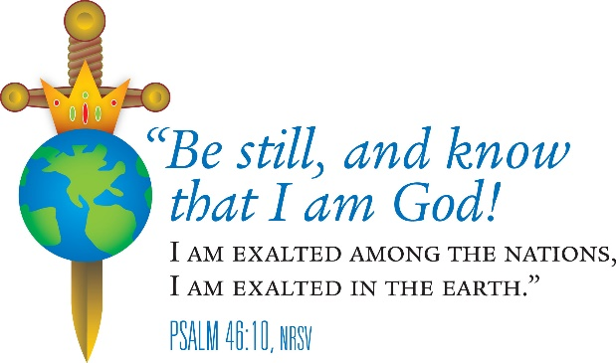

Pastor Ellen Schoepf prellen@faithlutheranokemos.org
Secretary Katie Love klove@faithlutheranokemos.org
Director of Christian Education Melinda Schultz
Director of Music Debra Borton-McDonough
Organist/Pianist Bruce Williams
November 13th Attendance:119
Serving Faith November 20 November 27

Acolyte Clayton Wenzel Zachary Hereza
Altar Care Brenda Kopf & Kay Showers
Communion Assistants Clayton Wenzel Zachary Hereza
Harold Sollenberger Jim Crum
Melinda Schultz Brenda Kopf
Greeters Mark & Molly DeHate Ken & Karen Whitmyer
Lay Assistants Harold Sollenberger Jim Crum
Readers Melinda Schultz Brenda Kopf
Ushers Sally & Dick Knoll
Nursery Corey & Kim O’Brien Melinda & Lauren Schultz

