Welcome to
Faith Lutheran

November 23, 2016 7:00pm

4515 Dobie Road
Okemos MI 48864-2203
517-349-0620

Pastor Ellen Schoepf
prellen@faithlutheranokemos.org

Bread of Life
Each year we celebrate Thanksgiving as a way to remember the gifts that God has given us. It is historically remembered as a time when the first European settlers gave thanks to God for safe journeys across the sea and successful harvests in their new home. This connection with the harvest is why we celebrate in autumn, and why abundant food is so much a part of most of our celebrations.
Successful harvests, farmers and laborers who work the land, workers who process and package the fruits of the earth for sale in stores, truckers who drive it across the country, employees who stock the shelves, cashiers who assist us with our purchases, and even volunteers who donate time, money, and groceries to the local food bank, are all part and parcel of God’s work of bringing to each one of us our daily bread.
In today’s gospel, Jesus reminds us that all food—whether it is your homegrown beef from your own pasture, tomatoes or zucchini from a neighbor’s garden, or mac and cheese off the grocery store shelf—will eventually leave us hungry again. Even the stuffed feeling with which many of us leave the Thanksgiving table will pass. Our greatest need—even beyond food—is for that which fills our souls. Because while stomachs will always be hungry for food, hearts are hungry for the one who created them.
Jesus Christ is the bread of life. He heals our sin-sick hearts with his self-giving. He feeds our souls with his very own body and blood. He fully satisfies us with forgiveness, life, and salvation in a way that cranberry sauce and pumpkin pie—no matter how delicious—never can. In the midst of our feasts this year, let us give thanks to God for this most precious gift.

Wednesday, November 23, 2016
Thanksgiving Eve
7:00 p.m.

INTRODUCTION

Every gathering for worship has elements of thanksgiving. When we are nourished with God’s bounty in holy communion, when we partake of Jesus’ word that gives life to the world, and even when two or three of us simply join our hearts in prayer to make our requests known to God, we do so “with thanksgiving.” Let us give thanks to the Lord, who is good and whose mercy endures forever.

If hearing assistance is needed, please ask an usher for a personal PA receiver.

The ushers also have large print copies of today’s worship folder available.

If it will be difficult for you to stand along with the congregation during
any part of the worship service, please feel free to remain seated.

There is a nursery available during the worship service for those who wish
to use it. It is located at the end of the hall beyond the coat racks.

PRELUDE

“We Gather Together” arr. Dale Wood

The assembly stands

Gathering Song
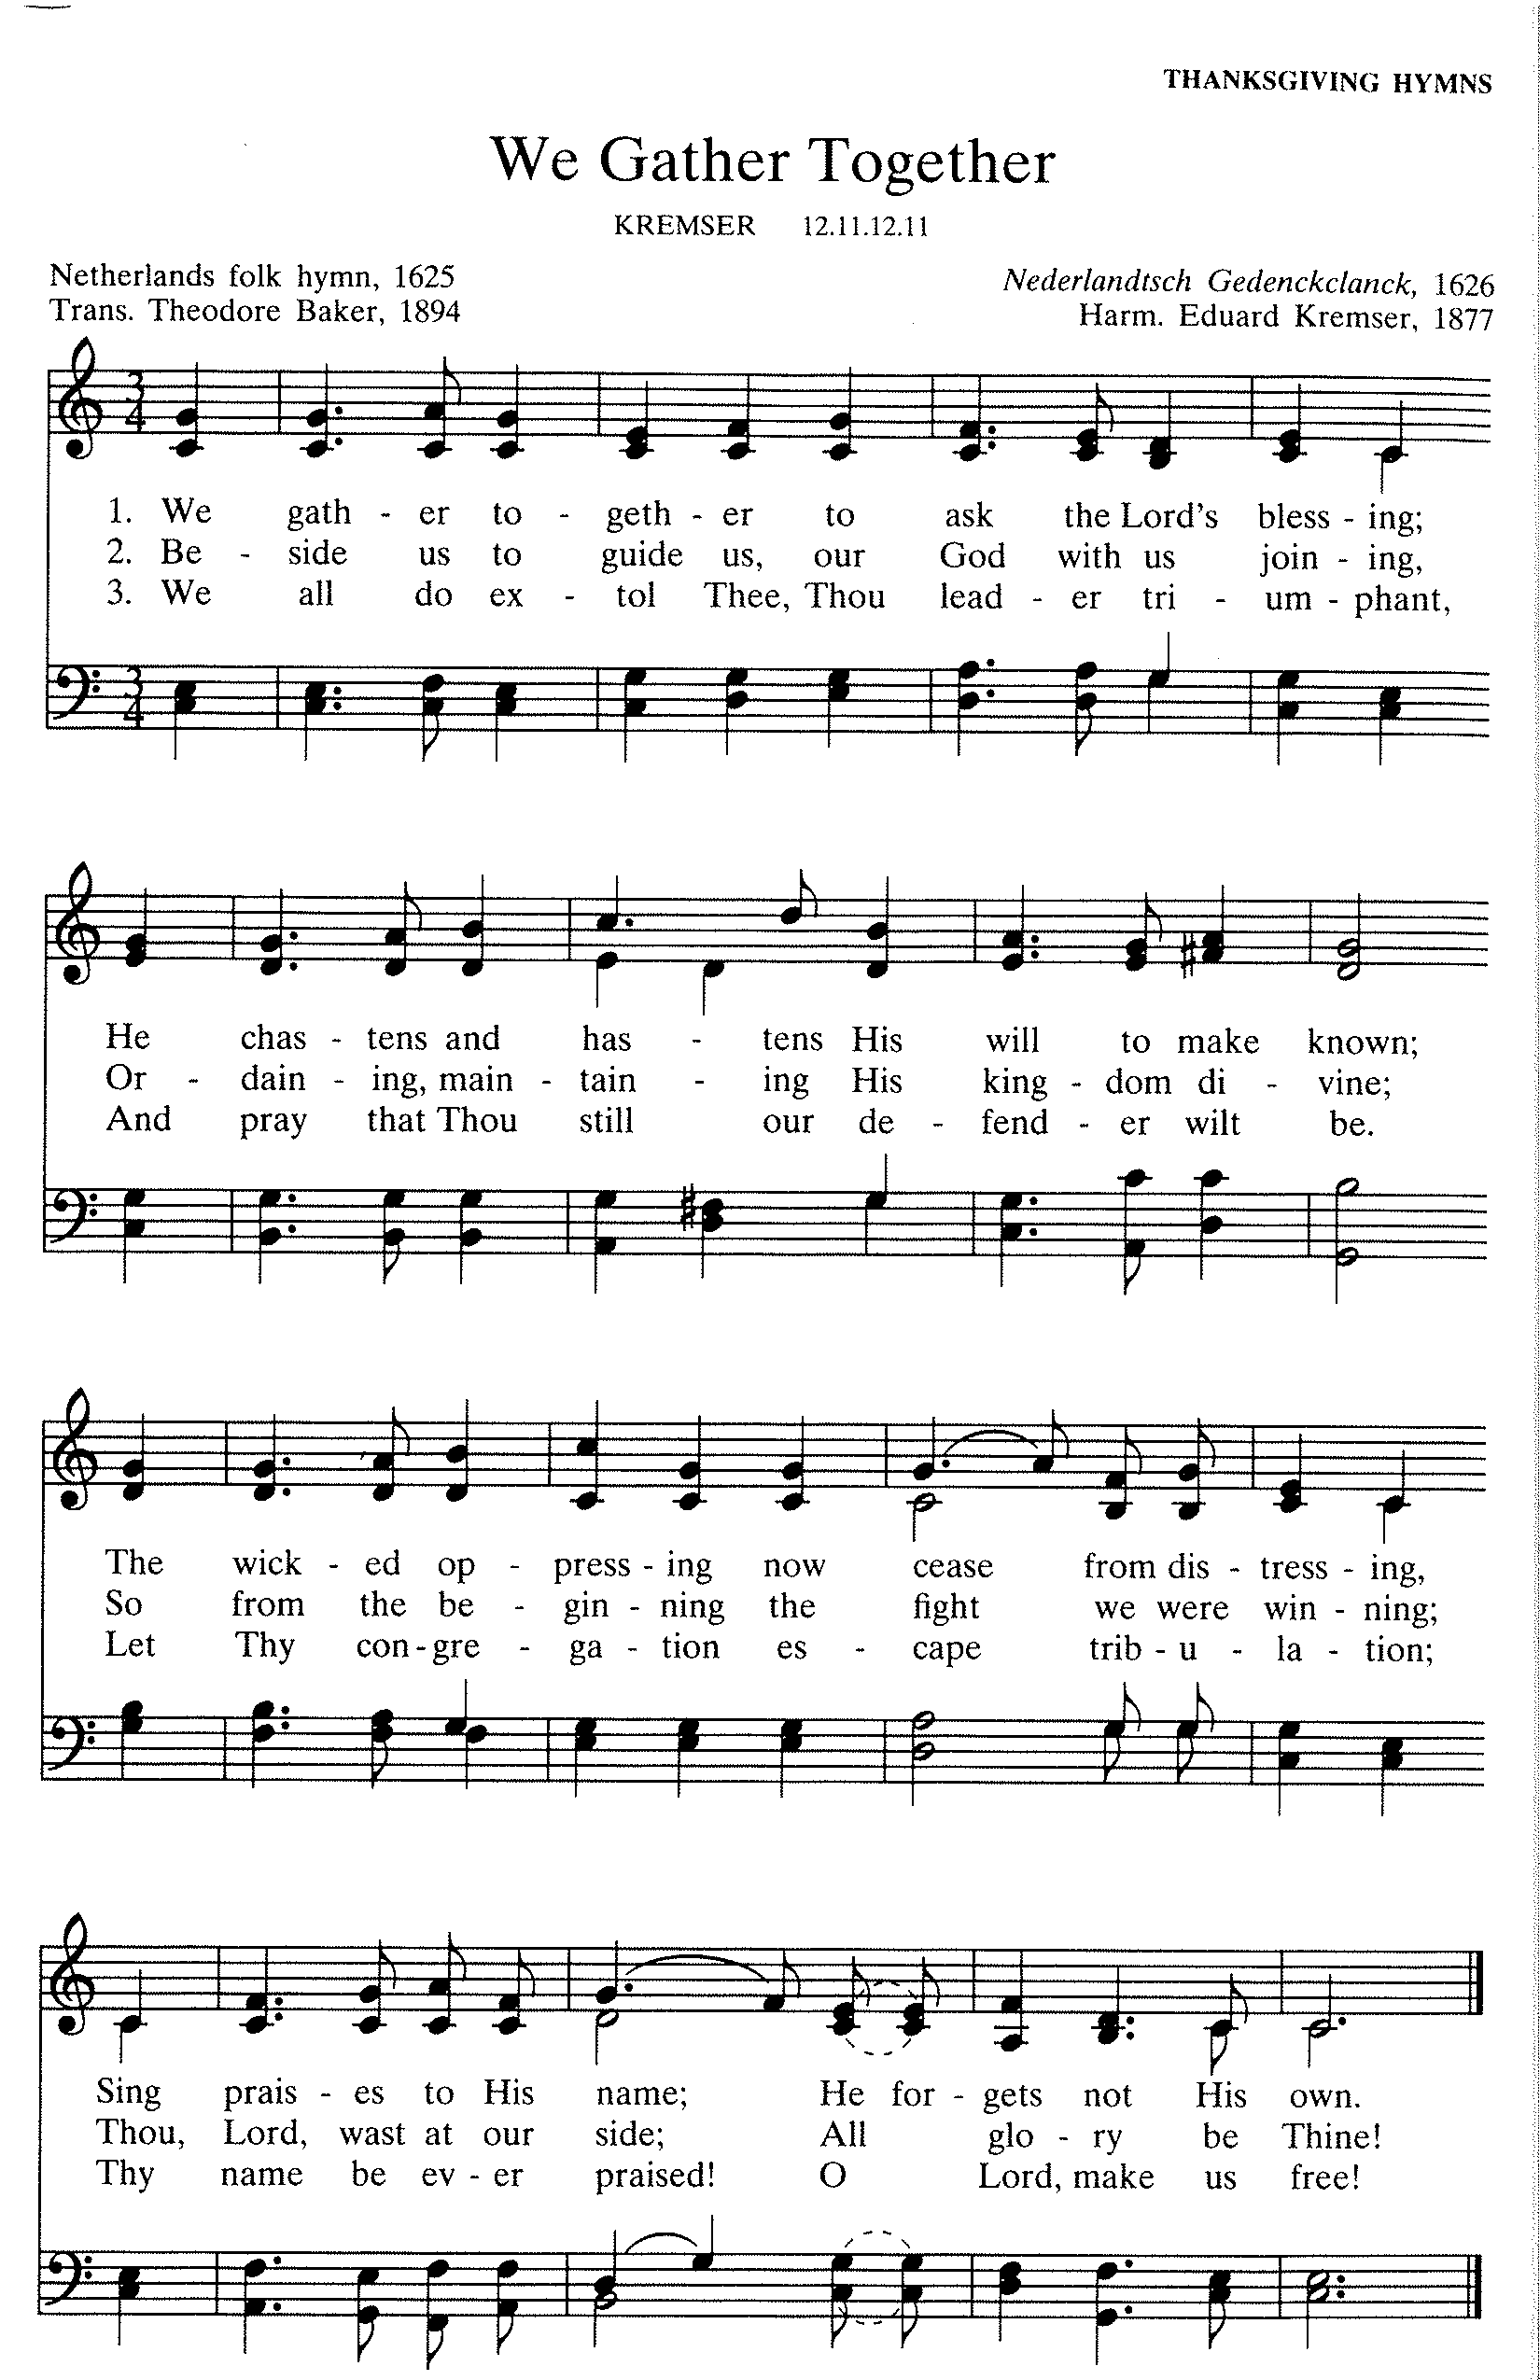
Greeting
The grace of our Lord Jesus Christ, the love of God,
and the communion of the Holy Spirit be with you all.
And also with you.

CANTICLE OF PRAISE
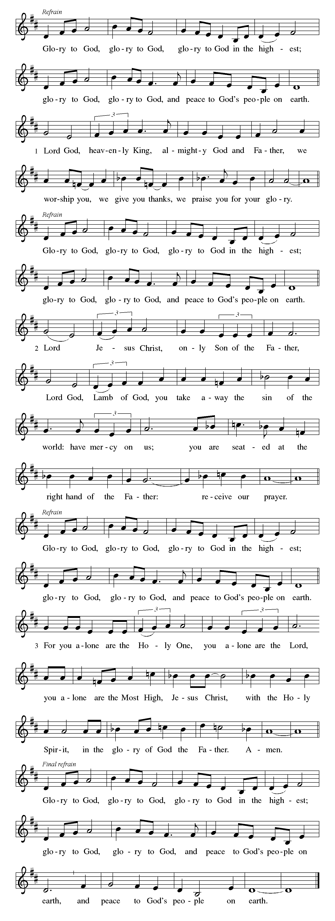

-7-
Prayer of the Day

Let us pray.
Almighty God our Father, your generous goodness comes to us new every day. By the work of your Spirit lead us to acknowledge your goodness, give thanks for your benefits, and serve you in willing obedience, through Jesus Christ, our Savior and Lord.
Amen

Gospel: John 6:25-35
The day after he multiplies bread to feed five thousand people, Jesus is pursued by the crowds clamoring for more bread. Recalling the image of manna in the wilderness, Jesus promises to provide the true bread from heaven that will never fail. Jesus himself is that bread of life.

The holy gospel according to John.
Glory to you, O Lord.

²⁵When [the disciples] found [Jesus] on the other side of the sea, they said to him, “Rabbi, when did you come here?” ²⁶Jesus answered them, “Very truly, I tell you, you are looking for me, not because you saw signs, but because you ate your fill of the loaves. ²⁷Do not work for the food that perishes, but for the food that endures for eternal life, which the Son of Man will give you. For it is on him that God the Father has set his seal.” ²⁸Then they said to him, “What must we do to perform the works of God?” ²⁹Jesus answered them, “This is the work of God, that you believe in him whom he has sent.” ³⁰So they said to him, “What sign are you going to give us then, so that we may see it and believe you? What work are you performing? ³¹Our ancestors ate the manna in the wilderness; as it is written, ‘He gave them bread from heaven to eat.’ ” ³²Then Jesus said to them, “Very truly, I tell you, it was not Moses who gave you the bread from heaven, but it is my Father who gives you the true bread from heaven. ³³For the bread of God is that which comes down from heaven and gives life to the world.” ³⁴They said to him, “Sir, give us this bread always.”
³⁵Jesus said to them, “I am the bread of life. Whoever comes to me will never be hungry, and whoever believes in me will never be thirsty.”
The gospel of the Lord. Praise to you, O Christ.

The assembly is seated

MEDITATION
The assembly stands

Hymn of the Day #840
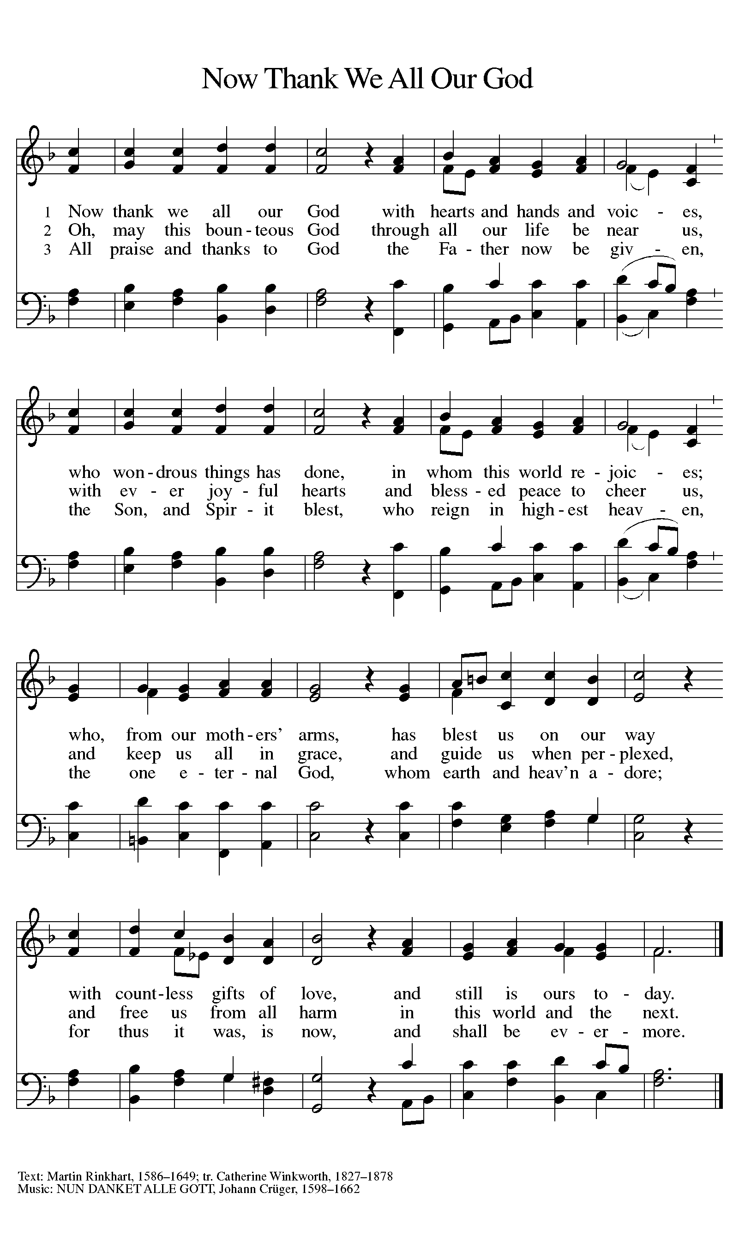
Arrangement printed under OneLicense.net license A-708005
Prayers of Intercession

With the people of God gathered here and throughout the world, we offer our prayers for the church, those in need, and all of creation.
Prayers of intercession are prayed.
To each petition, the assembly responds:

Let us pray.
Have mercy, O God.

The presiding minister concludes the
prayers, and the assembly responds:

Almighty God, you have promised to hear those who call upon your name. We commend all our spoken and silent prayers to you, trusting in your abundant mercy; through your Son, Jesus Christ our Lord.
Amen

The assembly is seated

Offering

An offering is gathered for the mission of the church, including the care of those in need.

“For the Beauty of the Earth,” arr. Alice Jordan

-10-
The assembly stands

OFFERING response
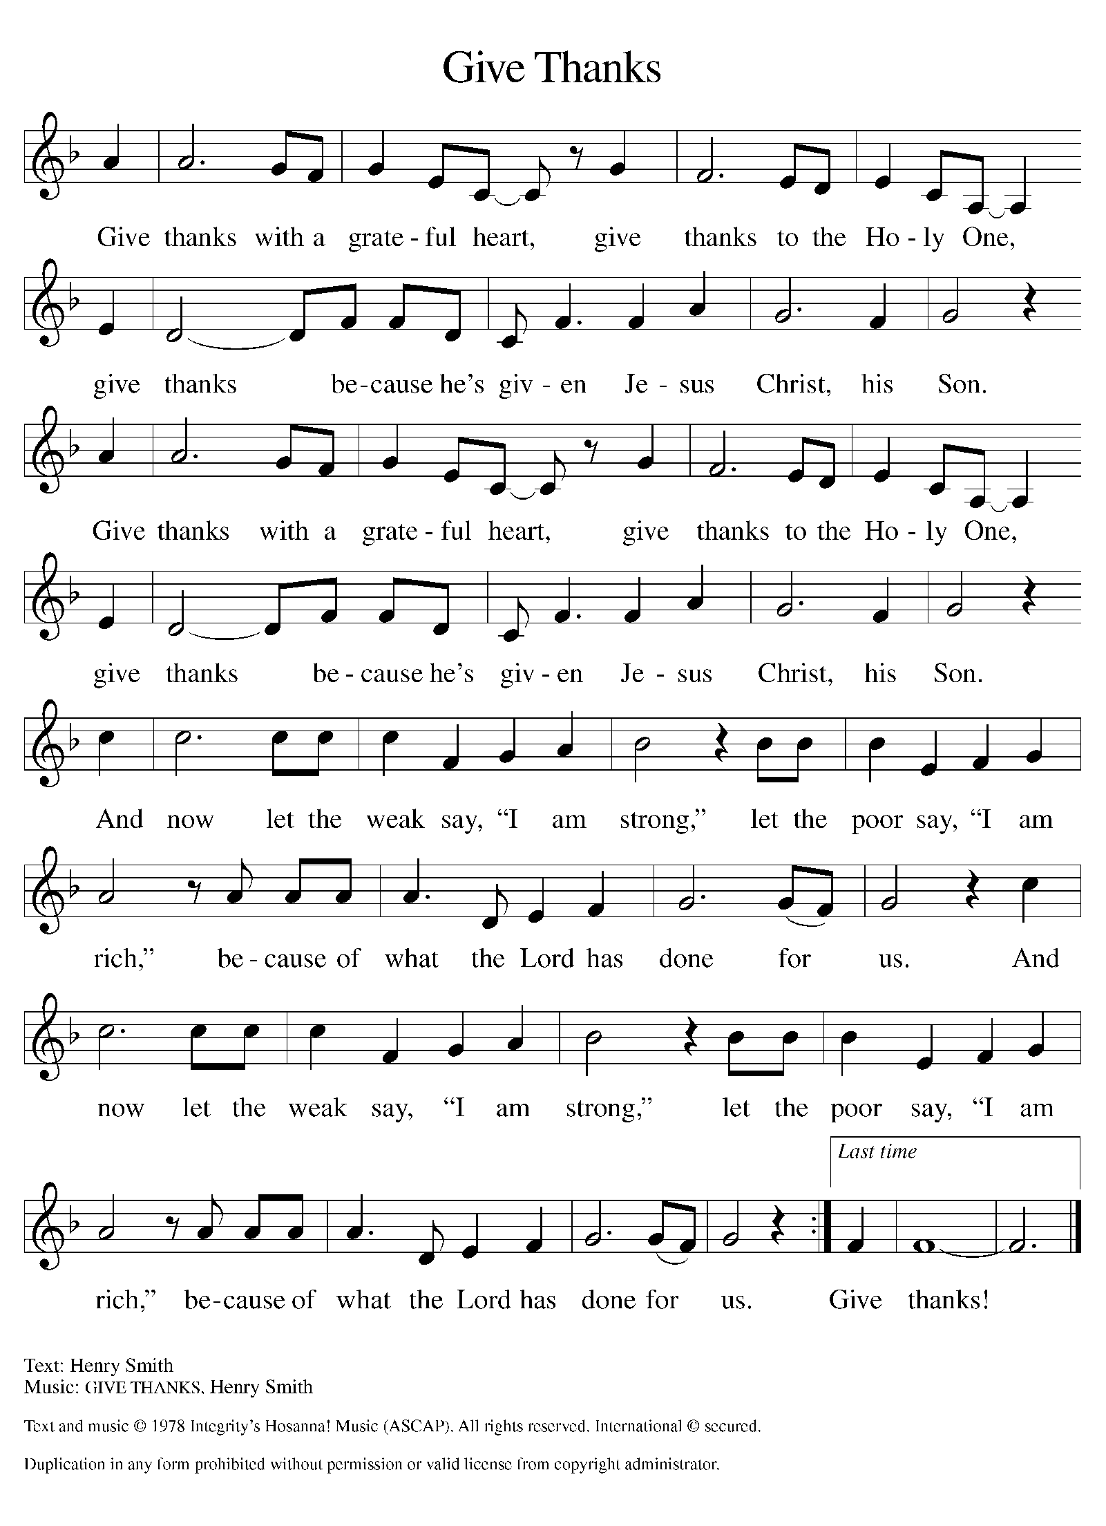
Text and music printed under CCLI license 720217

-11-

THANKSGIVING FOR THE WORD

p let us pray.
praise and thanks to you, holy God, for by your
Word you made all things: you spoke light into darkness,
called forth beauty from chaos, and brought life into being.
For your Word of life, O God,
C we give you thanks and praise.

P By your Word you called your people Israel to tell of your wonderful gifts: freedom from captivity, water on the desert journey, a pathway home from exile, wisdom for life with you.
For your Word of life, O God,
C we give you thanks and praise.

P Through Jesus, your Word made flesh, you speak to us and call us to witness: forgiveness through the cross, life to those entombed by death, the way of your self-giving love.
For your Word of life, O God,
C we give you thanks and praise.

P Send your Spirit of truth, O God; rekindle your gifts within us: renew our faith, increase our hope, and deepen our love, for the sake of a world in need. Faithful to your Word, O God, draw near to all who call on you; through Jesus Christ, our Savior and Lord, to whom, with you and the Holy Spirit, be honor and glory forever.
C Amen

-12-

Lord’s Prayer

Gathered into one by the Holy Spirit,
let us pray as Jesus taught us.
Our Father in heaven,
hallowed be your name,
your kingdom come,
your will be done,
on earth as in heaven.
Give us today our daily bread.
Forgive us our sins
as we forgive those
who sin against us.
Save us from the time of trial
and deliver us from evil.
For the kingdom, the power,
and the glory are yours,
now and forever. Amen

Blessing

May the God and Father of our Lord Jesus
Christ fill you with every spiritual blessing.
Amen

May the God of faithfulness and
encouragement grant you to live in
harmony with one another, in
accordance with Christ Jesus.
Amen

May the God of hope fill you with all joy
and peace in believing, so that you may abound
in hope by the power of the Holy Spirit.
Amen

-13-

Sending Song #881
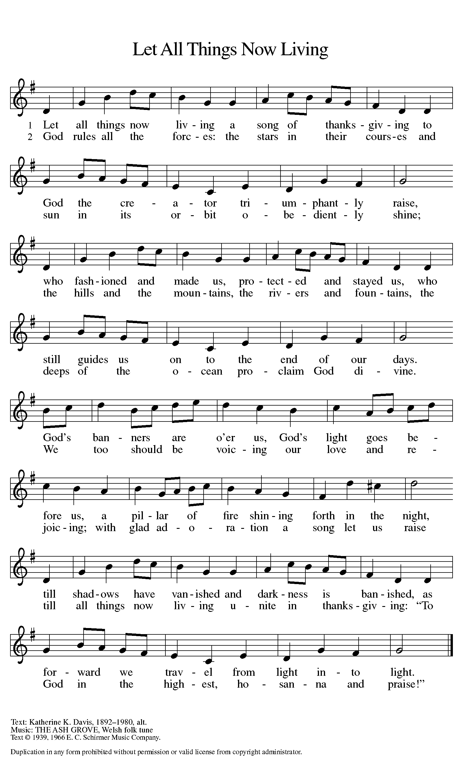
Text printed under OneLicense.net license A-708005
Dismissal
Go in peace, continuing to
give God your thanks and praise!
Thanks be to God!

POSTLUDE
“Now Thank We All Our God” arr. John Innes

Copyright © 2015 Augsburg Fortress. All rights reserved. Reprinted by permission under Augsburg Fortress Liturgies Annual License #SAS000803.
New Revised Standard Version Bible, copyright © 1989, Division of Christian Education of the National Council of the Churches of Christ in the United States of America.
Used by permission. All rights reserved.
Clipart copyright © 2015 by Communication Resources. All rights reserved. Used by permission.

“Taste and see that the LORD is good!” (Psalm 34:8). Before we dine at our holiday tables, let us feast on the Word of the Lord. Welcome to Thanksgiving worship!

Immediately following this evening’s Thanksgiving service,
we are gathering for fellowship and PIE.
You are invited to join us for a slice or two or. . .

Pastor Ellen M. Schoepf prellen@faithlutheranokemos.org
Secretary Katie Love klove@faithlutheranokemos.org
Director of Christian Education Melinda Schultz
Director of Music Debra Borton-McDonough
Organist/Pianist Bruce Williams

A Few Announcements… For a complete list of studies and events please visit www.faithlutheranokemos.org

60 +/- Christmas Luncheon Sign up Deadline 11/27

Join your 60 +/- friends for a Christmas luncheon at 12:00 p.m. on Sunday December 4th at the Kellogg Center on Harrison Avenue on the MSU Campus. We will enjoy the delicious buffet brunch at a group of reserved tables in the State Room. The buffet features a complete selection from breakfast items to entrees, dessert and coffee. The cost, including tax and gratuity, remains $21.35 with free parking (under cover and attached to the Kellogg Center). We’ll be paying individually on the day of the event.
As our name “60 Plus or Minus” suggests, we welcome friends and guests who have not yet reached that golden age! Be sure to add your name to the sign-up sheet in the narthex by November 27 so that we can reserve the proper number of tables.
If you arrive a little early or stay briefly after the luncheon, you can browse the festive seasonal decorations in the Kellogg Center, including the annual gingerbread house competition.

Decorate the Church Saturday 11/26 9:30am

Do you love to decorate? Do you love coffee and doughnuts? Join us this Saturday, November 26th as we decorate Faith for the Christmas season!! Pastor Ellen will provide the doughnuts and coffee!

To make disciples for Jesus Christ. . .
. . .we Gather in faith for worship, prayer,
study and fellowship
. . .we Equip the people of God with a faith
that works in real life
. . .we Serve the world in the name of Jesus Christ
_______________

Email address
faith@faithlutheranokemos.org

Websites
Faith Lutheran Church ≈ www.faithlutheranokemos.org
North/West Lower Michigan Synod ≈ www.mittensynod.org
Evangelical Lutheran Church in America ≈ www.elca.org

Facebook
facebook.com/faithlutheranokemos

Podcasts

ITUNES
https://itunes.apple.com/us/podcast/your-faith-journey/id1085174663?mt=2

STITCHER
http://www.stitcher.com/podcast/dad-spotlight/your-faith-journey?refid=stpr

You also can find the audio available on Faith’s website under worship

Sermons
http://faithlutheranokemos.org/sermons/

Special music
http://faithlutheranokemos.org/category/special-music/

