**ANNOUNCEMENTS**

FaithFamily&Friends3

**October 2nd**

*Log onto Faith’s website www.faithlutheranokemos.org 24/7 for updates*

**DEADLINES**

Sunday worship folder announcements⎯Tuesday of each week

Submit to Katie at klove@faithlutheranokemos.org

***November Faith Family News newsletter*⎯Monday October 17th**

Submit to Katie at klove@faithlutheranokemos.org

**PRAYERS OF INTERCESSION**

Please lift up in prayer this week:

🕆 Members—Max Ambs, Lowell Barricklow, Ellen Milne, Harry Nawrock,

and Dale Halverson.

🕆 Friends and family—

Pat Belonga, Chris Cotter, Dick and Lil Jennings, Max & Charlie Barry,

Terrie Becker, Allie, Heather, Al,

Lilly, Sai Eshwar Lingamgunta, Jenn Leitch, Jeanne and Leonard,

Tom Brown, Susan Heft, Pat Hillberg & Family, Marilyn Borri,

Jane Lightle, Dennis Cobler and John Joseph Lanzetta.

🕆 Our mission partner congregation⎯Lansing Redeemer Lutheran Church

🕆 Those in military service⎯Jon Schoepf, Lani Yearicks

and Melody, Adam Wright and Joe Galvin.

🕆 Lutheran Social Services of Michigan children who seek adoption—

Marshall & Lorenzo. Pray for each to be adopted and for Jesus to be their lifelong friend.

**NORTH/WEST LOWER MICHIGAN SYNOD PRAYER PARTNER**

As Jesus calls us to be one, even as he and the Father are one, please include

Pastor Lee Welker and the congregation of Gethsemane Lutheran Church in your prayers of intercession this week.

**ALTAR FLOWER DEDICATIONS**

Today’s altar flowers are given to the glory of God by…

Sheila Smith in honor of Rita Barry and her family and in thanks for her many years of service to the Faith family

**FINANCIAL UPDATE**

Weekly Offering 09/28/16 Year-to-date as of 08/31/2016

General Fund $3525.00 Income $191,621.49

Loose Cash 17.28 Expenses 199,304.81

Dorthy Young Memorial 30,000.00 Net Income $( 7,683.32)

Loose Checks 80.00

World Hunger 45.00

Parish Ed 20.00

Loaves & Fishes 20.00

Total $33707.28

THIS WEEK’S CHRONOLOGY OF EVENTS

Twentieth Sunday after Pentecost

**TODAY Reusable shopping bags are for sale $5/each in the narthex as a way to prevent “urban tumbleweeds” and as a fundraiser for the Youth.**

9:00 a.m. RIC DVD Series

9:00 a.m. Sunday School

10:00 a.m. WORSHIP: Youth Sunday

11:30 a.m RIC “Framing Conversation”

11:30 a.m. Worship Committee Meeting

Monday, October 3

Tuesday, October 4

Worship folder announcements deadline

12:00 p.m. No Lunch lectionary study this week

Wednesday, October 5

7:30 a.m. Men’s Study Group in the Library

9:30 a.m. Quilting and Samaritas ACTION

5:30 p.m. Joyful Noise Choir

6:00 p.m. Trinity and Confirmation

6:30 p.m. Faith Bells

6:30 p.m. Membership Development Meeting

7:30 p.m. Chancel Choir

Thursday, October 6

Friday, October 7

Saturday, October 8

IMPORTANT INFORMATION

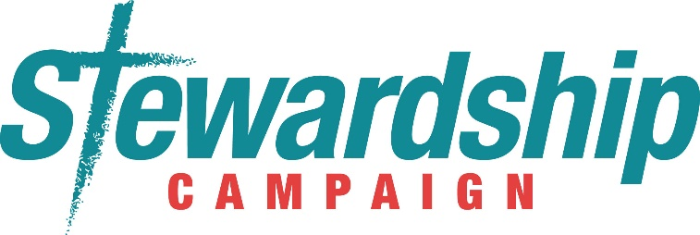

By now you should have received your pledge cards in the mail. If you did not, there are some available in the narthex. If you believe your address is incorrect please email klove@faithlutheranokemos.org to correct your address. Please return your pledge cards on Sunday, October 16th.



Openings are available this Fall for Sunday Coffee Hosts before the worship service. Please see the sign-up sheet on the kitchen counter in the narthex.



New Member Sunday will take place Sunday, October 30th. Are you interested in becoming a member of Faith? Contact Pastor Ellen for more details. prellen@faithlutheranokemos.org

UPCOMING MEETINGS & STUDIES

***CAREGIVERS SUPPORT Group Meeting***

Join us at 11:30am for a light lunch and discussion. All are Welcome!

Thursday October 13th: Kris Abbey, the Bereavement Coordinator at Hospice of Lansing will speak on Healthy Grieving.

Thursday November 10th: Tara Thiel from Medilodge will be discussing various Long Term Care Options.

***SIXTY +/- Meeting 11:30am Wednesday Oct 19th***

***Brown Bag Lunch and Program***

***Bonnie DePue, Occupational Therapist, presents***

***“CHUM Therapeutic Riding, Inc.”***

The website for Children and Horses United in Movement (CHUM) describes this therapeutic riding program as follows:

“It has always been clear that CHUM is a God driven, faith built, grace guided program where individuals with and without disabilities share and develop their love for horses. In this process, we see ‘life lessons’ occurring in the barn, victories over challenges, hope over despair, and relationship building in trust and love.”

Bonnie DePue will join us on October 19 to share pictures and tell us about her personal experiences working with this special riding program, based in nearby Dansville.

Bring your own brown bag or box lunch. The committee will furnish beverages and dessert, and all of you will provide the fellowship!



**RIC Education: October 2nd & October 9th  9:00 am**

All are welcome to meet in the library during the Sunday School hour.

We will be watching the DVD *Seven Passages: The Story of Gay*

*Christians.* During our time together we will watch a section of the

DVD, take time to discuss it, answer questions, and share stories.

We will continue meeting each Sunday until we complete the DVD.

UPCOMING MEETINGS & STUDIES CONT.



***How Lutherans Interpret the Bible*, starting October 16 at 9:00am**

Everyone is welcome! We will meet in the library during the Sunday School hour.

***BOOK CLUB***

**BOOK GROUP CONVERSATION** –

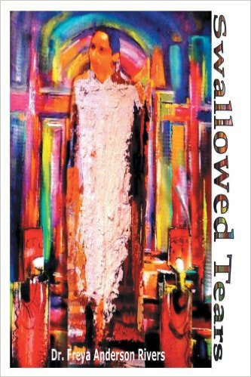As we host a series of anti-racism events facilitated by Dr. Rivers during the fall season, Pam Williams will also be leading a book group conversation based on Dr. Freya Rivers’ book, *Swallowed Tears*.

This next gathering will take place at 7:00 PM on

**Wednesday, October 26**

If you are able to participate, please add your name to the sign-up sheet in the Narthex.

***YOUNG ADULT GATHERING AT OLD CHICAGO***

Pastor Ellen will be hosting a Young Adult Gathering at Old Chicago (Ages 18-40ish.) This gathering will take place once a month and it will be a time when those present will discuss how faith intersects what is happening in present culture. The pizza at these gatherings is on Pastor Ellen while attendees will pay for their beverages.

The next gathering will be:

**Saturday, October 29, 12:00 Noon**

UPCOMING SEPTEMBER/OCTOBER EVENTS

**RIC “Framing” October 2nd following Worship Service**

 **All are welcome** as we discuss “Framing” and determine the frame of reference that we will use at Faith as we are going through the welcoming/RIC process.

Determining our frame is looking at who we are as a congregation, what we value the most, and what makes us unique.

This will last about an hour and will help the RIC planning group in understanding our congregation as they plan the rest of the educational events over the next year. The meeting will take place in the large fellowship hall.

**Quilt Sunday October 9th, During Worship**

On Sunday, October 9, we will be dedicating all of the quilts our Quilting Group has made for Lutheran World Relief and Samaritas. Making quilts and donating them to Lutheran World Relief is a ministry that touches the lives of countless people around the world. We give thanks for the commitment and world our Quilting Group diligently does every Wednesday morning. Join us on October 9, during the worship service, as we dedicate the quilts they have made and give thanks for the work they do.

The Quilting Ministry needs your help with some supplies.

Items Needed

* Flannel and cotton sheets, any size
* Blankets in good condition
* Large Fabric yardage to use as a “top”- each quilt requires a top, back and filler.

Everyone is welcome on Wednesday mornings. The quilting ministry thanks you for your donation.

UPCOMING SEPTEMBER/OCTOBER EVENTS

Anti-Racism Training:

October 15 and November 5th 9:00-3:00

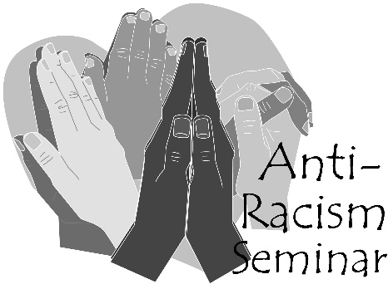

Dr. Freya A. Rivers and Angela Rivers will be offering Anti-Racism Training: Recognizing Seven Faces of Racism and Eradication from 9am-3pm. The remaining seminars are October 15 and November 5th.

Lunch will be provided. Please call the church office or sign up in the church narthex to register for these

training seminars

**Bread for the World Sunday October 16th**

On October 16th we celebrate Bread for the World Sunday as an opportunity to renew our commitment to pray, act and give for an end to hunger it God’s world. Empowered by Jesus’ presence in our lives, we seek not to be served, by to serve. Drawn into the gravity of God’s love, we reach out to our sisters and brothers who struggle to get enough to eat.

**Chili Chowdown Youth Fundraiser October 30th Noon**



Join us Sunday October 30th for a FUN Chili Chowdown and Games fundraiser for our Youth. Warm up with a bowl of chili and fellowship.

WAYS TO GET INVOLVED

**“Urban Tumbleweeds,”** better known as **plastic grocery bags,** have been littering our streets! When plastic bags don’t make it to the trash they often are seen blowing in the wind. The members of Faith Lutheran’s Green Team are asking you to bring all those plastic shopping bags to church so we can recycle them. We are placing recycle containers in the foyers in the northwest and southwest entrances to the building. It will be easy to drop those *urban tumbleweeds* in these containers as you enter the building.

Another Solution? Let’s reduce the demand for and manufacture of, plastic bags by using **reusable shopping bags.**  Beginning **TODAY** our youth will be selling **reusable shopping bags bearing the name of Faith Lutheran Church.**  These bags, a fundraising project for our youth, will be selling for $5.00 a bag. The Youth, the Green Team and the Evangelism Committee are teaming up to inspire you to use these reusable bags as we work to reduce the amount of plastic going into the landfills.

**CHRISTIAN EDUCATION AND YOUTH ANNOUNCEMENTS**

If you are unable to attend the meal fundraiser, we would appreciate if you would donate needed items to produce the meal. The more items that are donated, the less we have to take out of our profits. Here are the first couple dates so that you can add to them your calendar:

**October 30th**  12:00pm, Chili Chowdown

 and Games

**November 20th** 11:30am, Spaghetti Lunch

**CHRISTIAN EDUCATION AND YOUTH ANNOUNCEMENTS CONT.**

**Youth Group Fundraiser (partnering with Membership Development)  
Chili Chowdown – October 30th, 12:00-1:30pm**On Sunday, October 30th, the youth group will be offering a Chili meal (vegetarian choices as well), cornbread, cider, dessert, as well as fun games and activities for the children. We will also have pumpkin carving assistance if you bring in your own pumpkins with your family. It will be a great time!!! Cost for the meal is $5.00 each or $15.00 per family. Please make checks payable to Faith Lutheran Church. Money collected the evening of the event.

**\*\*\***Although we would **love** everyone to attend the Chili Chowdown, we understand that schedules can be hectic. If you would like to contribute for the actual meal, please see the list below and also in the Narthex, as there is a sign-up sheet for the items. Any donations help the youth defray costs that shrink their net gain:

**Items Needed:**

9 pounds ground beef  
12 cans red kidney beans (cans are 14.5 oz)  
12 cans diced tomatoes (cans are 14.5 oz)  
12 packages McCormick Chili Mild mix  
3 pounds Boca Veggie crumbles  
3 pounds ground turkey  
6 cans cannellini beans (cans are 14.5 oz)  
48 eggs  
1 GFS big Brownie Mix or (6 Duncan Hines Brownie Mix)  
2 vegetable oil, standard size  
13 boxes Jiffy cornbread mix

1 gallon of milk for cooking  
2 Gallons of Cider  
1 Gallon of White milk  
2 Gallons of Chocolate milk  
1 Can of Coffee  
1 box of Tea

6 bags shredded cheddar cheese  
3 bags shredded Monterey jack  
1 bag yellow onions  
3 large containers of sour cream  
4 chicken stock container

**CHRISTIAN EDUCATION AND YOUTH ANNOUNCEMENTS CONT.**

**Sunday School Participants**Please make sure that each of your children attending Sunday School have a yellow Registration Card filled out. Also, Pre-K through 3rd grade will be gathering in the old fellowship hall each Sunday from 9:00-9:15 to practice a song that we will share with the congregation the last Sunday of each month.

[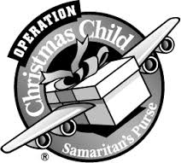](http://www.google.com/imgres?imgurl=http://www.samaritanspurse.ca/media/6221/operation_christmas_child_logo_black_and_white.jpg&imgrefurl=http://www.samaritanspurse.ca/rss/operation-christmas-child/resources/operation-christmas-child-promotional-material.aspx&h=239&w=266&tbnid=R94QDXpEy0fn0M:&zoom=1&docid=ZeNe6N2dbgiJnM&ei=-SwsVJetMcShyATvnIHYBw&tbm=isch&ved=0CEAQMygNMA0&iact=rc&uact=3&dur=499&page=2&start=8&ndsp=17)**Operation Christmas Child Shoebox Collection begins October 9th**Collections will be ongoing through November 13th, at which time we will have the boxes blessed during the church service. If you are available to help deliver the shoeboxes the week of November 17-18, please let Melinda Schultz know at mrsjas305@sbcglobal.net.

**Upcoming Activities**  
October 2nd 10:00am, Youth Sunday/2016 Mission

Trip Update  
October 5th 6:00-8:00pm, T&C  
October 9th Operation Christmas Shoebox begins  
October 12th 6:00-8:00pm, T&C  
October 19th 6:00-8:00pm, T&C/College Care

Packages Night  
October 23rd 3rd Graders receive their Bibles  
 Youth Group Activity/Haunted Maze,

house, time TBD  
October 26th 6:00-8:00pm, T&C Fun Night  
October 30th 10:00am, Children sing in church  
 11:15am, Quarterly Meeting  
 12:00pm, Chili Chowdown and Games





To make disciples for Jesus Christ. . .

. . .we **Gather** in faith for worship, prayer,

study and fellowship

. . .we **Equip** the people of God with a faith

that works in real life

. . .we **Serve** the world in the name of Jesus Christ

_______________

Email address

faith@faithlutheranokemos.org

Websites

Faith Lutheran Church ≈ www.faithlutheranokemos.org

North/West Lower Michigan Synod ≈ www.mittensynod.org

Evangelical Lutheran Church in America ≈ www.elca.org

Facebook

facebook.com/faithlutheranokemos

Podcasts

ITUNES

https://itunes.apple.com/us/podcast/your-faith-journey/id1085174663?mt=2

STITCHER

http://www.stitcher.com/podcast/dad-spotlight/your-faith-journey?refid=stpr

You also can find the audio available

on Faith’s website under worship

Sermons

http://faithlutheranokemos.org/sermons/

Special music

http://faithlutheranokemos.org/category/special-music/