Welcome to
Faith Lutheran Church

September 25, 2016

4515 Dobie Road
Okemos MI 48864-2203
517-349-0620

Pastor Ellen Schoepf
prellen@faithlutheranokemos.org

Build a Bridge
Many people travel the same route every day. Some drive to work via the same roads, past the same buildings, and around the same turns. Some ride the bus to school or work past the same stores or fields and over the same hills. Whether you ride in a truck or on a bike, whether you walk or drive a tractor, you probably pass by both things and people again and again and aren’t really aware of them.
Lazarus lay at the rich man’s gate day after day hungry and hurting. The rich man passed by him day after day on his way to and from his home. Even though there wasn’t a physical chasm between the two in their day-to-day life, the rich man never reached out to Lazarus. Jesus’ parable highlights how it will be too late in the next life to make a difference, and how our actions in this life have impact not only on our neighbor but also on the health of our relationship with God.
Luther defined sin as being curved in on oneself. When we are curved in on ourselves, we are turned toward ourselves and not toward God or our neighbor. It’s almost as though we dig the chasm in Jesus’ story ourselves, and it hems us in.
Thankfully, Jesus has come to bridge the chasm in this life between God and our sinful selves. Jesus lays himself down that we might be freed from our sinful selves to see and help our neighbor, freed to build bridges instead of digging chasms.
On your way to work, school, or wherever your daily life takes you, may God give you eyes to see your neighbor in need. May the living and resurrected Lord feed and strengthen you in worship today with the forgiveness, humility, and courage to reach out and get to know them. Build a bridge.

Sunday, September 25, 2016
19th Sunday after Pentecost
ELW Holy Communion Setting Nine
Introduction to the day
Consideration of and care for those in need (especially those “at our gate,” visible to us, of whom we are aware) is an essential component of good stewardship. It is in the sharing of wealth that we avoid the snare of wealth. It is the one whom death could not hold—who comes to us risen from the dead—who can free us from the death grip of greed.

If hearing assistance is needed, please ask an usher for a personal PA receiver.

The ushers also have large print copies of today’s worship folder available.

If it will be difficult for you to stand along with the congregation during
any part of the worship service, please feel free to remain seated.

There is a nursery available during the worship service for those who wish
to use it. It is located at the end of the hall beyond the coat racks.

WELCOME AND ANNOUNCEMENTS

We cordially greet all who have come to worship today.
Please register your attendance and join us in fellowship after the service.

Prayer Requests

STEWARDSHIP TEMPLE TALK John McCracken

PRELUDE

The pre-service music signals the beginning of the worship service. Silence during the
pre-service music enables worshipers to prepare for worship through quiet meditation.

“Ar Hyd Y Nos,” (Hymn #679) arr. Dale Wood

Gathering
The Holy Spirit calls us together as the people of God.

Confession and Forgiveness

Blessed be the holy Trinity, ☩ one God,
the only Sovereign, who dwells in light;
Christ Jesus, who came to save sinners;
the Holy Spirit, who lives within us.
Amen.

Let us confess our sin in the presence of God
and of one another.
Silence is kept for reflection.
God of overflowing grace,
we come to you with repentant hearts.
Forgive us for shallow thankfulness.
Forgive us for passing by the ones in need.
Forgive us for setting our hopes on fleeting treasures.
Forgive us our neglect and thoughtlessness.
Bring us home from the wilderness of sin,
and strengthen us to serve you
in all that we do and say;
through Jesus Christ, our Savior and Lord.
Amen.

There is joy in heaven over every sinner who repents.
By the grace of God in ☩ Christ Jesus,
who gave himself up for us all,
your sins are forgiven and you are made free.
Rejoice with the angels and with one another!
We are home in God’s mercy, now and forever.
Amen.

Gathering Song # 679
Text and arrangements printed under CCLI license 720217

Greeting
The grace of our Lord Jesus Christ, the love of God,
and the communion of the Holy Spirit be with you all.
And also with you.

Kyrie

Canticle of Praise
Prayer of the Day

Let us pray.
O God, rich in mercy, you look with compassion on this troubled world. Feed us with your grace, and grant us the treasure that comes only from you, through Jesus Christ, our Savior and Lord.
Amen.
The assembly is seated.

Word
God speaks to us in scripture reading, preaching, and song.

First Reading: Amos 6:1a, 4-7

The prophet Amos announces that Israel’s great wealth is a cause not for rejoicing but rather sorrow, because God’s people have forgotten how to share their wealth with the poor. The wealthy will be the first to go into exile when judgment comes.
A reading from Amos.

^{1a}Alas for those who are at ease in Zion,
and for those who feel secure on Mount Samaria,
⁴Alas for those who lie on beds of ivory,
and lounge on their couches,
and eat lambs from the flock,
and calves from the stall;
⁵who sing idle songs to the sound of the harp,
and like David improvise on instruments of music;
⁶who drink wine from bowls,
and anoint themselves with the finest oils,
but are not grieved over the ruin of Joseph!
⁷Therefore they shall now be the first to go into exile,
and the revelry of the loungers shall pass away.

The word of the Lord.
Thanks be to God.

Second Reading: 1 Timothy 6:6-19

Timothy is reminded of the confession he made at his baptism and of its implications for daily life. His priorities will be different from those of people who merely want to be rich.
A reading from 1 Timothy.

⁶Of course, there is great gain in godliness combined with contentment; ⁷for we brought nothing into the world, so that we can take nothing out of it; ⁸but if we have food and clothing, we will be content with these. ⁹But those who want to be rich fall into temptation and are trapped by many senseless and harmful desires that plunge people into ruin and destruction. ¹⁰For the love of money is a root of all kinds of evil, and in their eagerness to be rich some have wandered away from the faith and pierced themselves with many pains.
¹¹But as for you, man of God, shun all this; pursue righteousness, godliness, faith, love, endurance, gentleness. ¹²Fight the good fight of the faith; take hold of the eternal life, to which you were called and for which you made the good confession in the presence of many witnesses. ¹³In the presence of God, who gives life to all things, and of Christ Jesus, who in his testimony before Pontius Pilate made the good confession, I charge you ¹⁴to keep the commandment without spot or blame until the manifestation of our Lord Jesus Christ, ¹⁵which he will bring about at the right time—he who is the blessed and only Sovereign, the King of kings and Lord of lords. ¹⁶It is he alone who has immortality and dwells in unapproachable light, whom no one has ever seen or can see; to him be honor and eternal dominion. Amen.
¹⁷As for those who in the present age are rich, command them not to be haughty, or to set their hopes on the uncertainty of riches, but rather on God who richly provides us with everything for our enjoyment. ¹⁸They are to do good, to be rich in good works, generous, and ready to share, ¹⁹thus storing up for themselves the treasure of a good foundation for the future, so that they may take hold of the life that really is life.

The word of the Lord.
Thanks be to God.
Gospel Acclamation
The assembly stands to welcome the gospel.

Gospel: Luke 16:19-31

Jesus tells a parable in which the poor one is “lifted up” and the rich one is “sent away empty.” Jesus makes it clear that this ethic of merciful reversal is not new but is as old as Moses and the prophets.
The holy gospel according to Luke.
Glory to you, O Lord.

[Jesus said:] ¹⁹“There was a rich man who was dressed in purple and fine linen and who feasted sumptuously every day. ²⁰And at his gate lay a poor man named Lazarus, covered with sores, ²¹who longed to satisfy his hunger with what fell from the rich man’s table; even the dogs would come and lick his sores. ²²The poor man died and was carried away by the angels to be with Abraham. The rich man also died and was buried. ²³In Hades, where he was being tormented, he looked up and saw Abraham far away with Lazarus by his side. ²⁴He called out, ‘Father Abraham, have mercy on me, and send Lazarus to dip the tip of his finger in water and cool my tongue; for I am in agony in these flames.’ ²⁵But Abraham said, ‘Child, remember that during your lifetime you received your good things, and Lazarus in like manner evil things; but now he is comforted here, and you are in agony. ²⁶Besides all this, between you and us a great chasm has been fixed, so that those who might want to pass from here to you cannot do so, and no one can cross from there to us.’ ²⁷He said, ‘Then, father, I beg you to send him to my father’s house—²⁸for I have five brothers—that he may warn them, so that they will not also come into this place of torment.’ ²⁹Abraham replied, ‘They have Moses and the prophets; they should listen to them.’ ³⁰He said, ‘No, father Abraham; but if someone goes to them from the dead, they will repent.’ ³¹He said to him, ‘If they do not listen to Moses and the prophets, neither will they be convinced even if someone rises from the dead.’ ”

The gospel of the Lord.
Praise to you, O Christ.
The assembly is seated.

CHILDREN’S MESSAGE

Sermon

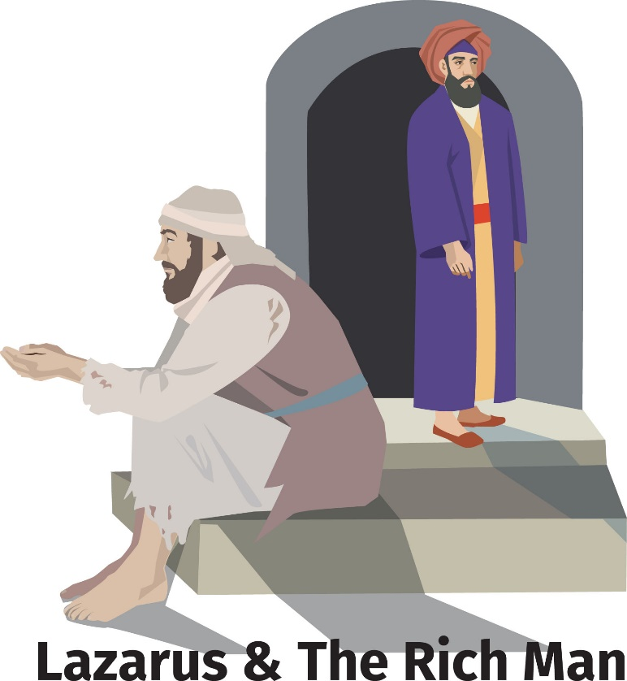

The assembly stands to proclaim the word of God in song
Hymn of the Day #583
Music printed under OneLicense.net license A-708005
Creed
I believe in God, the Father almighty,
creator of heaven and earth.
I believe in Jesus Christ, God’s only Son, our lord,
who was conceived by the Holy Spirit,
born of the virgin Mary,
suffered under Pontius Pilate,
was crucified, died and was buried;
he descended to the dead.
On the third day he rose again;
he ascended into heaven,
he is seated at the right hand of the Father,
and he will come to judge the living and the dead.
I believe in the Holy Spirit,
the holy catholic church,
the communion of saints,
the forgiveness of sins,
the resurrection of the body,
and the life everlasting. Amen.

Prayers of Intercession

Rejoicing in the Spirit’s work among us, let us pray for the church, the world, and all those in need.
Prayers of intercession are prayed.
To each petition, the assembly responds:

Lord, in your mercy,
hear our prayer.

The presiding minister concludes the
prayers, and the assembly responds:

Lord, in your mercy,
hear our prayer.

Into your hands, O God, we commend all for whom we pray, trusting in your mercy; through your Son, our Lord and Savior, Jesus Christ.
Amen.

Peace

The peace of Christ be with you always.
And also with you.

The assembly is seated.

Meal
God feeds us with the presence of Jesus Christ.

OFFERING
Chancel Choir Sing to the Lord (arr. Medema)

The assembly stands.

Offering Response

“We are an offering” Hymn # 692

Offering Prayer

Merciful God, as grains of wheat scattered upon the hills
were gathered together to become one bread,
so let your church be gathered together
from the ends of the earth into your kingdom,
for yours is the glory through Jesus Christ, now and forever.
Amen.

Great Thanksgiving

Dialogue

The Lord be with you.
And also with you.
Lift up your hearts.
We lift them to the Lord.
Let us give thanks to the Lord our God.
It is right to give our thanks and praise.

Preface

It is indeed right, our duty and our joy,
that we should at all times and in all places
give thanks and praise to you, almighty and merciful God,
through our Savior Jesus Christ;
who on this day overcame death and the grave,
and by his glorious resurrection opened to us the way of everlasting life.
And so, with all the choirs of angels,
with the church on earth and the hosts of heaven,
we praise your name and join their unending hymn:

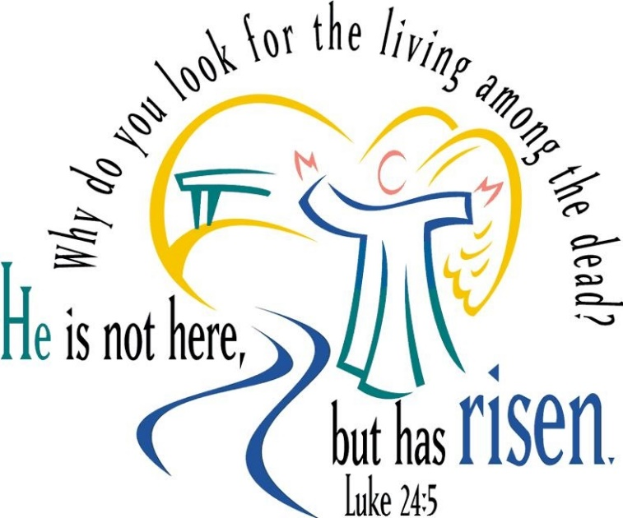

Holy, Holy, Holy

Thanksgiving at the Table

Holy God, our Bread of life, our Table, and our Food, you created a world in which all might be satisfied by your abundance.

You dined with Abraham and Sarah, promising them life, and fed your people Israel with manna from heaven. You sent your Son to eat with sinners and to become food for the world.

In the night in which he was betrayed, our Lord Jesus took bread, and gave thanks; broke it, and gave it to his disciples, saying:
Take and eat; this is my body, given for you. Do this for the remembrance of me.

Again, after supper, he took the cup, gave thanks, and gave it for all to drink, saying: This cup is the new covenant in my blood,
shed for you and for all people for the forgiveness of sin. Do this for the remembrance of me.

Remembering, therefore, his life given for us and his rising from the grave, we await his coming again to share with us the everlasting feast.

By your Spirit nurture and sustain us with this meal: strengthen us to serve all in hunger and want, and by this bread and cup make of us the body of your Son.

Through him all glory and honor is yours, Almighty Father, with the Holy Spirit, in your holy Church, both now and forever.
Amen

Lord’s Prayer
Gathered into one by the Holy Spirit,
let us pray as Jesus taught us.
Our Father in heaven,
hallowed be your name,
your kingdom come,
your will be done,
on earth as in heaven.
Give us today our daily bread.
Forgive us our sins
as we forgive those
who sin against us.
Save us from the time of trial
and deliver us from evil.
For the kingdom, the power,
and the glory are yours,
now and forever. Amen.

Invitation to Communion

Take hold of the life that really is life.
Come, take your place at the table.
The assembly is seated.

Communion
When giving the bread and cup, the communion ministers say
The body of Christ, given for you.
The blood of Christ, shed for you.
and each person may respond
Amen.

Communion Song

congregational song # 686

congregational song #689

Text and arrangement OneLicense.net license A-708005

The assembly stands.
The body and blood of our Lord Jesus Christ strengthen you and keep you in His grace.
Amen

Prayer after Communion

We come again to you, O God,
giving you thanks that in this feast of mercy
you have embraced us and healed us,
making us one in the body of Christ.
Go with us on our way.
Equip us for every good work,
that we may continue to give you thanks
by embracing others with mercy and healing;
through Jesus Christ, our Savior and Lord.
Amen.

Sending
God blesses us and sends us in mission to the world.

Blessing

God Almighty send you light and truth
to keep you all the days of your life.
The hand of God protect you;
the holy angels accompany you;
and the blessing of almighty God,
the Father, the ☩ Son, and the Holy Spirit,
be with you now and forever.
Amen.

Sending Song #655

Dismissal
Go in peace. Remember the poor.
Thanks be to God.

POSTLUDE
“In Babilone” Hymn #655 arr. Michael Burkhardt
Copyright © 2016 Augsburg Fortress. All rights reserved. Reprinted by permission under Augsburg Fortress Liturgies Annual License #SAS000803.
New Revised Standard Version Bible, copyright © 1989, Division of Christian Education of the National Council of the Churches of Christ in the United States of America. Used by permission. All rights reserved. Clipart copyright © 2016 by Communication Resources. All rights reserved. Used by permission.

“How lovely is your dwelling place, O LORD of hosts!...(our hearts and our) flesh sing for joy to the living God” (Psalm 84:1-2, NRSV). Welcome, friends, as we gather in praise.

Pastor Ellen Schoepf prellen@faithlutheranokemos.org
Secretary Katie Love klove@faithlutheranokemos.org
Director of Christian Education Melinda Schultz
Director of Music Debra Borton-McDonough
Organist/Pianist Bruce Williams

September 18th Worship and Attendance: 117

Serving Faith Today October 2nd

Acolyte
Altar Care Kay Showers & Gwynne Kadrofske
Altar Care Rich Weingartner & Melinda Schultz
Communion Assistants Harold Sollenberger Walter Kopf
Gus Lusis Jeff Rosenthal
Greeters Brendan Guenther Rich Weingartner
Lay Assistants Harold Sollenberger Walter Kopf
Readers Gus Lusis Jeff Rosenthal
Ushers Dingledine Family Doug & Linda Hirt
Nursery Mark & Jody Marquardt Drew & Pam Williams

