Welcome to
Faith Lutheran Church

September 18, 2016
Celebration Sunday
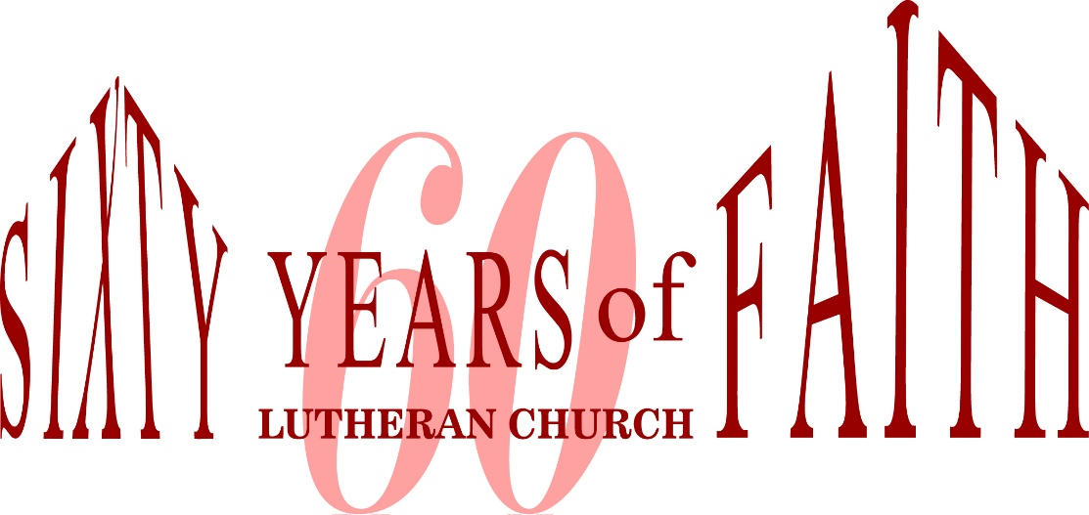

4515 Dobie Road
Okemos MI 48864-2203
517-349-0620

Pastor Ellen Schoepf
prellen@faithlutheranokemos.org

Who’s Your Master?
Someone once said you can tell what’s important to you by looking at your checkbook or account statement. There might be some big-ticket items on the list, but the most frequent items might tell the bigger story. What are the small things that add up over time? What are the patterns of spending that indicate what you value?
The same could probably be said for your calendar. What do you spend your time on and what does that say about what holds value for you? Who or what do you serve? Who or what is your master? An even more important question to ask might be what kind of a master do you want to serve?
Time and wealth are not very forgiving masters. They aren’t ultimately interested in your welfare or anyone else’s. To chase after these masters, no matter how successfully, is to run into a dead end. There’s never enough time to do it all. There’s never enough money to do it all.
However, the God who created time and provides for our every need is forgiving beyond measure and interested in you to the point of sending Jesus to die for you. To serve God is to experience a richness in this life that bubbles up to a life without end. To use your gifts, resources, and skills in service to this master is to invest in returns that are priceless not just for you, but for the world. According to Jesus’ parable for today, God can use your creativity, and even shrewdness, to benefit others and accomplish God’s mission.
May worshiping in the Spirit’s presence today free you to use your time and resources for the Master’s purpose.

Sunday, September 18, 2016
18th Sunday after Pentecost
ELW Holy Communion Setting Nine

Introduction to the day
As we are invited today to consider what it means to be managers (rather than owners) of all that we have, it is crucial to recall that we are bought with a price. “Christ Jesus, himself human, . . . gave himself a ransom for all.” Apart from the generosity of God we have nothing—we are nothing. By God’s gracious favor we have everything we need.

If hearing assistance is needed, please ask an usher for a personal PA receiver.

The ushers also have large print copies of today’s worship folder available.

If it will be difficult for you to stand along with the congregation during
any part of the worship service, please feel free to remain seated.

There is a nursery available during the worship service for those who wish
to use it. It is located at the end of the hall beyond the coat racks.

WELCOME AND ANNOUNCEMENTS

We cordially greet all who have come to worship today.
Please register your attendance and join us in fellowship after the service.

Prayer Requests

PRELUDE

The pre-service music signals the beginning of the worship service. Silence during the
pre-service music enables worshipers to prepare for worship through quiet meditation.

Faith Bells “Celebration” (Hughes)

Gathering
The Holy Spirit calls us together as the people of God.
Thanksgiving for Baptism

Blessed be the holy Trinity, ☩ one God,
the fountain of living water,
the rock who gave us birth,
our light and our salvation.
Amen.

A reading from the Psalms:

The voice of the Lord is upon the waters; the God of glory thunders; the Lord is upon the mighty waters. O Lord, give strength to your people; give them, O Lord, the blessings of peace. (Psalm 29:3, 11)

Let the sea roar, and all that fills it, the world and those who dwell therein. Let the rivers clap their hands, and let the hills ring out with joy before the Lord. (Psalm 98:7-8)

Joined to Christ in the waters of baptism, we are clothed with God’s mercy and forgiveness. Let us give thanks for the gift of baptism.

Holy God, holy and merciful, holy and mighty, you are the river of life, you are the everlasting wellspring, you are the fire of rebirth.

Glory to you for oceans and lakes, for rivers and streams.
We give you thanks for the Great Lakes that surround us, for Lake Lansing, the Grand River and the Red Cedar that are nearby us.

Honor to you for cloud and rain, for dew and snow.
Your waters are below us, around us, above us: our life is born in you. You are the fountain of resurrection.

Praise to you for your saving waters:
Noah and the animals survive the flood, Hagar discovers your well.
The Israelites escape through the sea, and they drink from your gushing rock.
Naaman washes his leprosy away, and the Samaritan woman will never be thirsty again. At the river your Son was baptized by John and anointed with the Holy Spirit.

By water and your Word you claim us as daughters and sons,
making us heirs of your promise and servants of all.
We praise you for the gift of water that sustains life,
and above all we praise you for the gift of new life in Jesus Christ.
We thank you for this Faith Lutheran community whose members have faithfully walked wet in your baptismal water for sixty years.

Shower us with your Spirit,
and renew our lives with your forgiveness, grace, and love.
To you be given honor and praise
through Jesus Christ our Lord in the unity of the Holy Spirit, now and forever.
Amen.

DEDICATION OF BAPTISMAL FONT

By your grace, O God, you have brought us into your covenant through the waters of baptism, and by the power of the Holy Spirit we are made members of the body of Christ, the church. At this font may lives be claimed by the death and resurrection of Jesus Christ for the work and witness of your people in this world. We did not choose you, O Lord, but you chose us. Trusting in Jesus Christ, we dedicate this font in the name of the Triune God.

Amen.

Today we dedicate our new baptismal font to the glory of God. This font is a gift to the congregation from Jim & Peggy Crum. Jim made the base of the font. A friend of the Crum's, Gail Johnston, is a potter. Gail designed and created the bowl and the pitcher. This font was created to celebrate the 60th Anniversary of Faith Lutheran Church. Our old baptismal font will be placed in the Narthex and be open every Sunday morning. Water will be in the bowl of the font and, if you so desire, you may dip your finger in the bowl and make the sign of the cross on your forehead as you enter the sanctuary.

Gathering Song #641
Text and Music printed under OneLicense.net license A-708005

Greeting
The grace of our Lord Jesus Christ, the love of God,
and the communion of the Holy Spirit be with you all.
And also with you.

Kyrie

Canticle of Praise
Prayer of the Day

Let us pray.
God among us, we gather in the name of your Son to learn love for one another. Keep our feet from evil paths. Turn our minds to your wisdom and our hearts to the grace revealed in your Son, Jesus Christ, our Savior and Lord.
Amen.
The assembly is seated.

Word
God speaks to us in scripture reading, preaching, and song.

First Reading: Amos 8:4-7

Amos was called by God to prophesy in the Northern Kingdom of Israel. Peace and prosperity in Israel led to corrupt business practices and oppression of the poor. The prophet declares that God will not tolerate such a situation.

A reading from Amos.
⁴Hear this, you that trample on the needy,
and bring to ruin the poor of the land,
⁵saying, “When will the new moon be over
so that we may sell grain;
and the sabbath,
so that we may offer wheat for sale?
We will make the ephah small and the shekel great,
and practice deceit with false balances,
⁶buying the poor for silver
and the needy for a pair of sandals,
and selling the sweepings of the wheat.”
⁷The Lord has sworn by the pride of Jacob:
Surely I will never forget any of their deeds.

The word of the Lord.
Thanks be to God.

Psalm: Psalm 113

Read responsively
¹Hallelujah! Give praise, you servants of the Lord;
praise the name of the Lord.
²Let the name of the Lord be blessed,
from this time forth forevermore.
³From the rising of the sun to its going down
let the name of the Lord be praised.
⁴The Lord is high above all nations;
God’s glory above the heavens.
⁵Who is like the Lord our God,
who sits enthroned on high,
⁶but stoops to behold
the heavens and the earth?
⁷The Lord takes up the weak out of the dust
and lifts up the poor from the ashes,
⁸enthroning them with the rulers,
with the rulers of the people.
⁹The Lord makes the woman of a childless house
to be a joyful mother of children. Hallelujah!

Second Reading: 1 Timothy 2:1-7

The Pastoral Epistles offer insight into how early Christians understood many practical matters, such as church administration and worship. The church’s focused prayer for others is an expression of the single-minded passion God has toward us in Jesus.
A reading from 1 Timothy.

¹First of all, then, I urge that supplications, prayers, intercessions, and thanksgivings be made for everyone, ²for kings and all who are in high positions, so that we may lead a quiet and peaceable life in all godliness and dignity. ³This is right and is acceptable in the sight of God our Savior, ⁴who desires everyone to be saved and to come to the knowledge of the truth. ⁵For
there is one God;
there is also one mediator between God and humankind,
Christ Jesus, himself human,
⁶who gave himself a ransom for all
—this was attested at the right time.⁷For this I was appointed a herald and an apostle (I am telling the truth, I am not lying), a teacher of the Gentiles in faith and truth.

The word of the Lord.
Thanks be to God.

The assembly stands to welcome the gospel.

Gospel Acclamation

Gospel: Luke 16:1-13
Jesus tells the curious story of a dishonest man who cheats his employer and then is commended by him for having acted so shrewdly. Jesus wonders why his own followers are less creative and diligent in their stewardship given that they are managers of a far more valuable household.

The holy gospel according to Luke.
Glory to you, O Lord.

¹Then Jesus said to the disciples, “There was a rich man who had a manager, and charges were brought to him that this man was squandering his property. ²So he summoned him and said to him, ‘What is this that I hear about you? Give me an accounting of your management, because you cannot be my manager any longer.’ ³Then the manager said to himself, ‘What will I do, now that my master is taking the position away from me? I am not strong enough to dig, and I am ashamed to beg. ⁴I have decided what to do so that, when I am dismissed as manager, people may welcome me into their homes.’ ⁵So, summoning his master’s debtors one by one, he asked the first, ‘How much do you owe my master?’ ⁶He answered, ‘A hundred jugs of olive oil.’ He said to him, ‘Take your bill, sit down quickly, and make it fifty.’ ⁷Then he asked another, ‘And how much do you owe?’ He replied, ‘A hundred containers of wheat.’ He said to him, ‘Take your bill and make it eighty.’ ⁸And his master commended the dishonest manager because he had acted shrewdly; for the children of this age are more shrewd in dealing with their own generation than are the children of light. ⁹And I tell you, make friends for yourselves by means of dishonest wealth so that when it is gone, they may welcome you into the eternal homes.
¹⁰“Whoever is faithful in a very little is faithful also in much; and whoever is dishonest in a very little is dishonest also in much. ¹¹If then you have not been faithful with the dishonest wealth, who will entrust to you the true riches? ¹²And if you have not been faithful with what belongs to another, who will give you what is your own? ¹³No slave can serve two masters; for a slave will either hate the one and love the other, or be devoted to the one and despise the other. You cannot serve God and wealth.”

The gospel of the Lord.
Praise to you, O Christ.
The assembly is seated.
children’s Message

Sermon
The assembly stands to proclaim the word of God in song.

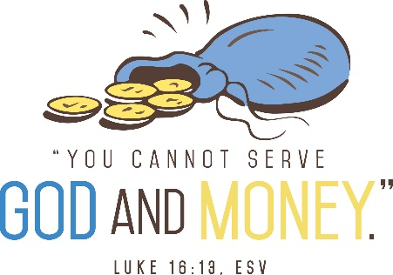

Hymn of the Day #651
Text and Music printed under OneLicense.net license A-708005
Creed
I believe in God, the Father almighty,
creator of heaven and earth.
I believe in Jesus Christ, God’s only Son, our Lord,
who was conceived by the Holy Spirit,
born of the virgin Mary,
suffered under Pontius Pilate,
was crucified, died, and was buried;
he descended to the dead.
On the third day he rose again;
he ascended into heaven,
he is seated at the right hand of the Father,
and he will come to judge the living and the dead.
I believe in the Holy Spirit,
the holy catholic church,
the communion of saints,
the forgiveness of sins,
the resurrection of the body,
and the life everlasting. Amen.

Prayers of Intercession

Rejoicing in the Spirit’s work among us, let us pray for the church, the world, and all those in need.
Prayers of intercession are prayed.
To each petition, the assembly responds:

Lord, in your mercy,
hear our prayer.

The presiding minister concludes the
prayers, and the assembly responds:

Lord, in your mercy,
hear our prayer.

Into your hands, O God, we commend all for whom we pray, trusting in your mercy; through your Son, our Lord and Savior, Jesus Christ.
Amen.
Peace

The peace of Christ be with you always.
And also with you.

The assembly is seated.

Meal
God feeds us with the presence of Jesus Christ.

Offering

Chancel Choir “Partnership of Faith” (English)

The assembly stands.

Offering Response

“We are an Offering” Hymn # 692

Offering Prayer

Merciful God, as grains of wheat scattered upon the hills
were gathered together to become one bread,
so let your church be gathered together
from the ends of the earth into your kingdom,
for yours is the glory through Jesus Christ, now and forever.
Amen.

Great Thanksgiving

Dialogue
The Lord be with you.
And also with you.
Lift up your hearts.
We lift them to the Lord.
Let us give thanks to the Lord our God.
It is right to give our thanks and praise.

Preface

It is indeed right, our duty and our joy,
that we should at all times and in all places
give thanks and praise to you, almighty and merciful God,
through our Savior Jesus Christ;
who on this day overcame death and the grave,
and by his glorious resurrection opened to us the way of everlasting life.
And so, with all the choirs of angels,
with the church on earth and the hosts of heaven,
we praise your name and join their unending hymn:

Holy, Holy, Holy

Thanksgiving at the Table

Holy God, our Bread of life, our Table, and our Food, you created a world in which all might be satisfied by your abundance.

You dined with Abraham and Sarah, promising them life, and fed your people Israel with manna from heaven. You sent your Son to eat with sinners and to become food for the world.

In the night in which he was betrayed, our Lord Jesus took bread, and gave thanks; broke it, and gave it to his disciples, saying:
Take and eat; this is my body, given for you. Do this for the remembrance of me.

Again, after supper, he took the cup, gave thanks, and gave it for all to drink, saying: This cup is the new covenant in my blood,
shed for you and for all people for the forgiveness of sin. Do this for the remembrance of me.

Remembering, therefore, his life given for us and his rising from the grave, we await his coming again to share with us the everlasting feast.

By your Spirit nurture and sustain us with this meal: strengthen us to serve all in hunger and want, and by this bread and cup make of us the body of your Son.

Through him all glory and honor is yours, Almighty Father, with the Holy Spirit, in your holy Church, both now and forever.
Amen

Lord’s Prayer
Gathered into one by the Holy Spirit,
let us pray as Jesus taught us.
Our Father in heaven,
hallowed be your name,
your kingdom come,
your will be done,
on earth as in heaven.
Give us today our daily bread.
Forgive us our sins
as we forgive those
who sin against us.
Save us from the time of trial
and deliver us from evil.
For the kingdom, the power,
and the glory are yours,
now and forever. Amen.

Invitation to Communion

Take hold of the life that really is life.
Come, take your place at the table.

The assembly is seated.

Communion

When giving the bread and cup, the communion ministers say
The body of Christ, given for you.
The blood of Christ, shed for you.
and each person may respond
Amen.

Communion Song

congregational song #732
Please use the hymnal next to your seat.

congregational song

music and text printed under OneLicense.net license A-708005

The assembly stands

The body and blood of our Lord Jesus Christ
Strengthen you and keep you in his grace.
Amen

Prayer after Communion

We come again to you, O God,
giving you thanks that in this feast of mercy
you have embraced us and healed us,
making us one in the body of Christ.
Go with us on our way.
Equip us for every good work,
that we may continue to give you thanks
by embracing others with mercy and healing;
through Jesus Christ, our Savior and Lord.
Amen.

Sending
God blesses us and sends us in mission to the world.

Blessing
God Almighty send you light and truth
to keep you all the days of your life.
The hand of God protect you;
the holy angels accompany you;
and the blessing of almighty God,
the Father, the ☩ Son, and the Holy Spirit,
be with you now and forever.
Amen.

Sending Song #773
Text and music printed under onelicense.net license a-708005
Dismissal
Go in peace. Remember the poor.
Thanks be to God.
POSTLUDE
“Te Deum, Prelude,” Charpentier, arr. Kaluza

The Gift

Come, stay a while and be my friend,
I’ll tell you a tale that has no end.
All corn and wheat fields are harvested in,
And the summer sky has turned clear blue.

God is smiling and tells us then,
Go forward and build a home where I may dwell therein.
Loving, sharing and caring, for these will be our golden rule.
Asking always, what can I do for you?

Taking away the stained glass windows,
The beautiful cross that hangs so high,
The candle softly burning,
And the song of silent night.

Standing alone, we’ll always know
You are holding us in Your heart,
And there You will keep us forever,
Yes, forever and a day.

Written by Helen Brinkman upon the occasion of the sixtieth anniversary of Faith Lutheran Church, Okemos, MI

Dedicated to Pastor Ellen M. Schoepf and
Helen’s parents, Thelma and DeWitt Pierson.

Copyright © 2016 Augsburg Fortress. All rights reserved. Reprinted by permission under Augsburg Fortress Liturgies Annual License #SAS000803.
New Revised Standard Version Bible, copyright © 1989, Division of Christian Education of the National Council of the Churches of Christ in the United States of America. Used by permission. All rights reserved. Clipart copyright © 2016 by Communication Resources. All rights reserved. Used by permission.

As we enter into worship, please share Christ’s peace with someone next to you. Welcome!

Pastor Ellen Schoepf prellen@faithlutheranokemos.org
Secretary Katie Love klove@faithlutheranokemos.org
Director of Christian Education Melinda Schultz
Director of Music Debra Borton-McDonough
Organist/Pianist Bruce Williams

September 11th Worship Attendance: 115

Serving Faith Today September 25

Acolyte
Alter Care Kay Showers & Gwynne Kadrofske
Communion Assistants Mike Eschelbach Harold Sollenberger
Deb Borton-McDonough Gus Lusis
Greeters Doug & Linda Hirt Brendan Guenther
Lay Assistants Mike Eschelbach Harold Sollenberger
Readers Deb Borton-McDonough Gus Lusis
Ushers Dingledine Family Dingledine Family
Nursery Beth Ballegeer Mark & Jody Marquardt

