Welcome to
Faith Lutheran Church
September 11, 2016
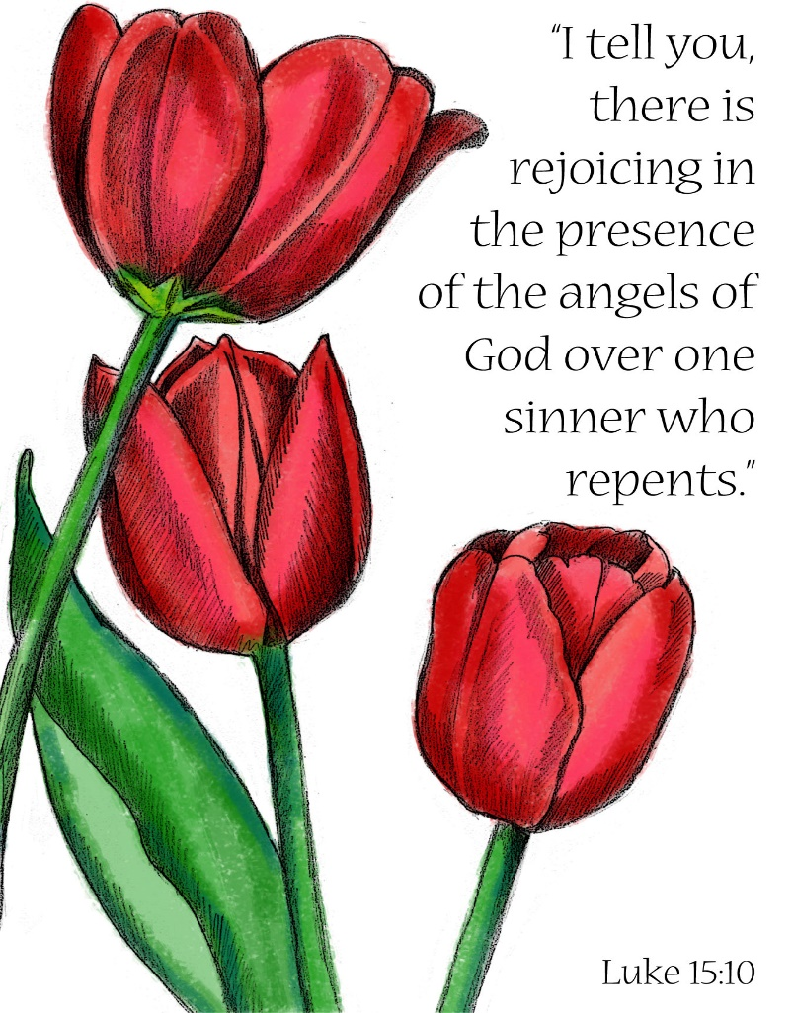
4515 Dobie Road
Okemos MI 48864-2203
517-349-0620

Pastor Ellen Schoepf
prellen@faithlutheranokemos.org

We Are Found!

Rescuers diligently searched for the lost. Cheers went up and tears of joy fell when someone was found alive! Though it has been 15 years since 9/11, there are many who carry with them today the images of searching for the lost in the mountain of debris at Ground Zero and the joy when someone was found.
Whether in the rubble of an earthquake, the aftermath of a tornado, the devastation of a hurricane, or the search for a lost child, rescuers rejoice when the lost are found safe and sound. Jesus tells us that the angels of God will rejoice in the same way over one sinner who repents. That’s why Jesus meets and eats with sinners. All are worth finding—even the religious leaders, who are sinners too.
If there is great joy when someone is found, then there is also great sorrow when someone is not. Many still carry the pain of having lost a loved one on 9/11 who was never found. Many around the world have lost a loved one who has never been found to war, natural disaster, or other tragedies. Many grieve someone who seems lost in their sin—perhaps even themselves.
The promise in Jesus is that we are never so lost that we can’t be found by our loving Savior. Even in death, Christ carries us to life. Jesus meets us in our grief to comfort and heal us. Daily, Christ searches to find us in the dust of our sin and wipes it away with his very own body and blood.
We all need rescue from sin, death, and the powers that seek to destroy us. And in bread, wine, water, and word, Jesus finds us again and again. Taste, see, and hear today: our rescuer comes to save us!

Sunday, September 11, 2016
Seventeenth Sunday after Pentecost
Holy Communion
INTRODUCTION TO THE DAY

The grumbling of the Pharisees and the scribes in today’s gospel is actually our holy hope: This Jesus welcomes sinners and eats with them. That our God wills to seek and to save the lost is not only a holy hope, it is our only hope. As Paul’s first letter to Timothy reminds us, “The saying is sure and worthy of full acceptance, that Christ Jesus came into the world to save sinners.” Thanks be to God.

If hearing assistance is needed, please ask an usher for a personal PA receiver.

The ushers also have large print copies of today’s worship folder available.

If it will be difficult for you to stand along with the congregation during
any part of the worship service, please feel free to remain seated.

There is a nursery available during the worship service for those who wish
to use it. It is located at the end of the hall beyond the coat racks.

WELCOME AND ANNOUNCEMENTS

We cordially greet all who have come to worship today.
Please register your attendance and join us in fellowship after the service.

Prayer Requests

PRELUDE

The pre-service music signals the beginning of the worship service. Silence during the
pre-service music enables worshipers to prepare for worship through quiet meditation.

“Canticle of the Turning” #723 arr. Ron Schmoltze

Gathering
The Holy Spirit calls us together as the people of God.

Confession and Forgiveness

All may make the sign of the cross, the sign marked
at baptism, as the presiding minister begins.
Blessed be the holy Trinity, ☩ one God,
the only Sovereign, who dwells in light;
Christ Jesus, who came to save sinners;
the Holy Spirit, who lives within us.
Amen.

Let us confess our sin in the presence of God and of one another.

Silence is kept for reflection.

God of overflowing grace,
we come to you with repentant hearts.
Forgive us for shallow thankfulness.
Forgive us for passing by the ones in need.
Forgive us for setting our hopes on fleeting treasures.
Forgive us our neglect and thoughtlessness.
Bring us home from the wilderness of sin,
and strengthen us to serve you
in all that we do and say;
through Jesus Christ, our Savior and Lord.
Amen.

There is joy in heaven over every sinner who repents.
By the grace of God in ☩ Christ Jesus,
who gave himself up for us all,
your sins are forgiven and you are made free.
Rejoice with the angels and with one another!
We are home in God’s mercy, now and forever.
Amen.

Gathering Song #834
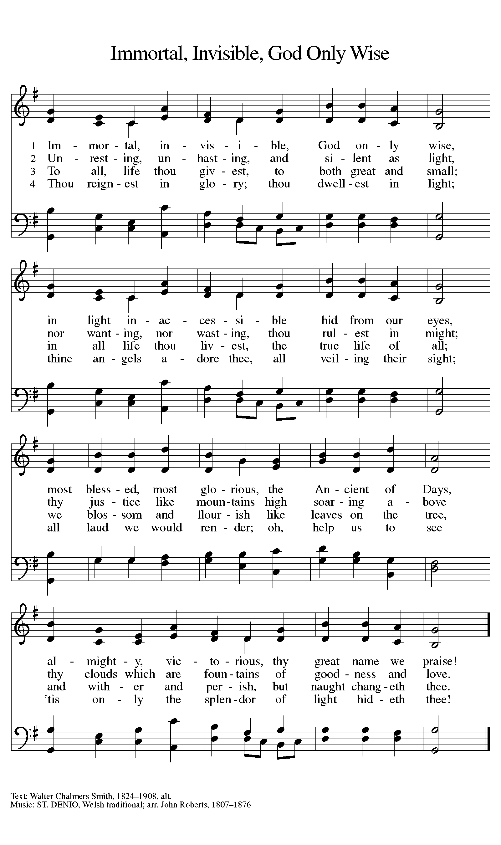
Greeting
The grace of our Lord Jesus Christ, the love of God,
and the communion of the Holy Spirit be with you all.
And also with you.
Canticle of Praise
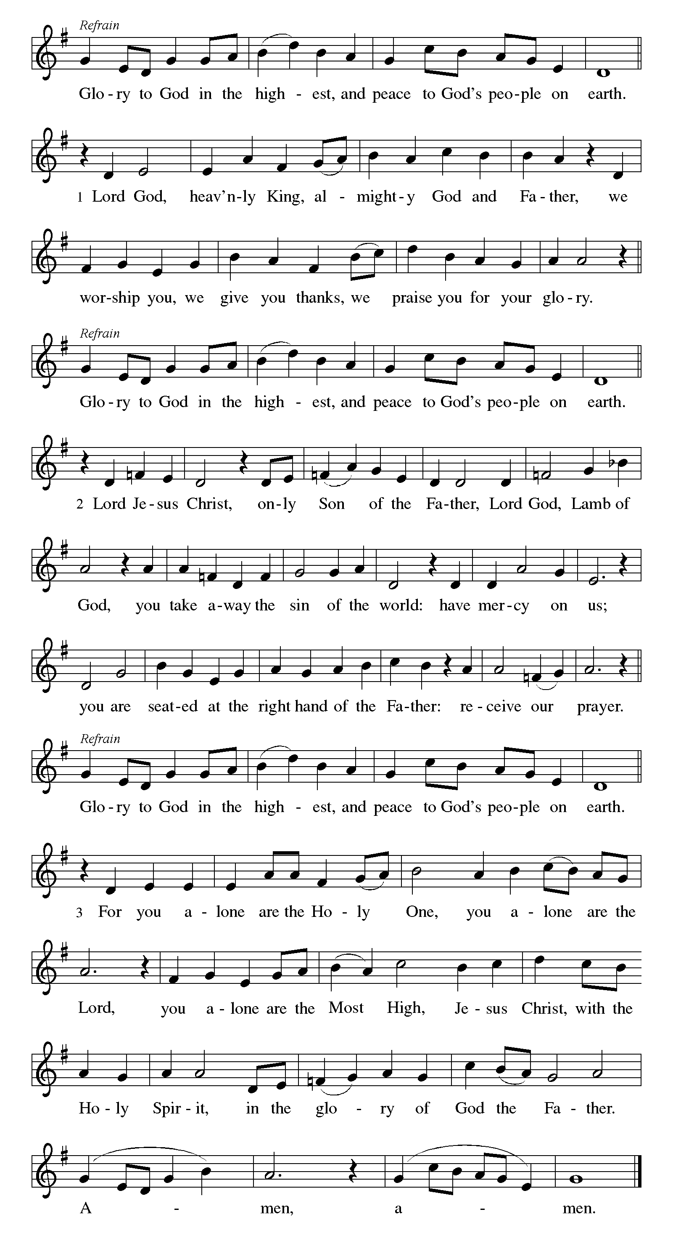

Prayer of the Day

Let us pray.
O God, overflowing with mercy and compassion, you lead back to yourself all those who go astray. Preserve your people in your loving care, that we may reject whatever is contrary to you and may follow all things that sustain our life in your Son, Jesus Christ, our Savior and Lord.
Amen.

The assembly is seated.

Word
God speaks to us in scripture reading, preaching, and song.

First Reading: Exodus 32:7-14

While Moses is on Mount Sinai, the people grow restless and make a golden calf to worship. Today’s reading shows Moses as the mediator between an angry God and a sinful people. Moses reminds God that the Israelites are God’s own people and boldly asks mercy for them.
A reading from Exodus.

⁷The Lord said to Moses, “Go down at once! Your people, whom you brought up out of the land of Egypt, have acted perversely; ⁸they have been quick to turn aside from the way that I commanded them; they have cast for themselves an image of a calf, and have worshiped it and sacrificed to it, and said, ‘These are your gods, O Israel, who brought you up out of the land of Egypt!’ ” ⁹The Lord said to Moses, “I have seen this people, how stiff-necked they are. ¹⁰Now let me alone, so that my wrath may burn hot against them and I may consume them; and of you I will make a great nation.”
¹¹But Moses implored the Lord his God, and said, “O Lord, why does your wrath burn hot against your people, whom you brought out of the land of Egypt with great power and with a mighty hand? ¹²Why should the Egyptians say, ‘It was with evil intent that he brought them out to kill them in the mountains, and to consume them from the face of the earth’? Turn from your fierce wrath; change your mind and do not bring disaster on your people. ¹³Remember Abraham, Isaac, and Israel, your servants, how you swore to them by your own self, saying to them, ‘I will multiply your descendants like the stars of heaven, and all this land that I have promised I will give to your descendants, and they shall inherit it forever.’ ” ¹⁴And the Lord changed his mind about the disaster that he planned to bring on his people.

The word of the Lord.
Thanks be to God.

Second Reading: 1 Timothy 1:12-17

The letters to Timothy are called the Pastoral Epistles because they contain advice especially intended for leaders in the church. Here the mercy shown to Paul, who once persecuted the church, is cited as evidence that even the most unworthy may become witnesses to the grace of God.

A reading from 1 Timothy.

¹²I am grateful to Christ Jesus our Lord, who has strengthened me, because he judged me faithful and appointed me to his service, ¹³even though I was formerly a blasphemer, a persecutor, and a man of violence. But I received mercy because I had acted ignorantly in unbelief, ¹⁴and the grace of our Lord overflowed for me with the faith and love that are in Christ Jesus. ¹⁵The saying is sure and worthy of full acceptance, that Christ Jesus came into the world to save sinners—of whom I am the foremost. ¹⁶But for that very reason I received mercy, so that in me, as the foremost, Jesus Christ might display the utmost patience, making me an example to those who would come to believe in him for eternal life. ¹⁷To the King of the ages, immortal, invisible, the only God, be honor and glory forever and ever. Amen.

The word of the Lord.
Thanks be to God.
The assembly stands to welcome the gospel

Gospel Acclamation

Gospel: Luke 15:1-10

Jesus tells two stories that suggest a curious connection between the lost being found and sinners repenting. God takes the initiative to find sinners, each of whom is so precious to God that his or her recovery brings joy in heaven.

The holy gospel according to Luke.
Glory to you, O Lord.

¹Now all the tax collectors and sinners were coming near to listen to [Jesus.] ²And the Pharisees and the scribes were grumbling and saying, “This fellow welcomes sinners and eats with them.”
³So he told them this parable: ⁴“Which one of you, having a hundred sheep and losing one of them, does not leave the ninety-nine in the wilderness and go after the one that is lost until he finds it? ⁵When he has found it, he lays it on his shoulders and rejoices. ⁶And when he comes home, he calls together his friends and neighbors, saying to them, ‘Rejoice with me, for I have found my sheep that was lost.’ ⁷Just so, I tell you, there will be more joy in heaven over one sinner who repents than over ninety-nine righteous persons who need no repentance.
⁸“Or what woman having ten silver coins, if she loses one of them, does not light a lamp, sweep the house, and search carefully until she finds it? ⁹When she has found it, she calls together her friends and neighbors, saying, ‘Rejoice with me, for I have found the coin that I had lost.’ ¹⁰Just so, I tell you, there is joy in the presence of the angels of God over one sinner who repents.”

The gospel of the Lord.
Praise to you, O Christ.

The assembly is seated.

CHILDREN’S MESSAGE

Sermon

The assembly stands to proclaim the word of God in song.

Hymn of the Day #668
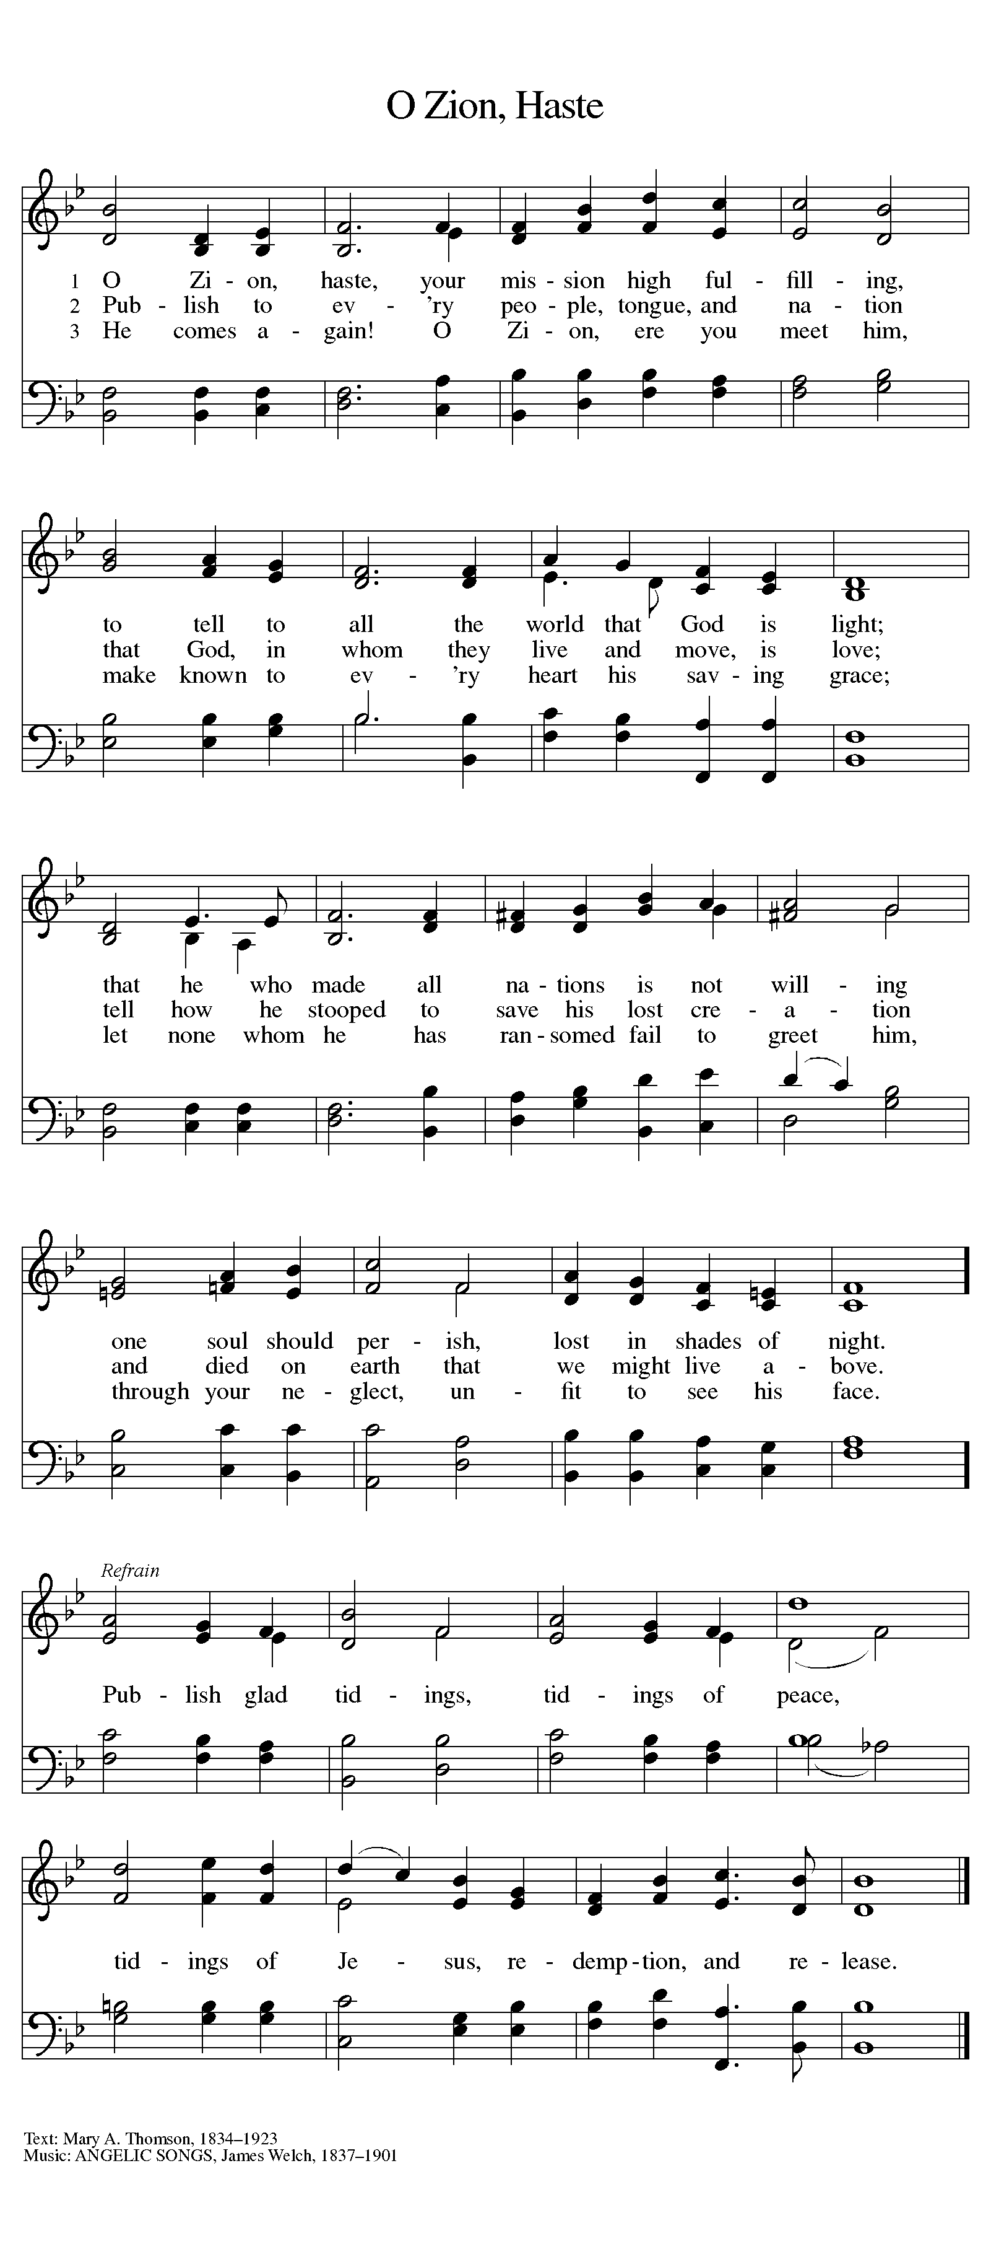
The assembly is seated
COMMISSIONING AND BLESSING OF TEACHERS
A reading from First Corinthians.

Now there are varieties of gifts, but the same Spirit; and there are varieties of services, but the same Lord; and there are varieties of activities, but it is the same God who activates all of them in everyone. To each is given the manifestation of the Spirit for the common good. (I Cor. 12:4-7)

Brothers and sisters, you have volunteered your time, your energy, and your gifts to the children, youth and family ministries of this congregation. Will you offer your giftedness to this ministry in the confidence that it comes from God?
I will, and I ask God to help me.

A reading from Proverbs.
Trust in the Lord with all your heart, and do not rely on your own insight. In all your ways acknowledge him, and he will make straight your paths. (Prov. 3:5-6)

Will you carry out this ministry centered in Christ’s call, striving to trust God as your guide and inspiration?
I will, and I ask God to help me.

A reading from Ephesians.
I pray that you may be strengthened in your inner being with power through God’s Spirit, and that Christ may dwell in your hearts through faith, as you are being rooted and grounded in love. I pray that you may have the power to comprehend, with all the saints, what is the breadth and length and height and depth, and to know the love of Christ that surpasses knowledge, so that you may be filled with all the fullness of God. (Eph. 3:16-19)

Will you trust in God’s care, seek to grow in love for those you serve, strive for excellence in your skills, and honor the gospel with a faithful life?
I will, and I ask God to help me.

The assembly stands

I now ask you, the people of Faith Lutheran Church:
Will you today renew your commitment to our youngest brothers and sisters, our children and youth who look to you for guidance, support, and examples of righteous living?
We will, and we ask God to help us.

People of Faith: Will you claim these gifted people as those called by God to help carry out our congregation’s ministry to children, youth, and families? Will you support them and enthusiastically celebrate the work they do?
We will, and we ask God to help us.

Will you pray for these leaders and the young people they serve, celebrating our children and youth as the ones Jesus blessed and welcomed?
We will, and we ask God to help us.

Let us pray.
Gracious God, for Jesus’ sake, empower these ministers to care for the young ones in our family of faith. Help them to teach faithfully, lead patiently, and guide confidently. Stir up in these servants the gift of your Holy Spirit: the spirit of knowledge and fear of the Lord, the spirit of joy in your presence, both now and forever.
Amen.

Almighty God, who has given you the gifts and the will to do these things, graciously give you the strength and compassion to perform them.
Amen.

On behalf of Faith Lutheran Church, we now commission you for ministry, grateful for your gifts and your willingness to serve.

The assembly may offer acclamation with applause

The worship service continues with the prayers.

Prayers of Intercession

Rejoicing in the Spirit’s work among us, let us pray for the church, the world, and all those in need.

Prayers of intercession are prayed.
To each petition, the assembly responds:

Hear us, O God.
Your mercy is great.

The presiding minister concludes the
prayers, and the assembly responds:

Into your hands, O God, we commend all for whom we pray, trusting in your mercy; through your Son, our Lord and Savior, Jesus Christ.
Amen.

Peace

The peace of Christ be with you always.
And also with you.

The people may greet one another with a sign of Christ’s peace, and may say, “Peace be with you,” or similar words.

The assembly is seated.

Meal
God feeds us with the presence of Jesus Christ.

offering

Chancel Choir "Now Let Us All Praise God and Sing" (Young)

The assembly stands.

Offering Response

“We are an Offering” Hymn # 692

Offering Prayer

Merciful God, as grains of wheat scattered upon the hills
were gathered together to become one bread,
so let your church be gathered together
from the ends of the earth into your kingdom,
for yours is the glory through Jesus Christ, now and forever.
Amen.

Great Thanksgiving

Dialogue
The Lord be with you.
And also with you.
Lift up your hearts.
We lift them to the Lord.
Let us give thanks to the Lord our God.
It is right to give our thanks and praise.

Preface
It is indeed right, our duty and our joy,
that we should at all times and in all places
give thanks and praise to you, almighty and merciful God,
through our Savior Jesus Christ;
who on this day overcame death and the grave,
and by his glorious resurrection opened to us the way of everlasting life.
And so, with all the choirs of angels,
with the church on earth and the hosts of heaven,
we praise your name and join their unending hymn:

Holy, Holy, Holy
Thanksgiving at the Table
Holy God, our Bread of life, our Table, and our Food, you created a world in which all might be satisfied by your abundance.

You dined with Abraham and Sarah, promising them life, and fed your people Israel with manna from heaven. You sent your Son to eat with sinners and to become food for the world.

In the night in which he was betrayed, our Lord Jesus took bread, and gave thanks; broke it, and gave it to his disciples, saying:
Take and eat; this is my body, given for you. Do this for the remembrance of me.

Again, after supper, he took the cup, gave thanks, and gave it for all to drink, saying: This cup is the new covenant in my blood,
shed for you and for all people for the forgiveness of sin.
Do this for the remembrance of me.
Remembering, therefore, his life given for us and his rising from the grave, we await his coming again to share with us the everlasting feast.

By your Spirit nurture and sustain us with this meal: strengthen us to serve all in hunger and want, and by this bread and cup make of us the body of your Son.

Through him all glory and honor is yours, Almighty Father, with the Holy Spirit, in your holy Church, both now and forever.
Amen

Lord’s Prayer

Gathered into one by the Holy Spirit,
let us pray as Jesus taught us.
Our Father in heaven,
hallowed be your name,
your kingdom come,
your will be done,
on earth as in heaven.
Give us today our daily bread.
Forgive us our sins
as we forgive those
who sin against us.
Save us from the time of trial
and deliver us from evil.
For the kingdom, the power,
and the glory are yours,
now and forever. Amen.

Invitation to Communion

Take hold of the life that really is life.
Come, take your place at the table.

The assembly is seated.

Communion

When giving the bread and cup, the communion ministers say

The body of Christ, given for you.
The blood of Christ, shed for you.
and each person may respond
Amen.

Communion Song

CONGREGATIONAL SONG #779

CONGREGATIONAL SONG

Text and Music printed under CCLI 720217

CONGREGATIONAL SONG #484
Text and Music printed under CCLI license 720217
The assembly stands
The body and blood of our Lord Jesus Christ
Strengthen you and keep you in his grace.
Amen

Prayer after Communion
We come again to you, O God,
giving you thanks that in this feast of mercy
you have embraced us and healed us,
making us one in the body of Christ.
Go with us on our way.
Equip us for every good work,
that we may continue to give you thanks
by embracing others with mercy and healing;
through Jesus Christ, our Savior and Lord.
Amen.

Sending
God blesses us and sends us in mission to the world.

Blessing

God Almighty send you light and truth
to keep you all the days of your life.
The hand of God protect you;
the holy angels accompany you;
and the blessing of almighty God,
the Father, the ☩ Son, and the Holy Spirit,
be with you now and forever.
Amen.

Sending Song #723
Text and arrangement printed under OneLicense.net license A-708005
Dismissal
Go in peace. Remember the poor.
Thanks be to God.
POSTLUDE
“Fague in C Major” (Jig) by Dietrich Buxtehude
Copyright © 2016 Augsburg Fortress. All rights reserved. Reprinted by permission under Augsburg Fortress Liturgies Annual License #SAS000803.
New Revised Standard Version Bible, copyright © 1989, Division of Christian Education of the National Council of the Churches of Christ in the United States of America. Used by permission. All rights reserved.

Brothers and sisters in Christ, welcome to worship in the name of the Father, Son and Holy Spirit. Amen.

Pastor Ellen Schoepf prellen@faithlutheranokemos.org
Secretary Katie Love klove@faithlutheranokemos.org
Director of Christian Education Melinda Schultz
Director of Music Debra Borton-McDonough
Organist/Pianist Bruce Williams

September 4 worship attendance: 69

Serving Faith Today September 18

Acolyte
Alter Care Kay Showers & Gwynne Kadrofske
Communion Assistants Deb Borton-McDonough Harold Sollenberger
August Colandrea Deb Borton-McDonough
Greeters Harold Sollenberger Doug & Linda Hirt
Lay Assistants Deb Borton-McDonough Harold Sollenberger
Readers August Colandrea Deb Borton-McDonough
Ushers Dingledine Family Dingeldine Family
Nursery Melinda & Lauren Beth Ballegeer

