**ANNOUNCEMENTS**

FaithFamily&Friends3

**June 26, 2016**

*Log onto Faith’s website www.faithlutheranokemos.org 24/7 for updates*

**DEADLINES**

Sunday worship folder announcements⎯Tuesday of each week

Submit to Rita at rbarry@faithlutheranokemos.org

**August *Faith Family News* newsletter⎯July 18**

Submit to Taylor Belonga tay3394@yahoo.com

**PRAYERS OF INTERCESSION**

Please lift up in prayer this week:

🕆 Members—Max Ambs, Lowell Barricklow, Ellen Milne and Harry Nawrock

🕆 Friends and family—

Pat Belonga, Chris Cotter, Tim Drummond, Dick and Lil Jennings,

Terrie Becker; Christine, Izzy and Danny Loewen; Allie, Heather, Al, Lilly,

Sai Eshwar Lingamgunta, Jenn Leitch, Jeanne and the Bob McCracken, Sr.

family

🕆 Our mission partner congregation⎯Lansing Redeemer Lutheran Church

🕆 Those in military service⎯Jon Schoepf, Lani Yearicks

and Melody and Adam Wright

🕆 Lutheran Social Services of Michigan children who seek adoption—

Tiana, Jysell, Ashlyn and Sally. Pray for each to be adopted and

for Jesus to be their lifelong friend.

**NORTH/WEST LOWER MICHIGAN SYNOD PRAYER PARTNER**

As Jesus calls us to be one, even as he and the Father are one, please include

Pastor Travis Wilson and the congregation of South Haven Peace Lutheran Church in your prayers of intercession this week.

**ALTAR FLOWER DEDICATIONS**

Today’s altar flowers are given to the glory of God by Harry Nawrock and Emily Richardson in celebration of Kathy and Carl Richardson’s wedding anniversary.

**FINANCIAL UPDATE**

Weekly Offering 06/19/16 Year-to-date as of 05/31/2016

General Fund $2,520.00 Income $117,595.75

Loose cash 55.00 Expenses 121,324.34

Facility rental 100.00 Net Income $ (3,728.59)

Racism forums 200.00

Trinity Seminary noisy offer. 99.25

Total $2,974.25

Simply Giving $2,826.00

Stewardship principle

As Paul encouraged those in Corinth, we should be encouraging our congregations to find abundant joy even in the midst of our struggles and let our poverty overflow in a wealth of generosity. “For as I can testify they voluntarily gave according to their means, and even beyond their means, begging us earnestly for the privilege of sharing in this ministry to the saints. . .they gave themselves first to the Lord.” ⎯Grace Pomroy

THIS WEEK’S CHRONOLOGY OF EVENTS

TODAY Sixth Sunday after Pentecost

9:00 a.m. Sopranos and altos warm-up

10:00 a.m. WORSHIP

11:30 a.m. Mutual Ministry Committee meeting in the library

4:00 p.m. Burcham Hills worship

Everyone is invited to join Pastor Ellen at Burcham Hills as she leads worship for staff, residents, family and friends of the Burcham Hills Retirement Community, 2700 Burcham Drive, East Lansing.

Monday, June 27

2:00 p.m. Women’s study group in the library

7:00 p.m. Green Team meeting

The Green Team is up and running. Please join us to learn more about ways to get involved and to help decide our mission. Pastor John Schleicher will be guiding us along the way. If you have any questions, please contact Jack or Natalie Dingledine or Pastor Ellen.

Tuesday, June 28

Worship folder announcements deadline

12:00 p.m. Lunch lectionary study group in Pastor Ellen’s office

6:30 p.m. Pub lectionary study group at Buddies Pub & Grill

Wednesday, June 29

7:30 a.m. Men’s study group in the library

9:00 a.m. Music planning

9:30 a.m. Quilting and Samaritas ACTION

11:00 a.m. Staff meeting

6:00 p.m. Young adult BBQ book study at Pastor Ellen’s house

Pastor Ellen will be hosting a four-week BBQ Book Study at her home—*she will be providing all the food*—on the following Wednesday evenings:

June 29, July 6, July 13 and July 20

6:00-8:00 p.m.

The study group will be reading the book *Outlaw Christian* by Jacqueline Bussie, professor of religion at Concordia College in Moorhead MN. The book is fantastic! It is a terrific book for Christians, agnostics and atheists alike. In this book, Bussie addresses the unwritten “rules” of modern Christianity and she talks about the pain, heartbreak and even broken faith that lurks behind these rules. She says that a faith governed by these “rules” is stifling, unsustainable and dishonest. Bussie writes that the only way she could keep her faith in the God she loved was to start breaking the rules. Please speak to Pastor Ellen if you are interested in participating.

LOOKING AHEAD

Sunday, July 3

10:00 a.m. WORSHIP

Monday, July 4 Church office closed

⇓ IMPORTANT ⇓

PHOTOGRAPHY APPOINTMENTS ARE NOW BEING SCHEDULED FOR

OUR 60TH ANNIVERSARY EDITION CHURCH PHOTO DIRECTORY

We have had many changes in our church family and there are many new faces and families. To strengthen the bond within our church, we have made the commitment with Lifetouch Church Directories and Portraits to produce a 60th anniversary fellowship pictorial directory for

our church. A new church family album—

~ Preserves this special time in the

life and ministry of our church

~ Becomes a lasting record of

our current membership

~ Introduces our church to friends,

the community and new members

~ Becomes a communication

tool for our church family

Lifetouch is providing the directory at no cost to our church. Plus, every family photographed receives a directory and a complimentary 8x10 portrait! We are encouraging everyone to participate.

Sign up for your photo session on Sunday mornings at church,

OR go to our website faithlutheranokemos.org and click the homepage Lifetouch link which will take you to the appointment scheduler,

OR call the church office for assistance 349-0620.

Photography days are--

Thursday, Friday and Saturday August 11-13

Tuesday and Wednesday September 6 and 7

Hours of photography-- Weekdays 2pm-8:30pm

Saturday 9:30am-4pm

For your convenience, all photography and portrait viewing will take place at our church where you will have a variety of poses taken, and Lifetouch never charges a sitting fee. One pose will be selected for the directory. You will have the opportunity to purchase additional portraits and portrait guides are available at the sign-up table that show the new portrait options offered by Lifetouch. Pets and meaningful items are welcome, too! If you donate a food item to our Caring Committee food drive, you will receive a $5 coupon from Lifetouch and, if you give us your email address, you will receive an email confirmation of your appointment. Lifetouch will also send you a reminder of your appointment time and give you an additional $10 coupon at your appointment session. Seniors age 60+ will receive a 20% discount.

Cont’d

You have the opportunity to invite your extended family and have portraits made with everyone together. Just schedule together and add additional time slots for each of your extended family units. Each family unit will be photographed and receive their own complimentary 8x10 portrait. Lifetouch will then photograph generational poses with everyone together, grandparents and grandkids, or any other special poses you would like to have. The additional families will count towards our program.

We are looking forward to seeing everyone take part and be photographed.

Our new directory will not be complete without you in it! There is NO obligation to purchase portraits; our only desire is for this special 60th anniversary edition to be as complete as possible to connect our families and tell our story.

CAREGIVER SUPPORT GROUP

Our Caregiver Support Group continues to meet on the 2nd Thursday of every month. We meet from 11:30am-1:00pm and lunch is always served. This meeting provides a time of respite for caregivers as we share about our struggles and joys in a safe environment, enjoy lunch and fellowship and hear from a different speaker each month. The topics for July and August—

Thursday, July 14 - Keith Morris, President of Elder Law of Michigan, will share information regarding long distance caregiving.

Thursday, August 11 – A representative from one of the local funeral homes will share information regarding funeral planning.

All caregivers are welcome. If you have any questions about this group, please speak to Lois Neves, Kathy Richardson or Diane Hill.

JOINT WORSHIP SERVICE WITH UNIVERSITY LUTHERAN CHURCH AT ULC

Our 60th anniversary celebration continues. . .

On Sunday, July 24 at 10:00 a.m., we will worship AT

UNIVERSITY LUTHERAN CHURCH. University Lutheran

was the congregation that was instrumental in the

forming of Faith Lutheran Church in Okemos when

Faith began as a mission start congregation. This year, University Lutheran Church celebrates its 75th anniversary as we celebrate our 60th. This service will be one of unity and celebration with lunch following worship. Please bring a lawn chair and join us as we worship under the trees on the north lawn and share lunch together via a food truck at ULC, 1020 South Harrison Road, East Lansing.

RACE, ETHNICITY AND CULTURE: TABLE TALK CONVERSATIONS

On Saturday, July 16, from 7:00-9:00 p.m., Faith Lutheran’s *Forum Planning Committee* will be hosting an evening of fellowship and conversation.



People of different backgrounds will be invited to share their stories. During this time of fellowship, we encourage those who are in attendance to speak, listen and learn from one another. There will be a chance for people to share their story and tell of the manner in which they have been impacted by racism. Attendees will have time to tell about their personal experiences. There will be an open mic. Individuals are encouraged to present his/her story in a safe environment with those who want to hear their stories. Everyone present will have a chance to share in small groups as attendees have time to learn from one another. One-on-one time in small groups is vitally important if we are to grow, change and become more hospitable as we live in relationship with those who are different from us. Please plan on coming to listen, learn and share.

Refreshments will be served. Plan on enjoying an ice cream sundae on a summer evening. If you have questions, please speak to Connie Nelson or Pastor Ellen.

LET’S TALK. . .LET’S LISTEN. . .LET’S SHARE

ANNOUNCING SPECIAL SUMMER CHOIR SUNDAY: JULY 31

Tenor/Bass Choir Sunday: July 31

Rehearse Wednesday, July 27, 7:00 p.m.

and then retire to Buddies for refreshments

Warm up Sunday, July 31, 9:00 a.m.

EVERYONE IS INVITED TO JOIN US FOR SINGING, FUN AND FELLOWSHIP!!

Save the date



**Sunday ~ July 31 11:00 a.m.**

**followed by catered lunch**



Rita is retiring at the end of July, and she will be greatly missed. We want to celebrate her 19+ years of service to Faith Lutheran Church. Therefore, **on Sunday,**

**July 31**, following the quarterly meeting, a special catered luncheon will be held downstairs to honor Rita and thank her for her service and commitment to this congregation. Please plan to join us for this celebration.

***If you are able to join us, please add your name to the sign-up sheet in the narthex. We need to know how many people are coming so we can notify the caterer.***

AUGUST STEWARDSHIP FOCUS: ADOPT-A-SCHOOL

Watch for back-to-school sales and pick up items for the August Stewardship school supplies collection. We hope to supply items needed by the Reo Elementary School near our synod mission partner church Redeemer Lutheran. Here are the items to watch for—dry erase markers, crayons, washable markers, colored pencils, Play Dough, scissors, water paints, shaving cream (to practice writing in), sidewalk chalk, bubbles and more bubbles and kinetic sand. . .and more listed on Faith@Work board.

“GOD’S WORK. OUR HANDS.” SUNDAY

On the afternoon of Sunday, September 11, ELCA churches all over the country will be participating in “God’s work. Our hands.” service projects.

We will be participating in this effort. At this point in time we are not certain what our service project will entail; however, we will be doing something that connects to make a difference in the lives of “first responders” in Meridian Township. Please mark your calendars for this event. And, if you wish to purchase a “God’s work. Our hands” shirt, add your name to the sign-up sheet you will find in the narthex. Shirts will cost $7/person. Deadline to order: August 7.

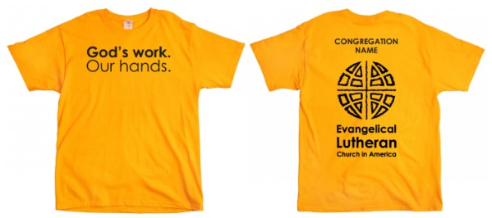

 RACE, ETHNICITY, RELIGION & CULTURE:

LEARNING ABOUT ISLAM

On Wednesday evening, August 10

from 7:00-9:00 p.m., we will be hosting

an evening of conversation with

Imam Schail Chaudhry from the East

Lansing Islamic Center. He will be joining us to talk about Islam and help us better understand Islam. We invite you to join us as we listen, learn and build bridges of understanding and peace. If you have any questions, please speak to Connie Nelson or Pastor Ellen.

60TH ANNIVERSARY BANQUET

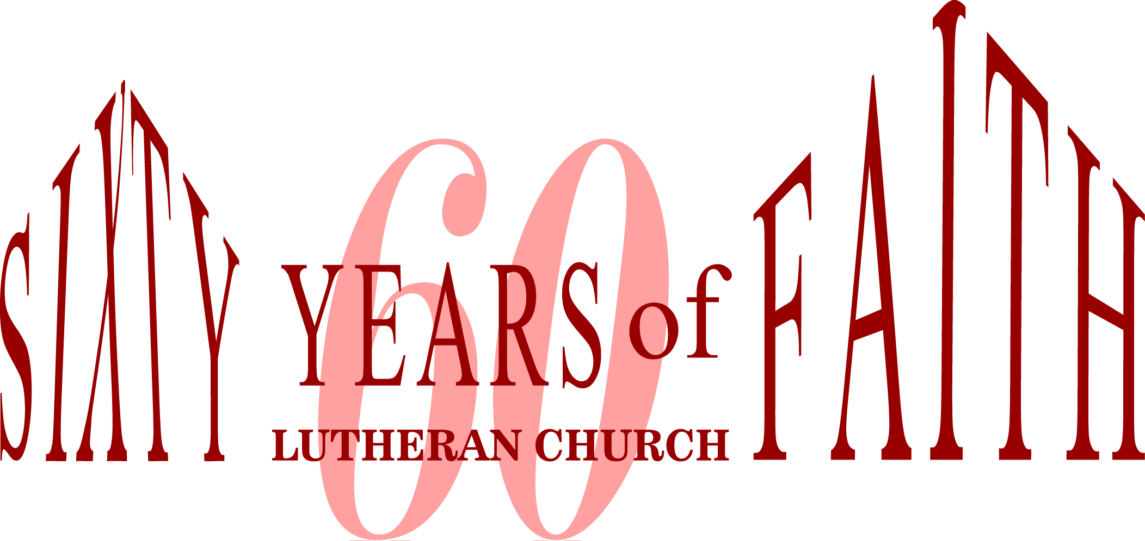

We will be holding a 60th anniversary banquet on Sunday, September 18

at the Kellogg Center shortly after noon. Tickets will be going on sale this summer. Be watching for more information regarding this celebratory event!

Looking for Pictures. . .

The 60th Anniversary Committee is asking for pictures you may have of events that have taken place over the past 60 years of ministry at Faith Lutheran Church. If you have any pictures you would like to share, please bring them in to the church office. We will scan them and include them in a PowerPoint loop we are creating for the September banquet.

**CHRISTIAN EDUCATION AND YOUTH ANNOUNCEMENTS**

**\*\*\*\*\*\*\*\*Need Vacation Bible School Funding - One more Thrivent Action Team needed!!!\*\*\*\*\*\*\*\*\*\*\*\*\*\*\*\*\*\***  
Please apply to help your youth group in a one-time fundraiser, service activity or educational event that can be completed within 90 days. Here are some suggestions for your Thrivent Action Teams: **Faith Vacation Bible School**. Use this link to get started: <https://www.thrivent.com/making-a-difference/living-generously/thrivent-action-teams/> Please talk to Melinda to get specific details or if you have any questions.

**Vacation Bible School (VBS)** will be from August 1-5 from 9:00am – 12:00pm and is entitled “High Seas Expedition: Exploring the Mighty Love of God”. We have several volunteer opportunities still available for this very entertaining and inspiring week. **VBS decorating and set-up will be on July 28th-30th from 1:00-6:00pm each day. The final set-up will be on Sunday, July 31st immediately following Rita’s Retirement Party.** Even ifyou cannot help during the VBS week, these decorating times are crucial and we would love to have as many helpers as possible. If you have any questions, please see Melinda. THANKS!!

CE/Youth announcements cont’d

**Tool Kits for Mission Trip**

Please see the display in the Narthex of the items we will need to have when we travel to Hurricane, West Virginia. Every time we go on a mission trip we need supplies and we usually have to beg and borrow. With these supplies, we will have a supply to go to every time we are doing service. Thanks for your continued support.

**Mandatory Mission Meeting for Youth and Parents**

At this meeting we will be completing all forms, discussing expectations, setting up departure times, and we will also have a mini-practice session with the tools and materials to assess the skill level of our participants. July 20th, 6:00-8:00pm.

**BINGO Fundraiser for the Youth –**

**July 15th, 5:00-8:00pm**

The Youth will be holding a Bingo Night Fundraiser for their mission trip for ages 1st Grade and above in the Large Fellowship Hall. The cost will be $10.00 for 8 cards and refreshments. All our games have prizes for the winners. There will also be a Jackpot Bingo game and that card will cost $5.00. We look forward to a fun night for **all ages**!!





To make disciples for Jesus Christ. . .

. . .we **Gather** in faith for worship, prayer,

study and fellowship

. . .we **Equip** the people of God with a faith

that works in real life

. . .we **Serve** the world in the name of Jesus Christ

_______________

Email address

faith@faithlutheranokemos.org

Websites

Faith Lutheran Church ≈ www.faithlutheranokemos.org

North/West Lower Michigan Synod ≈ www.mittensynod.org

Evangelical Lutheran Church in America ≈ www.elca.org

Facebook

facebook.com/faithlutheranokemos

Podcasts

ITUNES

https://itunes.apple.com/us/podcast/your-faith-journey/id1085174663?mt=2

STITCHER

http://www.stitcher.com/podcast/dad-spotlight/your-faith-journey?refid=stpr

You also can find the audio available

on Faith’s website under worship

Sermons

http://faithlutheranokemos.org/sermons/

Special music

http://faithlutheranokemos.org/category/special-music/