April 10, 2016

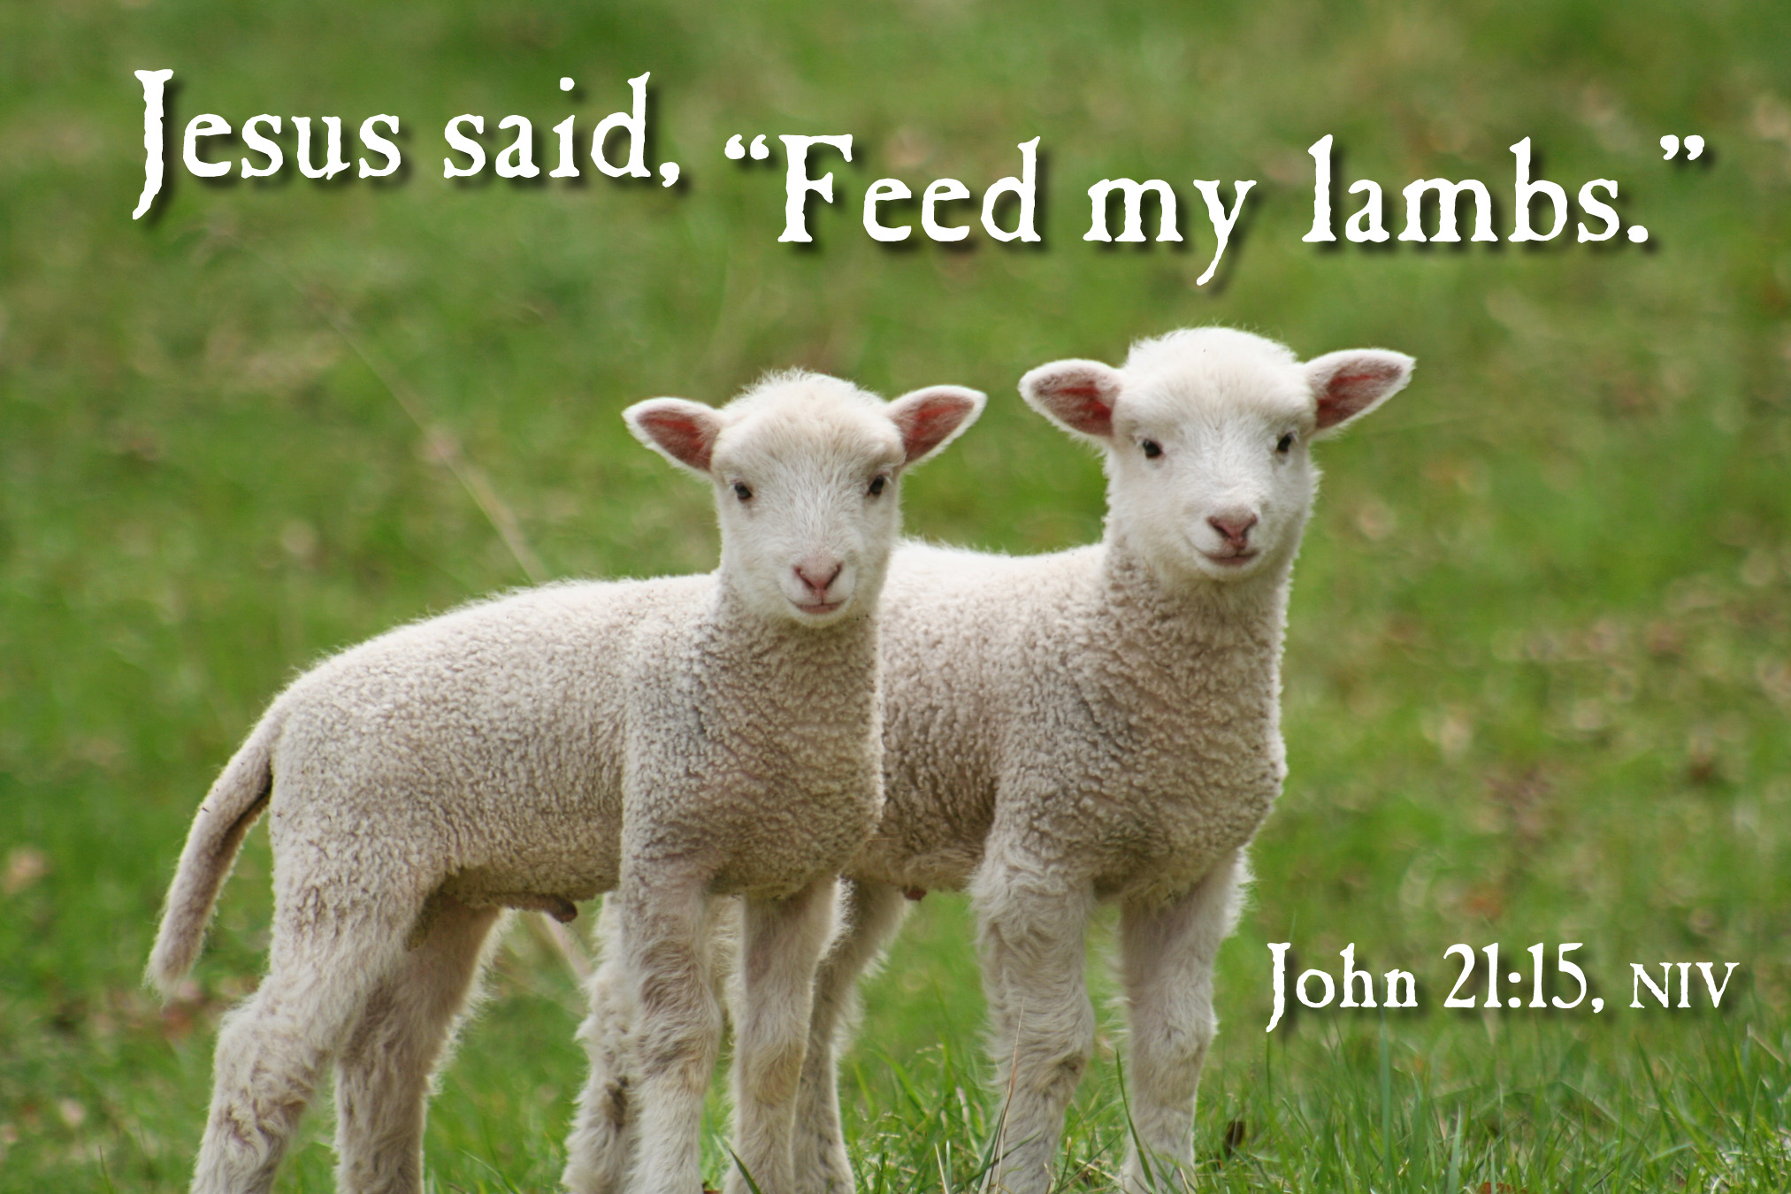

4515 Dobie Road
Okemos MI 48864-2203
517-349-0620

Pastor Ellen Schoepf
prellen@faithlutheranokemos.org

Washed onto Shore

What happened in the water as the night turned to day? What happened to make the still, lifeless water turn into a sea teeming with life so abundant that the disciples could scarcely haul it all into the boat?

Maybe these are questions the disciples asked that morning as they hauled in their nets full of fish after a long night with not so much as a bite. Maybe these are questions asked in our churches today as people contemplate the mystery of water poured over bodies at baptism. What happened in the water?

Two weeks ago, at the Easter Vigil, congregations all across the world met in the night to greet the Easter sun, asking these same questions. What happened in the water that night, as candidates for baptism were plunged into seemingly lifeless water only to be washed onto shore with more life than they could carry?

With the disciples, we ask these questions from the shore looking back at the sea. If Easter Day was a day marked by the water, then these weeks after Easter are weeks spent on the shore. This teeming water has marked us. What now? We have experienced this miracle of death transformed into life, empty nets transformed into full ones. What now?

Now we haul our catch onto shore! In the water we were made sons and daughters, we were given new life, forgiveness, and the promise of the Holy Spirit. We carry what we can of this tremendous catch out into the world.

Now, with Christ, we feast on the shore! On the beach Christ invited the disciples to add what they had to the meal he already had cooking. At the table each Sunday we are invited to do the same. We offer our gifts of time, talent, and treasure and place them beside the meal Christ has prepared for us. This is life on the shore. Taste and see!

Sunday, April 10, 2016
Third Sunday of Easter
Holy Communion

INTRODUCTION TO THE DAY
The disciples make a big splash and breakfast with the risen Jesus in the gospel. Wading in the water (remembering our baptism) and eating with Jesus (celebrating the holy communion) is our weekly encounter with the risen Christ. Jesus asks us, with Peter, again and again: Do you love me? And Jesus invites us, again and again, to follow him, bringing the Easter life to others.

If hearing assistance is needed, please ask an usher for a personal PA receiver.

The ushers also have large print copies of today’s worship folder available.

If it will be difficult for you to stand along with the congregation during
any part of the worship service, please feel free to remain seated.

There is a nursery available during the worship service for those who wish
to use it. It is located at the end of the hall beyond the coat racks.

WELCOME AND ANNOUNCEMENTS
We cordially greet all who have come to worship today.
Please register your attendance and join us in fellowship after the service.

P He is Risen!
C He is Risen indeed! Hallelujah!

Prayer Requests

PRELUDE
The pre-service music signals the beginning of the worship service. Silence during the
pre-service music enables worshipers to prepare for worship through quiet meditation.

“Love Divine, All Loves Excelling” Behnke

Reference today’s sending song on P. X, ELW #392

Gathering
The Holy Spirit calls us together as the people of God

The assembly stands

Thanksgiving for Baptism

All may make the sign of the cross, the sign marked
at baptism, as the presiding minister begins.
P Blessed be the holy Trinity, ☩ one God,
the fountain of living water,
the rock who gave us birth,
our light and our salvation.

Joined to Christ in the waters of baptism,
we are clothed with God's mercy and forgiveness.
Let us give thanks for the gift of baptism.

We give you thanks, O God, for in the beginning
your Spirit moved over the waters and by and
by your Word you created the world, calling
forth life in which you took delight.

Through the waters of the flood
you delivered Noah and his family.
Through the sea you led your people
Israel from slavery into freedom.
At the river your Son was baptized by
John and anointed with the Holy Spirit.
By water and your Word you claim us as
daughters and sons, making us heirs of
your promise and servants of all.

We praise you for the gift of water that sustains life,
and above all we praise you for the gift of new life
in Jesus Christ. Shower us with your Spirit, and renew
our lives with your forgiveness, grace, and love.

P To you be given honor and praise through Jesus Christ
our Lord in the unity of the Holy Spirit, now and forever.
C Amen

Gathering Song #389
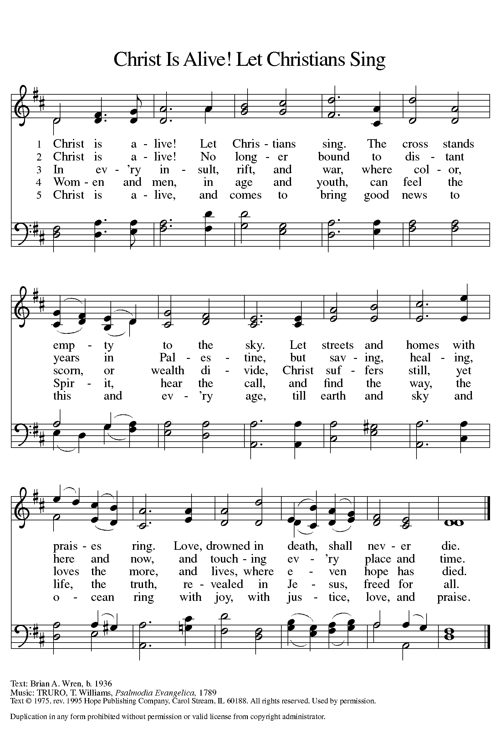
Text printed under OneLicense.net license A-708005

Greeting
A The grace of our Lord Jesus Christ, the love of God,
and the communion of the Holy Spirit be with you all.
C And also with you.

Kyrie
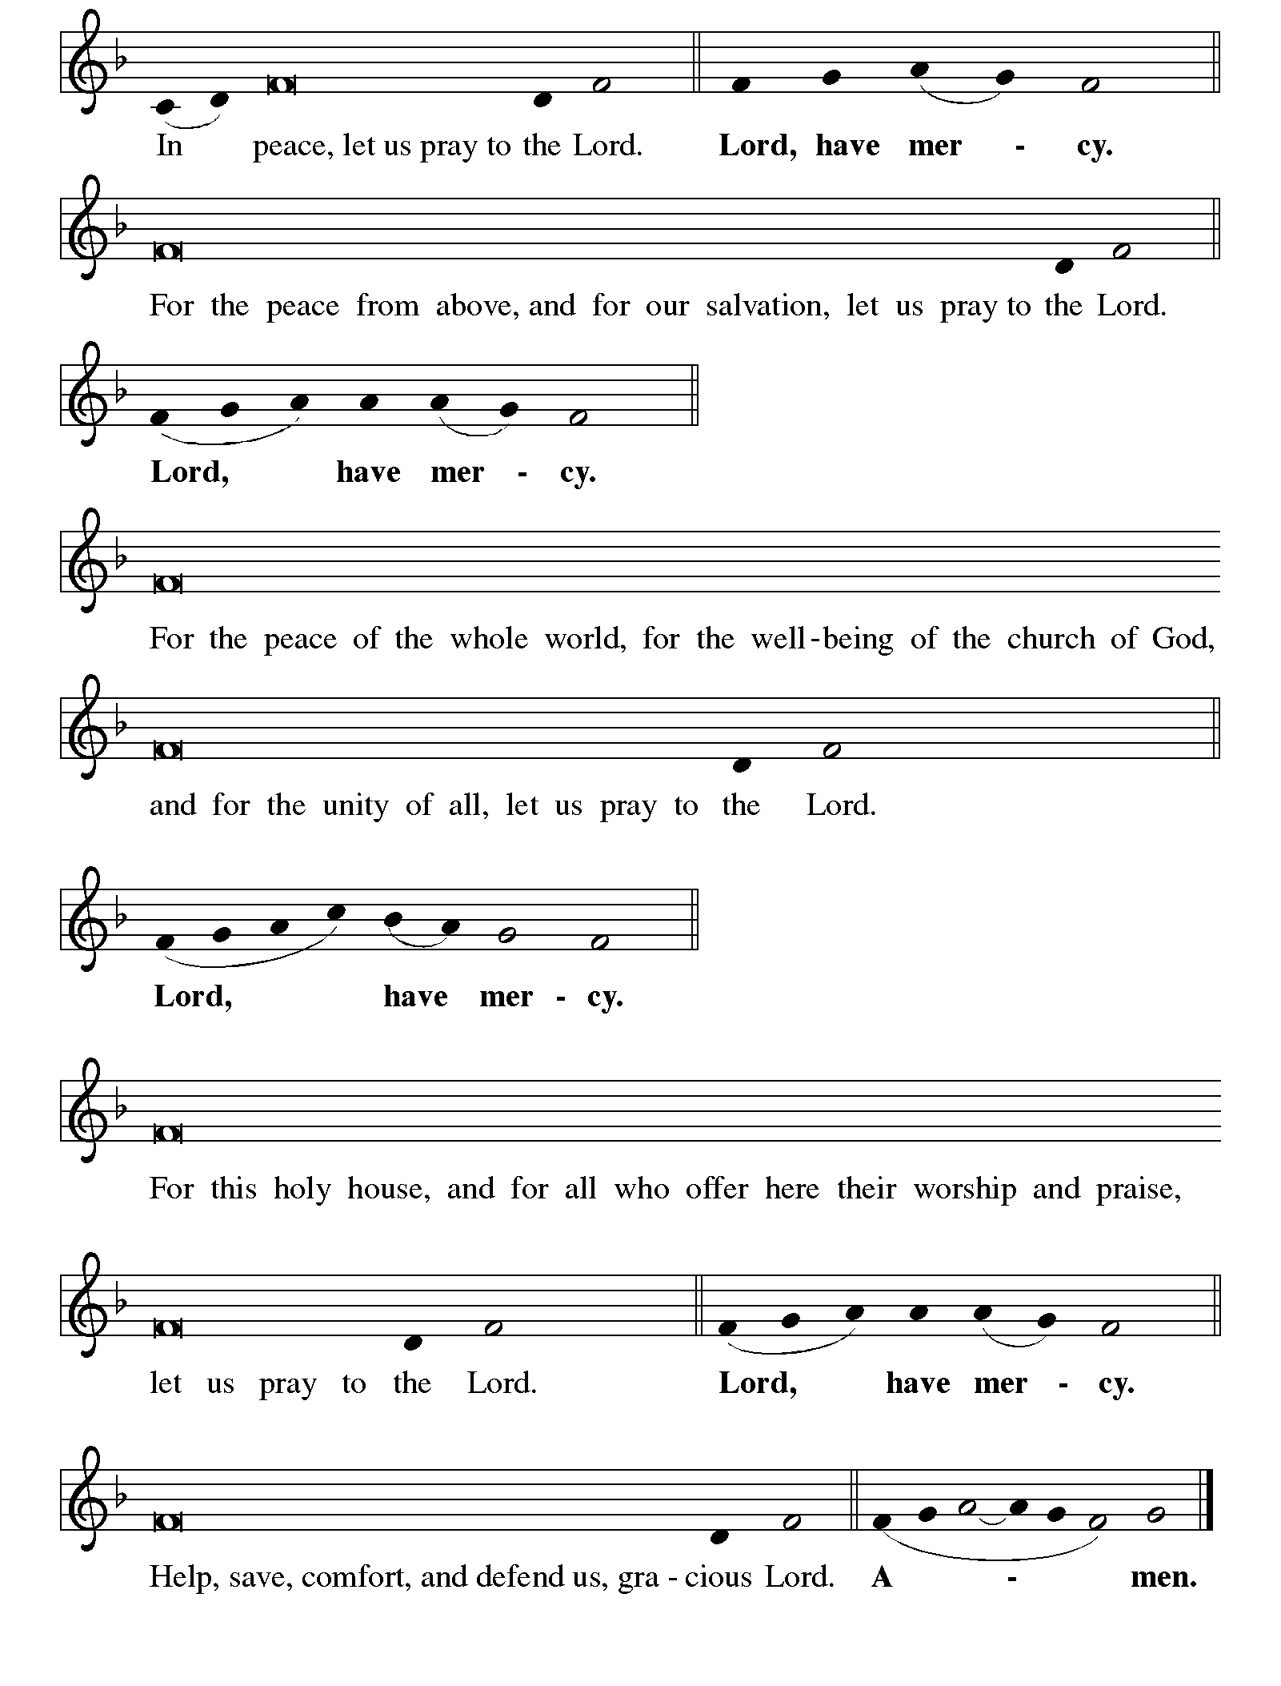
Canticle of Praise
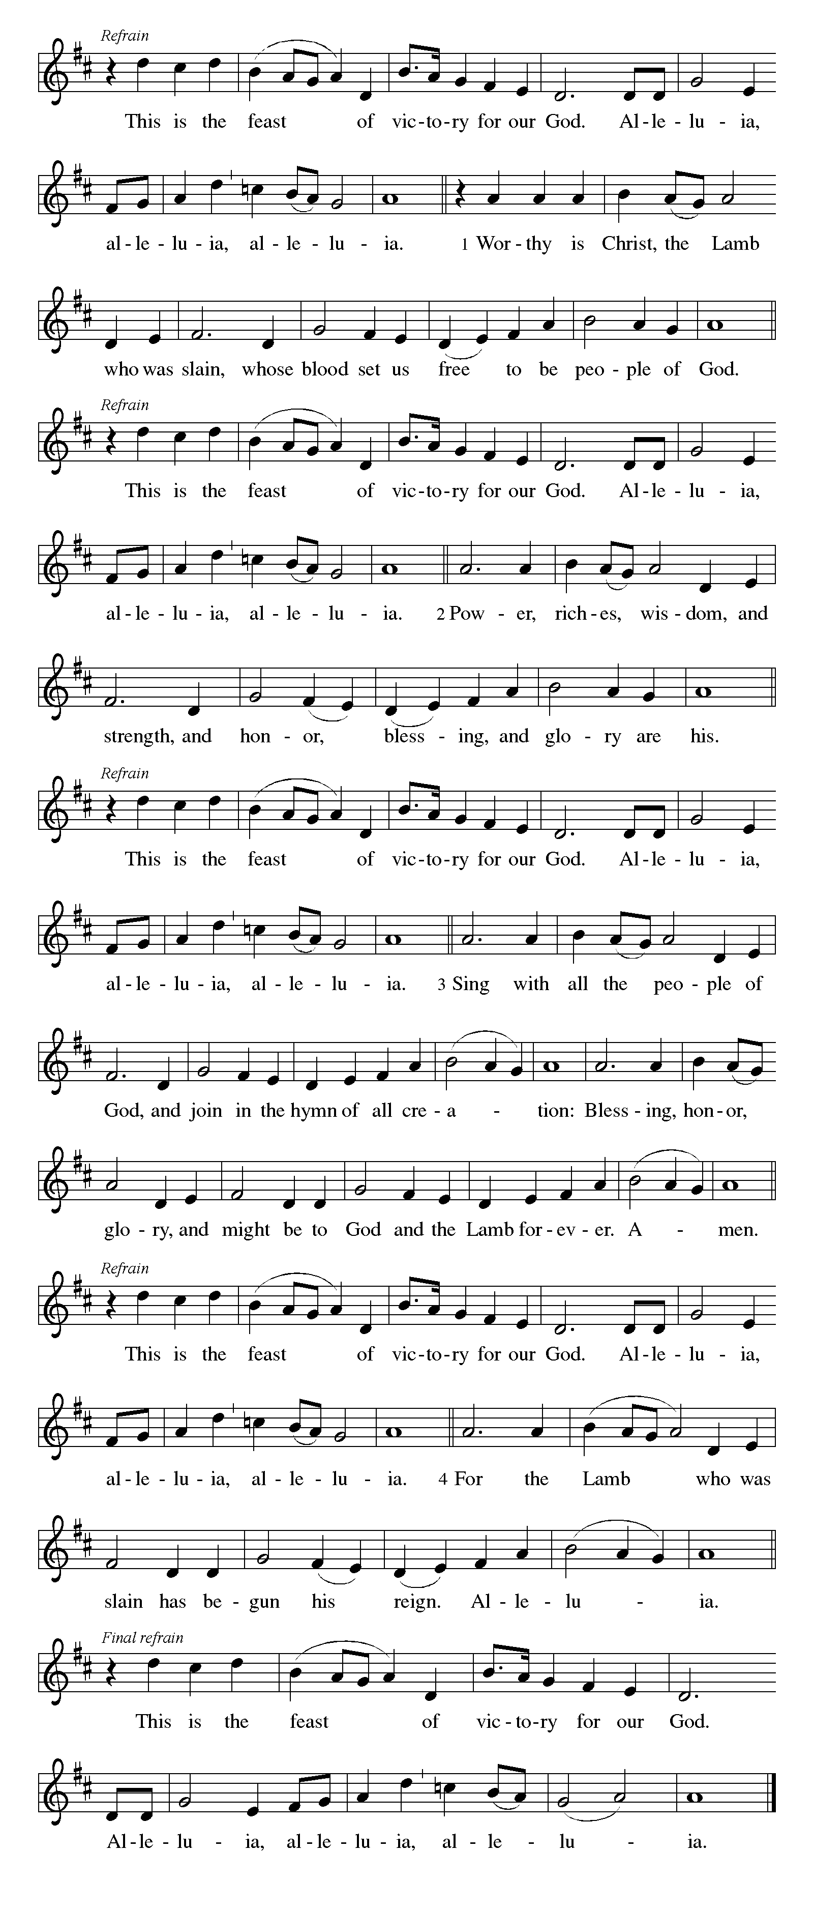
⇒

Prayer of the Day
A Let us pray.
Eternal and all-merciful God, with all the angels and all the
saints we laud your majesty and might. By the resurrection
of your Son, show yourself to us and inspire us to follow
Jesus Christ, our Savior and Lord, who lives and reigns
with you and the Holy Spirit, one God, now and forever.
C Amen

The assembly is seated

Word
God speaks to us in scripture reading, preaching, and song

First Reading: Acts 9:1-6 [7-20]

Each of us has a story of meeting God’s grace. Saul (later called Paul) was an ardent persecutor of all who followed the Way of Christ. This reading recounts the story of his transformation, beginning with an encounter with Jesus Christ on the way to Damascus.

A A reading from Acts.

¹Saul, still breathing threats and murder against the disciples of the Lord, went to the high priest ²and asked him for letters to the synagogues at Damascus, so that if he found any who belonged to the Way, men or women, he might bring them bound to Jerusalem. ³Now as he was going along and approaching Damascus, suddenly a light from heaven flashed around him. ⁴He fell to the ground and heard a voice saying to him, “Saul, Saul, why do you persecute me?” ⁵He asked, “Who are you, Lord?” The reply came, “I am Jesus, whom you are persecuting. ⁶But get up and enter the city, and you will be told what you are to do.” [⁷The men who were traveling with him stood speechless because they heard the voice but saw no one. ⁸Saul got up from the ground, and though his eyes were open, he could see nothing; so they led him by the hand and brought him into Damascus. ⁹For three days he was without sight, and neither ate nor drank.
¹⁰Now there was a disciple in Damascus named Ananias. The Lord said to him in a vision, “Ananias.” He answered, “Here I am, Lord.” ¹¹The Lord said to him, “Get up and go to the street called Straight, and at the house of Judas look for a man of Tarsus named Saul. At this moment he is praying, ¹²and he has seen in a vision a man named Ananias come in and lay his hands on him so that he might regain his sight.” ¹³But Ananias answered, “Lord, I have heard from many about this man, how much evil he has done to your saints in Jerusalem; ¹⁴and here he has authority from the chief priests to bind all who invoke your name.” ¹⁵But the Lord said to him, “Go, for he is an instrument whom I have chosen to bring my

name before Gentiles and kings and before the people of Israel; ¹⁶I myself will show him how much he must suffer for the sake of my name.” ¹⁷So Ananias went and entered the house. He laid his hands on Saul and said, “Brother Saul, the Lord Jesus, who appeared to you on your way here, has sent me so that you may regain your sight and be filled with the Holy Spirit.” ¹⁸And immediately something like scales fell from his eyes, and his sight was restored. Then he got up and was baptized, ¹⁹and after taking some food, he regained his strength.
For several days he was with the disciples in Damascus, ²⁰and immediately he began to proclaim Jesus in the synagogues, saying, “He is the Son of God.”]

A The word of the Lord.
C Thanks be to God.

Psalm: Psalm 30

Read responsively

¹I will exalt you, O Lord, because you have lifted me up
and have not let my enemies triumph over me.
²O Lord my God, I cried out to you,
and you restored me to health.
³You brought me up, O Lord, from the dead;
you restored my life as I was going down to the grave.
⁴Sing praise to the Lord, all you faithful;
give thanks in holy remembrance.
⁵God’s wrath is short; God’s favor lasts a lifetime.
Weeping spends the night, but joy comes in the morning.
⁶While I felt secure, I said,
“I shall never be disturbed.

⁷You, Lord, with your favor, made me as strong as the mountains.”
Then you hid your face, and I was filled with fear.
⁸I cried to you, O Lord;
I pleaded with my Lord, saying,
⁹“What profit is there in my blood, if I go down | to the pit?
Will the dust praise you or declare your faithfulness?
¹⁰Hear, O Lord, and have mercy upon me;
O Lord, | be my helper.”
¹¹You have turned my wailing into dancing;
you have put off my sackcloth and clothed me with joy.
¹²Therefore my heart sings to you without ceasing;
O Lord my God, I will give you thanks forever.

Second Reading: Revelation 5:11-14

The vision of John recorded in Revelation offers a glimpse of cosmic worship on the Lord’s Day. At its center is “the Lamb who was slain.”

A A reading from Revelation.

¹¹Then I looked, and I heard the voice of many angels surrounding the throne and the living creatures and the elders; they numbered myriads of myriads and thousands of thousands, ¹²singing with full voice,
“Worthy is the Lamb that was slaughtered
to receive power and wealth and wisdom and might
and honor and glory and blessing!”
¹³Then I heard every creature in heaven and on earth and under the earth and in the sea, and all that is in them, singing,
“To the one seated on the throne and to the Lamb
be blessing and honor and glory and might
forever and ever!”
¹⁴And the four living creatures said, “Amen!” And the elders fell down and worshiped.

A The word of the Lord. C Thanks be to God.

The assembly stands to welcome the gospel

Gospel Acclamation

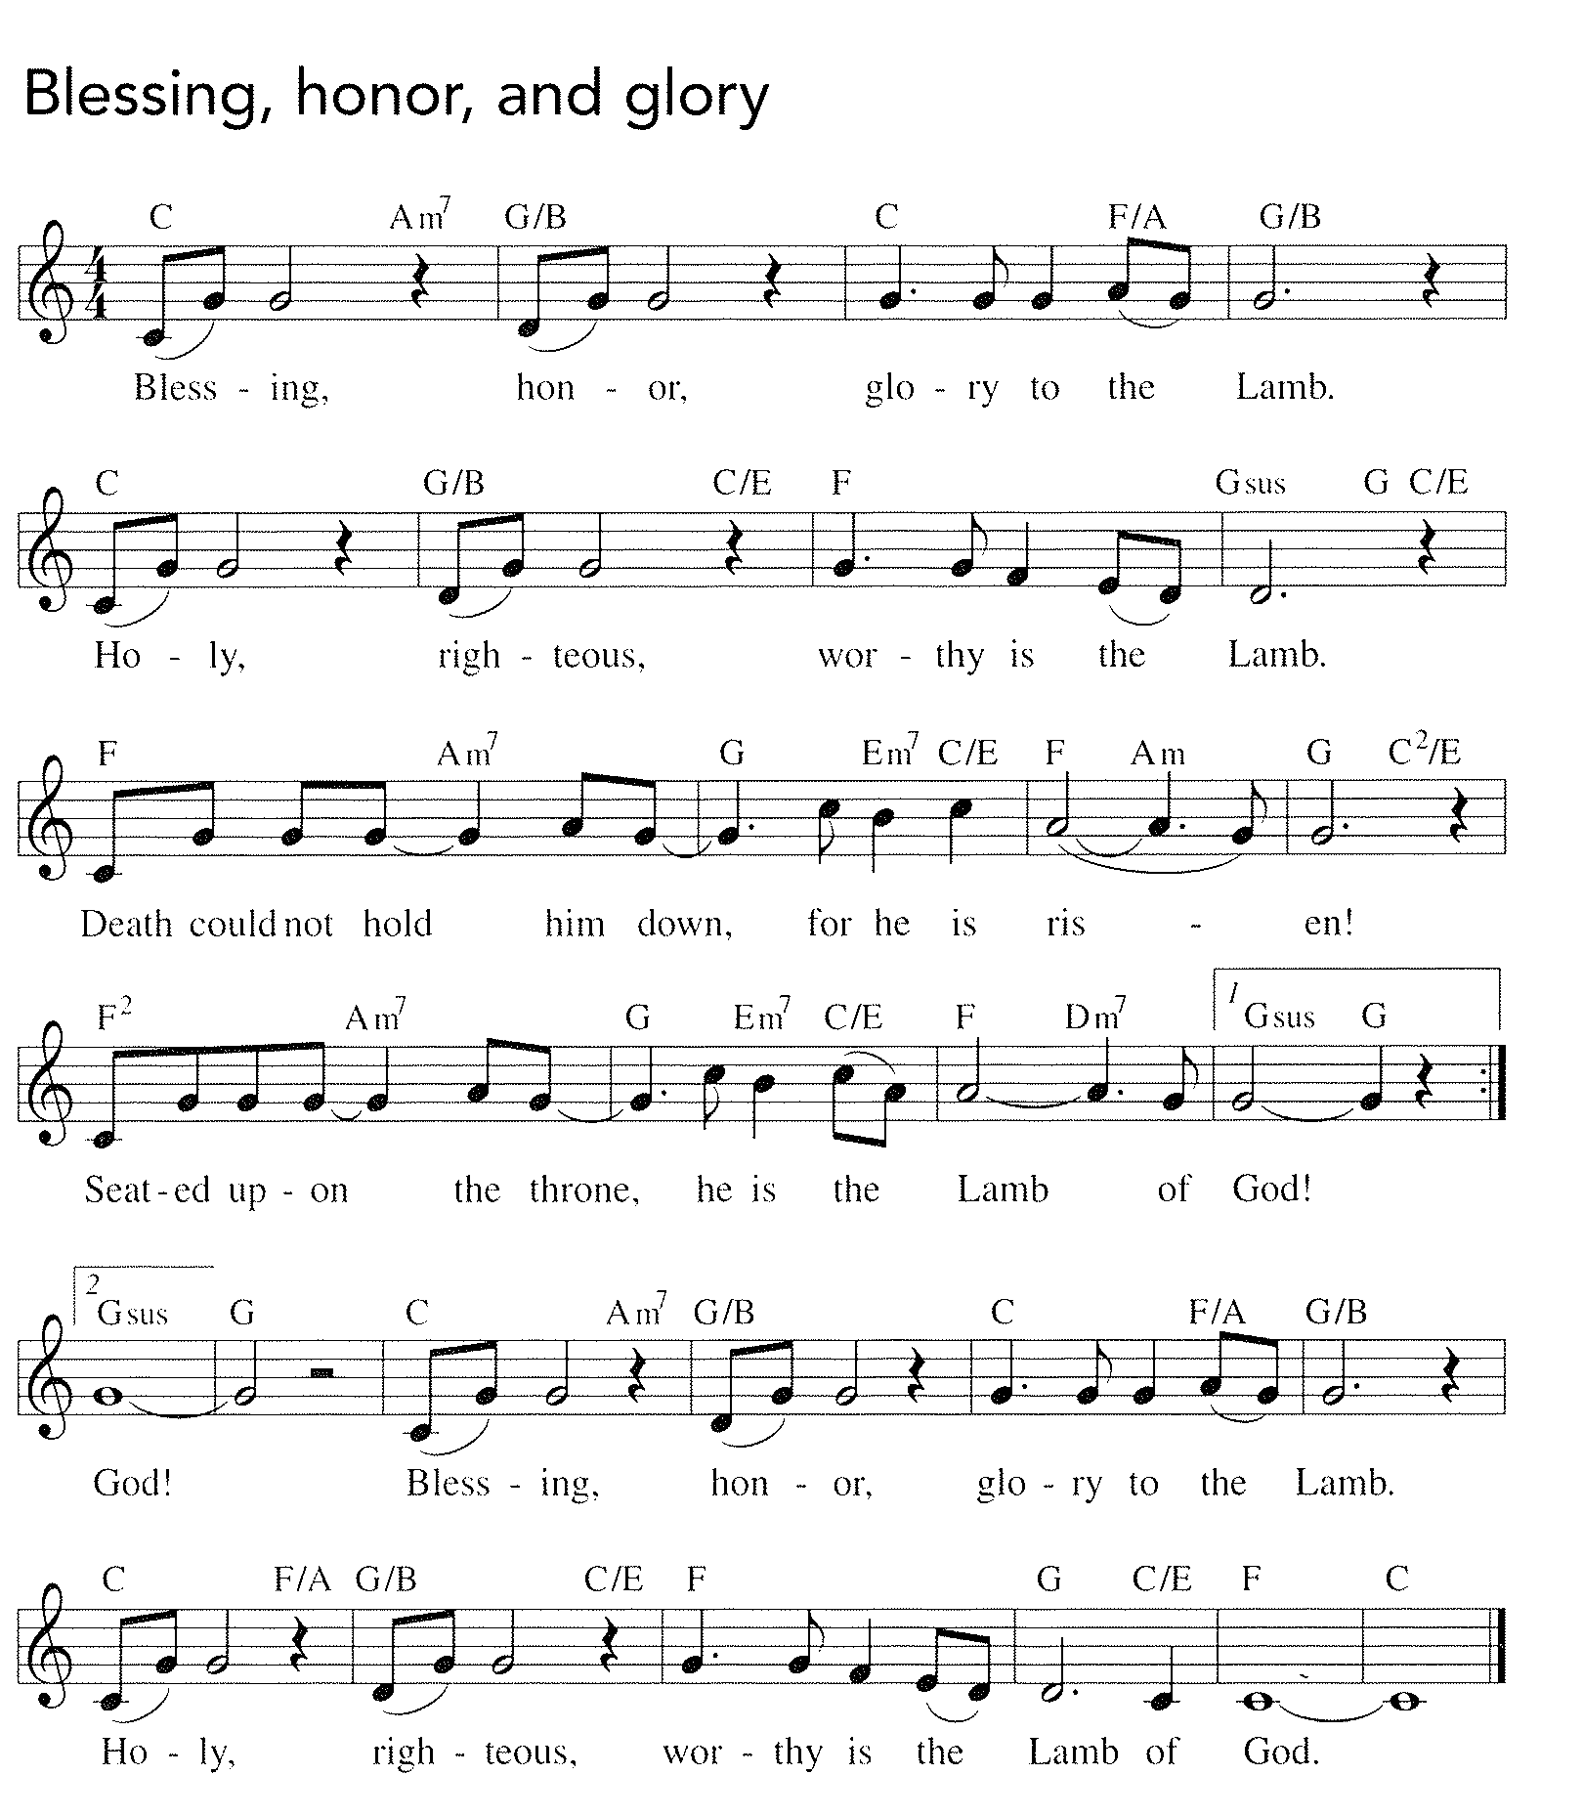

Text and music: Geoff Bullock and David Reidy
Text and music © 1990 Word Music, Inc., and Maranatha! Music, admin Word Music, Inc.
Text and music printed under CCLI license 720217

Gospel: John 21:1-19

The risen Christ appears again to his disciples by the sea where they were first called. After echoes of the fishing and feeding miracles, he gives a final reminder of the cost of a disciple’s love and obedience.

P The holy gospel according to John.
C Glory to you, O Lord.

¹After [he appeared to his followers in Jerusalem,] Jesus showed himself again to the disciples by the Sea of Tiberias; and he showed himself in this way. ²Gathered there together were Simon Peter, Thomas called the Twin, Nathanael of Cana in Galilee, the sons of Zebedee, and two others of his disciples. ³Simon Peter said to them, “I am going fishing.” They said to him, “We will go with you.” They went out and got into the boat, but that night they caught nothing.
⁴Just after daybreak, Jesus stood on the beach; but the disciples did not know that it was Jesus. ⁵Jesus said to them, “Children, you have no fish, have you?” They answered him, “No.” ⁶He said to them, “Cast the net to the right side of the boat, and you will find some.” So they cast it, and now they were not able to haul it in because there were so many fish. ⁷That disciple whom Jesus loved said to Peter, “It is the Lord!” When Simon Peter heard that it was the Lord, he put on some clothes, for he was naked, and jumped into the sea. ⁸But the other disciples came in the boat, dragging the net full of fish, for they were not far from the land, only about a hundred yards off.
⁹When they had gone ashore, they saw a charcoal fire there, with fish on it, and bread. ¹⁰Jesus said to them, “Bring some of the fish that you have just caught.” ¹¹So Simon Peter went aboard and hauled the net ashore, full of large fish, a hundred fifty-three of them; and though there were so many, the net was not torn. ¹²Jesus said to them, “Come and have breakfast.” Now none of the disciples dared to ask him, “Who are you?” because they knew it was the Lord. ¹³Jesus came and took the bread and gave it to them, and did the same with the fish. ¹⁴This was now the third time that Jesus appeared to the disciples after he was raised from the dead.

¹⁵When they had finished breakfast, Jesus said to Simon Peter, “Simon son of John, do you love me more than these?” He said to him, “Yes, Lord; you know that I love you.” Jesus said to him, “Feed my lambs.” ¹⁶A second time he said to him, “Simon son of John, do you love me?” He said to him, “Yes, Lord; you know that I love you.” Jesus said to him, “Tend my sheep.” ¹⁷He said to him the third time, “Simon son of John, do you love me?” Peter felt hurt because he said to him the third time, “Do you love me?” And he said to him, “Lord, you know everything; you know that I love you.” Jesus said to him, “Feed my sheep. ¹⁸Very truly, I tell you, when you were younger, you used to fasten your own belt and to go wherever you wished. But when you grow old, you will stretch out your hands, and someone else will fasten a belt around you and take you where you do not wish to go.” ¹⁹(He said this to indicate the kind of death by which he would glorify God.) After this he said to him, “Follow me.”

P The gospel of the Lord.
C Praise to you, O Christ.

The assembly is seated

CHILDREN’S MESSAGE

Sermon

the assembly stands to proclaim the word of God in song

Hymn of the Day #364
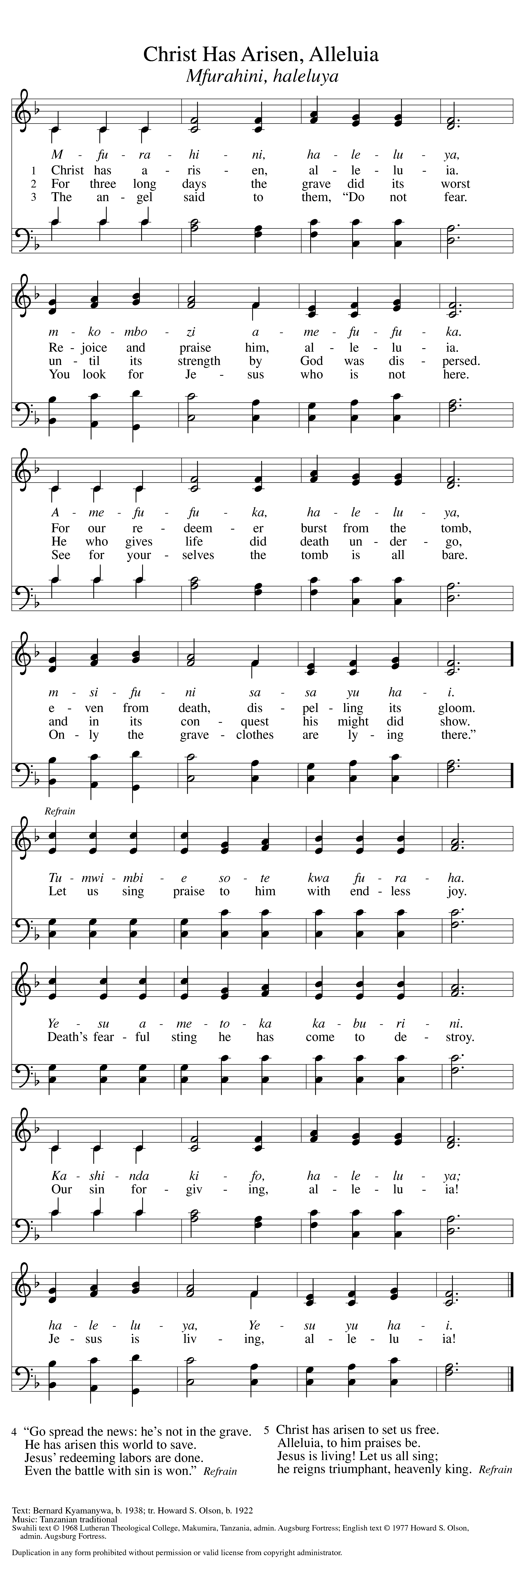Refrain ⇒

Text printed under OneLicense.net license A-708005

Creed
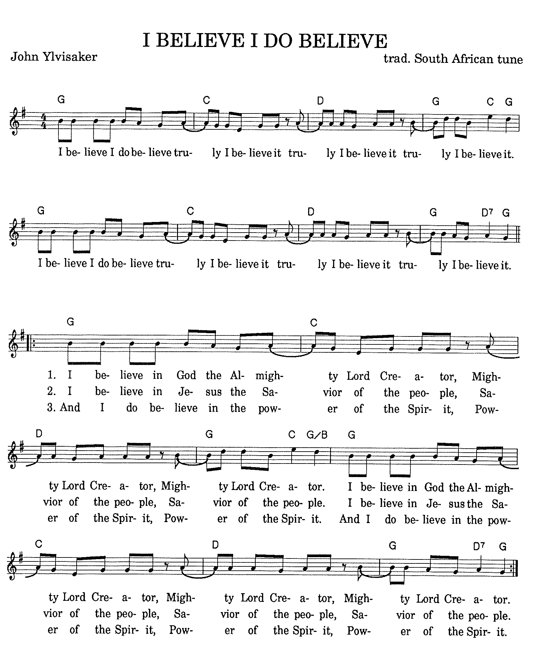
Used by permission, copyright 1989
John Ylvisaker, P. O. Box 321, Waverly, Iowa 50677
(319) 352-4396

Prayers of Intercession

A Rooted in the abundant life and love of
Christ Jesus, we pray for the life of the church, the
lives of people in need, and the life of all creation.

Prayers of intercession are prayed.
To each petition, the assembly responds:

A Hear us, O God.
C Your mercy is great.

The presiding minister concludes the
prayers, and the assembly responds:

P We deliver all this into your care, O God,
trusting in the work of your Holy Spirit to bring
all things into the risen life of Christ our Lord.
C Amen

Peace
P The peace of Christ be with you always.
C And also with you.

The people may greet one another with a sign of Christ’s peace,
and may say, “Peace be with you,” or similar words.

The assembly is seated

Meal
God feeds us with the presence of Jesus Christ

OFFERING

An offering is gathered for the mission of the church, including the care of those in need.

Chancel Choir “As the Deer” arr. Christopher
Gwynne Kadrofske, flute

The assembly stands

Offering Prayer
A Let us pray.
Blessed are you, O God, ruler of heaven and earth.
Day by day you shower us with blessings. As you
have raised us to new life in Christ, give us glad and
generous hearts, ready to praise you and to respond to
those in need, through Jesus Christ, our Savior and Lord.
C Amen

Great Thanksgiving

Dialogue

P The Lord be with you.
C And also with you.

P Lift up your hearts.
C We lift them to the Lord.

P Let us give thanks to the Lord our God.
C It is right to give our thanks and praise.
Preface
P It is indeed right, our duty and our joy, that we should at all times and in all places give thanks and praise to you, almighty
and merciful God, for the glorious resurrection of our Savior Jesus Christ, the true Paschal Lamb who gave himself to take away our sin; who in dying has destroyed death, and in rising has brought us to eternal life.

And so, with Mary Magdalene and Peter and all the witnesses of the resurrection, with earth and sea and all their creatures, and with angels and archangels, cherubim and seraphim, we praise your name and join their unending hymn:

Holy, Holy, Holy
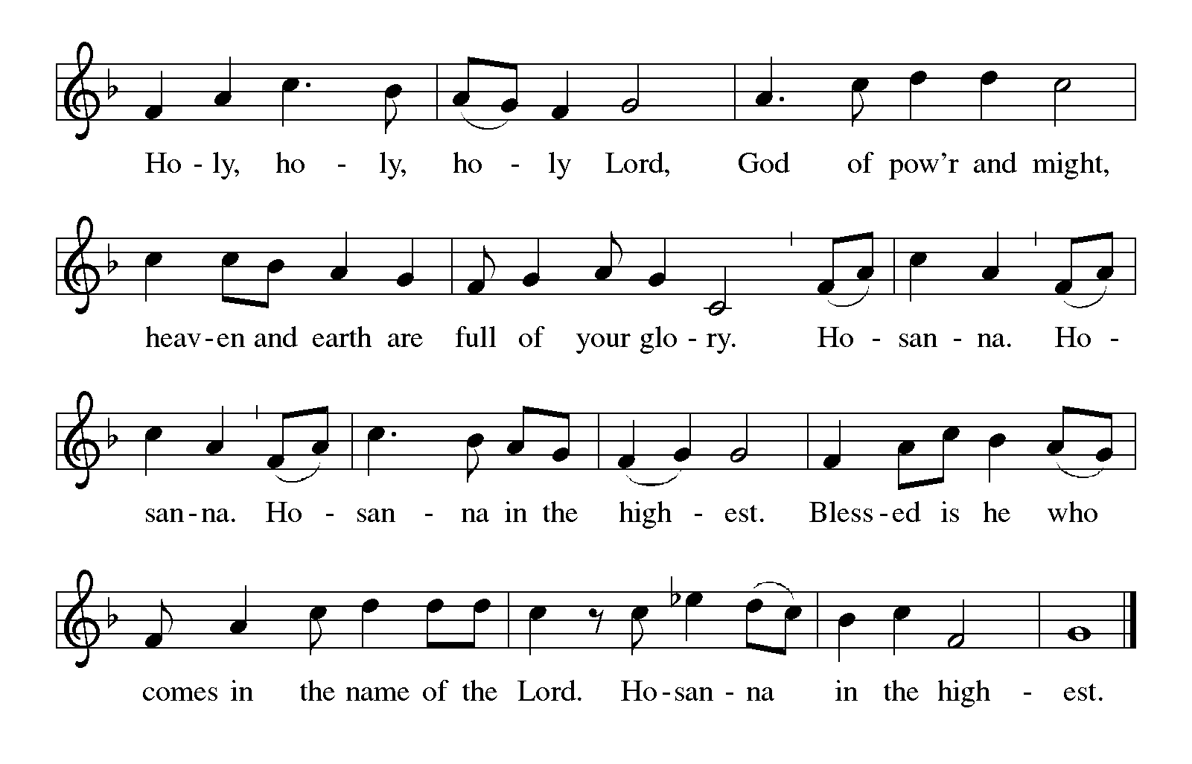

Thanksgiving at the Table
P In the night in which he was betrayed,
our Lord Jesus took bread, and gave thanks;
broke it, and gave it to his disciples, saying:
Take and eat; this is my body, given for you.
Do this for the remembrance of me.

Again, after supper, he took the cup, gave thanks,
and gave it for all to drink, saying:
This cup is the new covenant in my blood,
shed for you and for all people for the forgiveness of sin.
Do this for the remembrance of me.

Lord’s Prayer
P Gathered into one by the Holy Spirit,
let us pray as Jesus taught us.
C Our Father in heaven,
hallowed be your name,
your kingdom come,
your will be done,
on earth as in heaven.
Give us today our daily bread.
Forgive us our sins
as we forgive those
who sin against us.
Save us from the time of trial
and deliver us from evil.
For the kingdom, the power,
and the glory are yours,
now and forever. Amen.

Invitation to Communion

P The table of life is spread before you.
Feast on the goodness and mercy of God.

The assembly is seated

Communion

When giving the bread and cup, the communion ministers say
The body of Christ, given for you.
The blood of Christ, shed for you.
and each person may respond
Amen

WE WELCOME ALL GUESTS worshiping with us today and invite all baptized Christians to come to the Lord’s table. Children who have not yet received First Communion instruction are invited to come forward with their families to receive a blessing. There will be one chalice (cup) of wine, as well as trays of individual cups. In the center of each tray, there are a few glasses filled with white grape juice for those who prefer juice rather than wine.

Communion Song
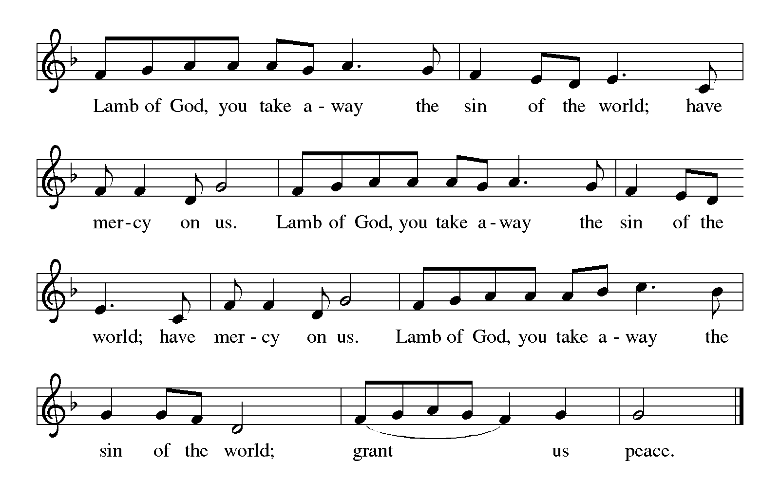

CONGREGATIONAL SONG #674
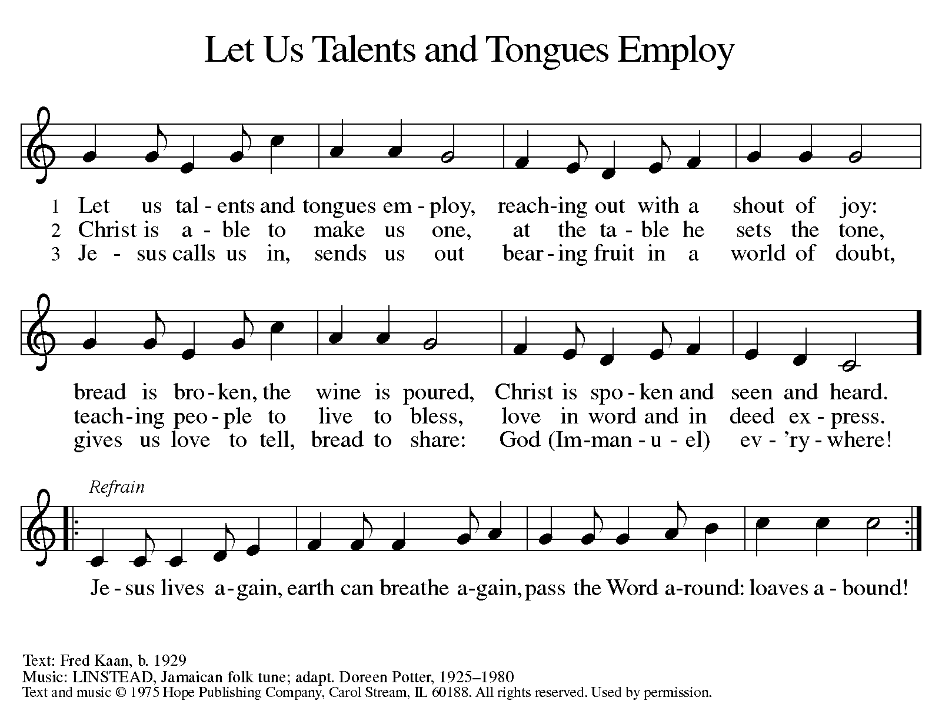
Text and music printed under OneLicense.net license A-708005

CONGREGATIONAL SONG
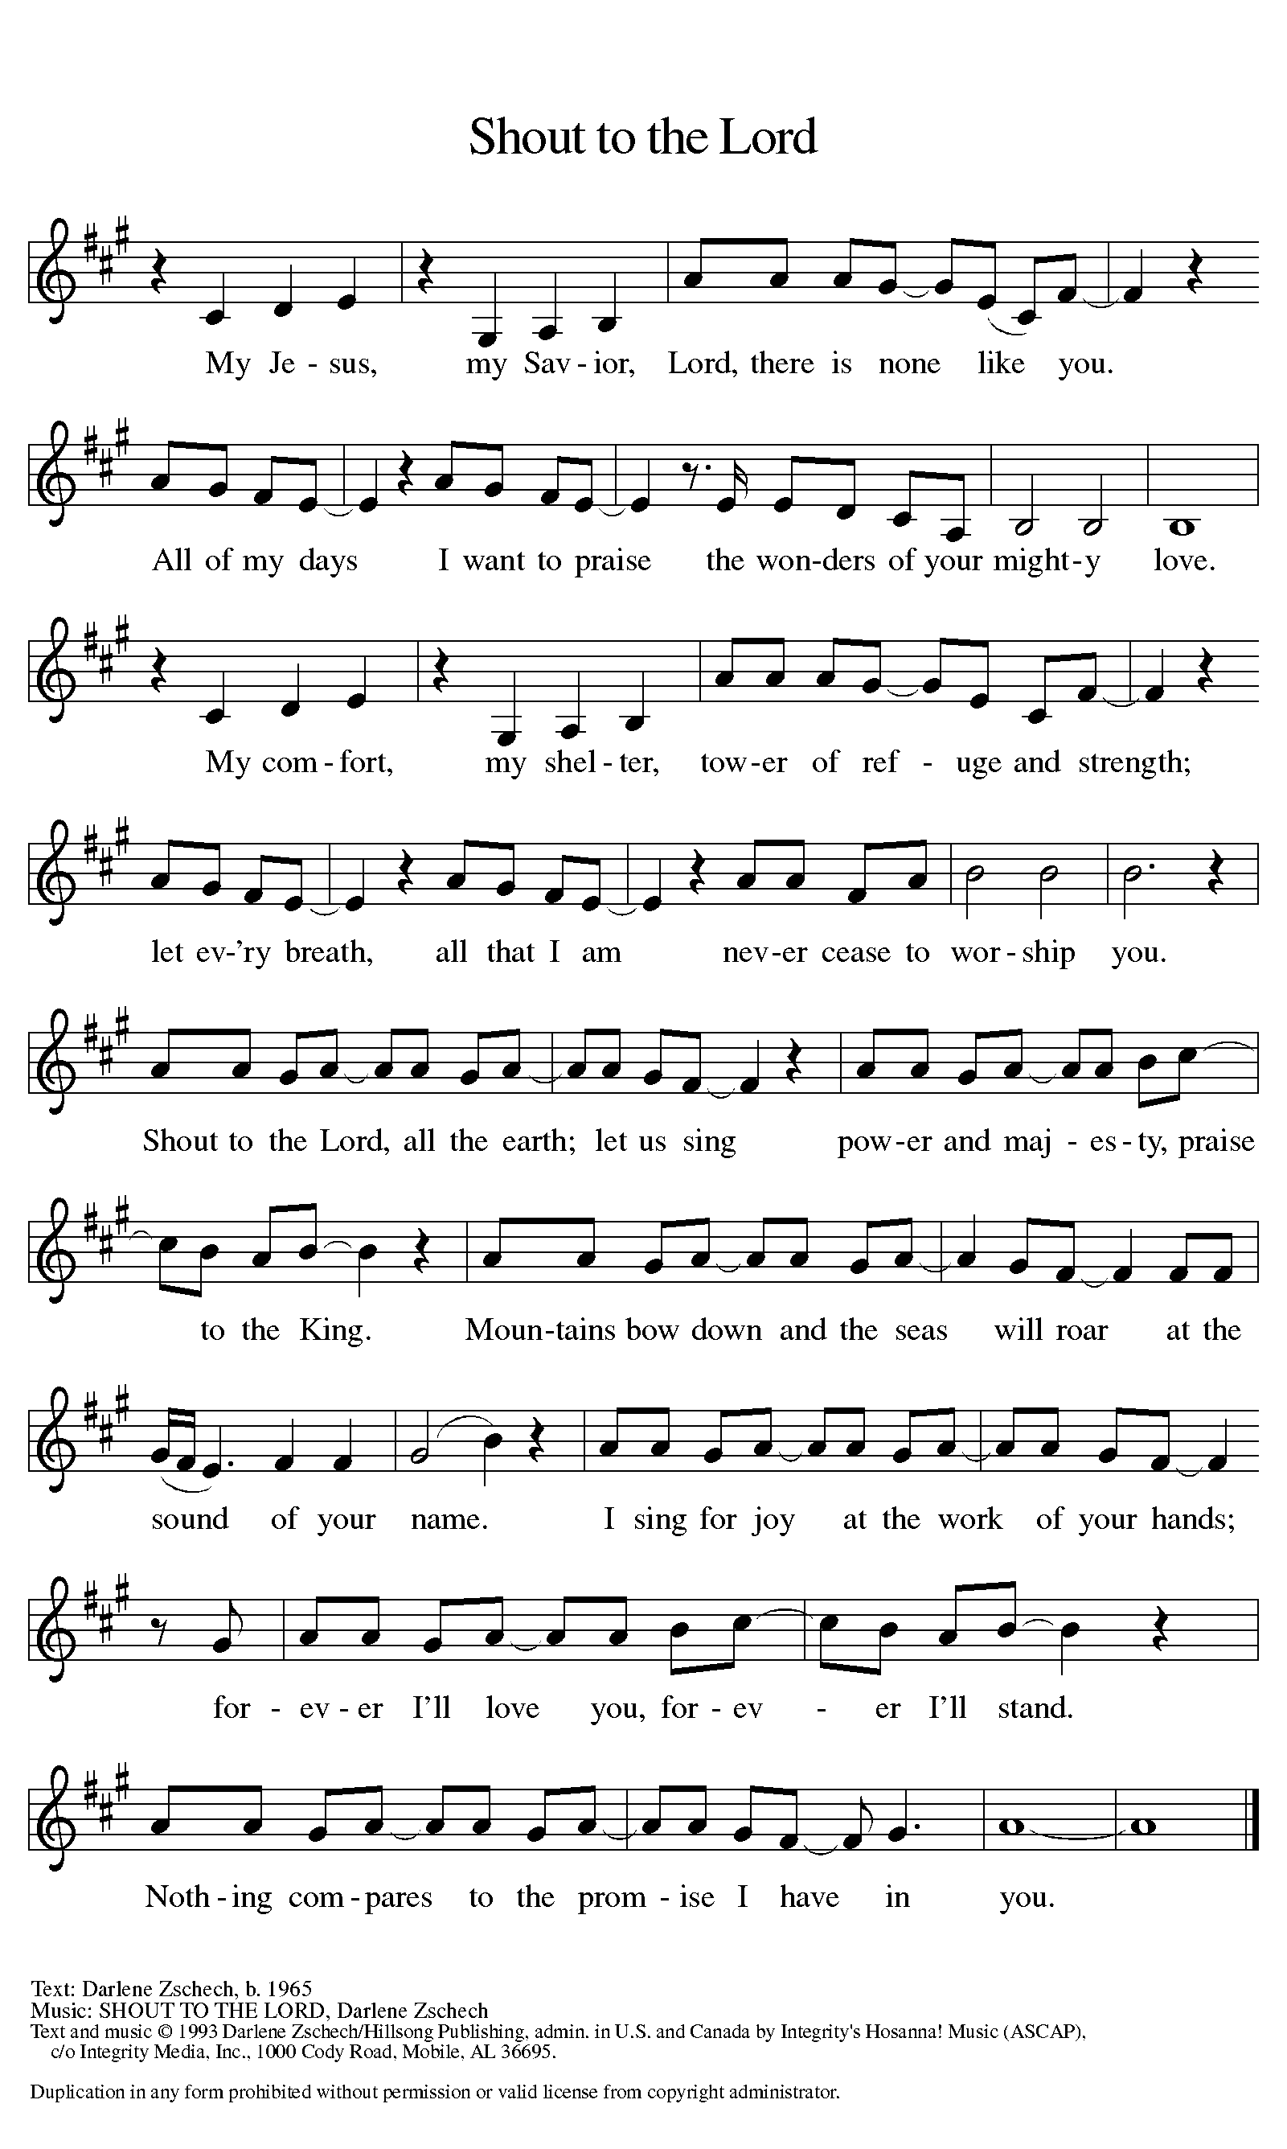
Text and music printed under CCLI license 720217

The assembly stands

P The body and blood of our Lord Jesus Christ
strengthen you and keep you in his grace.
C Amen

Prayer after Communion
A Let us pray.
Life-giving God, in the mystery of Christ’s resurrection
you send light to conquer darkness, water to give new life,
and the bread of life to nourish your people. Send us forth as
witnesses to your Son’s resurrection, that we may show your
glory to all the world, through Jesus Christ, our risen Lord.
C Amen

Sending
God blesses us and sends us in mission to the world

Blessing

P The blessing of the Lord God Almighty,
the blessing of ☩ Christ, the Lamb who was slain,
and the blessing of the Holy Spirit of truth
be among you and remain with you always.
C Amen

Sending Song #392
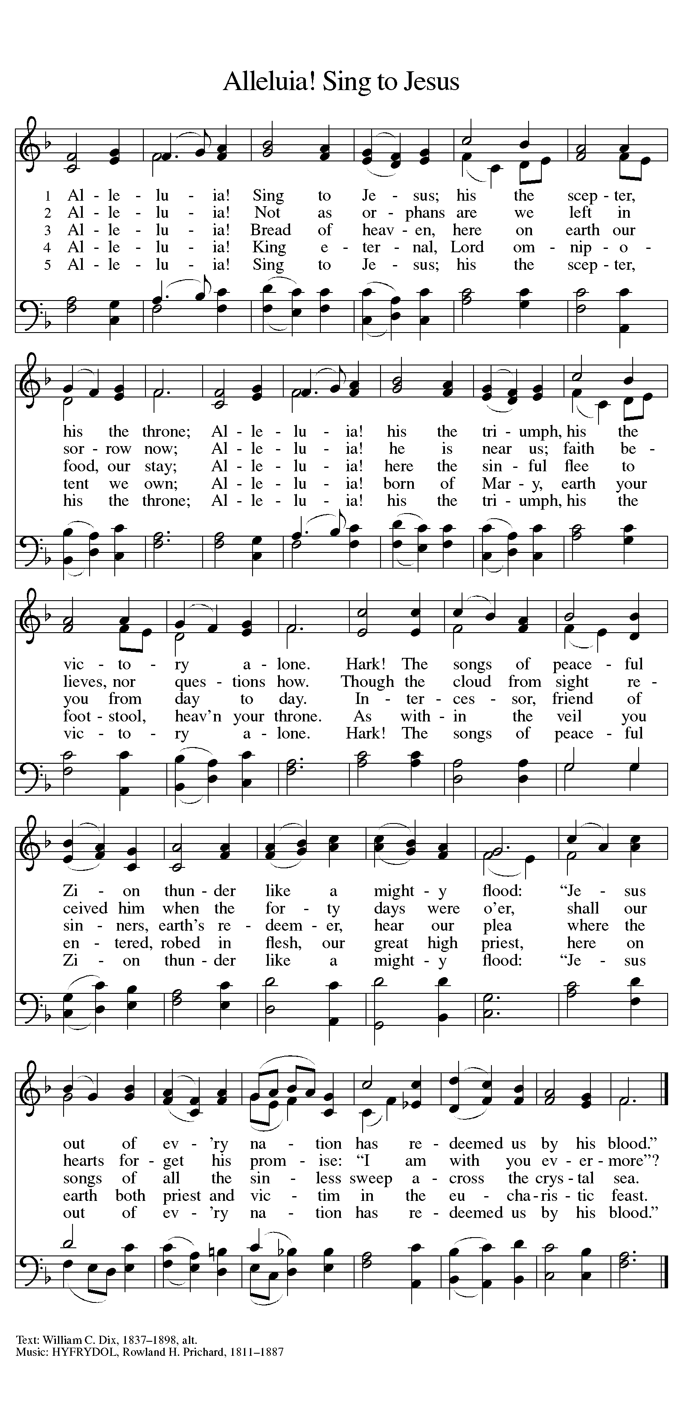
⇒

Dismissal

A Alleluia. Go in peace. Share the good news.
C Thanks be to God. Alleluia.

POST-SERVICE MUSIC

“This Joyful Eastertide”

Copyright © 2016 Augsburg Fortress. All rights reserved. Reprinted by permission under Augsburg Fortress Liturgies Annual License #SAS000803.
New Revised Standard Version Bible, copyright © 1989, Division of Christian Education of the National Council of the Churches of Christ in the United States of America.
Used by permission. All rights reserved.
Clipart copyright © 2016 by Communication Resources. All rights reserved. Used by permission.

As we gather, we pray,
“Holy God, receive our worship,
offered to the glory of your name. Amen.”

Sunday education hour 9:00 a.m.
SUNDAY WORSHIP 10:00 a.m.

Pastor Ellen Schoepf prellen@faithlutheranokemos.org
Secretary Rita Barry rbarry@faithlutheranokemos.org
Director of Christian Education Melinda Schultz
Director of Music Debra Borton-McDonough
Organist/Pianist Bruce Williams
Today’s instrumental worship leader Kathy Richardson

April 3 worship attendance: 73

Serving Faith Today April 17

Acolyte Alexis Hereza

Altar care Peggy Crum and Pam Williams

Communion assistants John McPhail Harold Sollenberger
David Baker Brendan Guenther
Alexis Hereza

Greeters Dick and Sally Knoll Ken and Karen Whitmyer

Lay assistants John McPhail Harold Sollenberger

Readers David Baker Brendan Guenther

Ushers Whitmyer/Bowers Walter and Brenda Kopf

Nursery Schultz Ballegeer

