February 14, 2016



4515 Dobie Road
Okemos MI 48864-2203
517-349-0620

Pastor Ellen Schoepf
prellen@faithlutheranokemos.org

Email ~ faith@faithlutheranokemos.org
Website ~ www.faithlutheranokemos.org
Facebook ~ facebook.com/faithlutheranokemos

Life in the Wilderness

The Christian life certainly includes moments of joy—times when the heavens open up, releasing the glories and colors of the reign of God. Sometimes we feel so alive with the Spirit we cannot contain it, or we sense a certainty of faith that defies understanding. And then there are those other wilderness times.

The Greek word for wilderness can mean a number of things.
It implies a desert, or a deserted area, land without capacity for cultivation, a lonely area, or deprivation of or desertion by others. The wilderness is not a place to which many of us would go voluntarily. It may not even have been Jesus’ choice to go there. Luke tells us that he is “led” there by the Spirit (Luke 4:1). And
for forty days he stayed there alone, likely pondering what his recent baptism meant. Experiencing, perhaps, a foretaste of the abandonment he would know on the cross. Wondering, perhaps,
if he’d be able to take it all.

In the Lord’s Prayer we pray that we not be led into temptation;
we ask God to save us from the time of trial. We pray that we
not be abandoned to places of despair. When we find ourselves
in those lonely places, what is important to see? Jesus knows
what it is to be in the wilderness, and is with us in ours.

Even when we are utterly desolate, we know the promise that Christ is present for us in the waters of baptism, in the bread
and wine of the Lord’s supper, in the conversation and mutual encouragement of the saints. Even when we sense little within
or around, we have the promise that there—in that wilderness place—our crucified, resurrected Lord reigns, giving hope, joy, mercy, and life. Abundant life.

Sunday, February 14, 2016
First Sunday in Lent
Holy Communion

INTRODUCTION TO THE DAY
These forty days called Lent are like no other. It is our opportune time to return to the God who rescues; to receive the gifts of God’s grace; to believe with the heart and confess with the mouth the wonder of God’s love in Jesus; and to resist temptation at every turn. This is no small pilgrimage on which we have just embarked. It is a struggle Jesus knew. It is a struggle Jesus shares. The nearness of the Lord, in bread and wine, water and word, will uphold and sustain us.

If hearing assistance is needed, please ask an usher for a personal PA receiver.

The ushers also have large print copies of today’s worship folder available.

If it will be difficult for you to stand along with the congregation during
any part of the worship service, please feel free to remain seated.

There is a nursery available during the worship service for those who wish
to use it. It is located at the end of the hall beyond the coat racks.

WELCOME AND ANNOUNCEMENTS
We cordially greet all who have come to worship today.
Please register your attendance and join us in fellowship after the service.

Prayer Requests

PRELUDE
The pre-service music signals the beginning of the worship service. Silence during the
pre-service music enables worshipers to prepare for worship through quiet meditation.

“I Want Jesus to Walk with Me” arr. Raymond Henry

Gathering
The Holy Spirit calls us together as the people of God

The assembly stands

Confession and Forgiveness

P Blessed be the holy Trinity, ☩ one God,
who brings us safely through the sea,
who gives us water from the rock,
who leads us into the land of milk and honey.
C Amen

P Let us come home to God, confessing our sin.

Silence is kept for reflection
P Merciful Father,
C we have sinned against heaven and before you.
We do not fully live as your sons and daughters.
We use your gifts to our own ends.
Forgive us and restore us, that we may
resist all that draws us away from you,
and be at peace with one another. Amen

P We are reconciled to God through Christ;
for his sake, God does not count our trespasses
against us. Once dead in sin, we are now alive
to God. Once lost, we now are found.
God clothes you in the finest robe of all,
the righteousness of ☩ Jesus Christ,
forgiving you all your sins and
making of you a new creation.
C Amen

Gathering Song #319
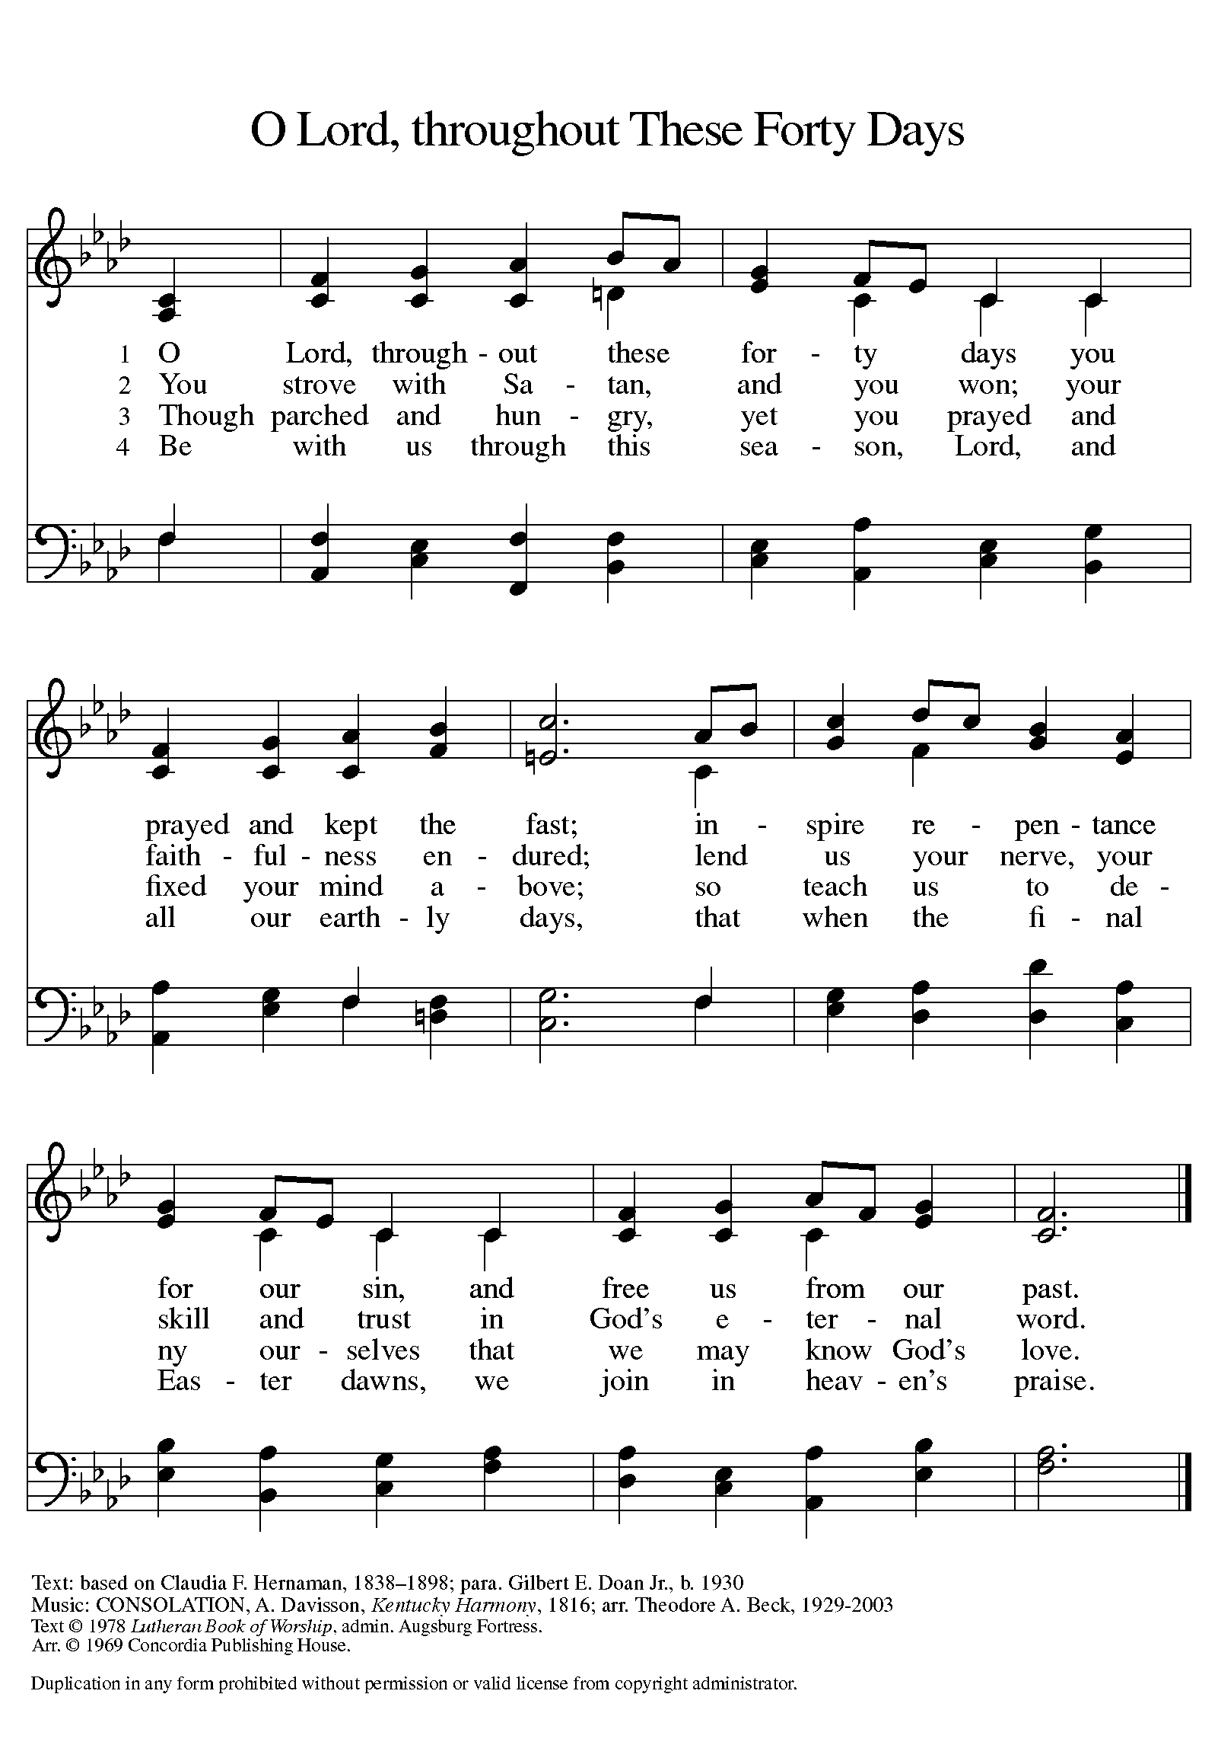
Text and arrangement printed under OneLicnese.net license A-708005

Greeting
A The grace of our Lord Jesus Christ, the love of God,
and the communion of the Holy Spirit be with you all.
C And also with you.

Kyrie
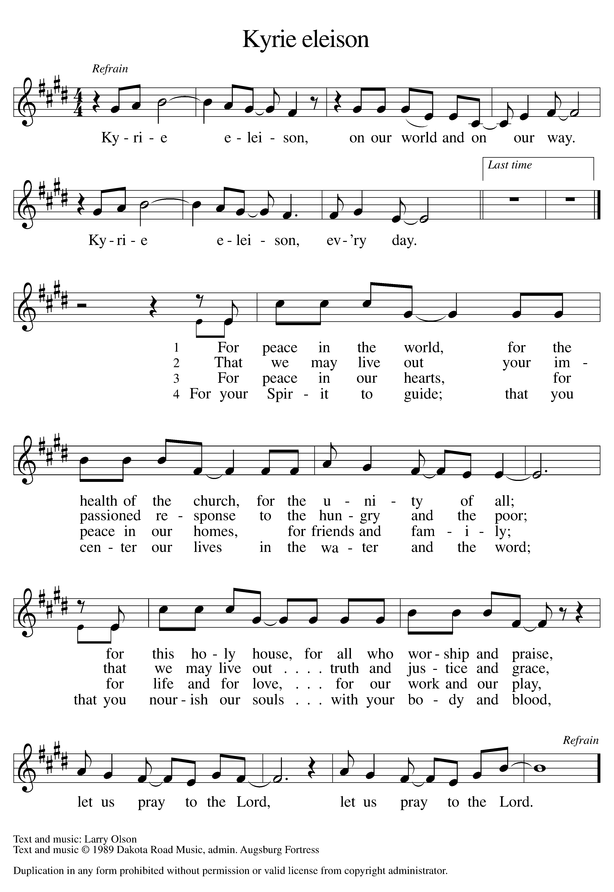 Text and music printed under OneLicense.net license A-708005

Prayer of the Day
A Let us pray.
O Lord God, you led your people through the wilderness
and brought them to the promised land. Guide us now, so that, following your Son, we may walk safely through the wilderness
of this world toward the life you alone can give, through Jesus Christ, our Savior and Lord, who lives and reigns with you
and the Holy Spirit, one God, now and forever.
C Amen

The assembly is seated

Word
God speaks to us in scripture reading, preaching, and song

First Reading: Deuteronomy 26:1-11

The annual harvest festival, called the feast of Weeks, provides the setting for this reading. This festival celebrates the first fruits of the produce of the land offered back to God in thanks. In this text, worshipers announce God’s gracious acts on behalf of Israel.

A A reading from Deuteronomy.

¹When you have come into the land that the Lord your God is giving you as an inheritance to possess, and you possess it, and settle in it, ²you shall take some of the first of all the fruit of the ground, which you harvest from the land that the Lord your God is giving you, and you shall put it in a basket and go to the place that the Lord your God will choose as a dwelling for his name. ³You shall go to the priest who is in office at that time, and say to him, “Today I declare to the Lord your God that I have come into the land that the Lord swore to our ancestors to give us.” ⁴When the priest takes the basket from your hand and sets it down before the altar of the Lord your God, ⁵you shall make this response before the Lord your God: “A wandering Aramean was my ancestor; he went down into Egypt and lived there as an alien, few in number, and there he became a great nation, mighty and populous. ⁶When the Egyptians treated us harshly and afflicted us,

by imposing hard labor on us, ⁷we cried to the Lord, the God of our ancestors; the Lord heard our voice and saw our affliction, our toil, and our oppression. ⁸The Lord brought us out of Egypt with a mighty hand and an outstretched arm, with a terrifying display of power, and with signs and wonders; ⁹and he brought us into this place and gave us this land, a land flowing with milk and honey. ¹⁰So now I bring the first of the fruit of the ground that you, O Lord, have given me.” You shall set it down before the Lord your God and bow down before the Lord your God. ¹¹Then you, together with the Levites and the aliens who reside among you, shall celebrate with all the bounty that the Lord your God has given to you and to your house.

A The word of the Lord.
C Thanks be to God.

Psalm: Psalm 91:1-2, 9-16

Read responsively

¹You who dwell in the shelter of the Most High,
who abide in the shadow of the Almighty—
²you will say to the Lord, “My refuge and my stronghold,
my God in whom I put my trust.”
⁹Because you have made the Lord your refuge,
and the Most High your habitation,
¹⁰no evil will befall you,
nor shall affliction come near your dwelling.
¹¹For God will give the angels charge over you,
to guard you in all your ways.
¹²Upon their hands they will bear you up,
lest you strike your foot against a stone.
¹³You will tread upon the lion cub and viper;
you will trample down the lion and the serpent.
¹⁴I will deliver those who cling to me;
I will uphold them, because they know my name.
¹⁵They will call me, and I will answer them;
I will be with them in trouble; I will rescue and honor them.
¹⁶With long life will I satisfy them,
and show them my salvation.

Second Reading: Romans 10:8b-13

Paul reminds the Christians at Rome of the foundation of their
creed, the confession of faith in the risen Christ as Lord.

A A reading from Romans.

^{8b}“The word is near you,
on your lips and in your heart”
(that is, the word of faith that we proclaim); ⁹because if you confess with your lips that Jesus is Lord and believe in your heart that God raised him from the dead, you will be saved. ¹⁰For one believes with the heart and so is justified, and one confesses with the mouth and so is saved. ¹¹The scripture says, “No one who believes in him will be put to shame.” ¹²For there is no distinction between Jew and Greek; the same Lord is Lord of all and is generous to all who call on him. ¹³For, “Everyone who calls on the name of the Lord shall be saved.”

A The word of the Lord.
C Thanks be to God.

The assembly stands to welcome the gospel

Gospel Acclamation
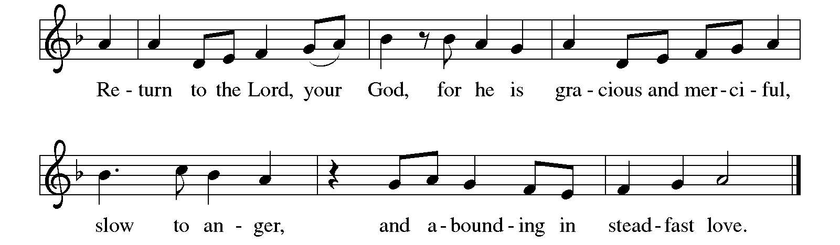
Gospel: Luke 4:1-13

After being filled with the Holy Spirit at his baptism, Jesus is led in the wilderness. Through his responses to the temptations of the devil he defines what it means to
be called “the Son of God.”

P The holy gospel according to Luke.
C Glory to you, O Lord.

¹Jesus, full of the Holy Spirit, returned from the Jordan and was led by the Spirit in the wilderness, ²where for forty days he was tempted by the devil. He ate nothing at all during those days, and when they were over, he was famished. ³The devil said to him, “If you are the Son of God, command this stone to become a loaf of bread.” ⁴Jesus answered him, “It is written, ‘One does not live by bread alone.’ ”
⁵Then the devil led him up and showed him in an instant all the kingdoms of the world. ⁶And the devil said to him, “To you I will give their glory and all this authority; for it has been given over to me, and I give it to anyone I please. ⁷If you, then, will worship me, it will all be yours.” ⁸Jesus answered him, “It is written,
‘Worship the Lord your God,
and serve only him.’ ”
⁹Then the devil took him to Jerusalem, and placed him on the pinnacle of the temple, saying to him, “If you are the Son of God, throw yourself down from here, ¹⁰for it is written,
‘He will command his angels concerning you,
to protect you,’
¹¹and
‘On their hands they will bear you up,
so that you will not dash your foot against a stone.’ ”
¹²Jesus answered him, “It is said, ‘Do not put the Lord your God to the test.’ ” ¹³When the devil had finished every test, he departed from him until an opportune time.

P The gospel of the Lord.
C Praise to you, O Christ.

The assembly is seated

CHILDREN’S MESSAGE

Sermon

The assembly stands to proclaim the word of God in song

Hymn of the Day #661
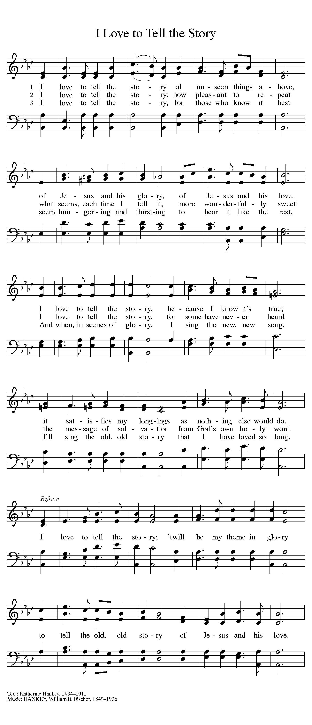
⇨



APOSTLES’ Creed
C I believe in God, the Father almighty,
creator of heaven and earth.
I believe in Jesus Christ, God’s only Son, our Lord,
who was conceived by the Holy Spirit,
born of the virgin Mary,
suffered under Pontius Pilate,
was crucified, died, and was buried;
he descended to the dead.
On the third day he rose again;
he ascended into heaven,
he is seated at the right hand of the Father,
and he will come to judge the living and the dead.
I believe in the Holy Spirit,
the holy catholic church,
the communion of saints,
the forgiveness of sins,
the resurrection of the body,
and the life everlasting. Amen

Prayers of Intercession

A Hearing the call to return to the Lord, let us join the whole people of God in prayer for all who cry out in pain and in hope.

Prayers of intercession are prayed.
To each petition, the assembly responds:

A Lord, in your mercy,
C hear our prayer.

The presiding minister concludes the
prayers, and the assembly responds:

P To you, gracious God, we commend all for whom we pray, trusting in your boundless mercy; through Jesus Christ, our Savior.
C Amen

Peace

P The peace of Christ be with you always.
C And also with you.

The people may greet one another with a sign of Christ’s peace,
and may say, “Peace be with you,” or similar words.

The assembly is seated

Meal
God feeds us with the presence of Jesus Christ

OFFERING

An offering is gathered for the mission of the church, including the care of those in need

Faith Chorale “My Jesus Walked” arr. McDonald

The assembly stands

Offering Prayer
A Let us pray.
God our provider, you have not fed us with bread alone, but with words of grace and life. Bless us and these your gifts, which we receive from your bounty, through Jesus Christ our Lord.
C Amen

Great Thanksgiving

Dialogue

P The Lord be with you.
C And also with you.

P Lift up your hearts.
C We lift them to the Lord.

P Let us give thanks to the Lord our God.
C It is right to give our thanks and praise.

Preface
P It is indeed right, our duty and our joy,
that we should at all times and in all places
give thanks and praise to you, almighty and merciful God,
through our Savior Jesus Christ.
You call your people to cleanse their hearts
and prepare with joy for the paschal feast,
that, renewed in the gift of baptism,
we may come to the fullness of your grace.
And so, with all the choirs of angels,
with the church on earth and the hosts of heaven,
we praise your name and join their unending hymn:

Holy, Holy, Holy
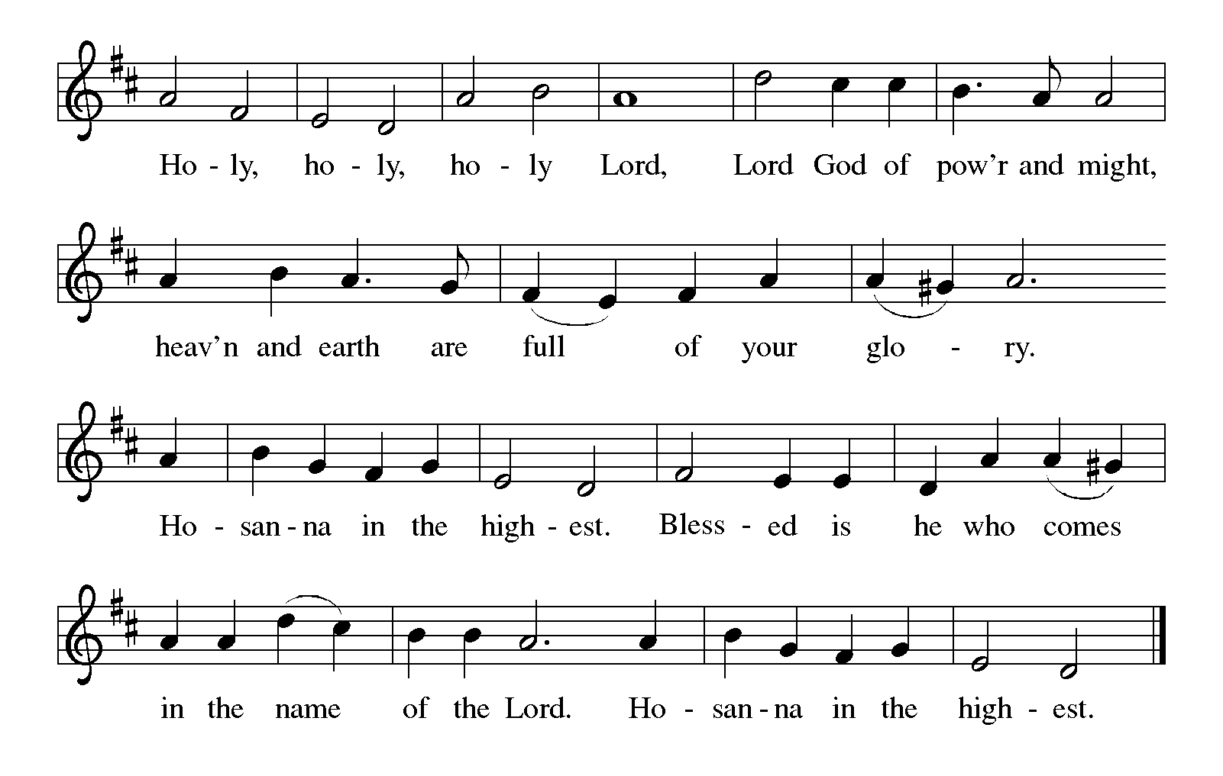

Thanksgiving at the Table
P Holy God,
our living Water and our merciful Guide,
together with rivers and seas, wells and
springs we bless and magnify you.

You led your people Israel through the desert,
and provided them water from the rock.

We praise you for Christ, our Rock and our Water,
who joined us in our desert,
pouring out his life for the world.

In the night in which he was betrayed,
our Lord Jesus took bread, and gave thanks;
broke it, and gave it to his disciples, saying:
Take and eat; this is my body, given for you.
Do this for the remembrance of me.

Again, after supper, he took the cup, gave thanks,
and gave it for all to drink, saying:
This cup is the new covenant in my blood, shed for
you and for all people for the forgiveness of sin.
Do this for the remembrance of me.

Remembering, therefore,
his life, death, and resurrection, we await
your salvation for all this thirsty world.

Pour out your Spirit on this holy food and on
all baptized gathered for this feast:
wash away our sin, that we may be revived
for our journey by the love of Christ.

Through him all glory and honor is yours,
Almighty Father, with the Holy Spirit, in
your holy Church, both now and forever.

C Amen

Lord’s Prayer
P Gathered into one by the Holy Spirit,
let us pray as Jesus taught us.
C Our Father in heaven,
hallowed be your name,
your kingdom come,
your will be done,
on earth as in heaven.
Give us today our daily bread.
Forgive us our sins
as we forgive those
who sin against us.
Save us from the time of trial
and deliver us from evil.
For the kingdom, the power,
and the glory are yours,
now and forever. Amen

Invitation to Communion

P All who thirst, all who hunger, come
and be filled with the goodness of God.

The assembly is seated

Communion
When giving the bread and cup, the communion ministers say
The body of Christ, given for you.
The blood of Christ, shed for you.
and each person may respond
Amen

WE WELCOME ALL GUESTS worshiping with us today and invite all baptized Christians to come to the Lord’s table. Children who have not yet received First Communion instruction are invited to come forward with their families to receive a blessing. There will be one chalice (cup) of wine, as well as trays of individual cups. In the center of each tray, there are a few glasses filled with white grape juice for those who prefer juice rather than wine.

Communion Song

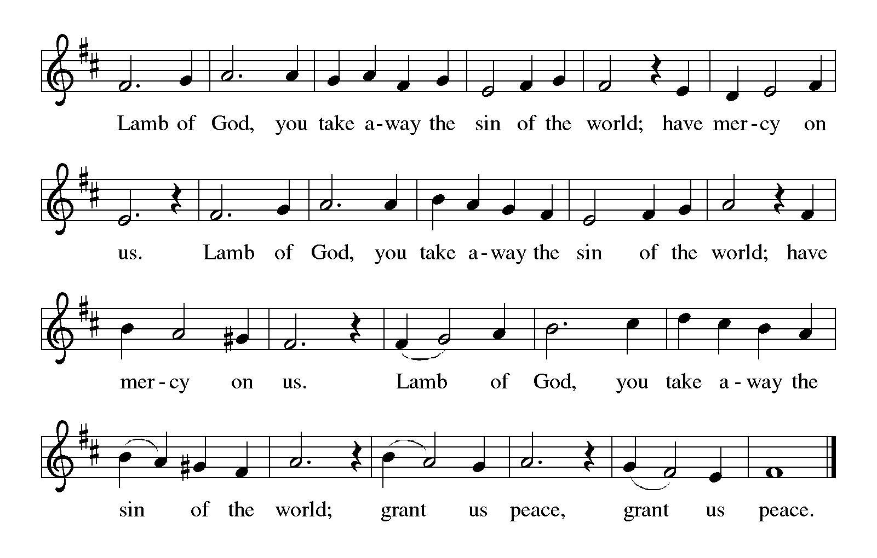

CONGREGATIONAL SONG

On Eagle’s Wings” #787

CONGREGATIONAL SONG #790
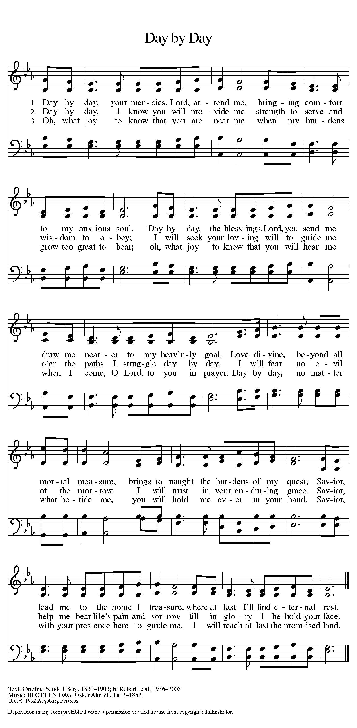
Text printed under OneLicnese.net license A-708005

The assembly stands

P The body and blood of our Lord Jesus Christ
strengthen you and keep you in his grace.
C Amen

Prayer after Communion
A Let us pray.
O God, we thank you for gathering and feeding us as a
mother hen embraces her young. Release us now to go
on our way in these forty days, ready to see our work as
prayer, ready to fast from complacency, and ready to share
with those in need; through Jesus Christ, our Savior and Lord.
C Amen

Sending
God blesses us and sends us in mission to the world

Blessing
P The blessing of God Almighty, the
wisdom and power of ☩ Christ Jesus,
and the light of the Holy Spirit be among
you and remain with you always.

Sending Song #323
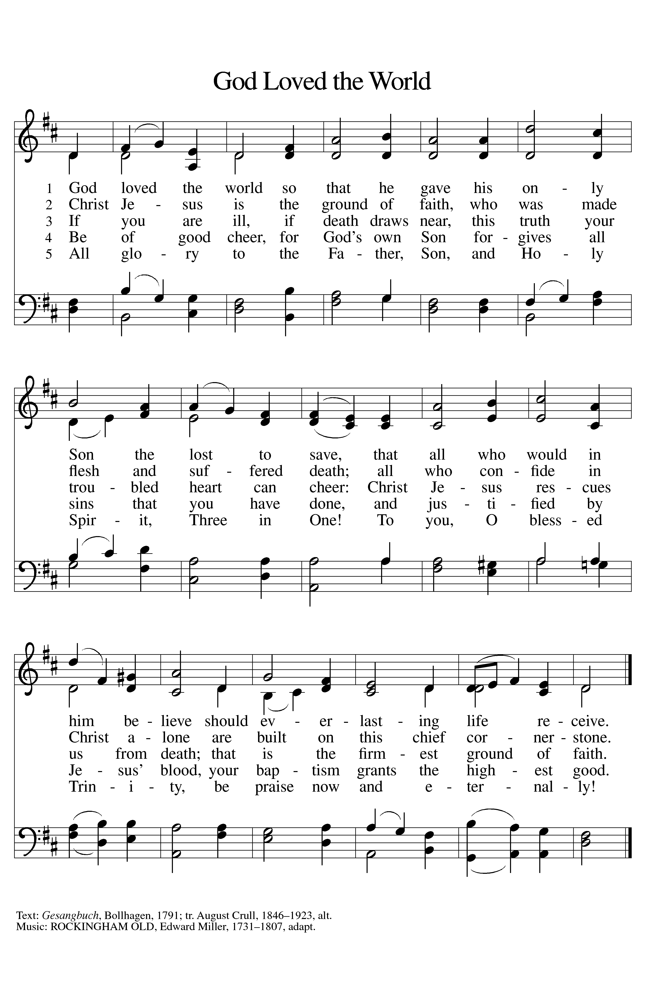
Dismissal
A Go in peace. Remember the poor.
C Thanks be to God.

POSTLUDE

“Trumpet Voluntary” John Bennett

Copyright © 2016 Augsburg Fortress. All rights reserved. Reprinted by permission under Augsburg Fortress Liturgies Annual License #SAS000803.
New Revised Standard Version Bible, copyright © 1989, Division of Christian Education of the National Council of the Churches of Christ in the United States of America.
Used by permission. All rights reserved.
Clipart copyright © 2016 by Communication Resources. All rights reserved. Used by permission.

We extend our welcome and Christ’s love
to all who gather for worship today.
We’re glad you’re here!

Sunday education hour 9:00 a.m.
SUNDAY WORSHIP 10:00 a.m.

Pastor Ellen Schoepf prellen@faithlutheranokemos.org
Secretary Rita Barry rbarry@faithlutheranokemos.org
Director of Christian Education Melinda Schultz
Director of Music Debra Borton-McDonough
Organist/Pianist Bruce Williams

February 7 worship attendance: 157
February 10 worship attendance: 65

Serving Faith Today February 21
Acolytes Lily O’Brien Sami Ransom
Altar care Elaine Harrison and Michelle Ransom
Communion assistants Lily O’Brien Sami Ransom
Walter Kopf Bob Nelson
Karen Whitmyer Susan Heft
Greeters Corey O’Brien Mark and Molly DeHate
Lay assistants Walter Kopf Bob Nelson
Readers Karen Whitmyer Susan Heft
Ushers Jon and Elaine Harrison Jon and Elaine Harrison
Nursery Connie Nelson

