ANNOUNCEMENTS

DECEMBER 20, 2015

Log onto Faith’s website www.faithlutheranokemos.org 24/7 for updates

DEADLINES

Weekly worship folder announcements⎯Tuesday of each week
Submit to Rita at rbarry@faithlutheranokemos.org

February newsletter articles⎯January 18
Submit to Rich at faith@mathwhiz.org

2015 Annual Reports⎯January 3

ALTAR FLOWER DEDICATIONS

Today’s altar flowers are given to the glory of God by. . .
Vase 1 Lee and Linda Gerard in celebration of Carter Sandel’s ninth birthday
Vase 2 The Luoma family in celebration of today’s wedding of Christopher Donald Luoma and Sarah Elizabeth McAdams.

PRAYERS OF INTERCESSION

Please lift up in prayer this week:

 Members—Max Ambs, Lowell Barricklow, Dale Halvorson,
Susan Heft, Bob Marklewitz, Ellen Milne and Harry Nawrock
 Friends and family—
Pat Belonga
Chris Cotter
Tim Drummond
Dick and Lil Jennings
Christine, Izzy and Danny Loewen
Annaliese, Heather, Bill, Al and Ron
 Our mission partner congregation⎯Lansing Redeemer Lutheran Church
 Those in military service⎯Jon Schoepf, Melody and Adam Wright
and Lani Yearicks
 Lutheran Social Services of Michigan children who seek adoption—
James, Devon, Gregory and Antoinette.

NORTH/WEST LOWER MICHIGAN SYNOD PRAYER PARTNER
As Jesus calls us to be one, even as he and the Father are one, please include Pastor Jane Mountain and the congregation of Muskegon Our Savior’s Lutheran Church in your prayers of intercession this week. Please also remember in prayer this week Pastor David E. Sprang, Director for Evangelical Mission and Assistant to the Bishop, N/WL Michigan Synod.

FINANCIAL UPDATE

Weekly offering 12/13/2015: Year-to-date as of 10/31/15:
General Fund $ 3,255.00 Income $213,344.77
Loose cash 171.00 Expenses 238,711.15
Loose checks 210.00 Net Income $(25,366.38)
Flowers 55.00
Facility Rental 100.00
Caring Cmte-Food Drive 18.00
Capital Repairs 25.00
Total $ 4,884.00



IMPORTANT ANNOUNCEMENT
REGARDING POINTS OF ENTRY INTO
THE CHURCH ON SUNDAY MORNINGS

On Sunday mornings, once the worship service has begun, the two south entry doors into the church building (Dobie Road and south parking lot entrances) will be locked. If you arrive for church after 10:00 a.m., please expect to enter through the north doors.

THIS WEEK’S CHRONOLOGY OF EVENTS

TODAY Fourth Sunday of Advent

Correction from last week regarding stained glass art pieces displayed in our church. Former member Jim Scott constructed most of the items. However, there are two pieces hanging in the south entryway that Pastor Douglas McBride and Robert Shorman made. Pastor McBride did the sunrise piece in the south window and Robert Shorman did the lily piece in the north window.

THANK YOU from the Caring Committee to everyone who brought in food, donated money for perishables and helped pack groceries. And thank you to those of you who will deliver to the 20 families in Meridian Township today. We are again grateful to GREAT HARVEST BREAD COMPANY in Okemos for donating bread goods for each family. Stop in and tell them how much Faith Lutheran appreciates their support in this important ministry.

➢10:00 a.m. Worship

➢11:30 a.m. Listening Post (library)

➢3:00 p.m. The Willows at Okemos Carol Sing

Pastor Ellen facilitates a monthly worship service for the residents and staff at The Willows at Okemos, 4830 Central Park Drive. This month’s format is a carol sing led by Choir Director Deb Borton-McDonough. Deb would love to see you there!

➢4:00 p.m. An Evening of Lessons and Carols at Presbyterian Church
of Okemos featuring their chancel and hand bell choirs
and an MSU brass ensemble. Admission is free; a freewill offering will benefit Advent House Ministries. Pastor Ellen will be participating in this community event. Please join
her for this special community Advent service.

➢6:00 p.m. Faith volunteers at Loaves and Fishes Ministries

MONDAY, DECEMBER 21

7:00 p.m. Church Council meeting

TUESDAY, DECEMBER 22

12:00 p.m. Lunch lectionary study group (Pastor Ellen’s office)

6:30 p.m. Pub lectionary study group at Okemos Buddies Pub & Grill

WEDNESDAY, DECEMBER 23

7:30 a.m. NO Men’s lectionary study group
Next Men’s lectionary study group will meet
at 7:30 a.m., Wednesday, January 6

9:30 a.m. Quilting and LSSM ACTION (parish house)

6:30 p.m. NO Faith Bells

7:30 p.m. Chancel Choir

THURSDAY, DECEMBER 24- Nativity of Our Lord: Christmas Eve
4:00 p.m. Family Worship
10:00 p.m. Candlelight Worship
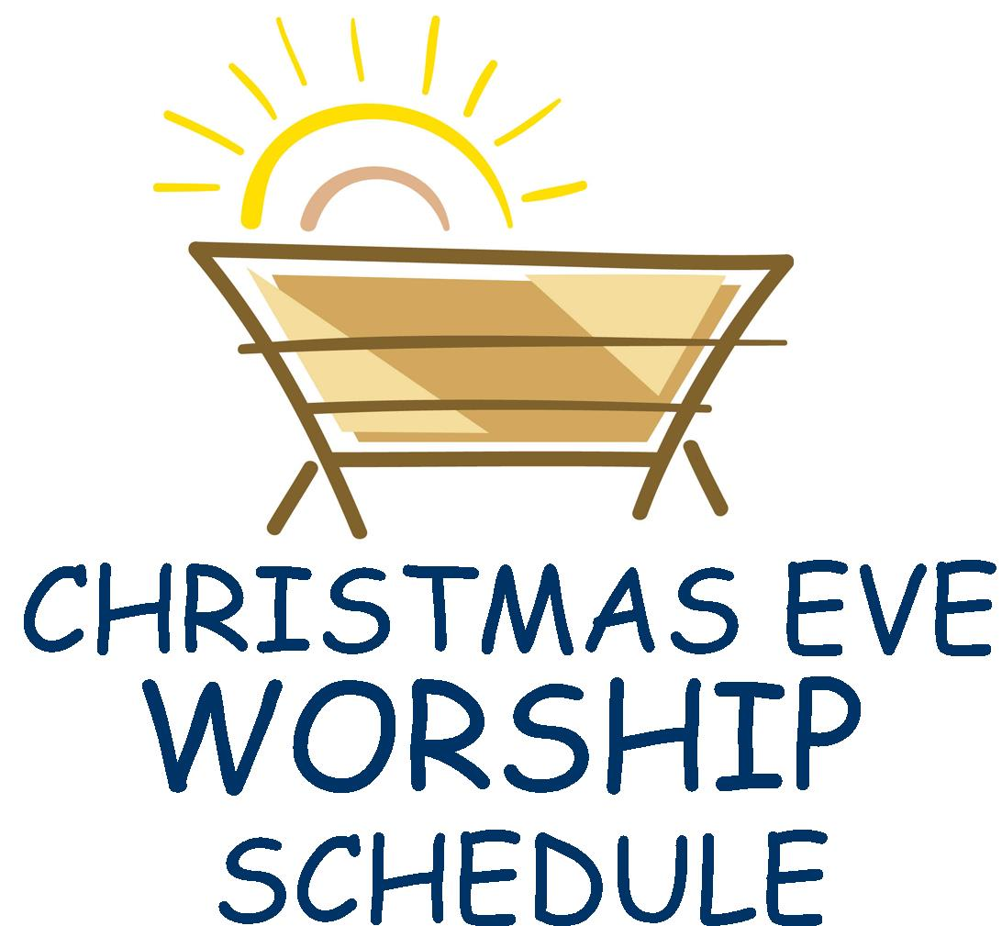
4:00pm & 10:00pm

LOOKING AHEAD

Next Sunday, December 27

World Hunger offering
Next Sunday we will receive our monthly offering to help fight world hunger. The offering globe for this special offering will be at the sanctuary entrance.

9:00 a.m. NO Sunday School

10:00 a.m. WORSHIP

Tuesday, December 29

12:00 p.m. NO Lunch lectionary study group
Next lunch lectionary study group will meet at 12:00 p.m. on Tuesday, January 5 in Pastor Ellen’s office

Wednesday, December 30

7:30 a.m. NO Men’s lectionary study group
Next Men’s lectionary study group will meet
at 7:30 a.m., Wednesday, January 6

9:30 a.m. Quilting and LSSM ACTION

6:30 p.m. NO Faith Bells

7:30 p.m. Chancel Choir



ANNUAL REPORTS ARE DUE SUNDAY, JANUARY 3
All annual reports are due in the church office by Sunday, January 3rd.
The following are included: Pastor, Church Council President, 2016
proposed budget, Nominating Committee, Director of Christian Education and all committees.

SUNDAY, JANUARY 10, 9:00 A.M.

UPDATED FLC CONSTITUTION AND BYLAWS REVIEW
In November, Church Council approved recommendations for an update church constitution and bylaws. Church Council will be asking for congregation approval at the annual January 31 congregational meeting (11:00 a.m.). The updated document is available on the narthex counter for perusal prior to the January 10 review and the January 31 annual meeting.
Help Decorate the Sharing Tree. . .Not with ornaments and tinsel. . .but with baby items!!!

Visit the fellowship area Sharing Tree and select a paper “ornament” or two. On each ornament, a specific layette item is indicated. So it can be a reminder of what to purchase, take the ornament home with you (only new baby items please). Bring your unwrapped layette items and tuck them into the Sharing Tree branches by Sunday, January 10th. Your gifts will be given to Shared Pregnancy of Lansing, an organization that offers emotional and spiritual support to new moms.

SIXTY PLUS/MINUS JANUARY LUNCH AND PROGRAM
On Wednesday, January 20 at 11:30 a.m., we plan to gather at the church for pizza and a program! We have rescheduled the physical therapy presentation that was cancelled due to the November 18 power outage. Come and learn about the NEW out-patient physical therapy program being offered to the community at the Dobie Road Ingham County Medical Care Rehabilitation Center. Watch for details in the January worship folder announcements.

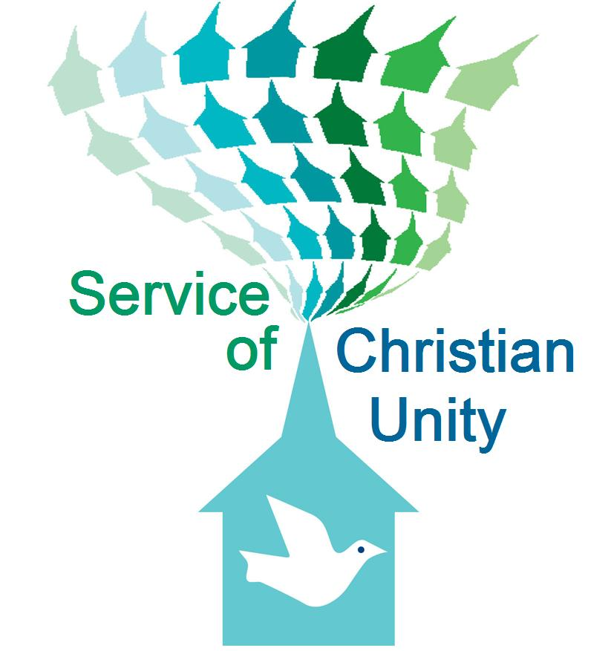
SERVICE OF CHRISTIAN UNITY – January 17 at 3:00 p.m.

On Sunday afternoon, January 17 at 3pm, we will be hosting a Service of Christian Unity here at Faith Lutheran Church. Members of The Church of Elohim will be joining us for this event. Pastors Derrick Knox and Linda Gardner serve The Church of Elohim. Linda was one of the panel members who participated in our fall Forum on Race, Ethnicity & Culture. This January worship service promises to be a very meaningful and enriching event. Please plan to join us and participate.

ANNUAL CONGREGATIONAL MEETING
Sunday, January 31 at 11:00 a.m.

OPEN HEARTS, OPEN CHURCH TASK FORCE – January 31 at 5:00 p.m.
On Sunday evening, January 31 at 5:00 p.m., members of the North/West Lower Michigan Synod’s Open, Hearts, Open Church Task Force will join us for an educational event. Members of this task force are going to various churches throughout the Synod to provide guidance, support and companionship as we journey together with regard to full inclusion of all sexual orientations and gender identities. All who are interested are invited to join us for this conversation. The event includes food! If you plan to attend, please sign the narthex sheet so we know how much food to prepare.

EASY WAYS TO FIGHT HUMAN TRAFFICKING –
February 21 following worship
On Sunday morning, February 21, following our morning worship service, Clarissa Grimes will be joining us to discuss issues of human trafficking. This is a growing problem in our community, in Michigan and throughout the world. Come to learn and become aware. Awareness is essential to enacting the personal and systemic changes that will free victims of human trafficking.

FAITH SIXTIETH ANNIVERSARY SAVE THE DATES
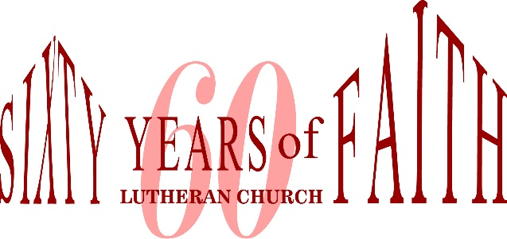
February 28, 10:00 a.m. – Special morning worship service and reception to commemorate the chartering of FLC.
September 18 – Luncheon banquet at MSU Kellogg Center

MARRIAGE RETREAT – March 11-13 in Grand Rapids
Interested members of Faith Lutheran Church will be joining with members of Muskegon First Lutheran Church to hold a marriage retreat in the Grand Rapids area. Any interested couples are invited to attend this event. More information to come!

CHRISTIAN EDUCATION AND YOUTH ANNOUNCEMENT

Winter break schedule
There are no Sunday School classes scheduled for December 27 and January 3. Classes resume at 9:00 a.m. on Sunday, January 10.

There are no Trinity and Confirmation classes scheduled December 23 and 30. T&C resumes at 6:00 p.m. on Wednesday, January 6.




To make disciples for Jesus Christ. . .
. . .we Gather in faith for worship, prayer,
study and fellowship
. . .we Equip the people of God with a faith
that works in real life
. . .we Serve the world in the name of Jesus Christ
_______________

