ANNOUNCEMENTS
NOVEMBER 29, 2015

Log onto Faith’s website www.faithlutheranokemos.org 24/7 for updates

WEEKLY WORSHIP FOLDER ANNOUNCEMENTS DEADLINE—
TUESDAY EACH WEEK
Submit to Rita at rbarry@faithlutheranokemos.org

FEBRUARY NEWSLETTER DEADLINE⎯
JANUARY 18TH
Submit to Rich at faith@mathwhiz.org

ALTAR FLOWER DEDICATIONS

Today’s altar flowers are given to the glory of God by the Richardson family in memory of Rose Marie Nawrock’s October 28th birthday.

PRAYERS OF INTERCESSION

Please lift up in prayer this week:

 Members—Max Ambs, Lowell Barricklow, Dale Halvorson,
Susan Heft, Bob Marklewitz, Ellen Milne and Harry Nawrock
 Friends and family—
Pat Belonga
Chris Cotter
Tim Drummond
Dick and Lil Jennings
Christine, Izzy and Danny Loewen
Annaliese, Heather, Bill, Al and Ron
 Our mission partner congregation⎯Lansing Redeemer Lutheran Church
 Those in military service⎯Jon Schoepf, Melody
and Adam Wright and Lani Yearicks
 Lutheran Social Services of Michigan children who seek adoption—
Sean, Ciera, Jacob and Ciana.

NORTH/WEST LOWER MICHIGAN SYNOD PRAYER PARTNER
As Jesus calls us to be one, even as he and the Father are one, please include North/West Lower Michigan Synod Bishop Craig Satterlee and Pastor Dana Hendershot and the congregation of Mt. Pleasant Immanuel Lutheran Church in your prayers of intercession this week.

FINANCIAL UPDATE

Weekly offering 11/22/2015: Year-to-date as of October 31:
General giving $ 2,693.00 Income $213,344.77
Loose cash 51.00 Expenses 238,711.15
Loose checks 25.00 Net Income $(25,366.38)
Youth – Bake Sale 212.00
Youth – Chili Dinner 315.00
Sunday School 0.00
Shoebox mailing 97.00
Caring Cmte – Food Drive 5.00
Total $ 3,398.00

Stewardship principle
Giving involves more than financial contributions⎯
we first commit ourselves to the Lord and to the church at large

THIS WEEK’S CHRONOLOGY OF EVENTS

TODAY First Sunday of Advent

➢ 9:00 a.m. The Bible makes Sense adult study (library)

➢10:00 a.m. WORSHIP

Reception of New Members – Please take a moment to welcome Rich Achtenberg and Diane Hill who are being received into membership today.

WORLD HUNGER OFFERING TODAY

Today we receive our monthly offering to help fight world hunger. The offering globe for this special offering is at the sanctuary entrance.

The light of life: Bangladesh

Saleha was living with a severe visual
impairment in her left eye, but due to
the cost of treatment, she was unable
to have it diagnosed. The majority of
eye-care facilities in her home
country of Bangladesh are also in
major cities, which would be a long
trip from her small village in Patgram
at the very northern tip of the country.

After hearing about an eye-care center
operated by Rangpur Dinajpur Rural
Service (RDRS), Saleha visited their
outreach clinic in her area and was
able to see an ophthalmic paramedic. RDRS, a development agency addressing the needs of people in the Rangpur-Dinajpur region, was started by The Lutheran World Federation in 1972 following the war of independence in Bangladesh. The service is now an independent non-profit organization supported by ELCA World Hunger.

After her examination, Saleha was told she needed an operation to reapir the damage in her eye. She received the operation free of charge. The day after her surgery, she was overjoyed to discover she could already see with her previously blind eye. Without the support of RDRS, Saleha and many others would never have the opportunity to see the light of life.

November Stewardship Focus: ELCA Good Gifts



Rethink your Christmas shopping this year, and substitute at least one gift with a gift from the ELCA Good Gifts catalog. Purchase a gift through the ELCA Good Gifts Program in honor of a special person in your life⎯just in time for Christmas. Check out the catalogs and order forms available in the narthex.

Order now

Select from more than 50 gift-giving options. Choose the gifts that mean the most to you or choose gifts in honor of friends or loved ones.

There are three ways to give⎯

Online www.ELCA.org/goodgifts
Phone 800-638-3522
Mail Send the order form to
Evangelical Lutheran Church in America
P. O. Box 1809
Merrifield VA 22116-8009

Get a card
If your gift is in honor of a friend or loved one, it’s easy to tell them about it! Visit www.ELCA.org/goodgifts for a selection of printable cards. Give online or through the mail and you may request that a printed card for each of your gifts be mailed to your home. Please allow two weeks for delivery when ordering online, and three weeks for delivery when ordering through the mail.

TUESDAY, DECEMBER 1ST
12:00 p.m. Lunch lectionary study group (Pastor Ellen’s office)

WEDNESDAY, DECEMBER 2ND
7:30 a.m. Men’s lectionary study group (library)
9:30 a.m. Quilting and LSSM ACTION (parish house)
5:30 p.m. Joyful Noise Choir
6:00 p.m. Trinity and Confirmation
6:30 p.m. Faith Bells
7:30 p.m. Chancel Choir

SATURDAY, DECEMBER 5TH
5:00p.m. Santa’s Little Helpers until 8:00 p.m.

Do you need some time to shop without the kids?? Let the High School Youth be in charge of the kids for an evening! Faith Youth are offering their services on December 5th from 5:00-8:00pm, for kids from ages 2-12 years old. The cost is $10/child or $20/family. Activities, games, dinner and more will be provided! Please sign up on the narthex Faith at Work display in the by December 4th.

LOOKING AHEAD

Next Sunday, December 6th

9:30 a.m. Usher meeting

If you will be serving as an usher in the coming year or you have thought about becoming an usher, it is important for you to attend this meeting. Pastor Ellen and usher coordinator Bill Williams will share information about new procedures that have been implemented; and you will have an opportunity to ask any questions you have about ushering.

11:30 a.m. Sunday School Christmas pageant dress rehearsal
Lunch will be served

11:30 a.m. Technology Committee meeting

11:30 a.m. Worship Committee meeting

3:30 p.m. Youth Group is going to Suburban Ice

The cost is $8.00 for skating and skate rentals. Please let Melinda know if you will be attending.


NEXT SUNDAY THE 6TH

HANDBELL CONCERT HERE AT FAITH AT 7:00 P.M.

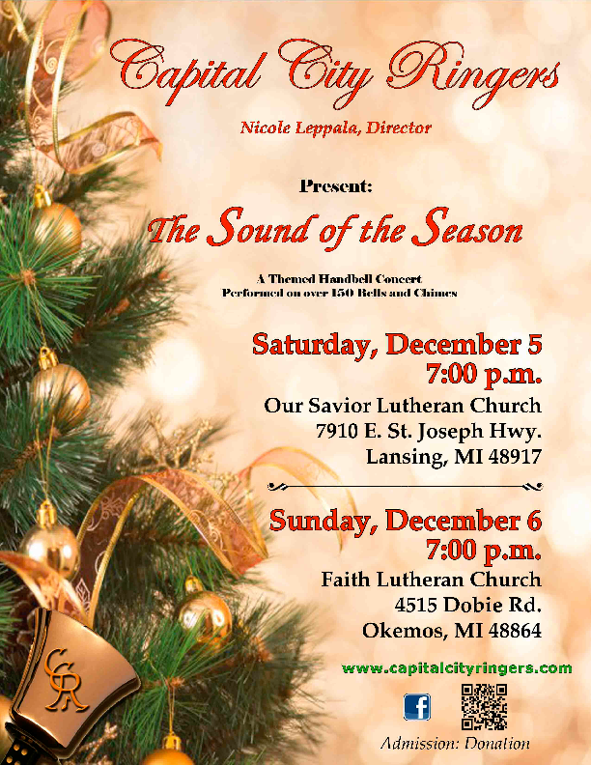

Sixty Plus/Minus announcements



All are Welcome!
Join your 60 Plus or Minus friends for brunch
at MSU’s Kellogg Center State Room next Sunday the 6th

Next Sunday, December 6th, is the second Sunday in Advent, a time
of preparation for the Holy Season of Christmas. Join your 60 Plus or Minus friends for a pre-Christmas luncheon at 12:00noon next Sunday
at the Kellogg Center on Harrison Avenue on the MSU campus.

We will enjoy the delicious buffet brunch at a group of reserved tables in the State Room. The buffet features a complete selection from breakfast items to entrees and desserts. The cost⎯including tax and gratuity⎯is $21.35 with free parking (under cover and attached to the Kellogg Center). We’ll be paying individually on the day of the event.

As our name “60 Plus or Minus” suggests, we welcome friends and guests who have not yet reached that golden age! Be sure to add your name to the sign-up sheet on the new Faith at Work display board TODAY so we can reserve the proper number of tables.

If you arrive early or stay after the brunch, you can browse the festive seasonal decorations in the Kellogg Center, including the annual gingerbread house competition.

See you there!
_______________

Looking ahead—Save the date!

On Wednesday, January 20, 1t 11:30 a.m., we plan to gather at the church for pizza and a program! We have rescheduled the physical therapy presentation that was cancelled on November 18 due to the power outage. Come and learn about the NEW out-patient physical therapy program being offered to the community at the Dobie Road Ingham County Medical Care Rehabilitation Center. Watch for details in the January worship folder announcements.

LUTHERAN SOCIAL SERVICES OF MICHIGAN GIFTS FOR FOSTER KIDS

Each Christmas season LSSM ACTION sends out wish lists for foster kids in their Child and Family Services program. Our Faith ACTION group invites you to participate with them in bringing the Christmas message and joy to these young people. Find the LSSM gifts for foster kids display in the fellowship area. Select a tag and take it with you⎯one gift/child; no fancy wrapping please, gift bags are best; attach the tag to the gift for identification purposes.
Gifts should be at church NLT Sunday, December 6th please.

CHRISTMAS POINSETTIA DEDICATIONS ARE DUE DECEMBER 13TH

Each Christmas Eve we decorate the sanctuary
with poinsettias. An order form has been
included in today’s worship folder or
can be found on the narthex counter.
The order deadline is
Sunday, December 13th.

Color choices are red, white and
pink. Plants are $10.00 each.

This shrub, native to Mexico, is at the
heart of legend about a poor girl who
wanted to bring Baby Jesus a gift one
Christmas Eve. As she walked to church,
she gathered a bouquet of weeds — which Jesus miraculously transformed into lovely red flowers. Thus the poinsettia (named for Joel Poinsett, the U.S. ambassador to Mexico who first brought the plant to America) is known in Mexico as la flor de la Nochebuena (flower of the Holy Night). The poinsettia is a Christmas symbol.

ADVENT LUNCHEON December 13th
Following the Sunday School Pageant

Mark your calendar for a Faith favorite!
Immediately following the Sunday School pageant on December 13th, we will gather for great food and fellowship. Membership
Development will provide the main dish and beverages. Parish Education will serve a “Happy Birthday Jesus” cake. All you have to do is sign up in the fellowship area and bring a dish to share.

CARING COMMITTEE NEWS



Food
Drive

The Faith Lutheran Caring Committee was asked by the Meridian Township Human Services Director if we could provide support to families during the Christmas/winter school break. There is a need for food items during this two-week break from school because children are at home during this time and do not get their breakfasts and/or lunches at school. Please look in the narthex for the grocery cart to appear and be ready to collect the donations for food items needs as follows:

Peanut butter, jelly, snack bars, Pop Tarts, muffin mix, syrup,
canned fruit, boxed cereals, oatmeal, macaroni and cheese,
soup, crackers, rice, pasta, spaghetti sauce
and boxed meals, i.e., Hamburger Helper

With your cash donations, we will purchase eggs, milk and bread to be included with the food.

Thank you, Faith family, for helping those in the community that have a need. Food collection for this project has begun. The deadline for bringing
in food is December 13th and our delivery date will be Sunday, December 20th.

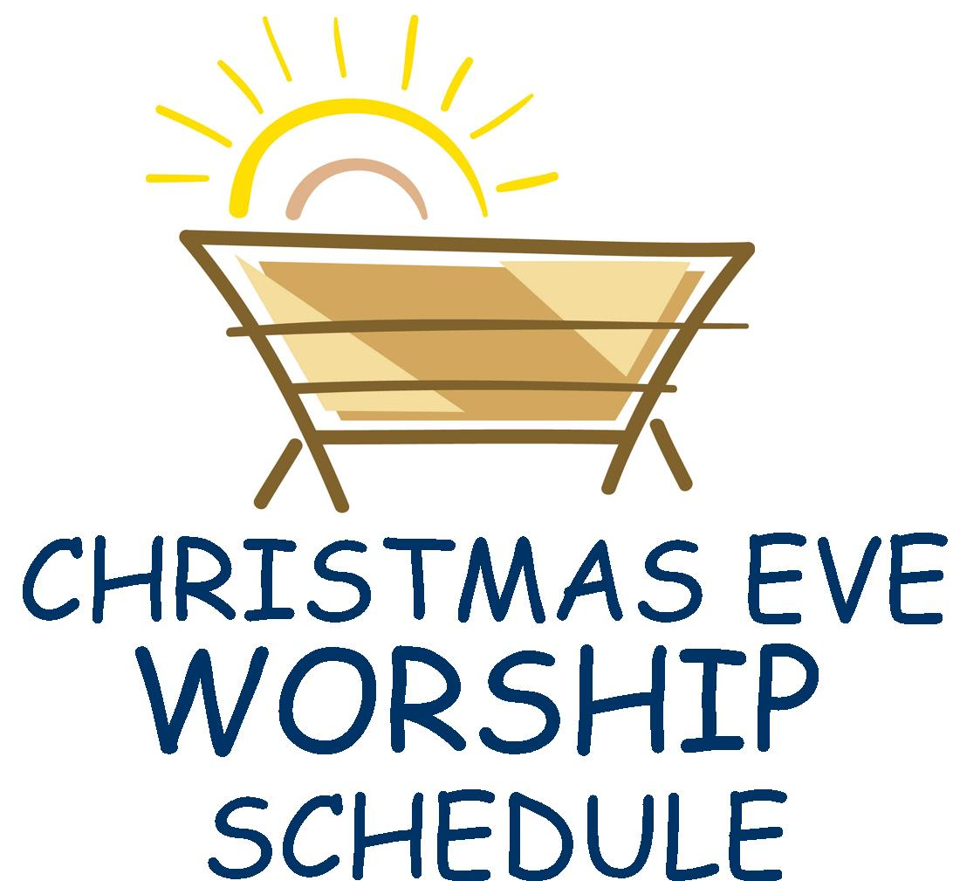
4:00pm & 10:00pm

Help Decorate the Sharing Tree

Not with ornaments and tinsel. . .

. . .but with baby items!!!

Visit the fellowship area Sharing Tree and select a paper “ornament” or two. On each ornament, a specific layette item is indicated. So it can be a reminder of what to purchase, take the ornament home with you (only new baby items please). Bring your unwrapped layette items and tuck them into the Sharing Tree branches by Sunday, January 10th. Your gifts will be given to Shared Pregnancy of Lansing, an organization that offers emotional and spiritual support to new moms.

COMING UP IN 2016

SERVICE OF CHRISTIAN UNITY – January 17 at 3:00 p.m.
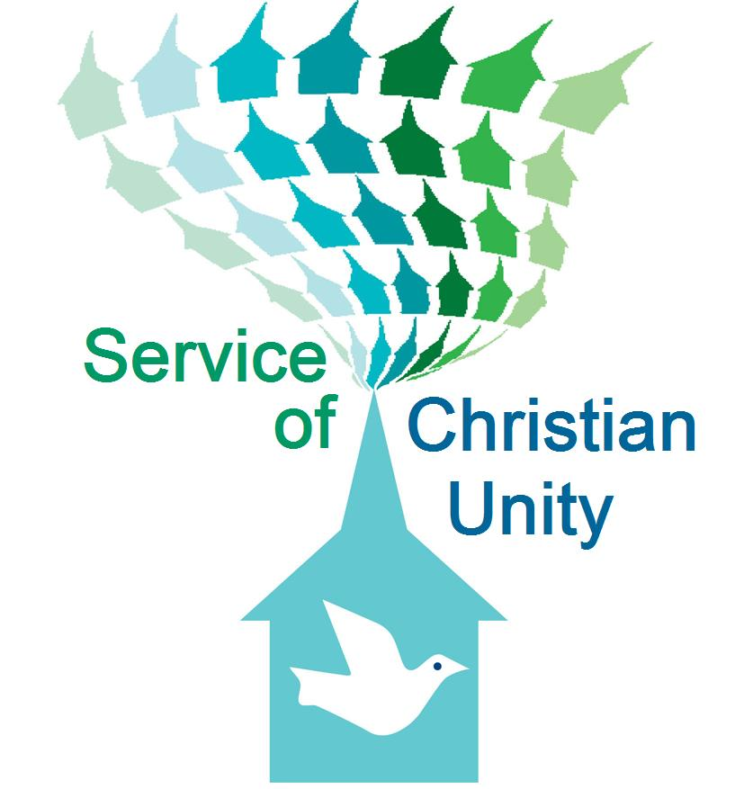
On Sunday afternoon, January 17 at 3pm, we will be hosting a Service of Christian Unity here at Faith Lutheran Church. Members of The Church of Elohim will be joining us for this event. Pastors Derrick Knox and Linda Gardner serve The Church of Elohim. Linda was one of the panel members who participated in our fall Forum on Race, Ethnicity & Culture. This January worship service promises to be a very meaningful and enriching event. Please plan to join us and participate.

OPEN HEARTS, OPEN CHURCH TASK FORCE – January 31 at 5:00 p.m.

On Sunday evening, January 31 at 5:00 p.m., members of the North/West Lower Michigan Synod’s Open, Hearts, Open Church Task Force will join us for an educational event. Members of this task force are going to various churches throughout the Synod to provide guidance, support and companionship as we journey together with regard to full inclusion of all sexual orientations and gender identities. All who are interested are invited to join us for this conversation. The event includes food! If you plan to attend, please sign the narthex sheet so we know how much food to prepare.

EASY WAYS TO FIGHT HUMAN TRAFFICKING –
February 21 following worship

On Sunday morning, February 21, following our morning worship service, Clarissa Grimes will be joining us to discuss issues of human trafficking. This is a growing problem in our community, in Michigan and throughout the world. Come to learn and become aware. Awareness is essential to enacting the personal and systemic changes that will free victims of human trafficking.

MARRIAGE RETREAT – March 11-13 in Grand Rapids

Interested members of Faith Lutheran Church will be joining with members of Muskegon First Lutheran Church to hold a marriage retreat in the Grand Rapids area. Any interested couples are invited to attend this event. More information to come!
CHRISTIAN EDUCATION AND YOUTH ANNOUNCEMENTS

Blessing Bag Monetary Donations
The Youth are collecting money and will then be making the Blessing Bags. The collection box is on the counter across from the Faith@Work display panel. The bags will be available in the Church Office for people to give out to any homeless individuals that they may encounter during their daily travels.
Thrivent Action Teams are needed again!!!
Please apply to help your youth group in a one-time fundraiser, service activity or educational event that can be completed within 90 days. Here are some suggestions for your Thrivent Action Teams: Blessing Bags, Winter Mission Project, Shrove Supper, and Faith Vacation Bible School . Use this link to get started: https://www.thrivent.com/making-a-difference/living-generously/thrivent-action-teams/ Please see Melinda to get specific details or if you have any questions.


‘Christmas: We’re on the Air’ Pageant
Here's a chance to hear about the birth of Jesus from the people who were there when it happened. In the program, you'll hear all of the children in the Christmas musical report on the story as it happens! Join us at the service on December 13th and for the potluck immediately following.
Christmas Pageant Dress Rehearsal Schedule
We will have a dress rehearsal for everyone (every child ages 3-13) after church on December 6th from 11:30pm - 2:00pm. We will feed the children and then rehearse. The pageant is Sunday, December 13th during the service. Hope to see everyone's family for our celebration of the birth of Jesus!


Santa’s Little Helpers - Holiday Babysitting Opportunity
Do you need some time to shop without the kids?? Let the High School Youth be in charge of the kids for an afternoon! We are offering our services on December 5th from 5:00-8:00pm, for any kids from age 2 to 12 years old. The cost is $10.00 per child or $20.00 per family. We will have activities, games, dinner and more! Please sign up on the form in the narthex by Dec. 4th.


Youth Group Outing
On December 6th the Youth (grades 9-12) will be going to Suburban Ice from 3:30-5:00pm. The cost is $8.00 for skating and skate rentals. Please let Melinda know if you will be attending.

COMMUNITY ANNOUNCEMENTS

Red Cross Blood Drive

Monday, November 30 from 12:00-5:45pm
Lower level social hall
Okemos Community Church
4734 Okemos Road, Okemos
Appointments are suggested, but walk-ins are also welcome. Please go online to set an appointment or contact OCC’s office at 349-4220.

The OCC blood drive flyer is posted on the hallway community bulletin board.

Christ Lutheran Church
Holiday Bazaar and Cookie Walk

Friday, December 4 – 10:00am-4:00pm
122 South Pennsylvania Avenue, Lansing

Famous cinnamon rolls
Light lunch of soup and sandwiches (11-1)
Homemade holiday cookies
Specialty jams and jellies. . .breads and other baked goods
Handcrafted holiday gifts

Come, relax and shop!




To make disciples for Jesus Christ. . .
. . .we Gather in faith for worship, prayer,
study and fellowship
. . .we Equip the people of God with a faith
that works in real life
. . .we Serve the world in the name of Jesus Christ
_______________
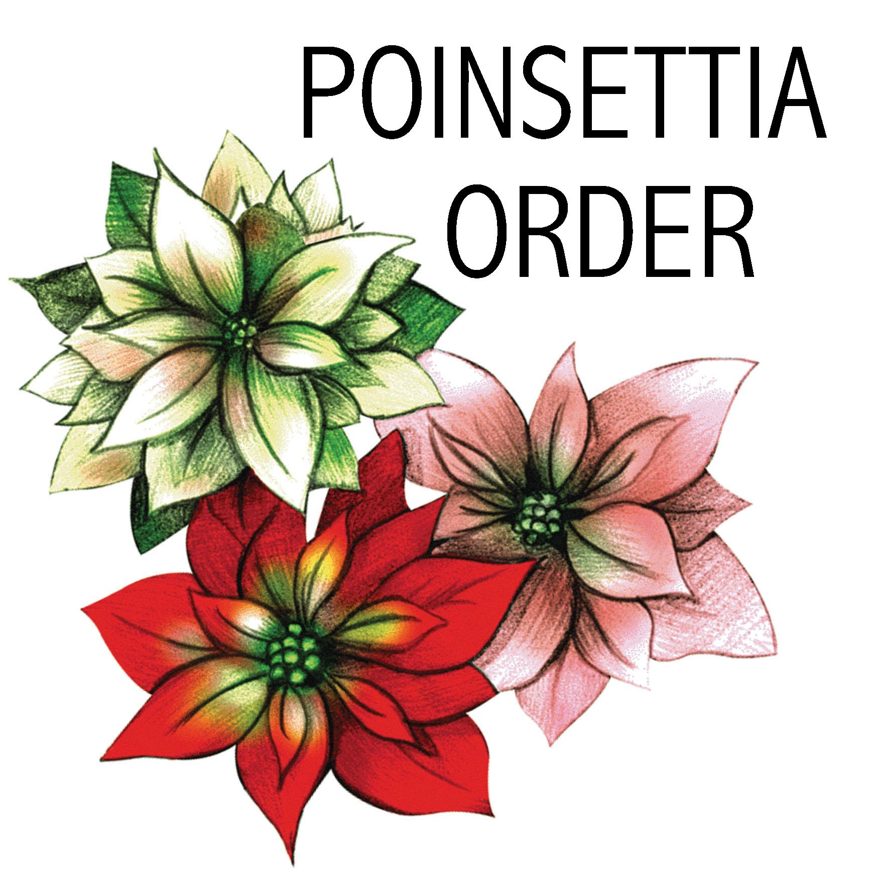
Please print name of person(s) dedicating:

In memory of

In honor of

In celebration of

Number of each color plant: _____Red _____Pink _____White

Cost: $10/plant
Checks should be made payable to Faith Lutheran Church
and placed in the offering plate.
Please mark envelope and check “Poinsettia order.”

LAST DAY TO ORDER IS SUNDAY, DECEMBER 13TH

Place this form in Connie Nelson’s church mailbox

You may take your poinsettia(s) home
after the 10pm Christmas Eve worship service.

