November 25, 2015

4515 Dobie Road
Okemos MI 48864-2203
517-349-0620

Pastor Ellen Schoepf
prellen@faithlutheranokemos.org

Email
faith@faithlutheranokemos.org

Website
www.faithlutheranokemos.org

Facebook
facebook.com/faithlutheranokemos

Not to Worry

Thanksgiving is a time when many of us feel God’s abundance—perhaps so much that we need to loosen our belts a notch. Oftentimes food pantries are overwhelmed with the generosity of donors around the holidays. Yet, somehow this awareness of God’s abundance wears off after a while. We forget that the same God who supplied that generous holiday table also supplies our daily bread. We fret and toil trying to get all we can while the getting is good.

And if we are honest, more than a little fretting goes into the holiday preparations themselves—who to invite, what to have, how to get everything ready at the same time. Add to that the onslaught of the holiday shopping season and the deals we can’t refuse. All of a sudden even a holiday to celebrate God’s abundance is itself overcome with striving and worry.

Jesus tells us not to worry about what we will eat or what we will wear. Of course, telling someone what not to do does not necessarily produce the desired result. Fortunately, Jesus also points us in the right direction. If we are going to strive for something, Jesus says to strive for God’s kingdom and God’s ways.

But striving for God’s kingdom isn’t like the striving we normally do—as though everything depends on us. Striving for God’s kingdom is more like yielding to the one who is greater than us. This one who created the universe and everything in it is providing abundantly for us.

God proved trustworthy through coming as Jesus—to be one of us, among us, demonstrating his provision of love without limit through his death on the cross. And then through Jesus’ resurrection, God demonstrated victory over all that worries us—even death itself! We can trust in this God’s abundance and give thanks for what God has done for us through Jesus Christ.

Wednesday, November 25, 2015
Thanksgiving Eve
7:00 p.m.

INTRODUCTION

As we come together to celebrate a national day of thanksgiving, Jesus' words encourage us to place our trust in God. The core meaning of Thanksgiving for many of us⎯a home feast for extended family and friends⎯is not reflected in our gospel reading. Rather, Jesus' words encourage us to let go of worry and entrust to God whatever it is that would rob our lives of peace and joy. Jesus urges us to give and entrust everything back to God who gives us all of that for which we give thanks in the first place.

If hearing assistance is needed, please ask an usher for a personal PA receiver.

The ushers also have large print copies of today’s worship folder available.

If it will be difficult for you to stand along with the congregation during
any part of the worship service, please feel free to remain seated.

There is a nursery available during the worship service for those who wish
to use it. It is located at the end of the hall beyond the coat racks.

PRE-SERVICE MUSIC

“We Gather Together” arr. Wilbur Held

The assembly stands

Gathering Song
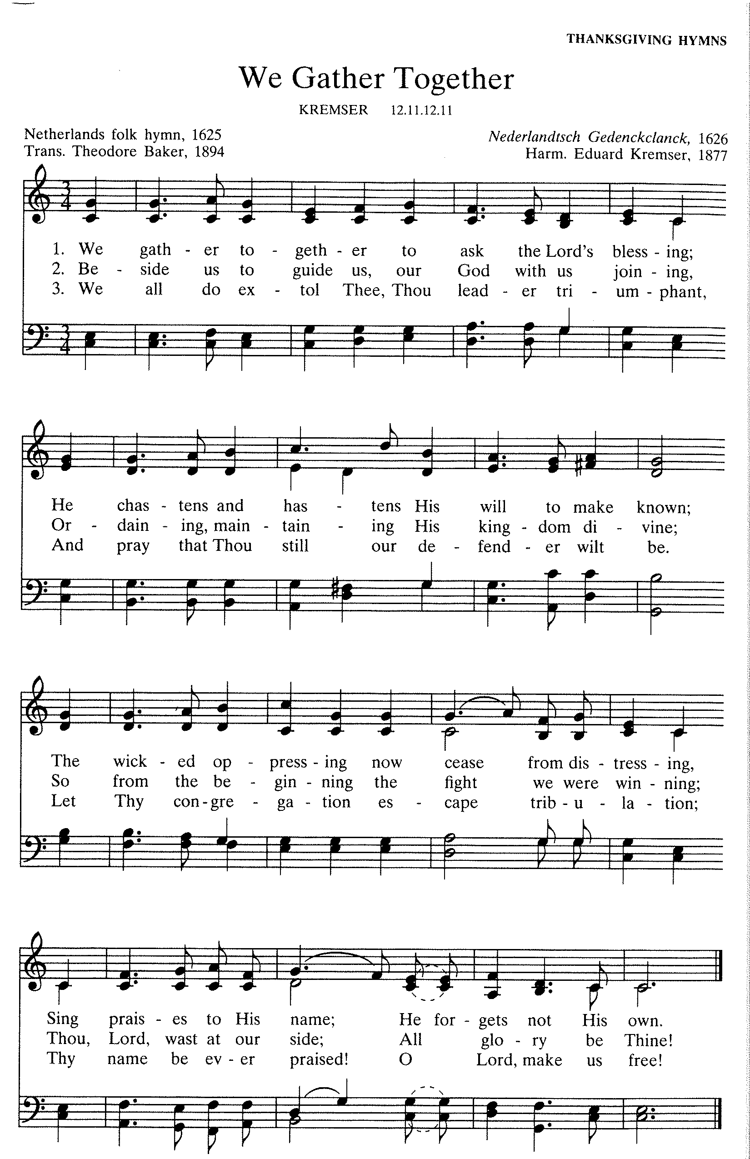
Greeting
A The grace of our Lord Jesus Christ, the love of God,
and the communion of the Holy Spirit be with you all.
C And also with you.

CANTICLE OF PRAISE
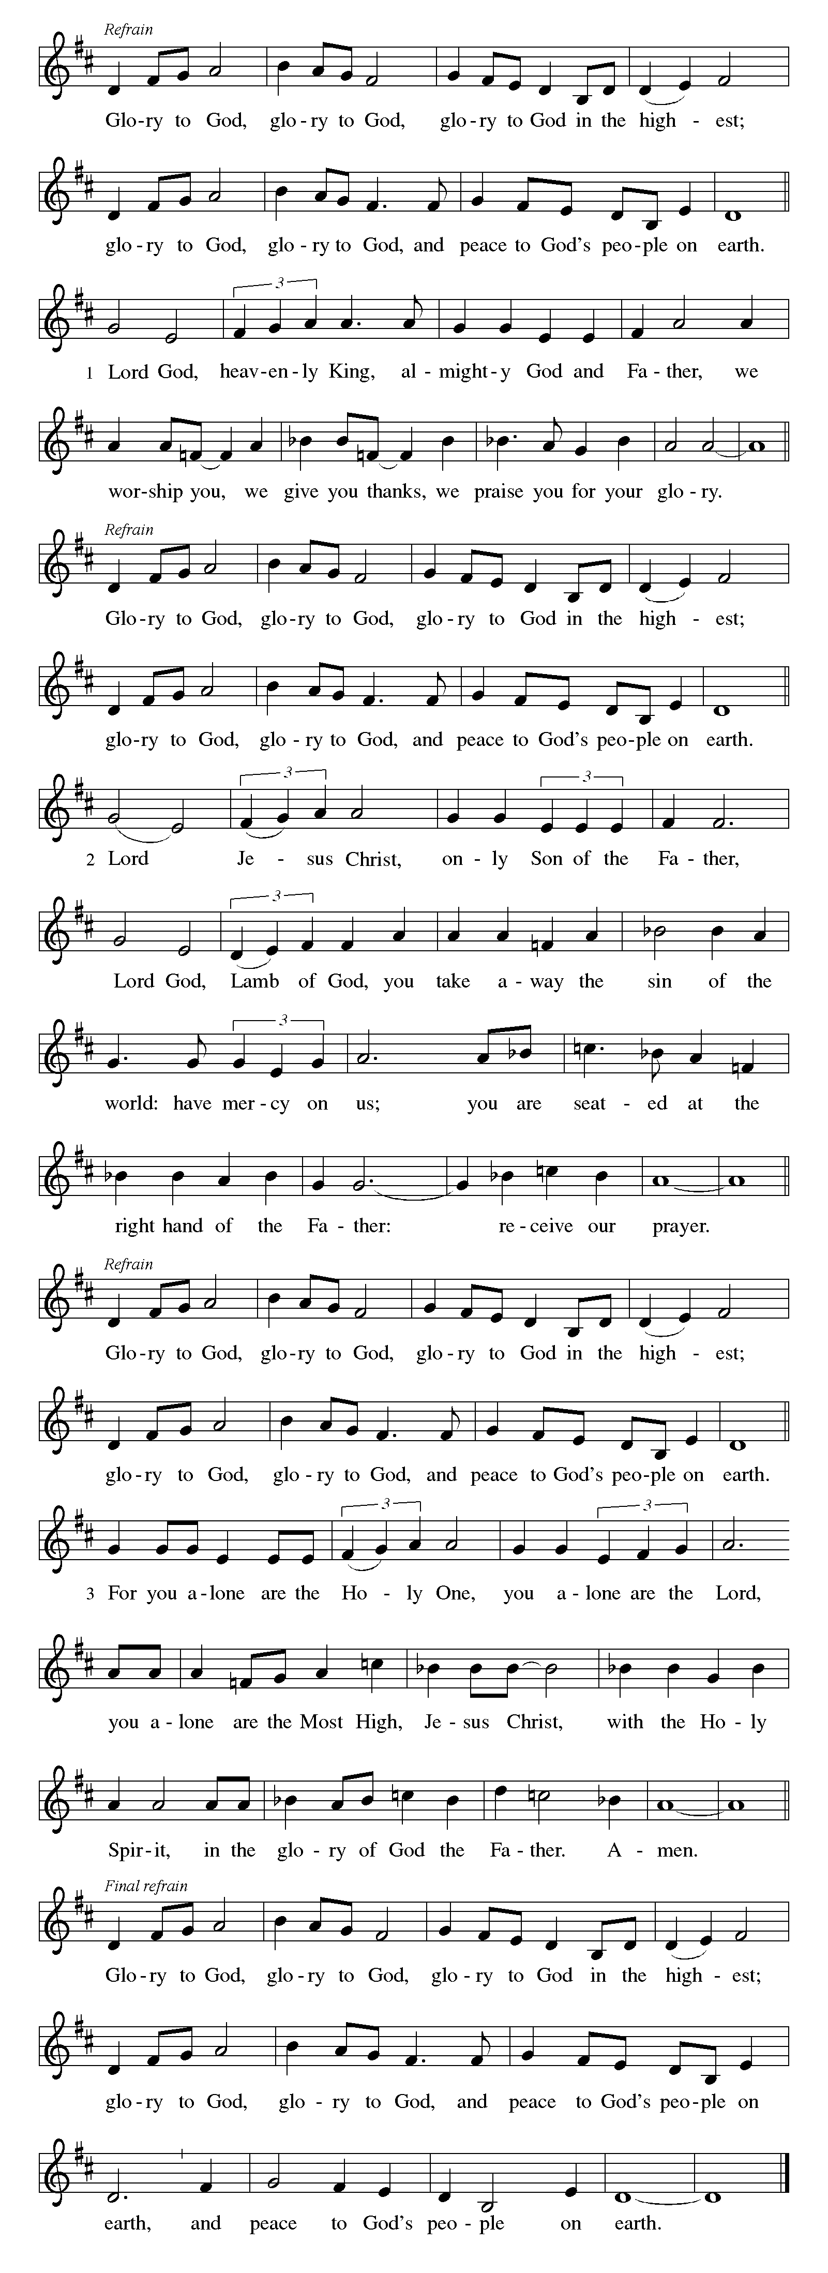

-7-
Prayer of the Day
A Let us pray.
Almighty God our Father, your generous goodness comes to us new every day. By the work of your Spirit lead us to acknowledge your goodness, give thanks for your benefits, and serve you in willing obedience, through Jesus Christ, our Savior and Lord.
C Amen

Gospel: Matthew 6:25-33

In the Sermon on the Mount, Jesus taught his disciples about the providence of God
so that they would regard life with thanksgiving and trust rather than anxiety.

P The holy gospel according to Matthew.
C Glory to you, O Lord.

[Jesus said,] ²⁵“Therefore I tell you, do not worry about your life, what you will eat or what you will drink, or about your body, what you will wear. Is not life more than food, and the body more than clothing? ²⁶Look at the birds of the air; they neither sow nor reap nor gather into barns, and yet your heavenly Father feeds them. Are you not of more value than they? ²⁷And can any of you by worrying add a single hour to your span of life? ²⁸And why do you worry about clothing? Consider the lilies of the field, how they grow; they neither toil nor spin, ²⁹yet I tell you, even Solomon in all his glory was not clothed like one of these. ³⁰But if God so clothes the grass of the field, which is alive today and tomorrow is thrown into the oven, will he not much more clothe you—you of little faith? ³¹Therefore do not worry, saying, ‘What will we eat?’ or ‘What will we drink?’ or ‘What will we wear?’ ³²For it is the Gentiles who strive for all these things; and indeed your heavenly Father knows that you need all these things. ³³But strive first for the kingdom of God and his righteousness, and all these things will be given to you as well.”

P The gospel of the Lord.
C Praise to you, O Christ.

The assembly is seated

MEDITATION

The assembly stands

Hymn of the Day #840
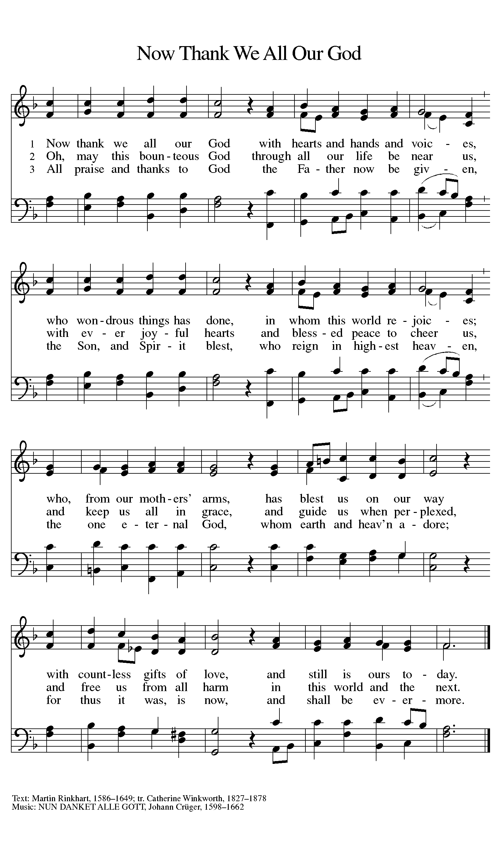
Arrangement printed under OneLicense.net license A-708005

Prayers of Intercession

A United into one by the power of the Holy Spirit, let us pray with all God’s saints for healing, wholeness, and peace in all the earth.

Prayers of intercession are prayed.
To each petition, the assembly responds:

A Lord, in your mercy,
C hear our prayer.

The presiding minister concludes the
prayers, and the assembly responds:

P Into your care, Alpha and Omega, we entrust all for whom we pray. Be with us now and always, through Jesus Christ our Lord.
C Amen

The assembly is seated

Offering

An offering is gathered for the mission of the church, including the care of those in need.

Chancel Choir “We Will Give Thanks” Patterson

-10-
The assembly stands

OFFERTORY
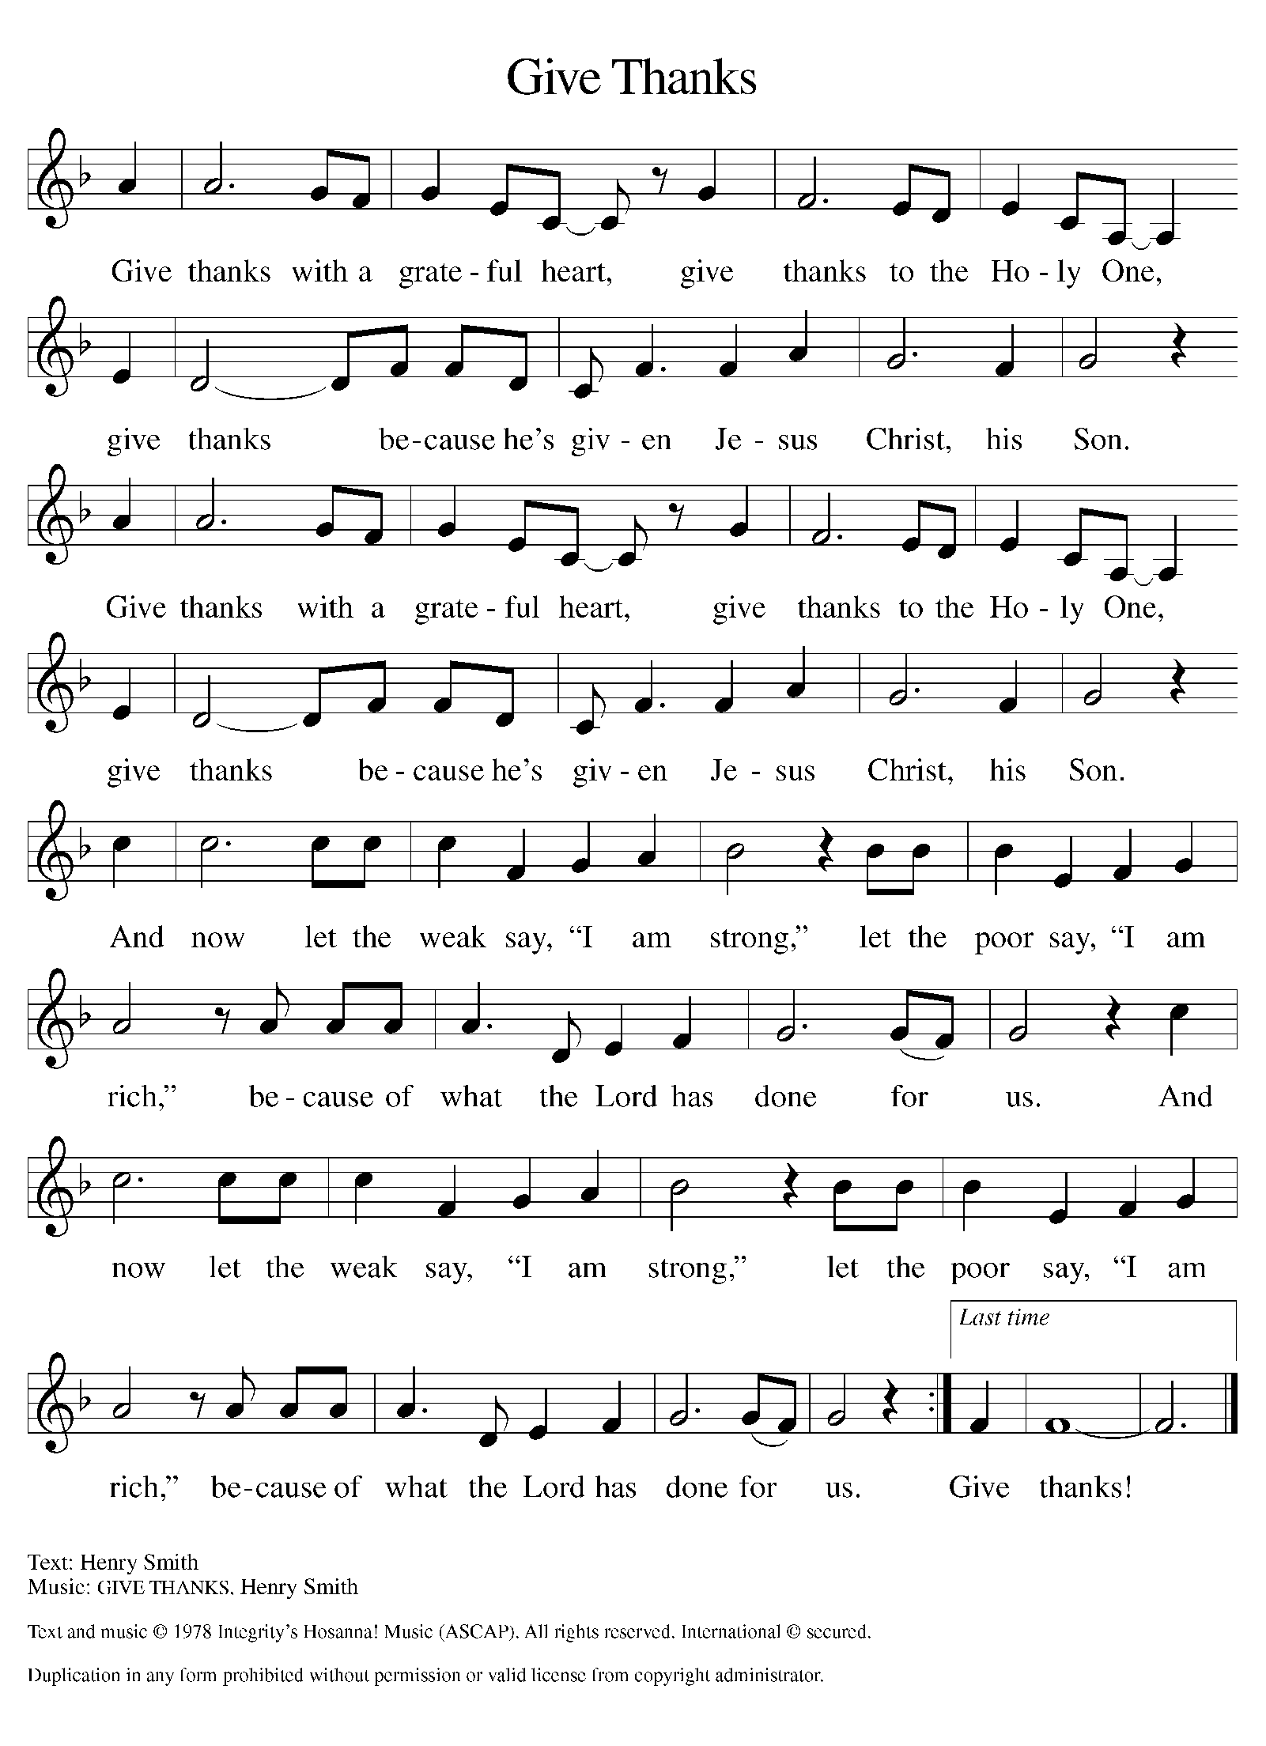
Text and music printed under CCLI license 720217

-11-

THANKSGIVING FOR THE WORD

p let us pray.
praise and thanks to you, holy God, for by your
Word you made all things: you spoke light into darkness,
called forth beauty from chaos, and brought life into being.
For your Word of life, O God,
C we give you thanks and praise.

P By your Word you called your people Israel to tell of your wonderful gifts: freedom from captivity, water on the desert journey, a pathway home from exile, wisdom for life with you.
For your Word of life, O God,
C we give you thanks and praise.

P Through Jesus, your Word made flesh, you speak to us and call us to witness: forgiveness through the cross, life to those entombed by death, the way of your self-giving love.
For your Word of life, O God,
C we give you thanks and praise.

P Send your Spirit of truth, O God; rekindle your gifts within us: renew our faith, increase our hope, and deepen our love, for the sake of a world in need. Faithful to your Word, O God, draw near to all who call on you; through Jesus Christ, our Savior and Lord, to whom, with you and the Holy Spirit, be honor and glory forever.
C Amen

-12-
Lord’s Prayer

P Gathered into one by the Holy Spirit,
let us pray as Jesus taught us.
C Our Father in heaven,
hallowed be your name,
your kingdom come,
your will be done,
on earth as in heaven.
Give us today our daily bread.
Forgive us our sins
as we forgive those
who sin against us.
Save us from the time of trial
and deliver us from evil.
For the kingdom, the power,
and the glory are yours,
now and forever. Amen

Blessing

P May the God and Father of our Lord Jesus
Christ fill you with every spiritual blessing.
C Amen

P May the God of faithfulness and
encouragement grant you to live in
harmony with one another, in
accordance with Christ Jesus.
C Amen

P May the God of hope fill you with all joy
and peace in believing, so that you may abound
in hope by the power of the Holy Spirit.
C Amen

-13-
Sending Song #881
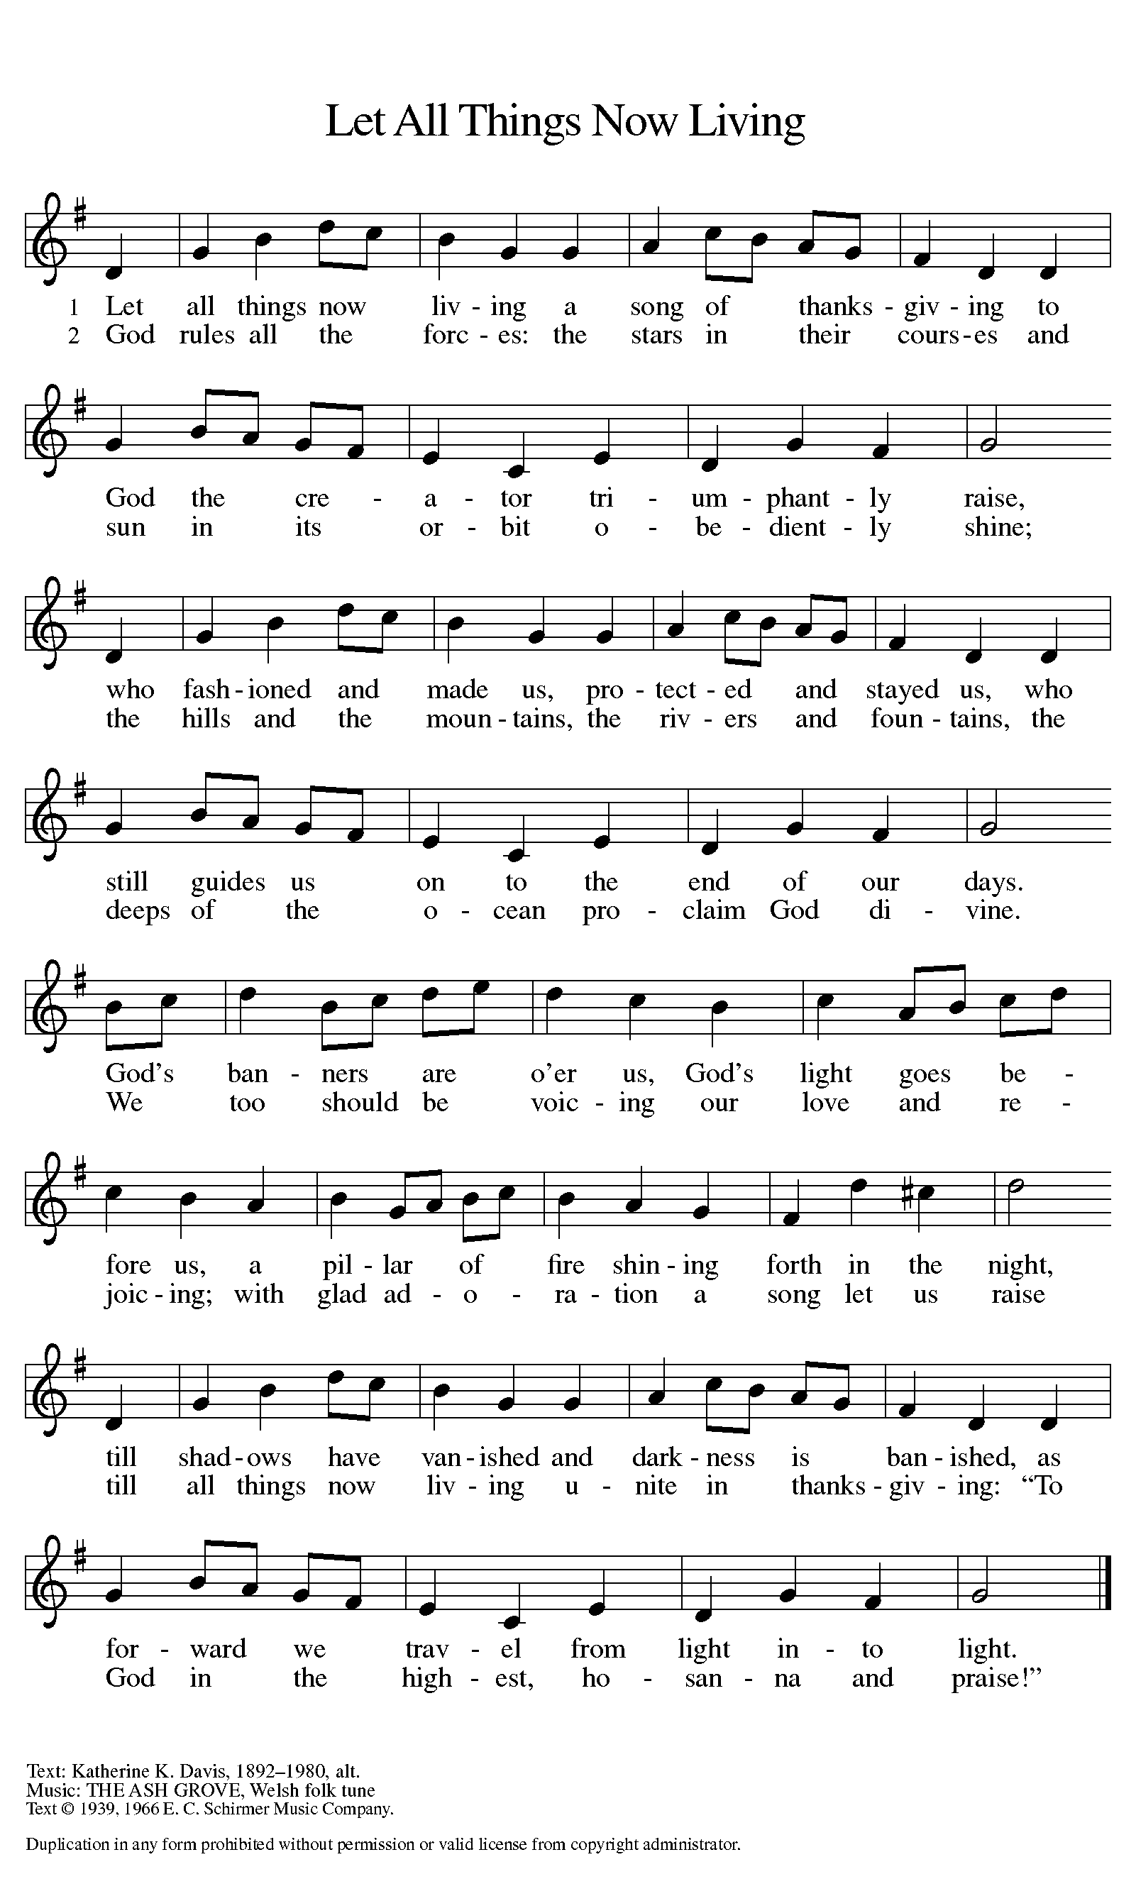
Text printed under OneLicense.net license A-708005
Dismissal
A Go in peace, continuing to
give God your thanks and praise!
C Thanks be to God!

POST-SERVICE MUSIC
“Now Thank We All Our God” arr. Paul Manz

Copyright © 2015 Augsburg Fortress. All rights reserved. Reprinted by permission under Augsburg Fortress Liturgies Annual License #SAS000803.
New Revised Standard Version Bible, copyright © 1989, Division of Christian Education of the National Council of the Churches of Christ in the United States of America.
Used by permission. All rights reserved.
Clipart copyright © 2015 by Communication Resources. All rights reserved. Used by permission.

Enter God’s gates with Thanksgiving and his courts with praise! Give thanks to him; bless his name!” (Psalm 100:4, ESV).
Welcome to Thanksgiving worship!

Immediately following this evening’s Thanksgiving service,
we are gathering for fellowship and PIE.
You are invited to join us for a slice or two or. . .

Sunday worship 10:00 a.m.

Pastor Ellen M. Schoepf
prellen@faithlutheranokemos.org
Secretary Rita Barry
rbarry@faithlutheranokemos.org
Director of Christian Education Melinda Schultz
Director of Music Debra Borton-McDonough
Organist/Pianist Bruce Williams
Lay assistant Diane Wilke

To make disciples for Jesus Christ. . .
. . .we Gather in faith for worship, prayer,
study and fellowship
. . .we Equip the people of God with a faith
that works in real life
. . .we Serve the world in the name of Jesus Christ
_______________

Faith’s email address
faith@faithlutheranokemos.org

Websites
Faith Lutheran Church ≈ www.faithlutheranokemos.org
North/West Lower Michigan Synod ≈ www.mittensynod.org
Evangelical Lutheran Church in America ≈ www.elca.org

