June 14, 2015

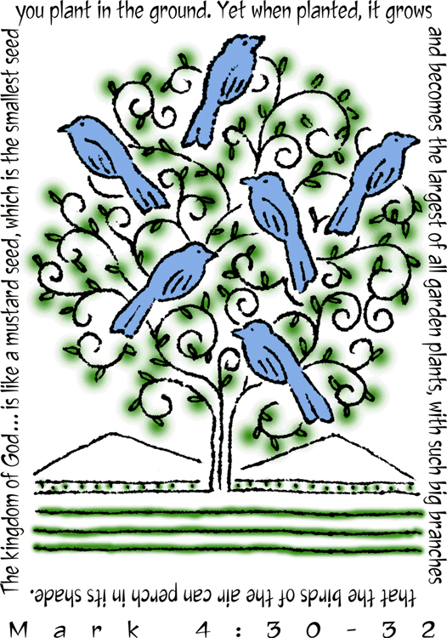

4515 Dobie Road

Okemos MI 48864-2203

517-349-0620

Pastor Ellen Schoepf
prellen@faithlutheranokemos.org

Website: www.faithlutheranokemos.org

Email: faith@faithlutheranokemos.org

Make It Sprout and Grow

What would it look like if God showed up? The world is a mess, and we want God to fix it. It is the twenty-first century, and there are wars and famines, new forms of slavery, governments that torture people. Shouldn't God come in with a bang, overthrow the evildoers, and save the innocent? If God has the power, shouldn't God use it and clean up the planet?

The expectation of the Messiah which Jewish people had in Jesus' day may seem alien to us, but it is not that different from what any of us wishes for when we are confronted with the evil, corruption, and suffering of the world. If God is all-powerful, why doesn't God do something?

Today's parables are part of Jesus' answer to that question. People wondered how an itinerant preacher and his followers could have anything to do with the kingdom of God they were hoping for. Where was the power there? Was anything changing?

These two parables of seeds present a picture of how God's power transforms the world. God's power here is not about control; the sower doesn't make the seed grow or even understand how it grows. God's power is hidden in apparent insignificance—the
tiny mustard seed. It brings change not by striking down but
by growing, not all at once but over time, until at last there is
a harvest to reap, a shrub tall enough to shelter the birds.

If we stop being star-struck by the sort of power that takes control and bowls you over, we can begin to notice God's hidden growing power. A teacher sees a student's gift and opens up her world. A baby calls his addicted father into hope and recovery. A nonviolent movement gradually prevails against a government with all its legal and military might. It isn't flashy, but it is the way God moves from within the dark earth, slowly leafing.

Sunday, June 14, 2015
Third Sunday after Pentecost
Holy Communion

INTRODUCTION

The mustard seed becomes a great shrub that shelters the birds, recalling ancient images of the tree of life. We'd expect a cedar or a sequoia, but Jesus finds the power of God better imaged in a tiny, no-account seed. It's not the way we expect divine activity to look. Yet the tree of life is here, in the cross around which we gather, the tree into which we are grafted through baptism, the true vine that nourishes us with its fruit in the cup we share. It may not appear all that impressive, but while nobody's looking it grows with a power beyond our understanding.

If hearing assistance is needed, please ask an usher for a personal PA receiver.

The ushers also have large print copies of today’s worship folder available.

If it will be difficult for you to stand along with the congregation during
any part of the worship service, please feel free to remain seated.

There is a nursery available during the worship service for those who wish
to use it. It is located at the end of the hall beyond the coat racks.

WELCOME
We cordially greet all who have come to worship today.
Please register your attendance and join us in fellowship after the service.

Announcements and Prayer Requests

PRELUDE
The pre-service music signals the beginning of the worship service. Silence during the
pre-service music enables worshipers to prepare for worship through quiet meditation.

“as the Grains of Wheat” arr. Ron Schmoltze

GATHERING
The Holy Spirit calls us together as the people of God

The assembly stands

Confession and Forgiveness

As the presiding minister begins, all may make the sign of the cross,
the sign marked at baptism.

P Blessed be the holy Trinity, + one God,
the creator of wind and rain, field and ocean,
the bread of life coming down from above,
the power at work within us and this world.
C Amen

P Before God and in the company of our
sisters and brothers, let us confess our sin.

Silence is kept for reflection

P God and Father of all,
C we confess that we have sinned
against you in thought, word, and deed.
We have thought better of ourselves than others.
We have told lies, said hurtful things, acted
in ways we wish we could take back, and
looked the other way when action was needed.
In your mercy, O God, forgive us, cleanse us,
and heal us, for the sake of Jesus, our Savior.
Amen

P If anyone is in Christ, there is a new creation:
everything old has passed away; everything has become new!
In Christ, + you are a new creation: your sins are
taken away and you are made new.
Be kind to one another, tenderhearted,
forgiving one another, as God in Christ
has forgiven you.
C Amen
-4-

Gathering Song Red #533
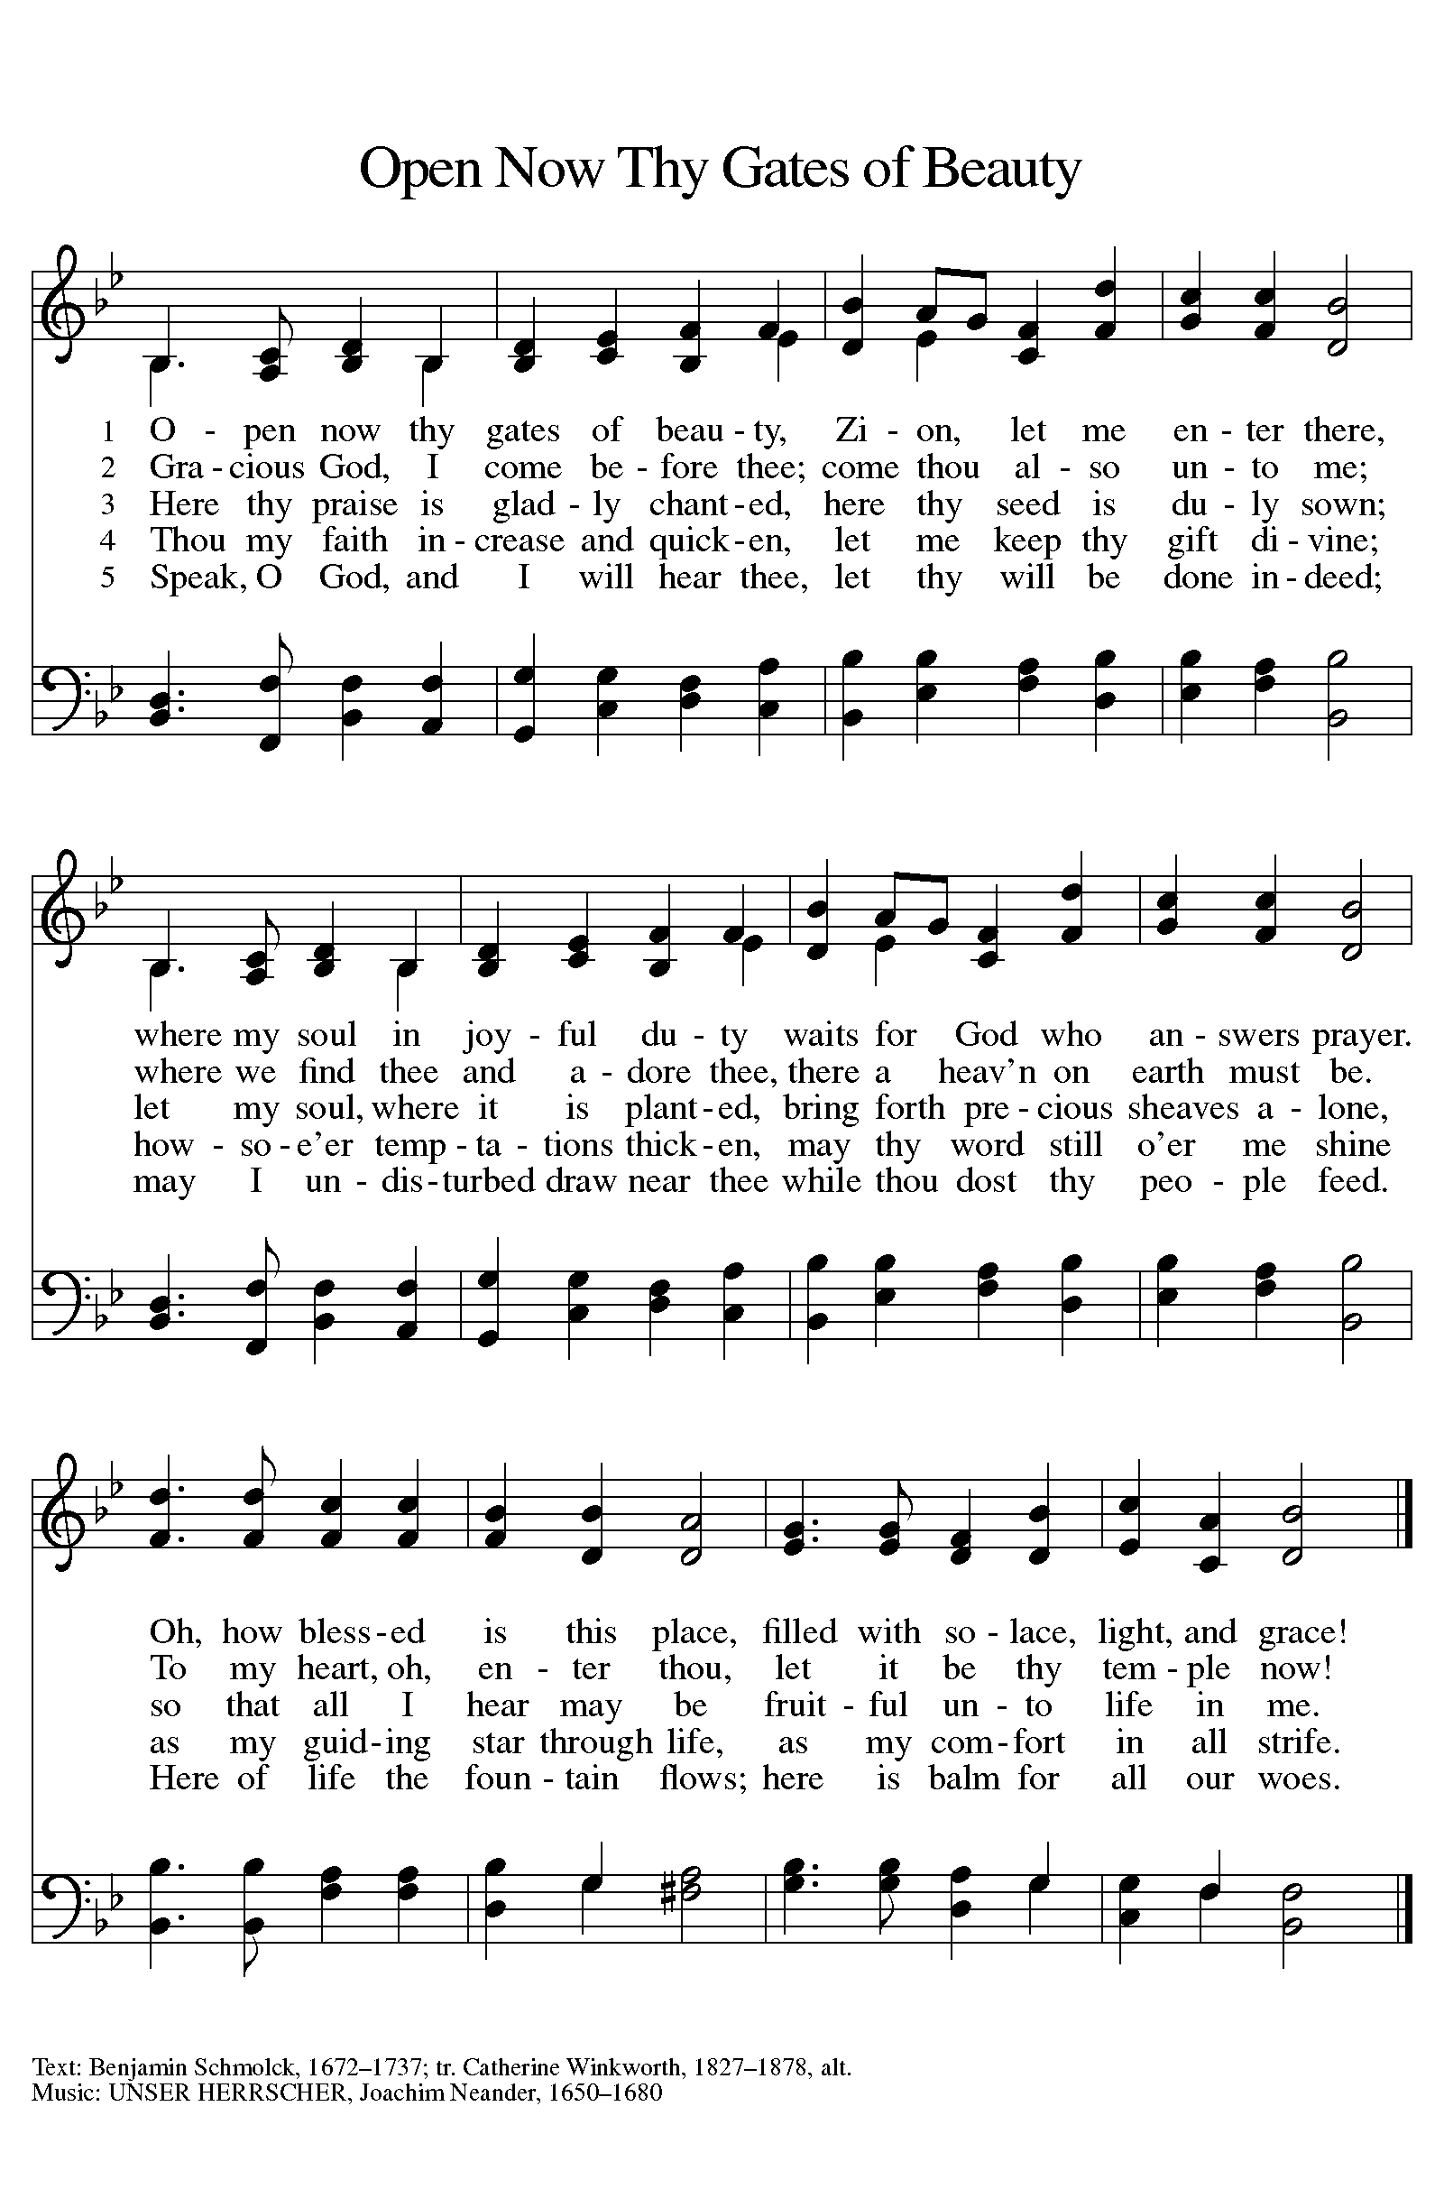

-5-
Greeting

A The grace of our Lord Jesus Christ, the love of God,
and the communion of the Holy Spirit be with you all.
C And also with you.

Canticle of Praise
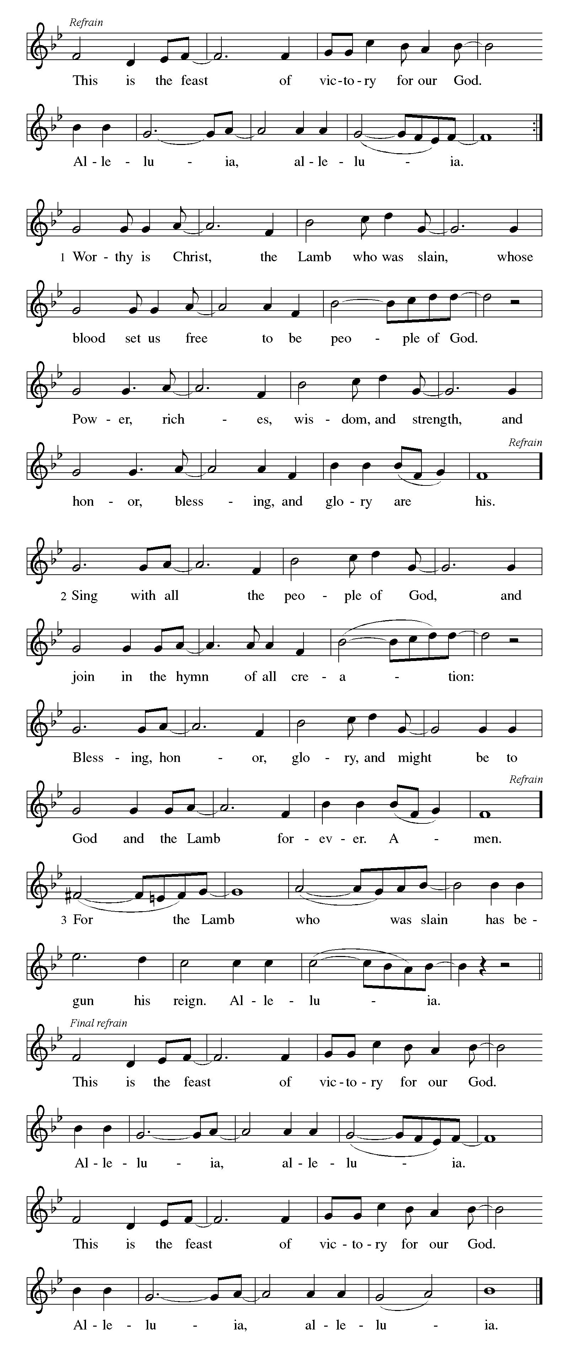

-6-
Prayer of the Day
A Let us pray.
O God, you are the tree of life, offering shelter to all the world. Graft us into yourself and nurture our growth, that we may bear your truth and love to those in need, through Jesus Christ, our Savior and Lord.
C Amen

The assembly is seated

-7-

WORD
God speaks to us in scripture reading, preaching and song

First Reading: Ezekiel 17:22–24

A A reading from Ezekial.

Tree imagery is used in a messianic prophecy to tell how the Lord will choose someone from Judah's royal family (the cedar tree) to reign over all creation. This tree will be planted on Mount Zion, the location of the holy temple.

²²Thus says the Lord GOD:
I myself will take a sprig
from the lofty top of a cedar;
I will set it out.
I will break off a tender one
from the topmost of its young twigs;
I myself will plant it
on a high and lofty mountain.
²³On the mountain height of Israel
I will plant it,
in order that it may produce boughs and bear fruit,
and become a noble cedar.
Under it every kind of bird will live;
in the shade of its branches will nest
winged creatures of every kind.
²⁴All the trees of the field shall know
that I am the LORD.
I bring low the high tree,
I make high the low tree;
I dry up the green tree
and make the dry tree flourish.
I the LORD have spoken;
I will accomplish it.

A The word of the Lord.
C Thanks be to God.

-8-
Second Reading: 2 Corinthians 5:6–10[11–13] 14–17

A A reading from second Corinthians.

Paul encourages believers to live by faith and not by sight. We do not consider Jesus from a human perspective but through the eyes of faith, believing he died for all and was raised. All who are in Christ are now in God's new creation.

⁶So we are always confident; even though we know that while we are at home in the body we are away from the Lord — ⁷for we walk by faith, not by sight. ⁸Yes, we do have confidence, and we would rather be away from the body and at home with the Lord. ⁹So whether we are at home or away, we make it our aim to please him. ¹⁰For all of us must appear before the judgment seat of Christ, so that each may receive recompense for what has been done in the body, whether good or evil.

¹¹Therefore, knowing the fear of the Lord, we try to persuade others; but we ourselves are well known to God, and I hope that we are also well known to your consciences. ¹²We are not commending ourselves to you again, but giving you an opportunity to boast about us, so that you may be able to answer those who boast in outward appearance and not in the heart. ¹³For if we are beside ourselves, it is for God; if we are in our right mind, it is for you. ¹⁴For the love of Christ urges us on, because we are convinced that one has died for all; therefore all have died. ¹⁵And he died for all, so that those who live might live no longer for themselves, but for him who died and was raised for them.

¹⁶From now on, therefore, we regard no one from a human point of view; even though we once knew Christ from a human point of view, we know him no longer in that way. ¹⁷So if anyone is in Christ, there is a new creation: everything old has passed away; see, everything has become new!

A The word of the Lord.
C Thanks be to God.

The assembly stands to welcome the gospel

-9-
Gospel Acclamation
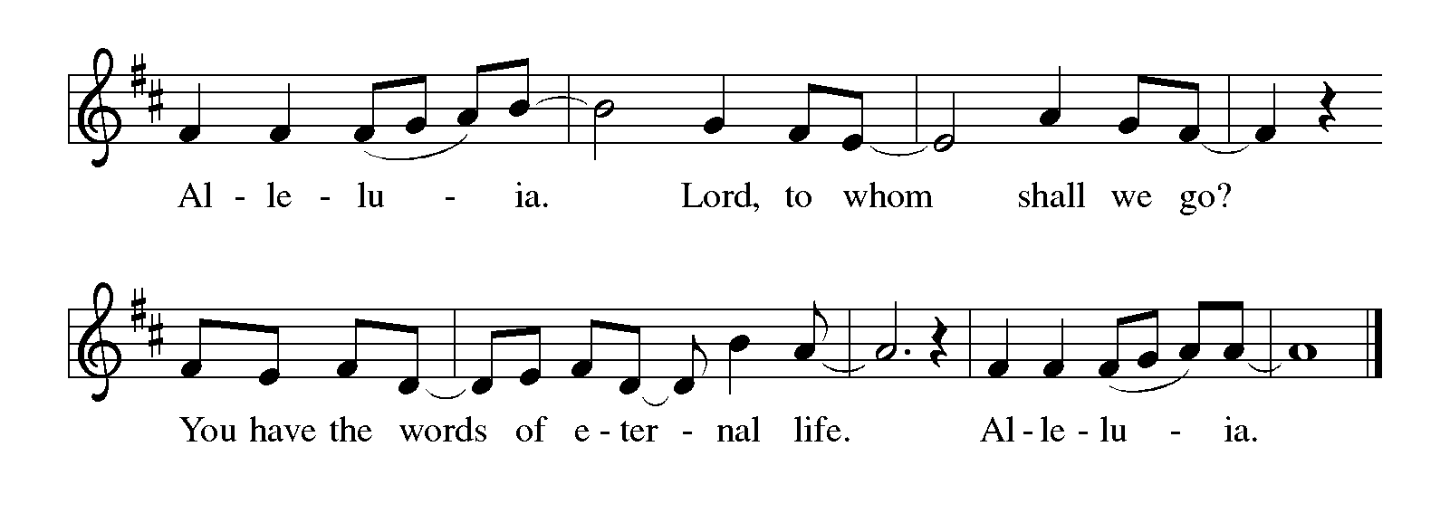
Gospel: Mark 4:26–34

P The holy gospel according to St. Mark, the fourth chapter.
C Glory to you, O Lord.

Jesus frequently uses parables to teach ordinary people as they are able to hear and understand. Images of sowing and growing show the vitality of God's kingdom.

²⁶He also said, "The kingdom of God is as if someone would scatter seed on the ground, ²⁷and would sleep and rise night and day, and the seed would sprout and grow, he does not know how. ²⁸The earth produces of itself, first the stalk, then the head, then the full grain in the head. ²⁹But when the grain is ripe, at once he goes in with his sickle, because the harvest has come."

³⁰He also said, "With what can we compare the kingdom of God, or what parable will we use for it? ³¹It is like a mustard seed, which, when sown upon the ground, is the smallest of all the seeds on earth; ³²yet when it is sown it grows up and becomes the greatest of all shrubs, and puts forth large branches, so that the birds of the air can make nests in its shade."

³³With many such parables he spoke the word to them, as they were able to hear it; ³⁴he did not speak to them except in parables, but he explained everything in private to his disciples.

P The gospel of the Lord.
C Praise to you, O Christ.

The assembly is seated

CHILDREN’S MESSAGE

Sermon

The assembly stands to proclaim the word of God in song

Hymn of the Day Red #635
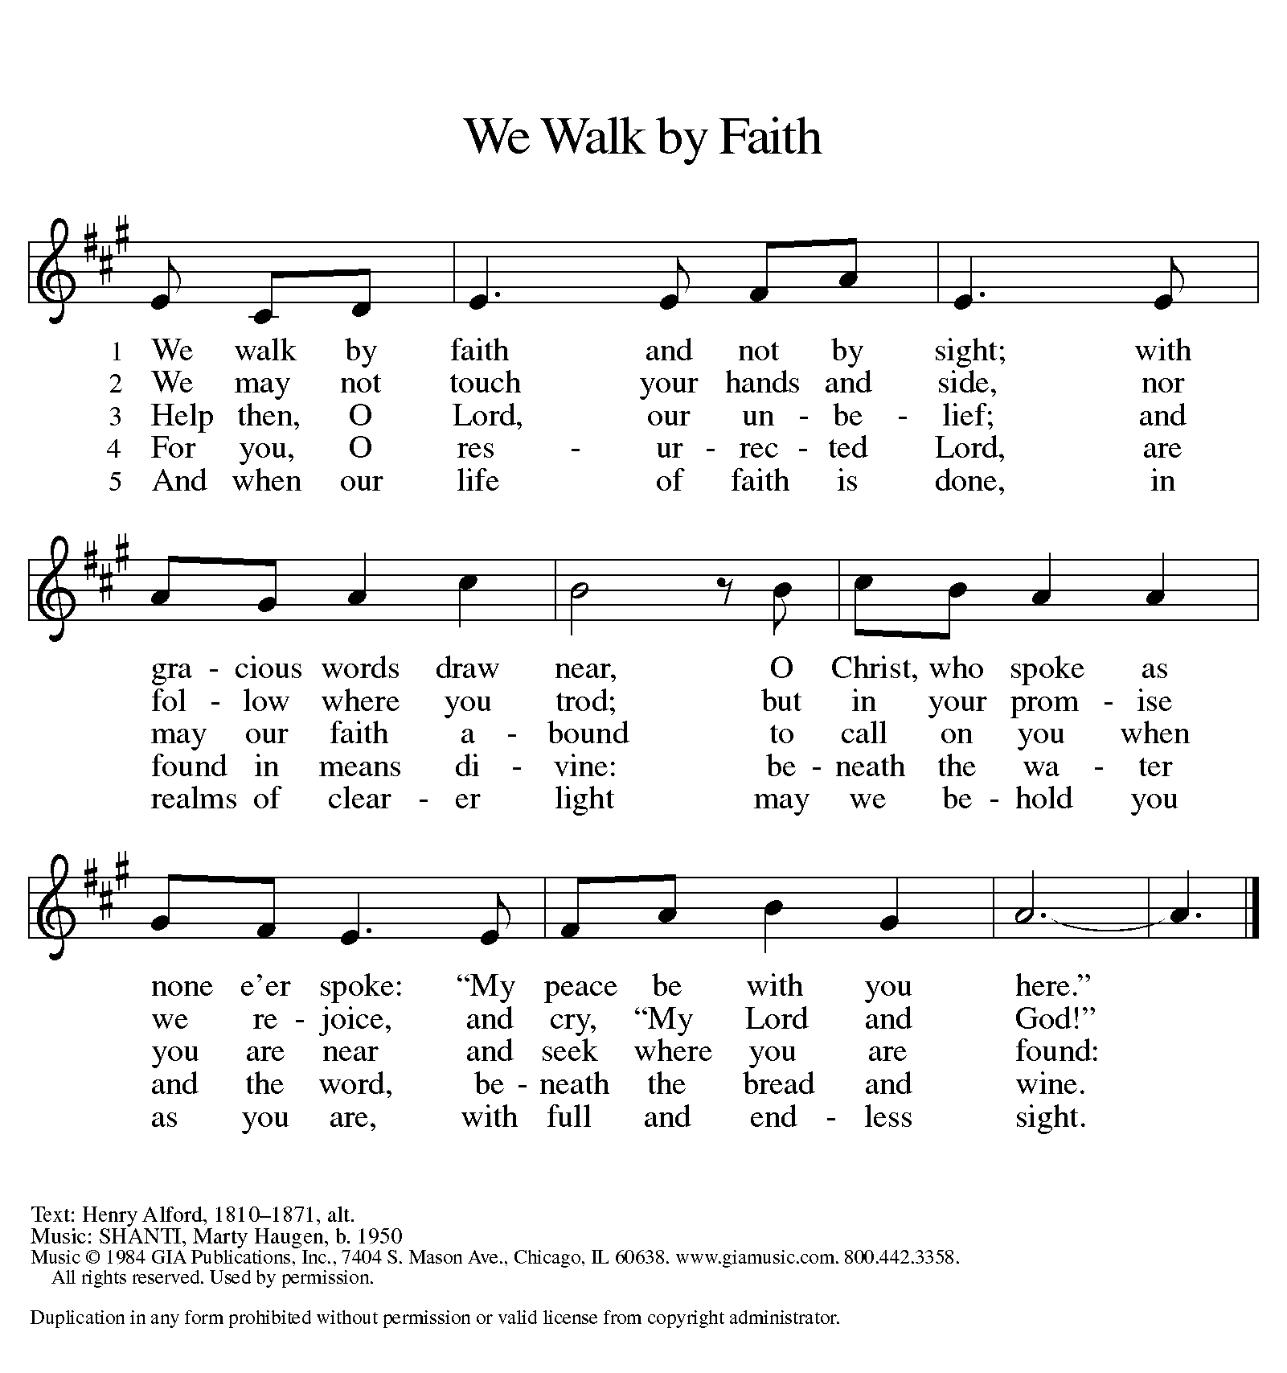
Music printed under OneLicense.net license A-708005

-11-
APOSTLES’ Creed

C I believe in God, the Father almighty,
creator of heaven and earth.

I believe in Jesus Christ, God's only Son, our Lord,
who was conceived by the Holy Spirit,
born of the virgin Mary,
suffered under Pontius Pilate,
was crucified, died, and was buried;
he descended to the dead.
On the third day he rose again;
he ascended into heaven,
he is seated at the right hand of the Father,
and he will come to judge the living and the dead.

I believe in the Holy Spirit,
the holy catholic church,
the communion of saints,
the forgiveness of sins,
the resurrection of the body,
and the life everlasting. Amen

The assembly is seated

Recognition of graduates

The assembly stands

Prayers of Intercession

A Trusting the Spirit's power, we pray for the
church, the world, and all of God's creation.

Prayers of intercession are prayed.
To each petition, the assembly responds:

A Lord, in your mercy,
C hear our prayer.

The presiding minister concludes the
prayers, and the assembly responds:

P Receive these prayers, gracious God,
and those prayers known only to you.
We ask this in the name of Jesus Christ
by the power of the Holy Spirit.
C Amen

Peace

P The peace of Christ be with you always.
C And also with you.

The people may greet one another with a sign of Christ's peace,
and may say, "Peace be with you," or similar words.

The assembly is seated

MEAL
God feeds us with the presence of Jesus Christ

Offering

Emma Heft and Sera Heft, piano “Canon in D” Pachelbel, arr. Matz

The assembly stands

Offering Prayer

A God of mercy and grace,
the eyes of all wait upon you,
and you open your hand in blessing.
Fill us with good things at your table,
that we may come to the help of all in need,
through Jesus Christ, our redeemer and Lord.
C Amen

-13-
Dialogue

P The Lord be with you.
C And also with you.

P Lift up your hearts.
C We lift them to the Lord.

P Let us give thanks to the Lord our God.
C It is right to give our thanks and praise.

Preface

P It is indeed right, our duty and our joy, that we should at all times and in all places give thanks and praise to you, almighty
and merciful God, through our Savior Jesus Christ; who on this day overcame death and the grave, and by his glorious resurrection opened to us the way of everlasting life. And so, with all the choirs of angels, with the church on earth and the hosts of heaven, we praise your name and join their unending hymn:

Holy, Holy, Holy
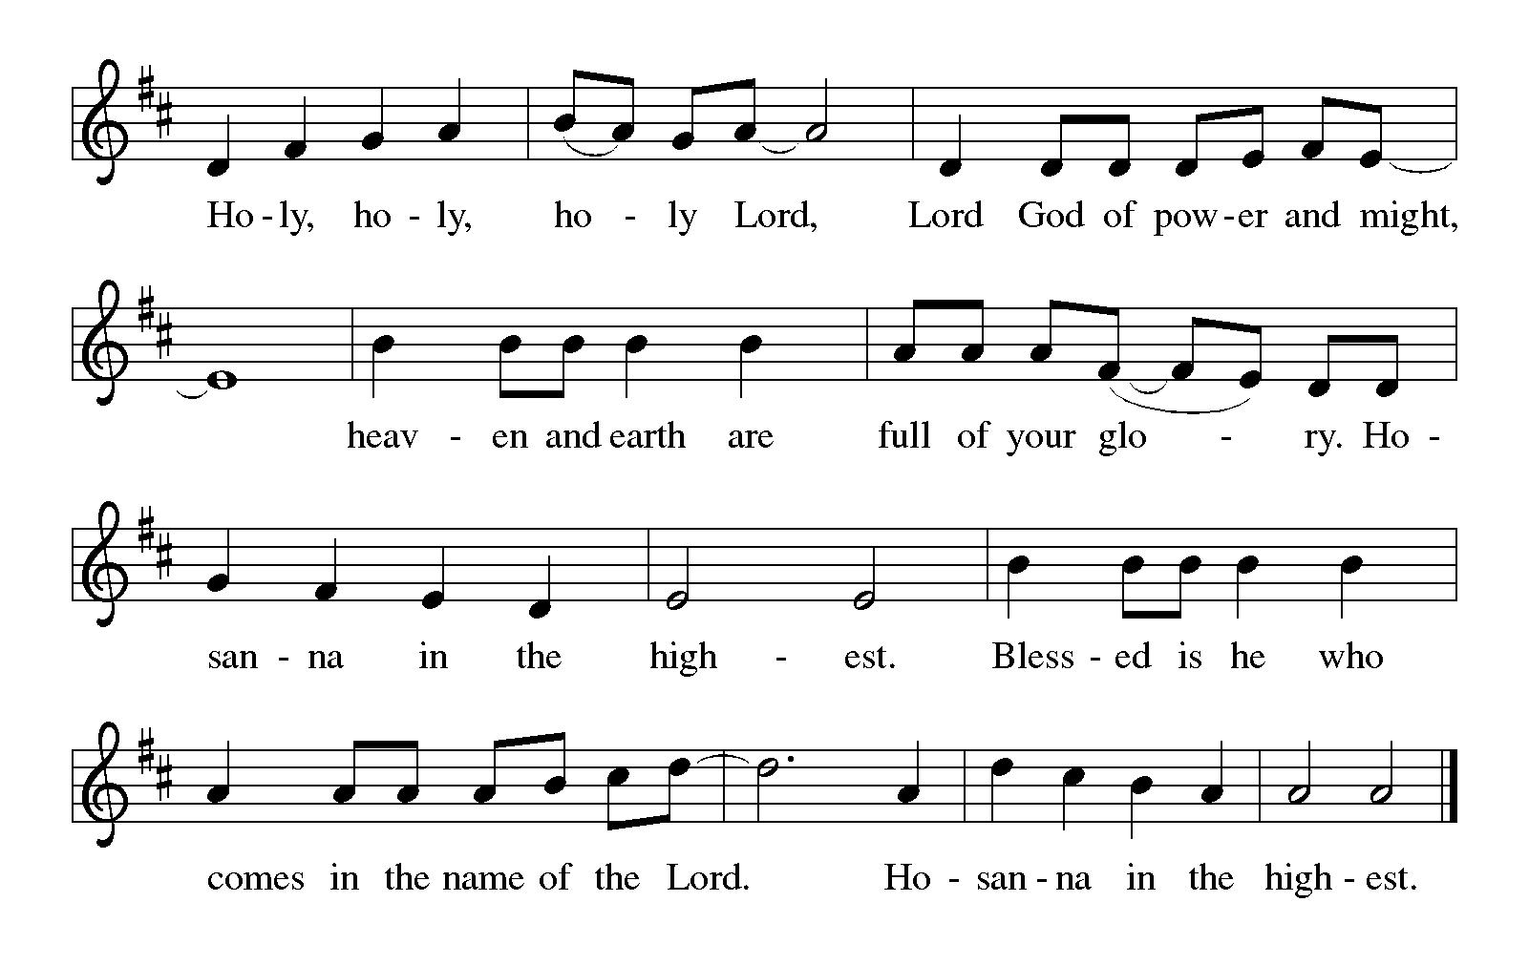

-14-
Thanksgiving at the Table

P In the night in which he was betrayed,
our Lord Jesus took bread, and gave thanks;
broke it, and gave it to his disciples, saying:
Take and eat; this is my body, given for you.
Do this for the remembrance of me.

Again, after supper, he took the cup, gave thanks,
and gave it for all to drink, saying:
This cup is the new covenant in my blood, shed for
you and for all people for the forgiveness of sin.
Do this for the remembrance of me.
C Amen

Lord's Prayer

P Let us pray with confidence
in the words our Savior gave us:
C Our Father in heaven,
hallowed be your name,
your kingdom come,
your will be done,
on earth as in heaven.
Give us today our daily bread.
Forgive us our sins
as we forgive those
who sin against us.
Save us from the time of trial
and deliver us from evil.
For the kingdom, the power,
and the glory are yours,
now and forever. Amen

Invitation to Communion

P Jesus said, "Whoever comes to me will never be hungry,
and whoever believes in me will never be thirsty."

-15-

Communion

When giving the bread and cup, the communion ministers say
The body of Christ, given for you.
The blood of Christ, shed for you.
and each person may respond
Amen

WE WELCOME ALL GUESTS worshiping with us today and invite all baptized Christians to come to the Lord’s table. Children who have not yet received First Communion instruction are invited to come forward with their families to receive a blessing. There will be one chalice (cup) of wine, as well as trays of individual cups. In the center of each tray, there are a few glasses filled with white grape juice for those who prefer juice rather than wine.

Communion Song
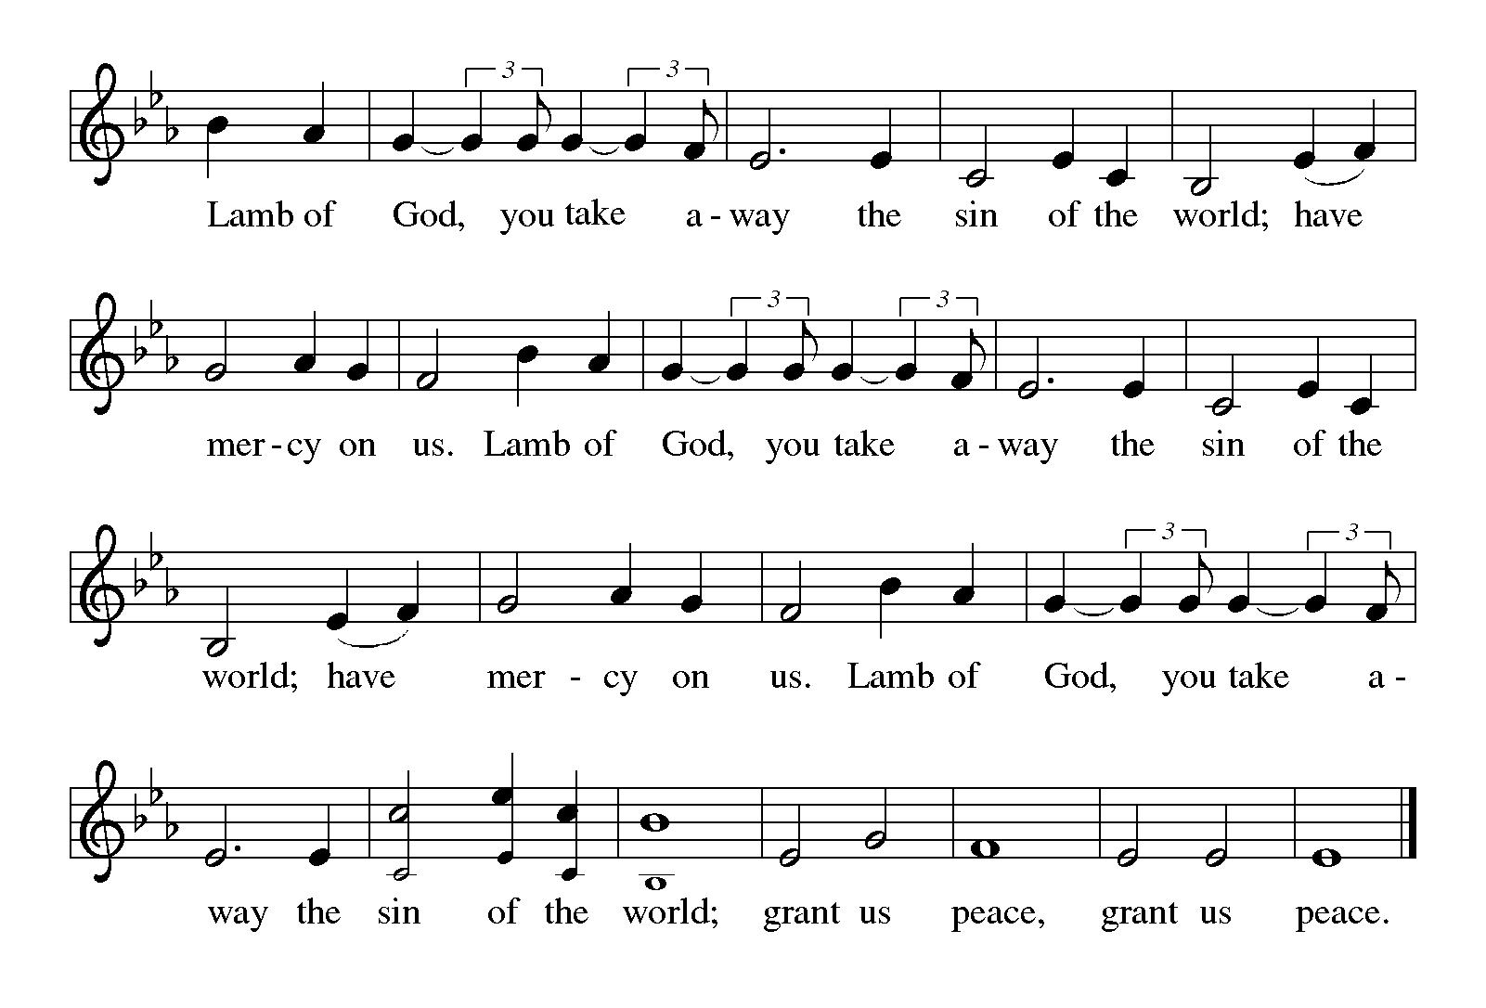

-16-

Music during communion:

Olivia Fassezke, piano “Moonlight Fantasy” Bober

Congregational Song Red #465
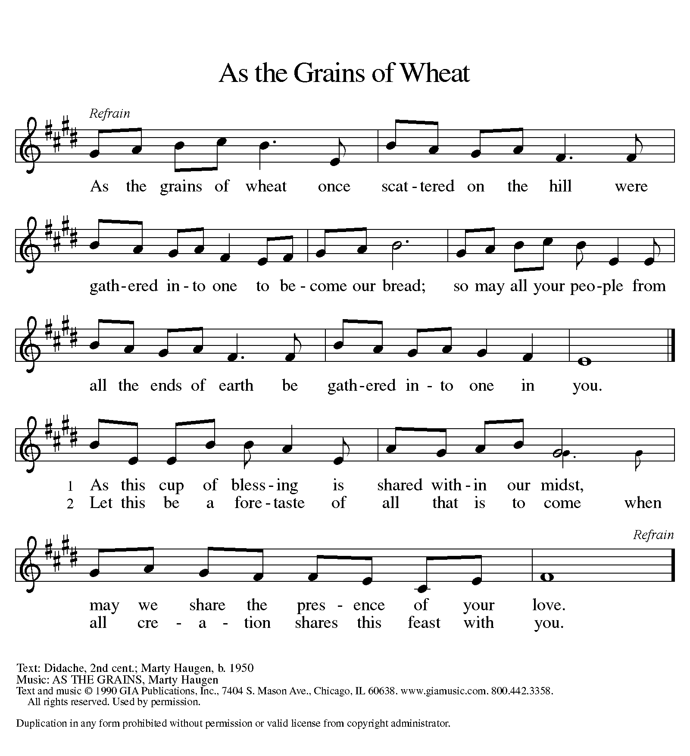
Text and music printed under OneLicense.net license A-708005

-17-

The assembly stands

P The body and blood of our Lord Jesus Christ
strengthen you and keep you in his grace.
C Amen

Prayer after Communion

A Wise and generous God, we thank you that at this holy
table you have fed us again with the food of everlasting life.
Send us with your blessing to seek the good of our neighbor
and call others to your feast; through Jesus Christ,
our Savior and Lord.
C Amen

SENDING
God blesses us and sends us in mission to the world

Blessing

P Almighty and merciful God,
Father, + Son, and Holy Spirit,
bless, preserve, and keep you
this day and forevermore.
C Amen

-18-
Sending Song
“you Are the Seed” Blue #753

Dismissal
A Go in peace. Live in love, as Christ loved us.
C Thanks be to God.

POSTLUDE
“Sortie in F Major” Cesar Franck

From SundaysAndSeasons.com. Copyright 2015 Augsburg Fortress. All rights reserved.
Reprinted by permission under Augsburg Fortress Liturgies Annual License #20803.
New Revised Standard Version Bible, copyright 1989, Division of Christian Education of the National Council of the Churches of Christ in the United States of America.
Used by permission. All rights reserved.
Clipart copyright © 2015 by Communication Resources. All rights reserved. Used by permission.

We gather in the name of our Savior, Jesus Christ.
Please greet those worshipping around you with words
and gestures of welcome.

Sunday worship and sacrament of Holy Communion at 9:30 a.m.

Pastor Ellen Schoepf prellen@faithlutheranokemos.org
Secretary Rita Barry rbarry@faithlutheranokemos.org
Director of Christian Education Melinda Schultz
Director of Music Debra Borton-McDonough
Organist/Pianist Bruce Williams

June 7th worship attendance: 112

Serving Faith Today June 21

Acolytes Drew Williams Brielle Bowers
Altar care Gretchen Bills and Becky Bills
Communion assistants Diane Wilke Bob Nelson
Jeff Rosenthal Beth Belonga
Drew Williams TBD
Greeters Mark and Molly DeHate Marla Holle
Lay assistants Diane Wilke Bob Nelson
Readers Jeff Rosenthal Beth Belonga
Ushers Mike Eschelbach Mike Eschelbach
Tammy Heilman Tammy Heilman
Warren Heilman Warren Heilman
Nursery Lori Webb Jennifer & Maia Guenther

