March 15, 2020

FAITH LUTHERAN CHURCH
4515 Dobie Road
Okemos, MI 48864
517-349-0620

Third Sunday in Lent
To make disciples for Jesus Christ. . .
. . .we Gather in faith for worship, prayer,
study and fellowship
. . .we Equip the people of God with a faith
that works in real life
. . .we Serve the world in the name of Jesus Christ

Pastor:……………………………………………………………………………. Ellen Schoepf
Music Director:…………………………………………….Debra Borton-McDonough
Organist/Pianist:…………………………………………..…………….…Bruce Williams
Church Secretary:…………………………………………………………........ Katie Love
High School Leaders: ………….........Kim O’Brien, Ryan & Addie Thompson
Pastor’s email:………………………………….prellen@faithlutheranokemos.org
Church email:…………………………………......faith@faithlutheranokemos.org
Website:…………………..……………………..…….www.faithlutheranokemos.org
Facebook Page:……………………….…….facebook.com/faithlutheranokemos

Aids for hearing, children’s activity bulletins, and large print bulletins are available from the ushers.

There is a nursery available during the worship service for those who wish to use it. It is located at the end of the hall beyond the coat racks.

If it will be difficult for you to stand along with the congregation during any part of the worship service, please feel free to remain seated.

Faith Lutheran live streams our services. No names of participants are broadcast.

There is NO service in the building this weekend. Please join the online service at
https://www.facebook.com/faithlutheranokemos/

We cordially greet all who have come to worship today.
Please register your attendance and join us in fellowship after the service.

Bi-Weekly Announcement packets are available in the Narthex.
Prayer requests and praises are listed in the announcement packets.

Introduction to the day
In today’s gospel the Samaritan woman asks Jesus for water, an image of our thirst for God. Jesus offers living water, a sign of God’s grace flowing from the waters of baptism. The early church used this gospel and those of the next two Sundays to deepen baptismal reflection during the final days of preparation before baptism at Easter. As we journey to the resurrection feast, Christ comes among us in word, bath, and meal—offering us the life-giving water of God’s mercy and forgiveness.
Welcome and Announcements

Prayer Requests

Prelude
Blessed Assurance (arr. Dobrinski)
Faith Bells
GATHERING
The assembly stands.
Confession and Forgiveness
All may make the sign of the cross, the sign marked at baptism, as the presiding minister begins.
Blessed be the holy Trinity, ☩ one God,
who is present, who gives life,
who calls into existence the things that do not exist.
Amen.

If you were to keep watch over sins, O Lord, who could stand?
Yet with you is forgiveness, and so we confess.
Silence is kept for reflection.

Gracious God,
have mercy on us.
We confess that we have turned away from you,
knowingly and unknowingly.
We have wandered from your resurrection life.
We have strayed from your love for all people.
Turn us back to you, O God.
Give us new hearts and right spirits,
that we may find what is pleasing to you
and dwell in your house forever. Amen.

Receive good news: God turns to you in love.
“I will put my spirit in you, and you shall live,” says our God.
All your sin is forgiven in the name of ☩ Jesus Christ,
who is the free and abounding gift of God’s grace for you. Amen.

GATHERING SONG
Praise the One Who Breaks the Darkness ELW #843
with Faith Bells
GREETING
The grace of our Lord Jesus Christ, the love of God,
and the communion of the Holy Spirit be with you all.
And also with you.

KYRIE

PRAYER OF THE DAY
Let us pray.
Merciful God, the fountain of living water, you quench our thirst and wash away our sin. Give us this water always. Bring us to drink from the well that flows with the beauty of your truth through Jesus Christ, our Savior and Lord, who lives and reigns with you and the Holy Spirit, one God, now and forever.
Amen.
The assembly is seated.

Old Testament Reading: Exodus 17:1-7
WORD
Because the thirsty Israelites quarreled with Moses and put God to the test, Moses cried out in desperation to God. God commanded Moses to strike the rock to provide water for the people. The doubt-filled question—“Is the Lord among us or not?”—received a very positive answer.
A reading from Exodus.
¹From the wilderness of Sin the whole congregation of the Israelites journeyed by stages, as the Lord commanded. They camped at Rephidim, but there was no water for the people to drink. ²The people quarreled with Moses, and said, “Give us water to drink.” Moses said to them, “Why do you quarrel with me? Why do you test the Lord?” ³But the people thirsted there for water; and the people complained against Moses and said, “Why did you bring us out of Egypt, to kill us and our children and livestock with thirst?” ⁴So Moses cried out to the Lord, “What shall I do with this people? They are almost ready to stone me.” ⁵The Lord said to Moses, “Go on ahead of the people, and take some of the elders of Israel with you; take in your hand the staff with which you struck the Nile, and go. ⁶I will be standing there in front of you on the rock at Horeb. Strike the rock, and water will come out of it, so that the people may drink.” Moses did so, in the sight of the elders of Israel. ⁷He called the place Massah and Meribah, because the Israelites quarreled and tested the Lord, saying, “Is the Lord among us or not?”
The word of the Lord.
Thanks be to God.

Psalm 95 (Read Responsively)
¹Come, let us sing to the Lord;
let us shout for joy to the rock of our salvation.
²Let us come before God’s presence with thanksgiving
and raise a loud shout to the Lord with psalms.
³For you, Lord, are a great God,
and a great ruler above all gods.
⁴In your hand are the caverns of the earth;
the heights of the hills are also yours.
⁵The sea is yours, for you made it,
and your hands have molded the dry land.
⁶Come, let us worship and bow down,
let us kneel before the Lord our maker.
⁷For the Lord is our God, and we are the people of God’s pasture and the sheep of God’s hand.
Oh, that today you would hear God’s voice!
⁸“Harden not your hearts,
as at Meribah, as on that day at Massah in the desert.
⁹There your ancestors tested me,
they put me to the test, though they had seen my works.
¹⁰Forty years I loathed that generation, saying,
‘The heart of this people goes astray; they do not know my ways.’
¹¹Indeed I swore in my anger,
‘They shall never come to my rest.’ ”
New testament Reading: Romans 5:1-11
Though we often hear that God helps those who help themselves, here Paul tells us that through Jesus’ death God helps utterly helpless sinners. Since we who had been enemies are reconciled to God in the cross, we now live in hope for our final salvation.
A reading from Romans.
¹Since we are justified by faith, we have peace with God through our Lord Jesus Christ, ²through whom we have obtained access to this grace in which we stand; and we boast in our hope of sharing the glory of God. ³And not only that, but we also boast in our sufferings, knowing that suffering produces endurance, ⁴and endurance produces character, and character produces hope, ⁵and hope does not disappoint us, because God’s love has been poured into our hearts through the Holy Spirit that has been given to us.
⁶For while we were still weak, at the right time Christ died for the ungodly. ⁷Indeed, rarely will anyone die for a righteous person—though perhaps for a good person someone might actually dare to die. ⁸But God proves his love for us in that while we still were sinners Christ died for us. ⁹Much more surely then, now that we have been justified by his blood, will we be saved through him from the wrath of God. ¹⁰For if while we were enemies, we were reconciled to God through the death of his Son, much more surely, having been reconciled, will we be saved by his life. ¹¹But more than that, we even boast in God through our Lord Jesus Christ, through whom we have now received reconciliation.
The word of the Lord.
Thanks be to God.

GOSPEL ACCLAMATION
The assembly stands to welcome the gospel.
Sung first by Chancel Choir, then by assembly.

John 4:5-42
A dramatic reading script for John 4:5-42.
There are 5 parts (Narrator, Jesus, Woman, Disciples, Samaritans).
The Congregation will be the Samaritans.

Narrator: ⁵ So [Jesus] came to a Samaritan city called Sychar, near the plot of ground that Jacob had given to his son Joseph. ⁶ Jacob’s well was there, and Jesus, tired out by his journey, was sitting by the well. It was about noon. ⁷ A Samaritan woman came to draw water, and Jesus said to her,

Jesus: “Give me a drink.”
Narrator: (His disciples had gone to the city to buy food.) ⁹ The Samaritan woman said to him,

Woman: “How is it that you, a Jew, ask a drink of me, a woman of Samaria?”
Narrator: (Jews do not share things in common with Samaritans.)
Jesus: “If you knew the gift of God, and who it is that is saying to you, “Give me a drink,’ you would have asked him, and he would have given you living water.”
Woman: “Sir, you have no bucket, and the well is deep. Where do you get that living water? ¹² Are you greater than our ancestor Jacob, who gave us the well, and with his sons and his flocks drank from it?”

Jesus: “Everyone who drinks of this water will be thirsty again, ¹⁴ but those who drink of the water that I will give them will never be thirsty. The water that I will give will become in them a spring of water gushing up to eternal life.”

Woman: “Sir, give me this water, so that I may never be thirsty or have to keep coming here to draw water.”
Jesus: “Go, call your husband, and come back.”
Woman: “I have no husband.”
Jesus: “You are right in saying, “I have no husband’; ¹⁸ for you have had five husbands, and the one you have now is not your husband. What you have said is true!”

Woman: “Sir, I see that you are a prophet. ²⁰ Our ancestors worshiped on this mountain, but you say that the place where people must worship is in Jerusalem.”

Jesus: “Woman, believe me, the hour is coming when you will worship the Father neither on this mountain nor in Jerusalem. ²² You worship what you do not know; we worship what we know, for salvation is from the Jews. ²³ But the hour is coming, and is now here, when the true worshipers will worship the Father in spirit and truth, for the Father seeks such as these to worship him. ²⁴ God is spirit, and those who worship him must worship in spirit and truth.”

Woman: “I know that Messiah is coming” (who is called Christ). “When he comes, he will proclaim all things to us.”
Jesus: “I am he, the one who is speaking to you.”
Narrator: Just then his disciples came. They were astonished that he was speaking with a woman, but no one said, “What do you want?” or, “Why are you speaking with her?” ²⁸ Then the woman left her water jar and went back to the city. She said to the people,
Woman: “Come and see a man who told me everything I have ever done! He cannot be the Messiah, can he?”
Narrator: ³⁰ They left the city and were on their way to him. ³¹ Meanwhile the disciples were urging him,

Disciples: “Rabbi, eat something.”
Jesus: “I have food to eat that you do not know about.”
Disciples (to one another): “Surely no one has brought him something to eat?”
Jesus: “My food is to do the will of him who sent me and to complete his work. ³⁵ Do you not say, “Four months more, then comes the harvest’? But I tell you, look around you, and see how the fields are ripe for harvesting. ³⁶ The reaper is already receiving wages and is gathering fruit for eternal life, so that sower and reaper may rejoice together. ³⁷ For here the saying holds true, “One sows and another reaps.’ ³⁸ I sent you to reap that for which you did not labor. Others have labored, and you have entered into their labor.”

Narrator: Many Samaritans from that city believed in him because of the woman’s testimony, “He told me everything I have ever done.” ⁴⁰ So when the Samaritans came to him, they asked him to stay with them; and he stayed there two days. ⁴¹ And many more believed because of his word. ⁴² They said to the woman,

Samaritans (Congregation): “It is no longer because of what you said that we believe, for we have heard for ourselves, and we know that this is truly the Savior of the world.”

CHILDREN’S MESSAGE
SERMON

The assembly stands to proclaim the word of God in song.
HYMN OF THE DAY
As the Deer Runs to the River ELW #331

Creed
I believe in God, the Father almighty,
creator of heaven and earth.
I believe in Jesus Christ, God’s only Son, our Lord,
who was conceived by the Holy Spirit,
born of the virgin Mary,
suffered under Pontius Pilate,
was crucified, died, and was buried;
he descended to the dead.
On the third day he rose again;
he ascended into heaven,
he is seated at the right hand of the Father,
and he will come to judge the living and the dead.
I believe in the Holy Spirit,
the holy catholic church,
the communion of saints,
the forgiveness of sins,
the resurrection of the body,
and the life everlasting. Amen.

PRAYERS OF INTERCESSION
Turning our hearts to God who is gracious and merciful, we pray for the church, the world, and all who are in need.
Prayers of intercession are prayed. To each petition, the assembly responds:

Lord in your mercy, receive our prayer.

The presiding minister concludes the prayers, and the assembly responds:

According to your steadfast love, O God, hear these and all our prayers as we commend them to you; through Christ our Lord. Amen.

PEACE
The peace of Christ be with you always.
And also with you.

The people may greet one another with a sign of Christ’s peace, and may say, “Peace be with you,” or similar words.
The assembly is seated.

OFFERING
MEAL
“Living Water” (Moore, arr. McDonald)
Chancel Choir
Tammy Heilman, soloist

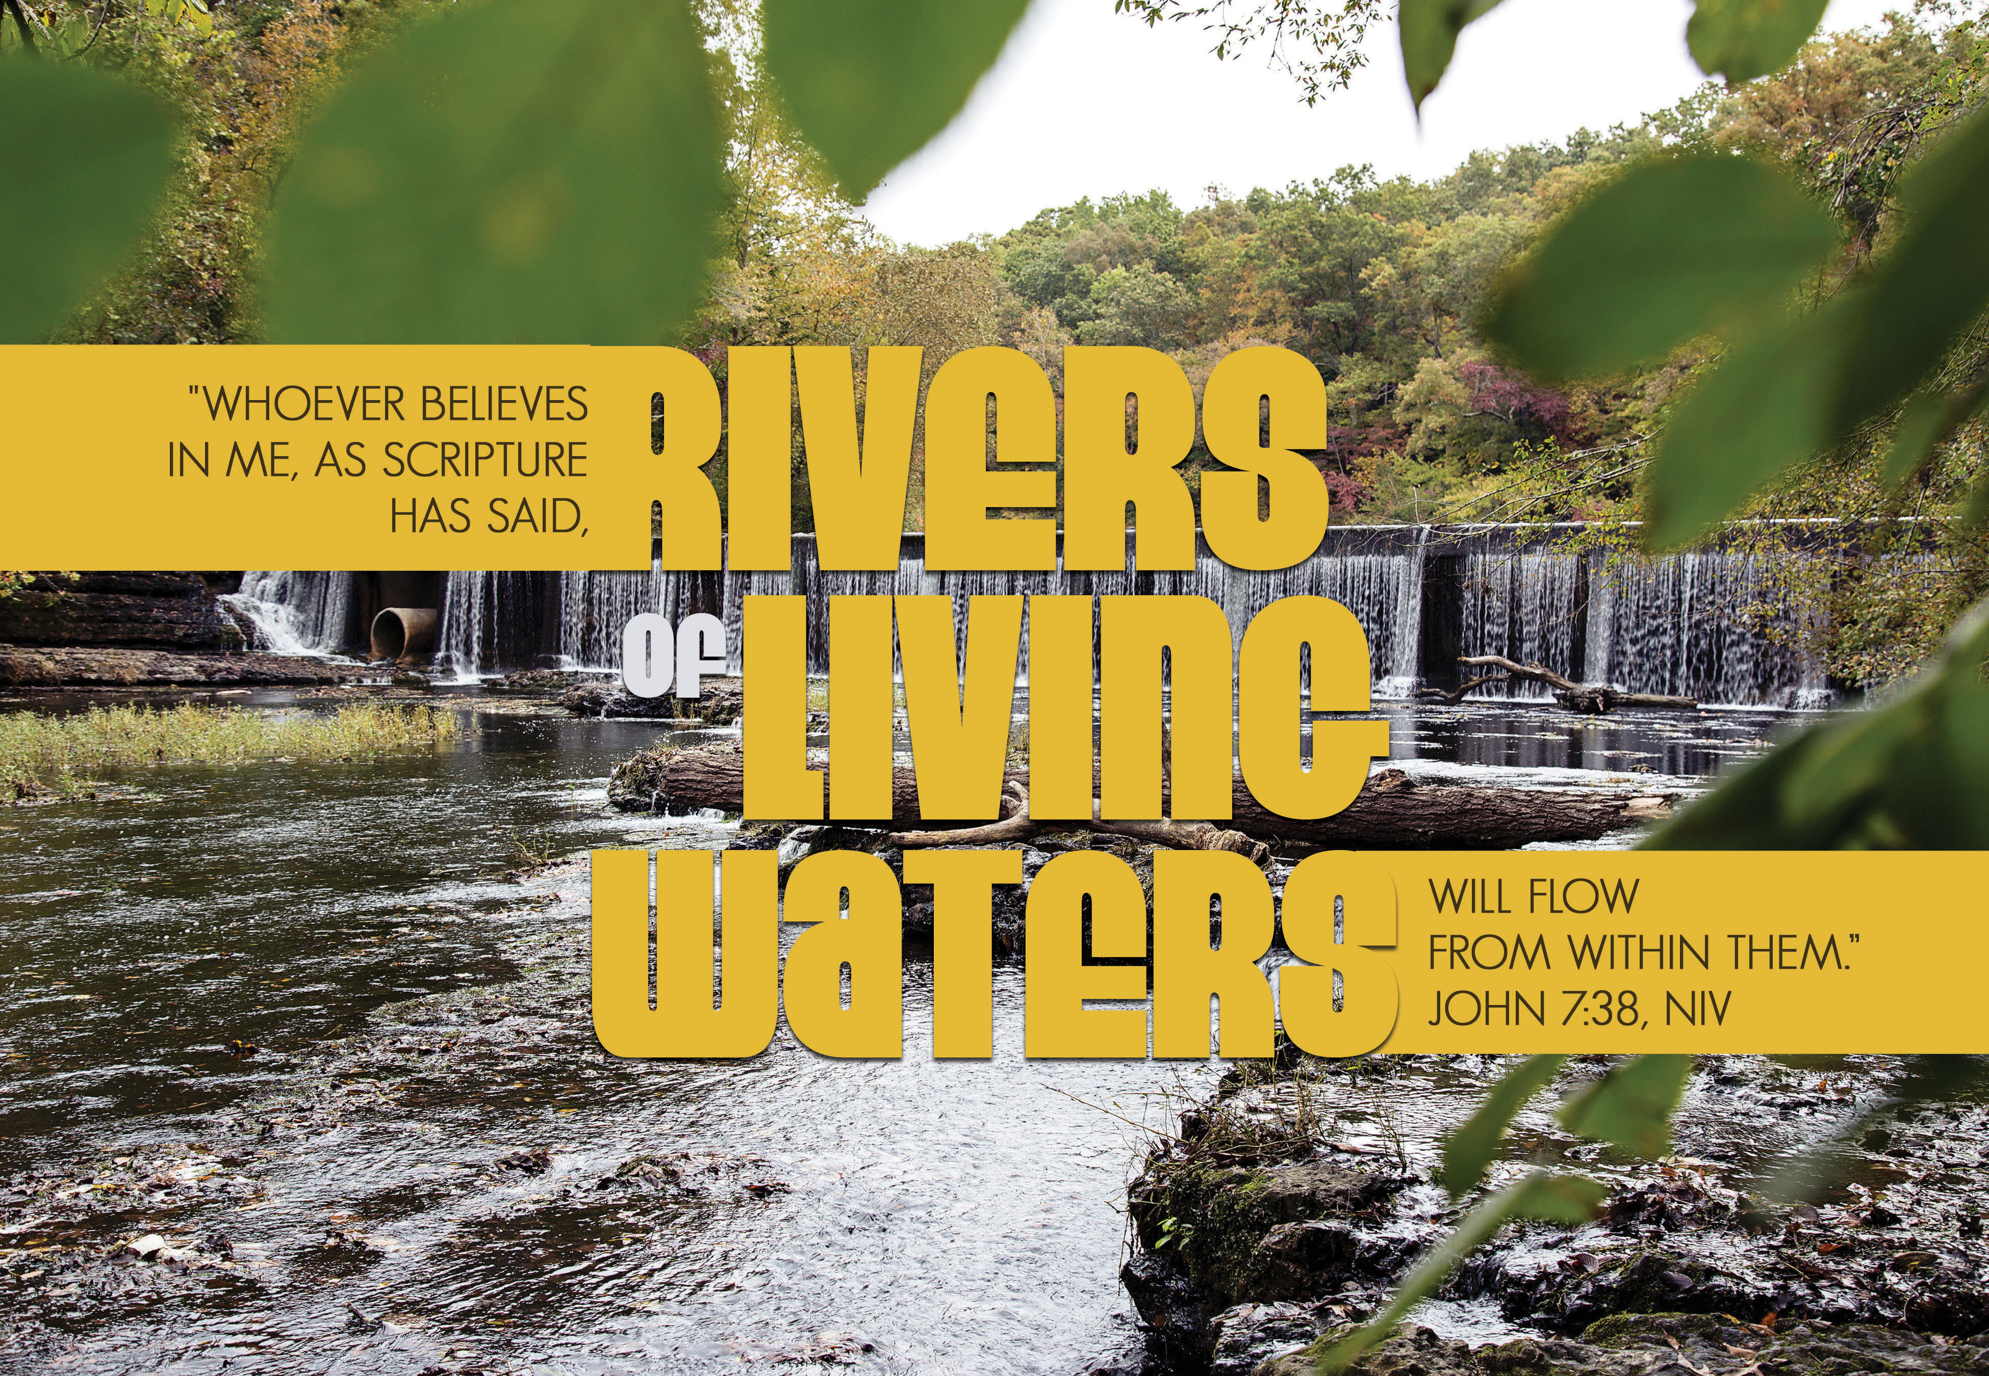

OFFERING RESPONSE
OFFERING PRAYER
Let us pray.
God our provider, you have not fed us with bread alone, but with words of grace and life. Bless us and these your gifts, which we receive from your bounty, through Jesus Christ our Lord. Amen.
Great Thanksgiving

Dialogue
The Lord be with you.
And also with you.
Lift up your hearts.
We lift them to the Lord.
Let us give thanks to the Lord our God.
It is right to give our thanks and praise.

Preface
It is indeed right, our duty and our joy,
that we should at all times and in all places
give thanks and praise to you, almighty and merciful God,
through our Savior Jesus Christ.
You call your people to cleanse their hearts
and prepare with joy for the paschal feast,
that, renewed in the gift of baptism,
we may come to the fullness of your grace.
And so, with all the choirs of angels,
with the church on earth and the hosts of heaven,
we praise your name and join their unending hymn:

ELW #190

Thanksgiving at the Table

Holy God, our living Water and our merciful Guide, together with rivers and seas, wells and springs we bless and magnify you.

You led your people Israel through the desert, and provided them water from the rock. We praise you for Christ, our Rock and our Water, who joined us in our desert, pouring out his life for the world.

In the night in which he was betrayed, our Lord Jesus took bread, and gave thanks; broke it, and gave it to his disciples, saying: Take and eat; this is my body, given for you. Do this for the remembrance of me.

Again, after supper, he took the cup, gave thanks, and gave it for all to drink, saying: This cup is the new covenant in my blood, shed for you and for all people for the forgiveness of sin. Do this for the remembrance of me.

Remembering, therefore, his life, death, and resurrection, we await your salvation for all this thirsty world. Pour out your Spirit on this holy food and on all the baptized gathered for this feast: wash away our sin, that we may be revived for our journey by the love of Christ.

Through him all glory and honor is yours, Almighty Father, with the Holy Spirit, in your holy Church, both now and forever.
Amen

THE LORDS PRAYER
Gathered into one by the Holy Spirit, let us pray as Jesus taught us.
Our Father in heaven, hallowed be your name, your kingdom come,
your will be done, on earth as in heaven. Give us today our daily bread.
Forgive us our sins as we forgive those who sin against us. Save us from the time of trial and deliver us from evil. For the kingdom, the power, and the glory are yours, now and forever.
Amen.

Invitation to Communion
Come to the banquet, for all is now ready.

Communion
The body of Christ, given for you. The blood of Christ, shed for you.
Amen.

Communion SONG

instrumental music
“I Love to Tell the Story” by William G Fischer Virgin Tutto
“Amor” by Francisco Durante
Flutes of Faith

CoNGREGATIONAL SONG
Give Me Jesus ELW #770

The assembly stands.
The body and blood of our Lord Jesus Christ
strengthen you and keep you in his grace. Amen.

Prayer after Communion
Let us pray.
Compassionate God, you have fed us with the bread of heaven. Sustain us in our Lenten pilgrimage: may our fasting be hunger for justice; our alms, a making of peace; and our prayer, the song of grateful hearts, through Jesus Christ, our Savior and Lord.
Amen.
SENDING

Blessing
Now is the acceptable time.
Now is the day of salvation.
Holy God,
speaking, spoken, and inspiring,
☩ bless you, unbind you,
and send you in love and in peace.
Amen.

SENDING SONG
Come to Me, All Pilgrims Thirsty ELW #777

Dismissal
Go in peace. Share the good news. Thanks be to God.

postlude
“Ripieno” by Petronio Giovagnoni

From sundaysandseasons.com.
Copyright © 2020 Augsburg Fortress. All rights reserved.

March 8, 2020 Attendance: 83

Serving Faith March 22
No Church Service at Faith Building. Please join us online at https://www.facebook.com/faithlutheranokemos/

Altar Flower Dedications
Sunday, March 15th
Altar flowers are given to the glory of God by Faith Lutheran.

Faith Lutheran Church's Welcoming Statement:
We, at Faith Lutheran Church, welcome you as a child of God. As Paul said in his letter to the Galatians, “for in Christ Jesus you are all children of God through faith.” (Galatians 3:26) We strive to be a place where everyone is welcomed and affirmed.

No matter your age, gender identity, sexual orientation, race, ethnicity, marital status, faith background, political leanings, or mental or physical ability - you are welcome as you are. As children of God, we are all one in Christ Jesus and rely on the unconditional nature of God’s love and grace to be our help and guide.

Email address
faith@faithlutheranokemos.org

Websites
Faith Lutheran Church ≈ www.faithlutheranokemos.org
North/West Lower Michigan Synod ≈ www.mittensynod.org
Evangelical Lutheran Church in America ≈ www.elca.org

Facebook
facebook.com/faithlutheranokemos

You also can find the audio available on Faith’s website under worship Sermons.

