**January 8, 2017**

Welcome to

Faith Lutheran

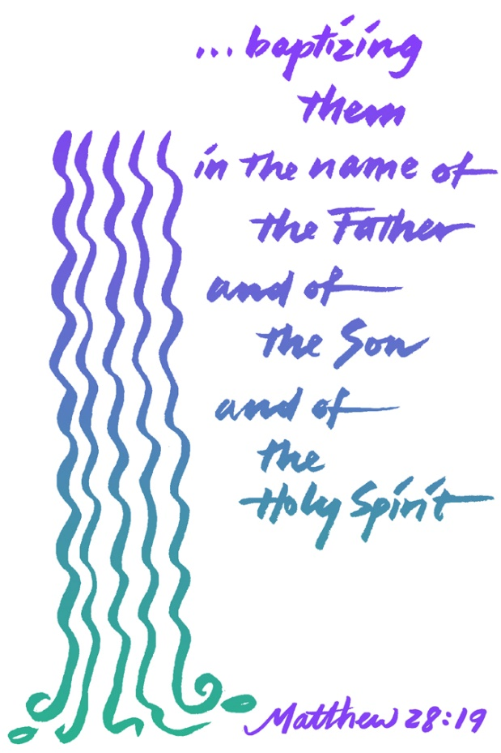

**4515 Dobie Road**

**Okemos, MI 48864**

**517-349-0620**

**Pastor Ellen Schoepf**

**prellen@faithlutheranokemos.org**

**Out of Love**

When people came to be baptized by John in the Jordan River, they did it because they knew their lives and actions had fallen short of God’s commandments, so they came to have their sins forgiven by John through a traditional Jewish custom of ritual washing. It was “a baptism of repentance for the forgiveness of sins” (Luke 3:3). So when Jesus shows up at the river to be baptized, John is understandably surprised. Jesus has not committed any sin, so John refuses to baptize him. But Jesus insists.

Jesus gets baptized not because he has to, but because he wants to show us that his life is not separated from ours. He does it out of love. For the same reason, Jesus goes on to eat and live with those regarded as public sinners: prostitutes, tax collectors, and criminals. For the same reason, Jesus touches lepers and those considered by society to be unclean. For the same reason, Jesus submits to crucifixion. He does it not because he has to, but out of love.

This pattern of voluntary humility and solidarity is the pattern for our life as well. We share in his baptism, in his love, and in his cross. When we gather together in worship, it is not because we have to, but out of love for God and for each other. When we serve our neighbors in volunteering, when we share in the pain of others, when we open our resources and lives to strangers in need, we do all of this not because we have to, but out of love.

In Jesus we embrace a faith that is free: Our sins are already forgiven; there is nothing left to prove; there is nothing left to lose; there is a whole world to gain . . . out of love.

**Sunday, January 08, 2017**

Baptism of Our Lord

Holy Communion Setting Eight

**Introduction to the day**

In the waters of the Jordan, Jesus is revealed as the beloved Son of God. Through this great epiphany, Jesus fulfills all righteousness and becomes the servant of God who will bring forth justice and be a light to the nations. In the waters of baptism we too are washed by the Word, anointed by the Spirit, and named God’s beloved children. Our baptismal mission is to proclaim good news to all who are oppressed or in need of God’s healing.

*If hearing assistance is needed, please ask an usher for a personal PA receiver.*

*The ushers also have large print copies of today’s worship folder available.*

*If it will be difficult for you to stand along with the congregation during*

*any part of the worship service, please feel free to remain seated.*

*There is a nursery available during the worship service for those who wish*

*to use it. It is located at the end of the hall beyond the coat racks.*

WELCOME AND ANNOUNCEMENTS

*We cordially greet all who have come to worship today.*

*Please register your attendance and join us in fellowship after the service.*

Prayer Requests

PRELUDE

*The pre-service music signals the beginning of the worship service. Silence during the*

*pre-service music enables worshipers to prepare for worship through quiet meditation.*

“Songs of Thankfulness and Praise” arr. Hall Hopson

Hymn 310

**Gathering**

*The Holy Spirit calls us together as the people of God.*

**Thanksgiving for Baptism**

*The assembly stands. All may make the sign of the cross,*

*the sign marked at baptism, as the presiding minister begins.*

In the name of the Father,

and of the ☩ Son,

and of the Holy Spirit.

**Amen.**

Joined to Christ in the waters of baptism,

we are clothed with God's mercy and forgiveness.

Let us give thanks for the gift of baptism.

We give you thanks, O God,

for in the beginning your Spirit moved over the waters

and by your Word you created the world,

calling forth life in which you took delight.

Through the waters of the flood you delivered Noah and his family.

Through the sea you led your people Israel from slavery into freedom.

At the river your Son was baptized by John and anointed with the Holy Spirit.

By water and your Word you claim us as daughters and sons,

making us heirs of your promise and servants of all.

We praise you for the gift of water that sustains life,

and above all we praise you for the gift of new life in Jesus Christ.

Shower us with your Spirit,

and renew our lives with your forgiveness, grace, and love.

To you be given honor and praise

through Jesus Christ our Lord

in the unity of the Holy Spirit, now and forever.

**Amen.**

**Gathering Hymn**

***Songs of Thankfulness and Praise ELW #310***

**Greeting**

The grace of our Lord Jesus Christ, the love of God,

and the communion of the Holy Spirit be with you all.

**And also with you.**

**Kyrie**



**Canticle of Praise**

**Prayer of the Day**

Let us pray.

O God our Father, at the baptism of Jesus you proclaimed him your beloved Son and anointed him with the Holy Spirit. Make all who are baptized into Christ faithful to their calling to be your daughters and sons, and empower us all with your Spirit, through Jesus Christ, our Savior and Lord, who lives and reigns with you and the Holy Spirit, one God, now and forever.

**Amen.**

*The assembly is seated.*

**Word**

*God speaks to us in scripture reading, preaching, and song.*

**First Reading: Isaiah 42:1-9**

*God’s servant Israel is endowed with the Spirit in order to bring justice to the nations. The servant will not exercise authority boisterously or with violence, nor will weariness ever keep it from fulfilling its task. God’s old promises have been fulfilled; the new assignment of the servant is to bring light to the nations.*

A reading from Isaiah.

1Here is my servant, whom I uphold,  
  my chosen, in whom my soul delights;  
 I have put my spirit upon him;  
  he will bring forth justice to the nations.  
 2He will not cry or lift up his voice,  
  or make it heard in the street;  
 3a bruised reed he will not break,  
  and a dimly burning wick he will not quench;  
  he will faithfully bring forth justice.  
 4He will not grow faint or be crushed  
  until he has established justice in the earth;  
  and the coastlands wait for his teaching.  
  
 5Thus says God, the Lord,  
  who created the heavens and stretched them out,  
  who spread out the earth and what comes from it,  
 who gives breath to the people upon it  
  and spirit to those who walk in it:  
 6I am the Lord, I have called you in righteousness,  
  I have taken you by the hand and kept you;  
 I have given you as a covenant to the people,  
  a light to the nations,  
  7to open the eyes that are blind,  
 to bring out the prisoners from the dungeon,  
  from the prison those who sit in darkness.  
 8I am the Lord, that is my name;  
  my glory I give to no other,  
  nor my praise to idols.  
 9See, the former things have come to pass,  
  and new things I now declare;  
 before they spring forth,  
  I tell you of them.

The word of the Lord.

**Thanks be to God.**

**Second Reading: Acts 10:34-43**

*Peter crosses the sharp religious boundary separating Jews from Gentiles and proclaims the good news of God’s inclusive forgiveness in Jesus’ name to Cornelius, a Roman centurion. As a result of Peter’s preaching, Cornelius and his family become the first Gentiles to be baptized in the name of Jesus Christ.*

A reading from Acts.

34Peter began to speak to [Cornelius and his household]: “I truly understand that God shows no partiality, 35but in every nation anyone who fears him and does what is right is acceptable to him. 36You know the message he sent to the people of Israel, preaching peace by Jesus Christ—he is Lord of all. 37That message spread throughout Judea, beginning in Galilee after the baptism that John announced: 38how God anointed Jesus of Nazareth with the Holy Spirit and with power; how he went about doing good and healing all who were oppressed by the devil, for God was with him. 39We are witnesses to all that he did both in Judea and in Jerusalem. They put him to death by hanging him on a tree; 40but God raised him on the third day and allowed him to appear, 41not to all the people but to us who were chosen by God as witnesses, and who ate and drank with him after he rose from the dead. 42He commanded us to preach to the people and to testify that he is the one ordained by God as judge of the living and the dead. 43All the prophets testify about him that everyone who believes in him receives forgiveness of sins through his name.”

The word of the Lord.

**Thanks be to God.**

*The assembly stands to welcome the gospel.*

**Gospel Acclamation**

**Gospel: Matthew 3:13-17**

*Before Jesus begins his ministry, he is baptized by John, touched by the Spirit, and identified publicly as God’s child.*

The holy gospel according to Matthew.

**Glory to you, O Lord.**

13Then Jesus came from Galilee to John at the Jordan, to be baptized by him. 14John would have prevented him, saying, “I need to be baptized by you, and do you come to me?” 15But Jesus answered him, “Let it be so now; for it is proper for us in this way to fulfill all righteousness.” Then he consented. 16And when Jesus had been baptized, just as he came up from the water, suddenly the heavens were opened to him and he saw the Spirit of God descending like a dove and alighting on him. 17And a voice from heaven said, “This is my Son, the Beloved, with whom I am well pleased.”

The gospel of the Lord.

**Praise to you, O Christ.**

*The assembly is seated.*

**Children’s message**

**Sermon**

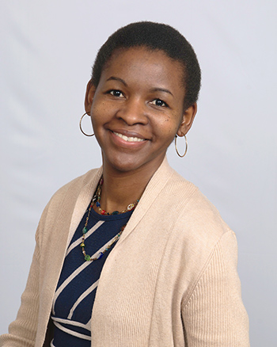Tula Ngasala is one of our members and she is working on her PhD in Environmental Engineering at MSU.  During this time, she has also been working on developing water projects in her home country of Tanzania.  Working with Engineers Without Borders and WEES (another non-profit organization), she was able to construct a much needed well at her father's home congregation in Tanzania.  This well serves people in the surrounding community.  Now she is developing and working on a water project in another part of her home country.

**

*The assembly stands to proclaim the word of God in song.*

**Hymn of the Day**

***When Jesus Came to Jordan ELW #305***

**Creed**

**I believe in God, the Father almighty,**

**creator of heaven and earth.**

**I believe in Jesus Christ, God’s only Son, our Lord,**

**who was conceived by the Holy Spirit,**

**born of the virgin Mary,**

**suffered under Pontius Pilate,**

**was crucified, died, and was buried;**

**he descended to the dead.**

**On the third day he rose again;**

**he ascended into heaven,**

**he is seated at the right hand of the Father,**

**and he will come to judge the living and the dead.**

**I believe in the Holy Spirit,**

**the holy catholic church,**

**the communion of saints,**

**the forgiveness of sins,**

**the resurrection of the body,**

**and the life everlasting. Amen.**

**Prayers of Intercession**

Called to be a light to the nations, let us pray for God’s justice, peace, and healing.

*Prayers of intercession are prayed.*

*To each petition, the assembly responds:*

Hear us, O God.

**Your mercy is great.**

*The presiding minister concludes the*

*prayers, and the assembly responds:*

Receive these prayers in the name of Christ, the light of the world, who is one with you and the Holy Spirit, now and forever.

**Amen.**

**Peace**

The peace of Christ be with you always.

**And also with you.**

*The assembly is seated.*

**Meal**

*God feeds us with the presence of Jesus Christ.*

**offering**

Chancel Choir “Jubilate Deo” (Wood)

*The assembly stands*

**Offering Response**

Text and music printed under onelicense.net license A-708005

**Offering Prayer**

Merciful God,

receive the gifts we bring,

our selves, our time, and our possessions.

Through this meal unite us as your body,

shining with the light of your justice and mercy;

for the sake of him who gave himself for us,

Jesus Christ our Lord.

**Amen.**

**Great Thanksgiving**

**Dialogue**

The Lord be with you.

**And also with you.**

Lift up your hearts.

**We lift them to the Lord.**

Let us give thanks to the Lord our God.

**It is right to give our thanks and praise.**

**Preface**

It is indeed right, our duty and our joy,

that we should at all times and in all places

give thanks and praise to you, almighty and merciful God,

through our Savior Jesus Christ.

By the leading of a star he was shown forth to all nations;

in the waters of the Jordan you proclaimed him your beloved Son;

and in the miracle of water turned to wine he revealed your glory.

And so, with all the choirs of angels,

with the church on earth and the hosts of heaven,

we praise your name and join their unending hymn:

**Holy, Holy, Holy**



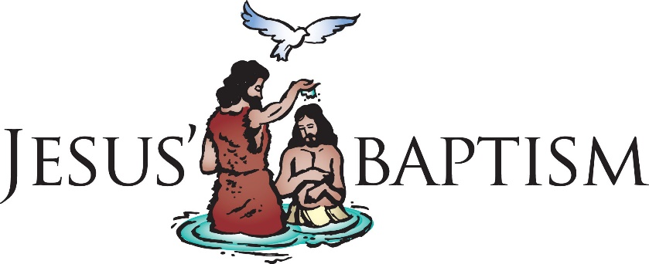

**Thanksgiving at the Table**

In the night in which he was betrayed, our Lord Jesus took bread, and gave thanks; broke it, and gave it to his disciples, saying: Take and eat; this is my body, given for you. Do this for the remembrance of me.

Again, after supper, he took the cup, gave thanks, and gave it for all to drink, saying: This cup is the new covenant in my blood,

shed for you and for all people for the forgiveness of sin. Do this for the remembrance of me.

**Amen**

**Lord’s Prayer**

Gathered into one by the Holy Spirit,

let us pray as Jesus taught us.

**Our Father in heaven,**

**hallowed be your name,**

**your kingdom come,**

**your will be done,**

**on earth as in heaven.**

**Give us today our daily bread.**

**Forgive us our sins**

**as we forgive those**

**who sin against us.**

**Save us from the time of trial**

**and deliver us from evil.**

**For the kingdom, the power,**

**and the glory are yours,**

**now and forever. Amen.**

**Invitation to Communion**

We who are many are one body,

for we all partake of the one bread.

Come. Be filled with light and life.

*The assembly may be seated*

**Communion**

The body of Christ, given for you.

The blood of Christ, shed for you.

Amen.

**communion song**



**congregational song**

***Christ, When for Us You Were Baptized ELW #304***

**congregational song**

***Hail to the Lord’s Anointed ELW #311***

*The assembly stands*

The body and blood of our Lord Jesus Christ

strengthen you and keep you in his grace.

**Amen**

**Prayer after Communion**

O Morning Star, fair and bright,

you have refreshed us again with heavenly food.

You are our dearest treasure.

Go with us now—

today, tomorrow, every day—

that we tell the story of your never-ending love

and sing your praise both now and forever.

**Amen.**

**Sending**

*God blesses us and sends us in mission to the world.*

**Blessing**

The God of glory dwell in you richly,

name you beloved,

and shine brightly on your path;

and the blessing of almighty God,

the Father, the ☩ Son, and the Holy Spirit,

be upon you and remain with you always.

**Amen.**

**Sending Song**

***Crashing Waters at Creation ELW #455***

**Dismissal**

Go in peace. Be the light of Christ.

**Thanks be to God.**

**postlude**

“Sortie in F Major” Cesar Franck

Copyright © 2017 Augsburg Fortress. All rights reserved. Reprinted by permission under Augsburg Fortress Liturgies Annual License #SAS000803. New Revised Standard Version Bible, copyright © 1989, Division of Christian Education of the National Council of the Churches of Christ in the United States of America. Used by permission. All rights reserved.



As the wise men followed the star to you, Jesus, may I follow your Word and encounter you in my life. Amen.

Adult study resumes on Sunday, February 5th, 2017.

Pastor Ellen Schoepf prellen@faithlutheranokemos.org

Secretary Katie Love klove@faithlutheranokemos.org

Director of Christian Education Melinda Schultz

Director of Music Debra Borton-McDonough

Organist/Pianist Bruce Williams

January 1, 2017 Attendance : 59

Serving Faith January 8 January 15

Acolyte Lily O’Brien Clayton Wenzel

Altar Care Carol Towl and Cecelia Kramer

Communion Assistants Lily O’Brien Clayton Wenzel

Jim Crum Doug Hirt

Melinda Schultz Dane Webb

Greeters Bill & Pam Williams Jack & Natalie Dingledine

Lay Assistants Jim Crum Doug Hirt

Readers Melinda Schultz Dane Webb

Ushers Dingledine Family Nussdorfer Family

Nursery Lori Webb Jennifer & Maia Guenther



The 2017 Flower Chart is up. There are several openings for the remainder of January and the rest of the year.

Sign up on the bulletin board in the hallway across from the coat rack.

**ANNOUNCEMENTS**

FaithFamily&Friends3

**January 8th , 2017**

*Log onto Faith’s website www.faithlutheranokemos.org 24/7 for updates*

**DEADLINES**

Sunday worship folder announcements⎯Tuesday of each week

Submit to Katie at klove@faithlutheranokemos.org

***February Faith Family News newsletter*⎯**

**Please submit by Monday January 16**

Submit to Katie at klove@faithlutheranokemos.org

**PRAYERS OF INTERCESSION**

Please lift up in prayer this week:

🕆 Members—Max Ambs, Lowell Barricklow, Ellen Milne, Harry Nawrock,

the Barry Family, Beth Belonga & Family.

🕆 Friends and family—

Pat Belonga, Chris Cotter, Terrie Becker, Allie, Heather,

Al, Lilly, Sai Eshwar Lingamgunta, Jenn Leitch, Jeanne and Leonard, Tom

Brown, Susan Heft, Pat Hillberg & Family, Dennis Cobler, John Joseph

Lanzetta and Bethany Robison

🕆 Our mission partner congregation⎯Lansing Redeemer Lutheran Church

🕆 Those in military service⎯Jon Schoepf, Lani Yearicks,

Melody and Adam Wright and Joe Galvin.

🕆 Samaritas children who seek adoption— Giovanni, Jessica, LeeAnn and

Valerie. Pray for each to be adopted and for Jesus to be their lifelong friend.

**NORTH/WEST LOWER MICHIGAN SYNOD PRAYER PARTNER**

As Jesus calls us to be one, even as he and the Father are one, please include Pastor Rachel Laughlin & Pastor and the congregation of St. Matthew Lutheran Church of Bridgeport, Michigan in your prayers of intercession this week.

**ALTAR FLOWER DEDICATIONS**

The flowers on the altar are given to the glory of God by Faith Church in celebration of the Baptism of our Lord.

**FINANCIAL UPDATE**

**Weekly Offering 01/01/17**  Year-to-date as of 11/30/2016

Loose Cash $ 30.00 Income $264,588.69

Loose Checks $ 25.00 Expenses 274,587.10

Flowers $ 20.00

General Fund $ 2513.00 Net Income (-9998.41)

Subtotal $ 2588.00

Simply Giving $ 2101.00

Total **$ 4689.00**



2017 Offering Envelopes are available in the narthex.

THIS WEEK’S CHRONOLOGY OF EVENTS

**Today**

9:00 a.m. Children’s Sunday School

10:00 a.m. Worship: Tula Ngasala speaking on Tanzania Water Project

11:30 a.m. Worship Committee Meeting

11:30 a.m. Perish Education Meeting

3:00 p.m. Worship at the Willows

Monday, January 9th

Committee Annual Reports are Due to the church office.

Tuesday, January 10th

Worship folder announcements deadline

Noon: Study in Pastor Ellen’s office

Wednesday, January 11th

7:30 a.m. Men’s Study

9:30 a.m. Quilting and Samaritas ACTION

5:30 p.m. Joyful Noise

6:00 p.m. T & C

6:00 p.m. First Communion Classes

6:30 p.m. Faith Bells

7:30 p.m. Chancel Choir

Thursday, January 12th

11:30 a.m. Caregivers Support Group in Library

6:30 p.m. Worship Service

Friday, January 13th

6:00 p.m. Confirmation Lock-In Begins

Saturday, January 14th

10:00 a.m. Confirmation Lock-In Ends



Thank you from all of us on staff at Faith! Your Christmas gift was truly appreciated by all!!

Happy New Year!

**Pastor Ellen, Melinda, Bruce, Deb,**

**Kelly and Katie**

**Beginning this week!**

**Thursday Evening Worship Service**

The Worship Committee has decided to experiment by adding a second worship service to our weekly schedule.  This service will NOT take place on Sundays.  It WILL take place on Thursday evenings at 6:30 PM.  This service will be more intimate, less formal, and more contemplative.  **The first gathering of this alternative worship service take place on Thursday evening, January 12.** Join us if you are able.  Please speak to Pastor Ellen if you have any questions.

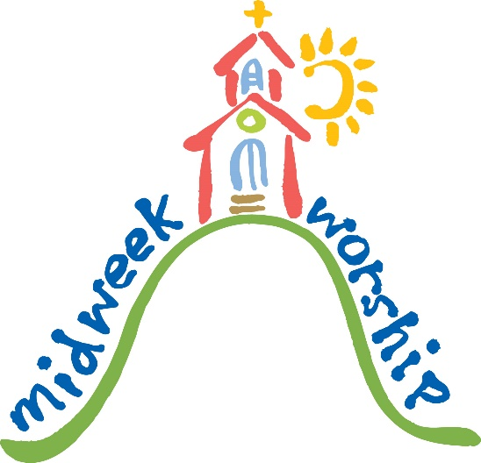

UPCOMING MEETINGS & STUDIES

**CAREGIVERS SUPPORT Group Meeting**

Join us at 11:30am for a light lunch and discussion. All are Welcome!

Thursday, January 12th: Angie Cantlon form CareLinc Medical Equipment will speak on how the Durable Medical Equipment World works. There is more offered then just a wheelchair and a walker!

Thursday, February 9th : Michelle Traill – Crosser from Caring Transitions will be speaking about downsizing.

Thursday, March 9th: Mike Harrison, Life & Business Coach. From Spectator to Spectacular: Living the Life YOU Want.

 **60 +/- Popcorn & a Movie**

Are you looking for ways to warm up your Michigan January? Join your friends from Sixty Plus or Minus for popcorn and a movie on **Wednesday,** **January 18, 2017, at 1 p.m.**! We will be watching the award-winning film “The Impossible,” the story of a tourist family in Thailand caught in the destruction and chaotic aftermath of the 2004 Indian Ocean tsunami. A Christmas vacation in a tropical paradise turned into the worst of nightmares.

******Annual Meeting- Sunday, January 22nd**

This year’s annual meeting will take place Sunday, January 22nd following the worship service. Committee annual reports are due to the church office by Monday, January 9th. RIC will be hosting a lunch following the meeting.

**SOGI Lunch and Learn  
January 22 - After the Annual Meeting**What does sexual orientation and gender identity (SOGI) mean? Is there more than just straight and gay? What does the Q really stand for in LGBTQ? Is everything black and white or is there more to it? The RIC team invites you to join us to explore these questions and more.

The lunch and learn will be held after the annual meeting on January 22.  We'll meet in the fellowship hall and have a light lunch of soups, breads, desserts, and beverages.  While we enjoy lunch we'll learn together about the SOGI spectrum and have an open discussion so we can all be more understanding of our LGBTQ siblings in Christ.  
  
Please sign up on the sheet in the narthex so we can plan for how many people are coming. We will also offer child care if you want to attend while someone else watches your children. Please indicate on the form if you'll be using the child care.

As the RIC team continues to plan and prepare a possible welcome statement that welcomes all of God's children regardless of gender, sexual orientation, race, political leanings, etc. we encourage you to attend the RIC events and the events offered by the racism planning team. If you have any questions or feedback about the RIC process and our plans, please reach out to Pastor Ellen or Rich Weingartner, chair of the RIC team.

**Adult Sunday School**

Class will resume on Sunday, February 5th at 9:00am in the library. We will be studying Walter Brueggemann’s book “Embracing the Prophets”

Walter, arguably America’s leading Old Testament scholar and theologian, takes us on a wild ride through the poetic prophecy of Hebrew Scripture, identifying cultural contexts, putting a framework to Israel’s history, and, most significantly -and at times challengingly! - drawing connections between Israel’s sociological, economic and spiritual status and that of America today.

**CHRISTIAN EDUCATION AND YOUTH ANNOUNCEMENTS**

**Shrove Tuesday Pancake Supper, February 28th, 5:30pm - 7:00pm, Items Needed**The Youth would appreciate any donations of the following items for the upcoming dinner next month: 2 jars of applesauce (23 oz.) and 200 (wow!) turkey sausage links. We appreciate your help and look forward to serving you that evening.

**Confirmation Lock-in – January 13-14**Our Confirmation Lock-in is fast approaching. The kids will arrive at the church on Friday night at 6:00 and can be picked up Saturday morning by 10:00am. I would really like everyone’s attendance at this event, so please let me know as soon as possible if your child is able to make this fun activity. We will also be completing our Faith chests.  
The cost is $5.00.  Please make checks payable to Faith Lutheran Church. If you have any questions, please let Melinda know.

**Important Dates in January and February**13th-14th Confirmation Lock-in, 6:00pm – 10:00am  
**15th -** **NO SUNDAY SCHOOL**  
22nd - Confirmation Review, 1:00-4:00pm  
22nd - Youth Group Outing, **Spare Time,** 4:30pm

29th - Children sing during service.  
**Feb. 5th - 1st Communion Sunday**  
**19th - NO SUNDAY SCHOOL**  
24th-26th Youth Weekend, 5:00pm – 3:00pm  
28th - Shrove Supper, 5:30-7:00pm



February 3, 2017: Membership Dev. Euchre Night

February 28, 2017: Shrove Supper

March 3-5, 2017: Marriage Retreat in Grand Rapids





To make disciples for Jesus Christ. . .

. . .we **Gather** in faith for worship, prayer,

study and fellowship

. . .we **Equip** the people of God with a faith

that works in real life

. . .we **Serve** the world in the name of Jesus Christ