Welcome to Faith Lutheran

November 6th 2016

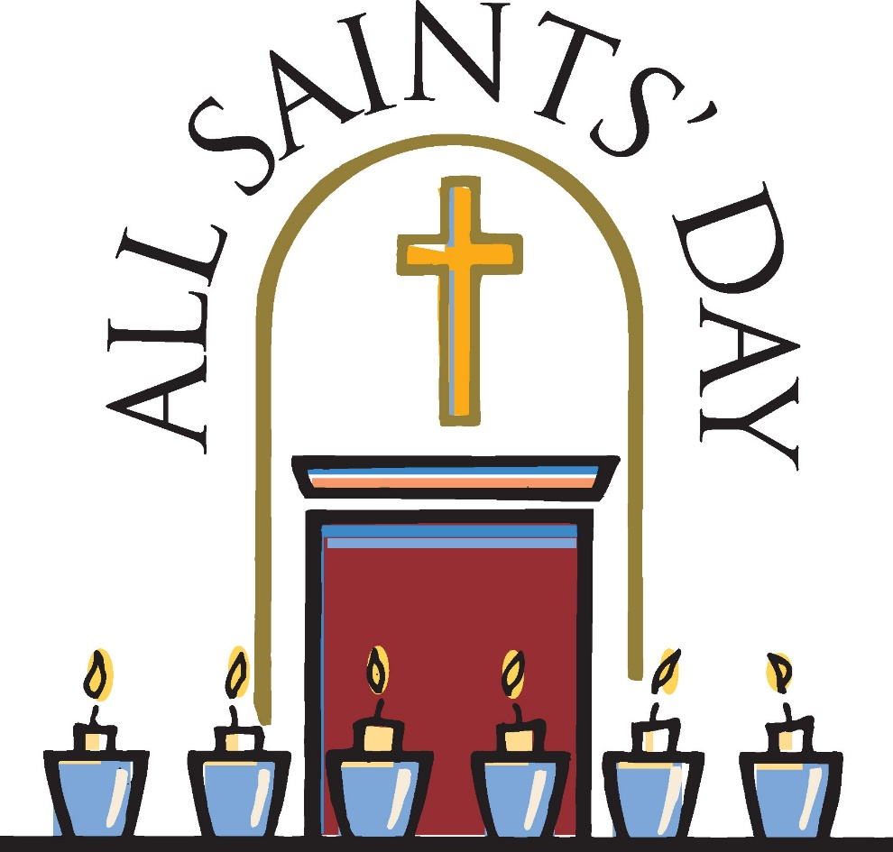
4515 Dobie Road
Okemos MI 48864-2203
517-349-0620
Pastor Ellen Schoepf
prellen@faithlutheranokemos.org

When Blessings Don’t Sound like Blessings
Jesus doesn’t mince words in today’s gospel. “Blessed are you who are poor” and “Woe to you who are rich” might make us uncomfortable and also cause us to scratch our heads. Poverty does not sound like a blessing. Wealth is often described as evidence of God’s blessing. What are we to do this All Saints Sunday with blessings and woes?
Sometimes blessings don’t sound like blessings. A dousing of water upon the head may not sound like much of a blessing, and yet we are promised that in baptism God claims us as beloved children and marks us as Christ’s own forever. A little bit of bread and a sip of wine doesn’t sound like much of a blessing, and yet we are promised that this meal is God’s banquet where Christ himself is the host.
So today we give thanks that Jesus doesn’t mince words. For in a life where we often get blessings and woes mixed up, when we often seek after those things which satisfy for a moment but pass away, it is good on All Saints Sunday to be reminded so clearly that, in Christ, we are assured the blessing of grace even when it doesn’t feel like we’re being blessed. And, likewise, it is good to be reminded that what so often looks like a blessing in this world is fleeting.
So join the saints in light today in streaming to the table of grace where a bit of bread and sip of wine will sustain you. Dip your fingers in the water of the font to remind yourself of the refreshing blessing of baptism. These blessings will see you through all the woes of life until that final blessing of eternity with Christ.

Worship Plan for Sunday, November 06, 2016
All Saints Sunday
Introduction to the day

In holy baptism God makes saints out of sinners. In holy communion God forgives the sins of all the saints. In the assembly today we give thanks for all the saints “who from their labors rest,” who have fought the good fight, who have gained the crown. In the same breath we petition our God for the strength to hear and to heed the admonitions of the Lord Jesus in today’s gospel. Recalling that we have been sealed by the Spirit and sustained by the Savior’s body and blood, we keep on keeping on as God gives us breath, to the praise of God’s glory.

If hearing assistance is needed, please ask an usher for a personal PA receiver.

The ushers also have large print copies of today’s worship folder available.

If it will be difficult for you to stand along with the congregation during
any part of the worship service, please feel free to remain seated.

There is a nursery available during the worship service for those who wish
to use it. It is located at the end of the hall beyond the coat racks.

WELCOME AND ANNOUNCEMENTS

We cordially greet all who have come to worship today.
Please register your attendance and join us in fellowship after the service.

Prayer Requests

PRELUDE

The pre-service music signals the beginning of the worship service. Silence during the
pre-service music enables worshipers to prepare for worship through quiet meditation.

“Shall we Gather at the River?” arr. Gordon Young

Gathering
The Holy Spirit calls us together as the people of God.
The assembly stands
Confession and Forgiveness

All may make the sign of the cross, the sign marked at baptism,
as the presiding minister begins.
In the name of God the Father of glory;
in the name of God the ☩ Son, our Redeemer;
in the name of God the holy and life-giving Spirit.
Amen.

The Sun of righteousness shall rise
with shining beams of healing.
Let us gather under the wings of God’s mercy.
Silence is kept for reflection.

Gracious God,
we acknowledge that we are sinners
and we confess our sins—
those known to us that burden our hearts,
and those unknown to us but seen by you.
We know that before you nothing remains hidden,
and in you everything is revealed.
Free us from the slavery of sin;
liberate us from the bondage of guilt;
and work in us that which is pleasing in your sight;
for the sake of Jesus Christ our Lord. Amen.

With a heart full of mercy and compassion,
God saves us and ☩ forgives us all our sins.
Christ, the dawn from on high, shines upon us
and by the light of the Holy Spirit
guides our feet into the way of peace.
Amen.

Gathering Song #422 VS. 1,2,6,7

Greeting
The grace of our Lord Jesus Christ, the love of God,
and the communion of the Holy Spirit be with you all.
And also with you.

Canticle of Praise
Prayer of the Day

Let us pray.
Almighty God, you have knit your people together in one communion in the mystical body of your Son, Jesus Christ our Lord. Grant us grace to follow your blessed saints in lives of faith and commitment, and to know the inexpressible joys you have prepared for those who love you, through Jesus Christ, our Savior and Lord, who lives and reigns with you and the Holy Spirit, one God, now and forever.
Amen.

The assembly is seated.

Word
God speaks to us in scripture reading, preaching, and song.

First Reading: Daniel 7:1-3, 15-18

The book of Daniel was written in the second century bce, when the Syrian king Antiochus Epiphanes was severely persecuting the Jews. Daniel’s vision of the four beasts serves to proclaim the message that human kings will come and go, but the kingdom will ultimately belong to God and to God’s people.
A reading from Daniel.
¹In the first year of King Belshazzar of Babylon, Daniel had a dream and visions of his head as he lay in bed. Then he wrote down the dream: ²I, Daniel, saw in my vision by night the four winds of heaven stirring up the great sea, ³and four great beasts came up out of the sea, different from one another.
¹⁵As for me, Daniel, my spirit was troubled within me, and the visions of my head terrified me. ¹⁶I approached one of the attendants to ask him the truth concerning all this. So he said that he would disclose to me the interpretation of the matter: ¹⁷“As for these four great beasts, four kings shall arise out of the earth. ¹⁸But the holy ones of the Most High shall receive the kingdom and possess the kingdom forever—forever and ever.”

The word of the Lord.
Thanks be to God.
Psalm: Psalm 149
The psalm for the day is read responsively

¹Hallelujah! Sing to the Lord a new song,
God’s praise in the assembly of the faithful.
²Let Israel rejoice in their maker;
let the children of Zion be joyful in their ruler.
³Let them praise their maker’s name with dancing;
let them sing praise with tambourine and harp.
⁴For the Lord takes pleasure in the people
and adorns the poor with victory.
⁵Let the faithful rejoice in triumph;
let them sing for joy on their beds.
⁶Let the praises of God be in their throat
and a two-edged sword in their hand,
⁷to wreak vengeance on the nations
and punishment on the peoples,
⁸to bind their kings in chains
and their nobles with links of iron,
⁹to inflict on them the judgment decreed;
this is glory for all God’s faithful ones. Hallelujah!

Second Reading: Ephesians 1:11-23

After giving thanks for the faith of the Ephesians, Paul prays that they might understand the wisdom, hope, and power of God that is embodied in Jesus Christ.
A reading from Ephesians.

¹¹In Christ we have also obtained an inheritance, having been destined according to the purpose of him who accomplishes all things according to his counsel and will, ¹²so that we, who were the first to set our hope on Christ, might live for the praise of his glory. ¹³In him you also, when you had heard the word of truth, the gospel of your salvation, and had believed in him, were marked with the seal of the promised Holy Spirit; ¹⁴this is the pledge of our inheritance toward redemption as God’s own people, to the praise of his glory.
¹⁵I have heard of your faith in the Lord Jesus and your love toward all the saints, and for this reason ¹⁶I do not cease to give thanks for you as I remember you in my prayers. ¹⁷I pray that the God of our Lord Jesus Christ, the Father of glory, may give you a spirit of wisdom and revelation as you come to know him, ¹⁸so that, with the eyes of your heart enlightened, you may know what is the hope to which he has called you, what are the riches of his glorious inheritance among the saints, ¹⁹and what is the immeasurable greatness of his power for us who believe, according to the working of his great power. ²⁰God put this power to work in Christ when he raised him from the dead and seated him at his right hand in the heavenly places, ²¹far above all rule and authority and power and dominion, and above every name that is named, not only in this age but also in the age to come. ²²And he has put all things under his feet and has made him the head over all things for the church, ²³which is his body, the fullness of him who fills all in all.

The word of the Lord.
Thanks be to God.
The assembly stands to welcome the gospel.

Gospel Acclamation

Gospel: Luke 6:20-31
In echoes of the prophet Isaiah and Mary’s song of praise, Jesus reveals surprising things about who enjoys blessing and who endures woe. He invites his disciples to shower radical love, blessing, forgiveness, generosity, and trust, even to enemies and outsiders.
The holy gospel according to Luke.
Glory to you, O Lord.

²⁰Then [Jesus] looked up at his disciples and said:
“Blessed are you who are poor,
for yours is the kingdom of God.
²¹“Blessed are you who are hungry now,
for you will be filled.
“Blessed are you who weep now,
for you will laugh.
²²“Blessed are you when people hate you, and when they exclude you, revile you, and defame you on account of the Son of Man. ²³Rejoice in that day and leap for joy, for surely your reward is great in heaven; for that is what their ancestors did to the prophets.
²⁴“But woe to you who are rich,
for you have received your consolation.
²⁵“Woe to you who are full now,
for you will be hungry.
“Woe to you who are laughing now,
for you will mourn and weep.
²⁶“Woe to you when all speak well of you, for that is what their ancestors did to the false prophets.
²⁷“But I say to you that listen, Love your enemies, do good to those who hate you, ²⁸bless those who curse you, pray for those who abuse you. ²⁹If anyone strikes you on the cheek, offer the other also; and from anyone who takes away your coat do not withhold even your shirt. ³⁰Give to everyone who begs from you; and if anyone takes away your goods, do not ask for them again. ³¹Do to others as you would have them do to you.”

The gospel of the Lord.
Praise to you, O Christ.

The assembly is seated

children’s message
Sermon

Hymn of the Day #418
The assembly stands to proclaim the word of God in song.
Text printed under Onelicense.net license A-708005
Creed
I believe in God, the Father almighty,
creator of heaven and earth.
I believe in Jesus Christ, God’s only Son, our Lord,
who was conceived by the Holy Spirit,
born of the virgin Mary,
suffered under Pontius Pilate,
was crucified, died, and was buried;
he descended to the dead.
On the third day he rose again;
he ascended into heaven,
he is seated at the right hand of the Father,
and he will come to judge the living and the dead.
I believe in the Holy Spirit,
the holy catholic church,
the communion of saints,
the forgiveness of sins,
the resurrection of the body,
and the life everlasting. Amen.

Prayers of Intercession
With the people of God gathered here and throughout the world, we offer our prayers for the church, those in need, and all of creation.
For the church and its leaders, that we continue to proclaim the gospel of salvation to every corner of the earth, so that all embody the hope of eternal life, let us pray.
Have mercy, O God.

For the well-being of creation, for the seas and their creatures, for those preparing for changing weather, and for those who serve as good stewards of God’s gifts, let us pray.
Have mercy, O God.

For peace among nations, for governments and electorates, for all who rule and have authority at any level, that they rule with justice, keeping in mind those who have no power, let us pray.
Have mercy, O God.

For the troubled and terrified, the poor and hungry, the abuser and abused, those who weep, those suffering from malaria or any sickness (especially), that God lift up people to provide care and consolation, let us pray.
Have mercy, O God.

For those who lead and support music in this assembly, that our song may point us all to Christ; for those who were baptized this year,
Brian Douglas Ottinger
Kristen Anne Barry
Samantha Ann Barry
Nolan James Baker
Jacob Allen Coe
Audrey Nicole Harwick
Cameron Jerry Sandel
Patrick Henry Bach
that the Holy Spirit guides them in love and service, following the example of our Lord, let us pray.
Have mercy, O God.

In thanksgiving for all the saints, known and unknown, who have died in the faith.
Bob Marklewitz
Bill Williams Sr.
Richard Jennings
Max Barry
Georgia Solem
Shirley Jirele
Marjorie Marquardt
We thank you that they serve as witnesses to the inheritance granted to us by Jesus Christ, let us pray.
Have mercy, O God.

Here other intercessions may be offered.
Almighty God, you have promised to hear those who call upon your name. We commend all our spoken and silent prayers to you, trusting in your abundant mercy; through your Son, Jesus Christ our Lord.
Amen.
Peace

The peace of Christ be with you always.
And also with you.

The assembly is seated.

Meal
God feeds us with the presence of Jesus Christ.

offering

Chancel Choir Crossing Over There (Choplin)

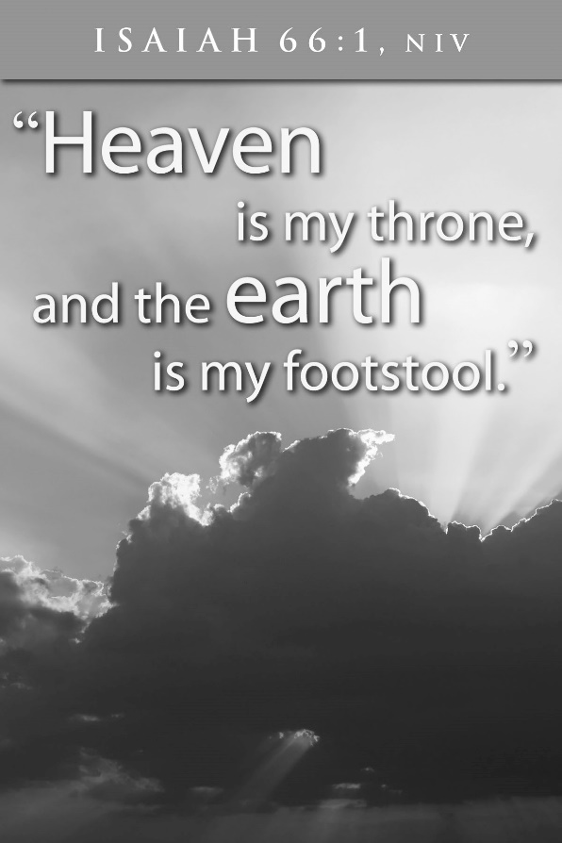

The assembly stands
Offering response
Printed under onelicense.net license a-708005

Offering Prayer

Merciful God, as grains of wheat scattered upon the hills
were gathered together to become one bread,
so let your church be gathered together
from the ends of the earth into your kingdom,
for yours is the glory through Jesus Christ, now and forever.
Amen.

Great Thanksgiving

Dialogue

The Lord be with you.
And also with you.
Lift up your hearts.
We lift them to the Lord.
Let us give thanks to the Lord our God.
It is right to give our thanks and praise.

Preface

It is indeed right, our duty and our joy,
that we should at all times and in all places
give thanks and praise to you, almighty and merciful God,
through our Savior Jesus Christ.
By the witness of your saints
you show us the hope of our calling,
and strengthen us to run the race set before us,
that we may delight in your mercy and rejoice with them in glory.
And so, with all the saints,
with the choirs of angels and all the hosts of heaven,
we praise your name and join their unending hymn:

Holy, Holy, Holy
Thanksgiving at the Table
With all the saints of Africa and Asia, India and the islands, Europe and the Americas,
we praise you, O God, for you create the worlds.
With all the baptized, the old and the young, the weak and the strong, the famous and the forgotten,
we bless you, O God, for you provide us with water and food.
With all the faithful in cities and on farms, in mansions and huts, past and present,
we worship you, O God, for you shelter the generations.
With all your holy people, those who ministered in the church, those who served the poor,
and all who walked the way of the cross,
we glorify you, O God, for in Jesus you journeyed with us on earth.
With Paul and the evangelists, we remember the meal of your Son:

In the night in which he was betrayed . . .
. . . Do this for the remembrance of me.

With Peter and all the martyrs, we honor Christ’s death, saying Amen.
Amen!

With Mary Magdalene and all the apostles, we proclaim his resurrection, shouting Amen.
Amen!

With John and all the theologians and mystics, we look for his returning, pleading Amen.
Amen!

With the Virgin Mary and all who sang of your greatness,
we pray for the power of the Spirit.
Visit this gathering, this bread and this cup,
with the presence of the body and blood of Christ.
Form us into a communion of service,
and infuse your earth with the wholeness we seek.
With grandparents and godparents and with the church universal,
lead us to a future we cannot yet see,
and at the end draw all humanity to yourself.
Now with all of the family you saved by your love,
we shout blessing
blessing,
glory
glory,
wisdom
wisdom,
thanksgiving
thanksgiving,
honor
honor,
power
power,
might
might,
be to our God forever and ever. Amen.
Amen!

Lord’s Prayer

Gathered into one by the Holy Spirit,
let us pray as Jesus taught us.
Our Father in heaven,
hallowed be your name,
your kingdom come,
your will be done,
on earth as in heaven.
Give us today our daily bread.
Forgive us our sins
as we forgive those
who sin against us.
Save us from the time of trial
and deliver us from evil.
For the kingdom, the power,
and the glory are yours,
now and forever. Amen.

Invitation to Communion
Share in the inheritance of all the saints.
Come to the table prepared for you.

The assembly may be seated

Communion

The body of Christ, given for you.
The blood of Christ, shed for you.

Amen.

Communion Song
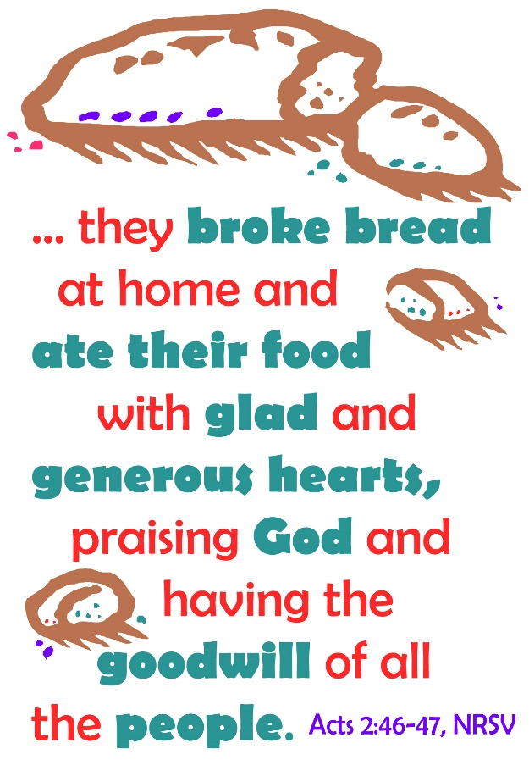

congregational song #426
Music printed under onelicense.net license a-708005
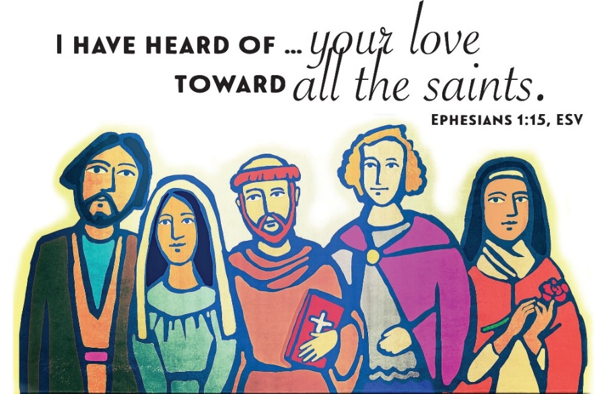
Music printed under onelicense.net license a-708005

congretational song #622

text and music printed under OneLicense.net license A-708005

The body and blood of our Lord Jesus Christ
strengthen you and keep you in his grace.
Amen

Prayer after Communion
We give you thanks, shepherding God,
that you have gathered your scattered flock again this day,
feeding us richly with the food of Paradise.
Accompany us as we serve you all the days of our lives,
and gather us with the saints in the day of our death;
through Jesus Christ, our Redeemer and Lord.
Amen.

Sending
God blesses us and sends us in mission to the world.

Blessing
God who loves us,
who gives us eternal consolation and good hope,
comfort your hearts
and strengthen them in every good work and word;
and the blessing of almighty God,
Father, ☩ Son, and Holy Spirit,
be among you and remain with you forever.
Amen.

Sending Song #428
Text printed under onelicense.net license a-708005

Dismissal
Go in peace. Christ is with you.
Thanks be to God.
postlude
“Toccata in Seven” John Rutter

Copyright © 2016 Augsburg Fortress. All rights reserved. Reprinted by permission under Augsburg Fortress Liturgies Annual License #SAS000803.New Revised Standard Version Bible, copyright © 1989, Division of Christian Education of the National Council of the Churches of Christ in the United States of America. Used by permission. All rights reserved. Clipart copyright © 2016 by Communication Resources. All rights reserved. Used by permission.

We are mindful today of the “great cloud of witnesses” (Hebrews 12:1, NIV) who have gone before us in faith, modeled a life of discipleship, and worship alongside us even now.

Pastor Ellen Schoepf prellen@faithlutheranokemos.org
Secretary Katie Love klove@faithlutheranokemos.org
Director of Christian Education Melinda Schultz
Director of Music Debra Borton-McDonough
Organist/Pianist Bruce Williams
October 30th Attendance:116
Serving Faith November 6 November 13

Acolyte Clayton Wenzel Juliana Lewis
Altar Care Brenda Kopf & Kay Showers
Communion Assistants Clayton Wenzel Juliana Lewis
Bob Nelson Ken Schoepf
Warren Heilman Linda Hirt
Greeters Brian & Michelle Ransom Chris and Jean Lewis
Lay Assistants Bob Nelson Ken Schoepf
Readers Warren Heilman Linda Hirt
Ushers Sally & Dick Knoll Sally & Dick Knoll
Nursery Jennifer & Maia Guenther Alexis Hereza

