Welcome to Faith Lutheran

October 30th 2016
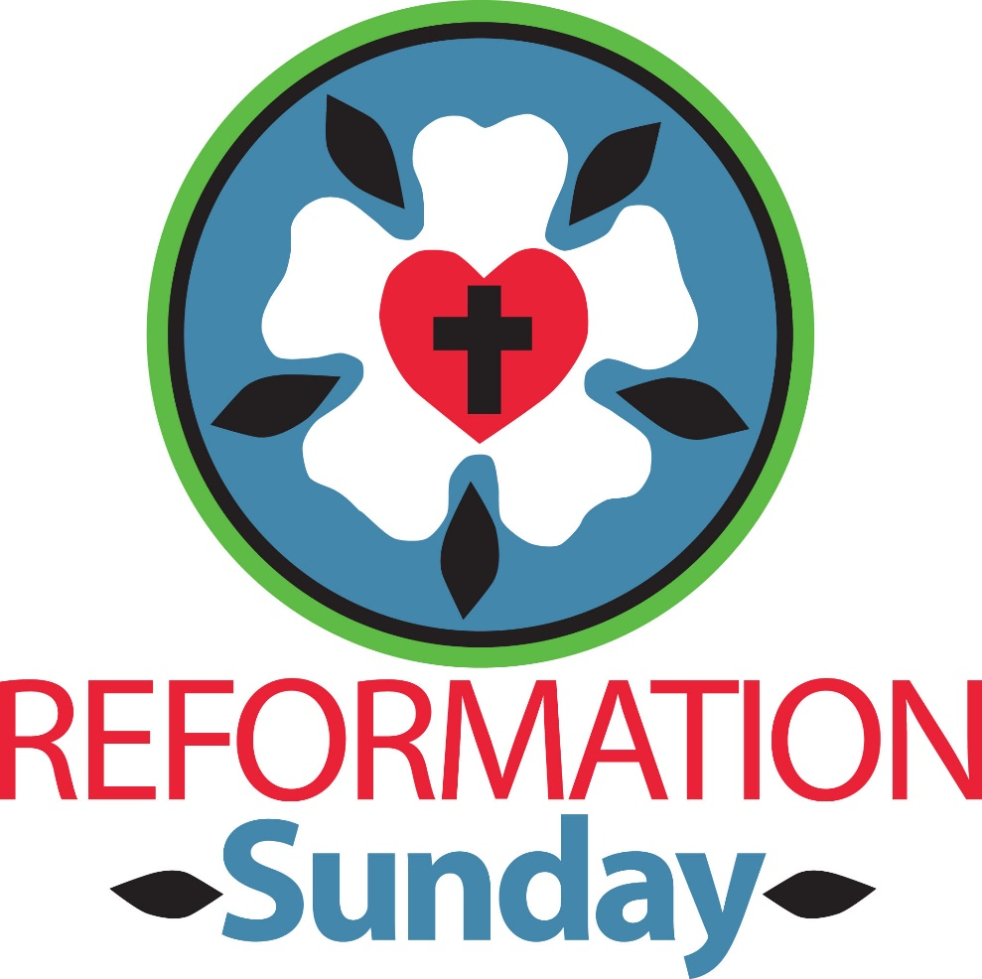

4515 Dobie Road
Okemos MI 48864-2203
517-349-0620
Pastor Ellen Schoepf
prellen@faithlutheranokemos.org

REFORMATION SUNDAY

A Glad Surprise
Imagine how Martin Luther felt when, in his careful study of Romans 3:21-28, he discovered the incredible gift of God’s amazing grace in the words of scripture! It may have been such a glad surprise to Luther that it felt like chains falling from his spirit. To finally be able to hear that our salvation does not depend on anything that we do, but strictly on what God has already done, must have been the ultimate in glad surprises for a monk who was taught all his life that his salvation depended on his own works.
What a glad surprise we are reminded of today for our own lives! In a society where competition is a major way of relating to one another, we hear today from the pages of scripture that receiving God’s love is not a competition; that our salvation is not dependent on our winning anything; that our rightness in God’s sight is not something that we earn—but that indeed, it is all because of God’s amazing grace through our Lord and Savior Jesus.
Because God’s grace is indeed so amazing, it is often easy for us to miss its import. In practically every other category of life we have to prove ourselves before we receive affirmation. We have to make good grades before we are acknowledged as a good student. We have to be good at our jobs before we are considered to be a good employee. We even have to impress our date or our children in order to be considered a good “catch” or a good parent.
But there is a place where we are acknowledged, blessed, and loved before we do a single thing—and that place is in God’s sight. Daily remembrance of the gift of baptism and weekly reception of the gift of Christ’s own self in communion continue to surprise and fortify us with God’s amazing grace.

Worship Plan for Sunday, October 30, 2016
Reformation Sunday
Introduction to the day
On this day we celebrate the heart of our faith: the gospel of Christ—the good news—that makes us free! We pray that the Holy Spirit would continue to unite the church today in its proclamation and witness to the world. In the waters of baptism we are made one body; we pray for the day that all Christians will also be one at the Lord’s table.

If hearing assistance is needed, please ask an usher for a personal PA receiver.

The ushers also have large print copies of today’s worship folder available.

If it will be difficult for you to stand along with the congregation during
any part of the worship service, please feel free to remain seated.

There is a nursery available during the worship service for those who wish
to use it. It is located at the end of the hall beyond the coat racks.

WELCOME AND ANNOUNCEMENTS

We cordially greet all who have come to worship today.
Please register your attendance and join us in fellowship after the service.

Prayer Requests

PRELUDE

The pre-service music signals the beginning of the worship service. Silence during the
pre-service music enables worshipers to prepare for worship through quiet meditation.

Faith Bells “Canon” (Pachelbel)

Gathering
The Holy Spirit calls us together as the people of God.
The assembly stands
Confession and Forgiveness

Blessed be the holy Trinity, ☩ one God,
the only Sovereign, who dwells in light;
Christ Jesus, who came to save sinners;
the Holy Spirit, who lives within us.
Amen.

Let us confess our sin in the presence of God
and of one another.
Silence is kept for reflection.

God of overflowing grace,
we come to you with repentant hearts.
Forgive us for shallow thankfulness.
Forgive us for passing by the ones in need.
Forgive us for setting our hopes on fleeting treasures.
Forgive us our neglect and thoughtlessness.
Bring us home from the wilderness of sin,
and strengthen us to serve you
in all that we do and say;
through Jesus Christ, our Savior and Lord.
Amen.

There is joy in heaven over every sinner who repents.
By the grace of God in ☩ Christ Jesus,
who gave himself up for us all,
your sins are forgiven and you are made free.
Rejoice with the angels and with one another!
We are home in God’s mercy, now and forever.
Amen.

Gathering Song #504
arrangement printed under onelicense.net license a-708005
Greeting

The grace of our Lord Jesus Christ, the love of God,
and the communion of the Holy Spirit be with you all.
And also with you.

Canticle of Praise

Prayer of the Day

Let us pray.
Almighty God, gracious Lord, we thank you that your Holy Spirit renews the church in every age. Pour out your Holy Spirit on your faithful people. Keep them steadfast in your word, protect and comfort them in times of trial, defend them against all enemies of the gospel, and bestow on the church your saving peace, through Jesus Christ, our Savior and Lord, who lives and reigns with you and the Holy Spirit, one God, now and forever.
Amen.
The assembly is seated.

Word
God speaks to us in scripture reading, preaching, and song.
First Reading: Jeremiah 31:31-34

The renewed covenant will not be breakable, but like the old covenant it will expect the people to live upright lives. To know the Lord means that one will defend the cause of the poor and needy (Jer. 22:16). The renewed covenant is possible only because the Lord will forgive iniquity and not remember sin. Our hope lies in a God who forgets.
A reading from Jeremiah.

³¹The days are surely coming, says the Lord, when I will make a new covenant with the house of Israel and the house of Judah. ³²It will not be like the covenant that I made with their ancestors when I took them by the hand to bring them out of the land of Egypt—a covenant that they broke, though I was their husband, says the Lord. ³³But this is the covenant that I will make with the house of Israel after those days, says the Lord: I will put my law within them, and I will write it on their hearts; and I will be their God, and they shall be my people. ³⁴No longer shall they teach one another, or say to each other, “Know the Lord,” for they shall all know me, from the least of them to the greatest, says the Lord; for I will forgive their iniquity, and remember their sin no more.
The word of the Lord.
Thanks be to God.

Chancel Choir Arise, O Church, Arise (Choplin)

Second Reading: Romans 3:19-28

Paul’s words stand at the heart of the preaching of Martin Luther and the other Reformation leaders. No human beings make themselves right with God through works of the law. We are brought into a right relationship with God through the divine activity centered in Christ’s death. This act is a gift of grace that liberates us from sin and empowers our faith in Jesus Christ.
A reading from Romans.

¹⁹Now we know that whatever the law says, it speaks to those who are under the law, so that every mouth may be silenced, and the whole world may be held accountable to God. ²⁰For “no human being will be justified in his sight” by deeds prescribed by the law, for through the law comes the knowledge of sin.
²¹But now, apart from law, the righteousness of God has been disclosed, and is attested by the law and the prophets, ²²the righteousness of God through faith in Jesus Christ for all who believe. For there is no distinction, ²³since all have sinned and fall short of the glory of God; ²⁴they are now justified by his grace as a gift, through the redemption that is in Christ Jesus, ²⁵whom God put forward as a sacrifice of atonement by his blood, effective through faith. He did this to show his righteousness, because in his divine forbearance he had passed over the sins previously committed; ²⁶it was to prove at the present time that he himself is righteous and that he justifies the one who has faith in Jesus.
²⁷Then what becomes of boasting? It is excluded. By what law? By that of works? No, but by the law of faith. ²⁸For we hold that a person is justified by faith apart from works prescribed by the law.

The word of the Lord.
Thanks be to God.

The assembly stands to welcome the gospel.
Gospel Acclamation

Gospel: John 8:31-36

Jesus speaks of truth and freedom as spiritual realities known through his word. He reveals the truth that sets people free from sin.
The holy gospel according to John.
Glory to you, O Lord.

³¹Jesus said to the Jews who had believed in him, “If you continue in my word, you are truly my disciples; ³²and you will know the truth, and the truth will make you free.” ³³They answered him, “We are descendants of Abraham and have never been slaves to anyone. What do you mean by saying, ‘You will be made free’?”
³⁴Jesus answered them, “Very truly, I tell you, everyone who commits sin is a slave to sin. ³⁵The slave does not have a permanent place in the household; the son has a place there forever. ³⁶So if the Son makes you free, you will be free indeed.”

The gospel of the Lord.
Praise to you, O Christ.

The assembly is seated

Children Sing
“Give Me Oil in My Lamp”
Bible Songs by Mike and Sue Martin Gay

Sermon

Hymn of the Day
The assembly stands to proclaim the word of God in song.

Printed under OneLicense.net license A-708005
The assembly is seated
Presentation of New members

The presiding minister begins. Dear friends, we give thanks for the gift of baptism and for Zachary Russell, united with us in the body of Christ, whom we welcome into the life and ministry of Faith Lutheran Church.

Apostles’ Creed
The presiding minister continues.
With the whole church, let us confess our faith.
I believe in God, the Father almighty, creator of heaven and earth. I believe in Jesus Christ, God’s only Son, our Lord, who was conceived by the Holy Spirit, born of the virgin Mary, suffered under Pontius Pilate, was crucified, died, and was buried; he descended to the dead.

On the third day he rose again; he ascended into heaven, he is seated at the right hand of the Father, and he will come to judge the living and the dead.

I believe in the Holy Spirit, the holy catholic church,
the communion of saints, the forgiveness of sins,
the resurrection of the body, and the life everlasting. Amen.

ADDRESS AND QUESTIONS

A lay leader (usually a congregation president or other officer) address those being welcomed.
In baptism we are welcomed into the body of Christ and sent to share in the mission of God. We are called to live amount God’s faithful people, to hear the word of God and share in the Lord’s Supper, to proclaim the good news of God in Christ through word and deed, to serve all people, following the example of Jesus, and to strive for justice and peace in all the earth.

The presiding minister addresses the new member.
Do you intend to continue in the covenant of your baptism among God’s people in this place?

Those being welcomed respond.
I do, and I ask God to help and guide me.

The presiding minister addresses the assembly.
People of God, do you promise to support and pray for this new member in Christian living?
We do, and we ask God to help and guide us.

WELCOME
Those being welcomed face the assembly. The pastor addresses the assembly.
Let us welcome our new member to this community of faith.
We rejoice with you in the life of baptism. Together we will give thanks and praise to God and proclaim the good news to the entire world.
The congregation gives acclamation and thanks.

The assembly stands

Prayers of Intercession

Set free by the truth of God’s gracious love, we pray for the church, the world, and all of God’s good creation.
Prayers of intercession are prayed.
To each petition, the assembly responds:

Hear us, O God.
Your mercy is great.

The presiding minister concludes the
prayers, and the assembly responds:

Into your hands, faithful God, we place ourselves and our prayers, spoken and unspoken, trusting in your mercy; through Jesus Christ, our Savior.
Amen.

Peace

The peace of Christ be with you always.
And also with you.

The assembly is seated.

Meal
God feeds us with the presence of Jesus Christ.

offering

"Christ is Made the Sure Foundation," arr. James Kimball

The assembly stands

offering response

Printed under onelicense.net license a-708005

Offering Prayer

Merciful God, as grains of wheat scattered upon the hills
were gathered together to become one bread,
so let your church be gathered together
from the ends of the earth into your kingdom,
for yours is the glory through Jesus Christ, now and forever.
Amen.

Great Thanksgiving

Dialogue

The Lord be with you.
And also with you.
Lift up your hearts.
We lift them to the Lord.
Let us give thanks to the Lord our God.
It is right to give our thanks and praise.

Preface

It is indeed right, our duty and our joy,
that we should at all times and in all places
give thanks and praise to you, almighty and merciful God,
through our Savior Jesus Christ;
who on this day overcame death and the grave,
and by his glorious resurrection opened to us the way of everlasting life.
And so, with all the choirs of angels,
with the church on earth and the hosts of heaven,
we praise your name and join their unending hymn:

Holy, Holy, Holy

Thanksgiving at the Table
We praise you, all-holy God,
our maker, our lover, our keeper,
our Covenant Lord, our Redeemer, the Strength of Truth,
for the universe beyond our knowing,
for seas and forests and fields,
for the waters of Wittenberg and for flowers in this place,
for creatures seen and unseen,
for animals both wild and tame,
for our ancestors and godparents from around the globe,
and for the places we humans call home,
for cities and churches and schools,
for seminaries and missions and fellowship halls.

We praise you for your covenant people,
for Moses and Miriam and Aaron,
for Jeremiah and the psalmists,
and for centuries of faithful Christians,
for Mary Magdalene, Peter and Paul,
for Luther, Melanchthon and Muhlenberg
for Katie Luther and Cranach, Bach and Nicolai,
Kierkegaard and Bonhoeffer, and
for all servants of the Reformation.

We praise you, O God, for Jesus Christ,
who saves us from sin and from evil,
embodying forgiveness, granting us grace, setting us free,
who on the night before he died,
took bread, and gave thanks; broke it,
and gave it to his disciples, saying:
Take and eat; this is my body, given for you.
Do this for the remembrance of me.

Again, after supper, he took the cup, gave thanks,
and gave it for all to drink, saying:
This cup is the new covenant in my blood,
shed for you and for all people for the forgiveness of sin.
Do this for the remembrance of me.
And so we remember your Word,
his life, his death, and his glorious resurrection,
his presence in this meal around the world,
and we proclaim the mystery of our faith:
Christ has died.
Christ is risen.
Christ will come again.

We pray, O God, for your Spirit,
your breath, your fire, your wisdom,
your law, your grace, your freedom.
Bless this meal and all those who share it;
inspire your people for service;
continue the reformation of your churches;
and renew the world with your mercy,
with your healing, your justice, and your peace,
with the joy of life in your household.
We praise you, all-holy God,
the Father, the Son, the Holy Spirit,
mighty Fortress, victorious Champion, powerful Shield,
today, tomorrow, and forever.
Amen!

Lord’s Prayer

Gathered into one by the Holy Spirit,
let us pray as Jesus taught us.
Our Father in heaven,
hallowed be your name,
your kingdom come,
your will be done,
on earth as in heaven.
Give us today our daily bread.
Forgive us our sins
as we forgive those
who sin against us.
Save us from the time of trial
and deliver us from evil.
For the kingdom, the power,
and the glory are yours,
now and forever. Amen.
Invitation to Communion

Take hold of the life that really is life.
Come, take your place at the table.

The assembly may be seated

Communion

When giving the bread and cup
the communion ministers say
The body of Christ, given for you.
The blood of Christ, shed for you.

and each person may respond
Amen.

Communion Song

congregational song #779

congregational song #708
Text and arrangement printed under Onelicense.net license A-708005
The assembly stands.

The body and blood of our Lord Jesus Christ strengthen you and keep you in His grace.

Prayer after Communion
We come again to you, O God,
giving you thanks that in this feast of mercy
you have embraced us and healed us,
making us one in the body of Christ.
Go with us on our way.
Equip us for every good work,
that we may continue to give you thanks
by embracing others with mercy and healing;
through Jesus Christ, our Savior and Lord.
Amen.
Sending
God blesses us and sends us in mission to the world.

Blessing
God Almighty send you light and truth
to keep you all the days of your life.
The hand of God protect you;
the holy angels accompany you;
and the blessing of almighty God,
the Father, the ☩ Son, and the Holy Spirit,
be with you now and forever.
Amen.

Sending Song #645

Dismissal
Go in peace. Remember the poor.
Thanks be to God.

POSTLUDE
"A Mighty Fortress is our God," arr. Wilbur Held
Copyright © 2016 Augsburg Fortress. All rights reserved. Reprinted by permission under Augsburg Fortress Liturgies Annual License #SAS000803.
New Revised Standard Version Bible, copyright © 1989, Division of Christian Education of the National Council of the Churches of Christ in the United States of America. Used by permission. All rights reserved. Clipart copyright © 2016 by Communication Resources. All rights reserved. Used by permission.
We are blessed by one another’s presence, in friendly handshakes or hugs, in the voices that join our own in song and prayer, in coffee and conversation. Together, we are Christ’s church. Welcome!

Pastor Ellen Schoepf prellen@faithlutheranokemos.org
Secretary Katie Love klove@faithlutheranokemos.org
Director of Christian Education Melinda Schultz
Director of Music Debra Borton-McDonough
Organist/Pianist Bruce Williams
October 23rd Attendance:104
Serving Faith October 30 November 6

Acolyte Adelle Dingledine Clayton Wenzel
Altar Care Rich Weingartner & Melinda Schultz
Brenda Kopf & Melinda Schultz
Communion Assistants Adelle Dingledine Clayton Wenzel
John McPhail Bob Nelson
Brendan Guenther Warren Heilman
Greeters Jack & Natalie Dingledine Brian & Michelle Ransom
Lay Assistants John McPhail Bob Nelson
Readers Brendan Guenther Warren Heilman
Ushers Doug & Linda Hirt Sally & Dick Knoll
Nursery Lori Webb Jennifer & Maia Guenther

