Welcome to Faith Lutheran

October 23rd 2016
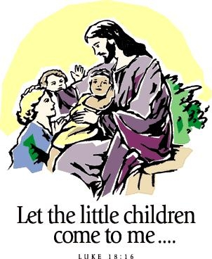

4515 Dobie Road
Okemos MI 48864-2203
517-349-0620
Pastor Ellen Schoepf
prellen@faithlutheranokemos.org

Putting Privilege at Risk
The concept of privilege has become an important talking point in our society. One way of describing privilege is that some people have access to and enjoy rights and immunities that others do not get to access or enjoy. We have heard much in recent years about the many types and expressions of privilege that are present in our society, privilege related to gender, race, socioeconomic status, sexual orientation, education, or ability—just to name a few.
For those of us who have some kind of privilege in this society—which includes a vast majority of members of North American Lutheran faith communities—being able to see, hear, and empathize with those who for whatever reason live life differently than we do can be a real challenge. Often, unhelpful narratives can make their way into our public and private conversations that place unjust blame on others, misinterpret or misrepresent others’ motives, and create walls of division instead of open spaces of understanding.
Jesus’ parable about the Pharisee and the tax collector reminds us that God does not share in our prejudices or our privileges, our name-calling or our numerous divisions. Jesus’ words concerning these two people who both went to pray in the temple reverses our expectations. Jesus lifts up the tax collector’s humility. Can we hear this as an invitation to put our privilege at risk by being willing to listen to those who are in different circumstances than we are? To hear their stories of joy and pain, to empathize in love, and to commit to justice and equality for all?
We are publicly baptized into a worldwide community of faith that has committed itself to love in the way Jesus loved, to care about the things Jesus cared about. Today Jesus encourages us to put our privilege at risk and to put our love on the table.

Sunday, October 23, 2016
23rd Sunday after Pentecost
Holy Communion Setting Nine

Introduction to the day
Genuine repentance and pretentious piety stand in stark contrast in the gospel and all around us. All creation stands in need of God’s forgiveness. Keep the faith. God’s people—“all who have longed for his appearing”—shall be accounted righteous for Jesus’ sake. Our God is merciful to sinners. For all this the assembly glorifies God forever.

If hearing assistance is needed, please ask an usher for a personal PA receiver.

The ushers also have large print copies of today’s worship folder available.

If it will be difficult for you to stand along with the congregation during
any part of the worship service, please feel free to remain seated.

There is a nursery available during the worship service for those who wish
to use it. It is located at the end of the hall beyond the coat racks.

WELCOME AND ANNOUNCEMENTS

We cordially greet all who have come to worship today.
Please register your attendance and join us in fellowship after the service.

Prayer Requests

PRELUDE

The pre-service music signals the beginning of the worship service. Silence during the
pre-service music enables worshipers to prepare for worship through quiet meditation.

“For The Beauty of the Earth,” arr. Alice Jordan

Gathering
The Holy Spirit calls us together as the people of God.

The assembly stands.

Confession and Forgiveness
All may make the sign of the cross, the sign marked at baptism,
as the presiding minister begins.
Blessed be the holy Trinity, ☩ one God,
the only Sovereign, who dwells in light;
Christ Jesus, who came to save sinners;
the Holy Spirit, who lives within us.
Amen.

Let us confess our sin in the presence of God
and of one another.

Silence is kept for reflection.

God of overflowing grace,
we come to you with repentant hearts.
Forgive us for shallow thankfulness.
Forgive us for passing by the ones in need.
Forgive us for setting our hopes on fleeting treasures.
Forgive us our neglect and thoughtlessness.
Bring us home from the wilderness of sin,
and strengthen us to serve you
in all that we do and say;
through Jesus Christ, our Savior and Lord. Amen.

There is joy in heaven over every sinner who repents.
By the grace of God in ☩ Christ Jesus,
who gave himself up for us all,
your sins are forgiven and you are made free.
Rejoice with the angels and with one another!
We are home in God’s mercy, now and forever.
Amen.

Gathering Song #631
Greeting
The grace of our Lord Jesus Christ, the love of God,
and the communion of the Holy Spirit be with you all.
And also with you.

Canticle of Praise
⇒

Prayer of the Day

Let us pray.
Holy God, our righteous judge, daily your mercy surprises us with everlasting forgiveness. Strengthen our hope in you, and grant that all the peoples of the earth may find their glory in you, through Jesus Christ, our Savior and Lord.
Amen.

The assembly is seated.

Word
God speaks to us in scripture reading, preaching, and song.

First Reading: Jeremiah 14:7-10, 19-22
In a time of drought, the people pray for mercy, repenting of their sins and the sins of their ancestors. They appeal to God to remember the covenant, to show forth God’s power, and to heal their land by sending life-giving rain.
A reading from Jeremiah.

⁷Although our iniquities testify against us,
act, O Lord, for your name’s sake;
our apostasies indeed are many,
and we have sinned against you.
⁸O hope of Israel,
its savior in time of trouble,
why should you be like a stranger in the land,
like a traveler turning aside for the night?
⁹Why should you be like someone confused,
like a mighty warrior who cannot give help?
Yet you, O Lord, are in the midst of us,
and we are called by your name;
do not forsake us!
¹⁰Thus says the Lord concerning this people:
Truly they have loved to wander,
they have not restrained their feet;
therefore the Lord does not accept them,
now he will remember their iniquity
and punish their sins.
¹⁹Have you completely rejected Judah?
Does your heart loathe Zion?
Why have you struck us down
so that there is no healing for us?
We look for peace, but find no good;
for a time of healing, but there is terror instead.
²⁰We acknowledge our wickedness, O Lord,
the iniquity of our ancestors,
for we have sinned against you.
²¹Do not spurn us, for your name’s sake;
do not dishonor your glorious throne;
remember and do not break your covenant with us.
²²Can any idols of the nations bring rain?
Or can the heavens give showers?
Is it not you, O Lord our God?
We set our hope on you,
for it is you who do all this.

The word of the Lord.
Thanks be to God.

Joyful Noise Choir “I Am a Promise” (Gaither)

Second Reading: 2 Timothy 4:6-8, 16-18

The conclusion of this letter to a young minister offers a final perspective on life from one who is now facing death. Though others have let him down, Paul is sure of his faith in the Lord, who has stood by him and lent him strength.

A reading from 2 Timothy.

⁶As for me, I am already being poured out as a libation, and the time of my departure has come. ⁷I have fought the good fight, I have finished the race, I have kept the faith. ⁸From now on there is reserved for me the crown of righteousness, which the Lord, the righteous judge, will give me on that day, and not only to me but also to all who have longed for his appearing.
¹⁶At my first defense no one came to my support, but all deserted me. May it not be counted against them! ¹⁷But the Lord stood by me and gave me strength, so that through me the message might be fully proclaimed and all the Gentiles might hear it. So I was rescued from the lion’s mouth. ¹⁸The Lord will rescue me from every evil attack and save me for his heavenly kingdom. To him be the glory forever and ever. Amen.

The word of the Lord.
Thanks be to God.
The assembly stands to welcome the gospel.

Gospel Acclamation

Gospel: Luke 18:9-14

The coming reign of God will involve unexpected reversals of fortune with judgment rooted in mercy. Jesus tells a parable in which the one who humbles himself is exalted and the one who exalts his own righteousness is humbled.
The holy gospel according to Luke.
Glory to you, O Lord.

⁹[Jesus] also told this parable to some who trusted in themselves that they were righteous and regarded others with contempt:¹⁰“Two men went up to the temple to pray, one a Pharisee and the other a tax collector. ¹¹The Pharisee, standing by himself, was praying thus, ‘God, I thank you that I am not like other people: thieves, rogues, adulterers, or even like this tax collector. ¹²I fast twice a week; I give a tenth of all my income.’ ¹³But the tax collector, standing far off, would not even look up to heaven, but was beating his breast and saying, ‘God, be merciful to me, a sinner!’ ¹⁴I tell you, this man went down to his home justified rather than the other; for all who exalt themselves will be humbled, but all who humble themselves will be exalted.”

The gospel of the Lord.
Praise to you, O Christ.

The assembly is seated.
children’s message
Sermon

Hymn of the Day #208
The assembly stands to proclaim the word of God in song.
Text & Music printed under OneLicense.net license A-708005
Presentation of Bibles

When each of you was baptized, the members of the congregation-all of us here-made a commitment to you. We promised to support each of you, pray for each of you as you live the life God calls you to live, and provide, teach and share God’s word with you. As part of that promise we made to you, we are doing something very special for you today. We are giving each of you a Bible, the most treasured book in our lives.

Jonas Osmo Guenther
Austin Ryan Jones
Paige Josephine Lewis
Claire Louisa Nelson
Sean Michael O’Brien and
Kaden James Steinke

Members of the congregation, let us affirm
our promise to each of these children.

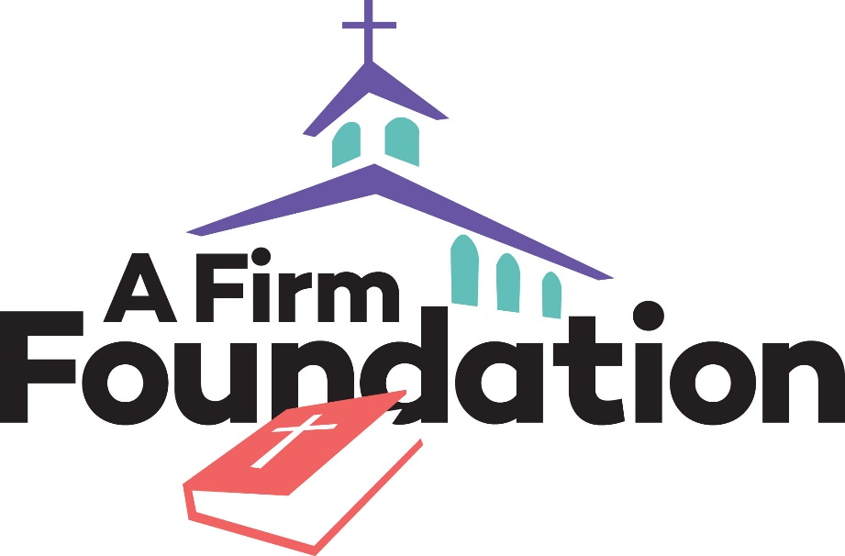
We promise to care for you, love you and continue to share God’s word with you as you grow in faith. We promise to support you in the mission we share, always giving thanks and praise to God as together we carry God’s creative and redeeming word in the world.

Creed
I believe in God, the Father almighty,
creator of heaven and earth.
I believe in Jesus Christ, God’s only Son, our Lord,
who was conceived by the Holy Spirit,
born of the virgin Mary,
suffered under Pontius Pilate,
was crucified, died, and was buried;
he descended to the dead.
On the third day he rose again;
he ascended into heaven,
he is seated at the right hand of the Father,
and he will come to judge the living and the dead.
I believe in the Holy Spirit,
the holy catholic church,
the communion of saints,
the forgiveness of sins,
the resurrection of the body,
and the life everlasting. Amen.

Prayers of Intercession

Set free by the truth of God’s gracious love, we pray for the church, the world, and all of God’s good creation.
Prayers of intercession are prayed.
To each petition, the assembly responds:

Hear us, O God.
Your mercy is great.

The presiding minister concludes the
prayers, and the assembly responds:

Into your hands, faithful God, we place ourselves and our prayers, spoken and unspoken, trusting in your mercy; through Jesus Christ, our Savior.
Amen.

Peace
The peace of Christ be with you always.
And also with you.

The people may greet one another with a sign of Christ’s peace, and may say, “Peace be with you,” or similar words.
The assembly is seated.

Meal
God feeds us with the presence of Jesus Christ.

offering
Chancel Choir “Nothing But the Blood of Jesus”
The assembly stands.

offering response 691, vs. 1&2
Text and arrangement printed under OneLicense.net license A-708005

Offering Prayer

Merciful God, as grains of wheat scattered upon the hills
were gathered together to become one bread,
so let your church be gathered together
from the ends of the earth into your kingdom,
for yours is the glory through Jesus Christ, now and forever.
Amen.

Great Thanksgiving

Dialogue

The Lord be with you.
And also with you.
Lift up your hearts.
We lift them to the Lord.
Let us give thanks to the Lord our God.
It is right to give our thanks and praise.

Preface

It is indeed right, our duty and our joy,
that we should at all times and in all places
give thanks and praise to you, almighty and merciful God,
through our Savior Jesus Christ;
who on this day overcame death and the grave,
and by his glorious resurrection opened to us the way of everlasting life.
And so, with all the choirs of angels,
with the church on earth and the hosts of heaven,
we praise your name and join their unending hymn:

Holy, Holy, Holy
Thanksgiving at the Table
In the night in which he was betrayed,
our Lord Jesus took bread, and gave thanks;
broke it, and gave it to his disciples, saying:
Take and eat; this is my body, given for you.

Do this for the remembrance of me.
Again, after supper, he took the cup, gave thanks,
and gave it for all to drink, saying:
This cup is the new covenant in my blood,
shed for you and for all people for the forgiveness of sin.
Do this for the remembrance of me.

Lord’s Prayer

Gathered into one by the Holy Spirit, let us pray as Jesus taught us.
Our Father in heaven,
hallowed be your name,
your kingdom come,
your will be done,
on earth as in heaven.
Give us today our daily bread.
Forgive us our sins
as we forgive those
who sin against us.
Save us from the time of trial
and deliver us from evil.
For the kingdom, the power,
and the glory are yours,
now and forever. Amen.

Invitation to Communion
Taste and see that the Lord is good.
The assembly may be seated.

Communion
The body of Christ, given for you.
The blood of Christ, shed for you.

Amen.

Communion song

congregational song

congregational song #608
The assembly stands.
The body and blood of our Lord Jesus Christ
strengthen you and keep you in his grace.
Amen

Prayer after Communion
We come again to you, O God,
giving you thanks that in this feast of mercy
you have embraced us and healed us,
making us one in the body of Christ.

Go with us on our way.
Equip us for every good work,
that we may continue to give you thanks
by embracing others with mercy and healing;
through Jesus Christ, our Savior and Lord.
Amen.

Sending
God blesses us and sends us in mission to the world.

Blessing
God Almighty send you light and truth
to keep you all the days of your life.
The hand of God protect you;
the holy angels accompany you;
and the blessing of almighty God,
the Father, the ☩ Son, and the Holy Spirit,
be with you now and forever.
Amen.

Sending Song 618

Dismissal
Go in peace. Remember the poor.
Thanks be to God.

POSTLUDE
“All Glory be to God on High,” arr. Michael Burkhardt

Copyright © 2016 Augsburg Fortress. All rights reserved. Reprinted by permission under Augsburg Fortress Liturgies Annual License #SAS000803.New Revised Standard Version Bible, copyright © 1989, Division of Christian Education of the National Council of the Churches of Christ in the United States of America. Used by permission. All rights reserved. Clipart copyright © 2016 by Communication Resources. All rights reserved. Used by permission.

Welcome, friends, as we gather in praise!

Pastor Ellen Schoepf prellen@faithlutheranokemos.org
Secretary Katie Love klove@faithlutheranokemos.org
Director of Christian Education Melinda Schultz
Director of Music Debra Borton-McDonough
Organist/Pianist Bruce Williams
October 16th Attendance:109
Serving Faith Today October 30

Acolyte Clayton Wenzel Adelle Dingledine
Altar Care Rich Weingartner & Melinda Schultz
Communion Assistants Clayton Wenzel Adelle Dingledine
Rich Weingartner John McPhail
Elaine Harrison Brendan Guenther
Greeters Doug & Linda Hirt Jack and Natalie Dingledine
Lay Assistants Rich Weingartner John McPhail
Readers Elaine Harrison Brendan Guenther
Ushers Doug & Linda Hirt Doug & Linda Hirt
Nursery Heidi Bowers Lori Webb

