October 9th 2016
Welcome to
Faith Lutheran Church
4515 Dobie Road
Okemos MI 48864-2203
517-349-0620

Pastor Ellen Schoepf
prellen@faithlutheranokemos.org

Who to Thank
One of these things is not like the others. Did you ever sing that song when you were small? In our gospel story today, ten lepers are healed but only one turned back to Jesus, praising God. He was not like the others somehow. What did the one man see that the other nine did not? Jesus told them all to go and show themselves to the priests. That was what the law said a leper should do in order to be cleansed and declared clean. While they were on their way, all of them were healed.
We aren’t told what happened to the other nine. Perhaps they went on to the priests to give God thanks there and to go through ritual cleansing. That would make sense since Jesus hadn’t spoken any particular words of healing. They might have thought the reason for their healing had something to do with the priests, the rituals, and God in Jerusalem.
So why did the one leper turn back to Jesus to give God thanks? He seems to be the only one who recognized that the healing power of God came through Jesus and wanted to give God thanks where credit was due—at Jesus’ feet.
Jesus points out the other difference—this man was a Samaritan. The people in Samaria had once been Hebrews but over time had intermarried with other cultures and worshiped God on a different mountain than in Jerusalem. Who had the eyes of faith to see God in Jesus? The one who was different.
God sometimes heals in ways we don’t expect and aren’t looking for. And sometimes God works through those who are different to help us see the power of God. It is indeed right to give God thanks and praise for God’s unexpected mercy and grace. Taste and see Jesus present in simple bread and wine—unexpected healing, mercy, and grace.

Sunday, October 09, 2016
21st Sunday after Pentecost
ELW Holy Communion Setting Nine
INTRODUCTION TO THE DAY

It’s a miracle! Multiple miracles! The waters of holy baptism have healed us. The body and blood of Jesus in holy communion have made us clean. We have died with Christ and been raised with him. For all this we have returned to offer thanks. From this place we are sent on our way rejoicing to share the good news.

If hearing assistance is needed, please ask an usher for a personal PA receiver.

The ushers also have large print copies of today’s worship folder available.

If it will be difficult for you to stand along with the congregation during
any part of the worship service, please feel free to remain seated.

There is a nursery available during the worship service for those who wish
to use it. It is located at the end of the hall beyond the coat racks.

WELCOME AND ANNOUNCEMENTS

We cordially greet all who have come to worship today.
Please register your attendance and join us in fellowship after the service.

PRAYER REQUESTS

STEWARDSHIP TEMPLE TALK Jack Dingledine

PRELUDE

The pre-service music signals the beginning of the worship service. Silence during the
pre-service music enables worshipers to prepare for worship through quiet meditation.

“Healer of Every Ill” arr. Jeffery Honoré

Gathering
The Holy Spirit calls us together as the people of God.
The assembly stands
Confession and Forgiveness

Blessed be the holy Trinity, ☩ one God,
the only Sovereign, who dwells in light;
Christ Jesus, who came to save sinners;
the Holy Spirit, who lives within us.
Amen.

Let us confess our sin in the presence of God
and of one another.

Silence is kept for reflection.

God of overflowing grace,
we come to you with repentant hearts.
Forgive us for shallow thankfulness.
Forgive us for passing by the ones in need.
Forgive us for setting our hopes on fleeting treasures.
Forgive us our neglect and thoughtlessness.
Bring us home from the wilderness of sin,
and strengthen us to serve you
in all that we do and say;
through Jesus Christ, our Savior and Lord.
Amen.

There is joy in heaven over every sinner who repents.
By the grace of God in ☩ Christ Jesus,
who gave himself up for us all,
your sins are forgiven and you are made free.
Rejoice with the angels and with one another!
We are home in God’s mercy, now and forever.
Amen.

Gathering Song # 458
Greeting
The grace of our Lord Jesus Christ, the love of God,
and the communion of the Holy Spirit be with you all.
And also with you.

Canticle of Praise

Prayer of the Day

Let us pray.
Almighty and most merciful God, your bountiful goodness fills all creation. Keep us safe from all that may hurt us, that, whole and well in body and spirit, we may with grateful hearts accomplish all that you would have us do, through Jesus Christ, our Savior and Lord.
Amen.
The assembly is seated.

Word
God speaks to us in scripture reading, preaching, and song.

First Reading: 2 Kings 5:1-3, 7-15c

Naaman, a Syrian general, suffers from leprosy. In this passage Elisha miraculously cures his illness, but only after Naaman realizes, with the help of his servants, that he also needs healing for his pride. This foreign general then acknowledges the sovereignty of the God of Israel.

A reading from 2 Kings.

¹Naaman, commander of the army of the king of Aram, was a great man and in high favor with his master, because by him the Lord had given victory to Aram. The man, though a mighty warrior, suffered from leprosy. ²Now the Arameans on one of their raids had taken a young girl captive from the land of Israel, and she served Naaman’s wife. ³She said to her mistress, “If only my lord were with the prophet who is in Samaria! He would cure him of his leprosy.” ⁷When the king of Israel read the letter, he tore his clothes and said, “Am I God, to give death or life, that this man sends word to me to cure a man of his leprosy? Just look and see how he is trying to pick a quarrel with me.”
⁸But when Elisha the man of God heard that the king of Israel had torn his clothes, he sent a message to the king, “Why have you torn your clothes? Let him come to me, that he may learn that there is a prophet in Israel.” ⁹So Naaman came with his horses and chariots, and halted at the entrance of Elisha’s house. ¹⁰Elisha sent a messenger to him, saying, “Go, wash in the Jordan seven times, and your flesh shall be restored and you shall be clean.” ¹¹But Naaman became angry and went away, saying, “I thought that for me he would surely come out, and stand and call on the name of the Lord his God, and would wave his hand over the spot, and cure the leprosy! ¹²Are not Abana and Pharpar, the rivers of Damascus, better than all the waters of Israel? Could I not wash in them, and be clean?” He turned and went away in a rage. ¹³But his servants approached and said to him, “Father, if the prophet had commanded you to do something difficult, would you not have done it? How much more, when all he said to you was, ‘Wash, and be clean’?” ¹⁴So he went down and immersed himself seven times in the Jordan, according to the word of the man of God; his flesh was restored like the flesh of a young boy, and he was clean.
^{15a-c}Then he returned to the man of God, he and all his company; he came and stood before him and said, “Now I know that there is no God in all the earth except in Israel.”

The word of the Lord.
Thanks be to God.

Psalm: Psalm 111

The psalm of the day is read responsively

¹Hallelujah! I will give thanks to the Lord with my whole
heart, in the assembly of the upright, in the congregation.
²Great are your works, O Lord,
pondered by all who delight in them.
³Majesty and splendor mark your deeds,
and your righteousness endures forever.
⁴You cause your wonders to be remembered;
you are gracious and full of compassion.

⁵You give food to those who fear you,
remembering forever your covenant.
⁶You have shown your people the power of your works
in giving them the lands of the nations.
⁷The works of your hands are faithfulness and justice;
all of your precepts are sure.
⁸They stand fast forever and ever,
because they are done in truth and equity.
⁹You sent redemption to your people and commanded your
covenant forever; holy and awesome is your name.
¹⁰The fear of the Lord is the beginning of wisdom;
all who practice this have a good understanding. God’s
praise endures forever.

Second Reading: 2 Timothy 2:8-15

Though Paul is chained as a prisoner, he reminds Timothy that the word of God is never shackled or confined. He encourages his young friend to proclaim that word of freedom in an honest and upright life as well as in his teaching and preaching.

A reading from 2 Timothy.

⁸Remember Jesus Christ, raised from the dead, a descendant of David—that is my gospel, ⁹for which I suffer hardship, even to the point of being chained like a criminal. But the word of God is not chained. ¹⁰Therefore I endure everything for the sake of the elect, so that they may also obtain the salvation that is in Christ Jesus, with eternal glory. ¹¹The saying is sure:
If we have died with him, we will also live with him;
¹²if we endure, we will also reign with him;
if we deny him, he will also deny us;
¹³if we are faithless, he remains faithful—
for he cannot deny himself.
¹⁴Remind them of this, and warn them before God that they are to avoid wrangling over words, which does no good but only ruins those who are listening. ¹⁵Do your best to present yourself to God as one approved by him, a worker who has no need to be ashamed, rightly explaining the word of truth.

The word of the Lord.
Thanks be to God.

The assembly stands to welcome the gospel

Gospel Acclamation
Gospel: Luke 17:11-19

Jesus’ mission includes making the unclean clean again. Unexpectedly, a cleansed Samaritan leper becomes a model for those who would praise and worship God and give thanks for God’s mercy.
The holy gospel according to Luke.
Glory to you, O Lord.

¹¹On the way to Jerusalem Jesus was going through the region between Samaria and Galilee. ¹²As he entered a village, ten lepers approached him. Keeping their distance, ¹³they called out, saying, “Jesus, Master, have mercy on us!” ¹⁴When he saw them, he said to them, “Go and show yourselves to the priests.” And as they went, they were made clean. ¹⁵Then one of them, when he saw that he was healed, turned back, praising God with a loud voice. ¹⁶He prostrated himself at Jesus’ feet and thanked him. And he was a Samaritan. ¹⁷Then Jesus asked, “Were not ten made clean? But the other nine, where are they? ¹⁸Was none of them found to return and give praise to God except this foreigner?” ¹⁹Then he said to him, “Get up and go on your way; your faith has made you well.”

The gospel of the Lord.
Praise to you, O Christ.

The assembly is seated.

Children’s message

Sermon

The assembly stands to proclaim the word of God in song

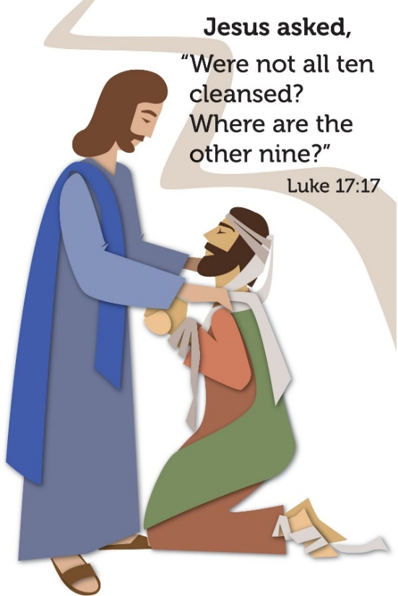

Hymn of the Day #612
Text and music printed under OneLicense.net license A-708005
Creed
I believe in God, the Father almighty,
creator of heaven and earth.
I believe in Jesus Christ, God’s only Son, our Lord,
who was conceived by the Holy Spirit,
born of the virgin Mary,
suffered under Pontius Pilate,
was crucified, died, and was buried;
he descended to the dead.
On the third day he rose again;
he ascended into heaven,
he is seated at the right hand of the Father,
and he will come to judge the living and the dead.
I believe in the Holy Spirit,
the holy catholic church,
the communion of saints,
the forgiveness of sins,
the resurrection of the body,
and the life everlasting. Amen.
QUILT DEDICATION
P: We give thanks for the variety of gifts that have enabled the creation of these quilts: donations of fabric, thread and sewing machines, the faithful people who cut the squares, design the patterns, sew the tops, iron the fabric, make backs and fillers, tie and stitch the bindings, donate boxes, and contribute money for the shipping of these items.
C: We celebrate generosity.
P: We give thanks for the fellowship of all who work together to make the quilts, the laughter, the shared stories, the joy of crafting something with one’s hands and heart for another and the time to reflect and wonder about the recipient.
C: We celebrate community.
P: We send these quilts as a sign of God’s love and blessing for each person who receives one, trusting that these gifts will be a source of comfort and hope in the midst of disaster and fear, a symbol of Christ’s love to those who suffer, a reminder that each recipient is a beloved child of God.
We pray that these quilts will serve a useful purpose in the life of the recipient; that they will bring warmth in the cold, shelter from the sun and heat, a wall for a home, or a carrier for a few precious belongings. May it be a message of care from someone they may never meet.
C: We celebrate hope in the midst of life’s trials.
P: We ask that you bless the fruits of our labor and the whole mission of Lutheran World Relief, that together we may minister to our neighbors in need.
Bless all who give and all who receive, as we are sewn together in the unity of your Holy Spirit, one God, now and forever.
C: Amen
Prayers of Intercession

Set free by the truth of God’s gracious love, we pray for the church, the world, and all of God’s good creation.
Prayers of intercession are prayed.
To each petition, the assembly responds:

Hear us, O God.
Your mercy is great.

The presiding minister concludes the
prayers, and the assembly responds:

Into your hands, faithful God, we place ourselves and our prayers, spoken and unspoken, trusting in your mercy; through Jesus Christ, our Savior.
Amen.

Peace

The peace of Christ be with you always.
And also with you.
The assembly is seated.

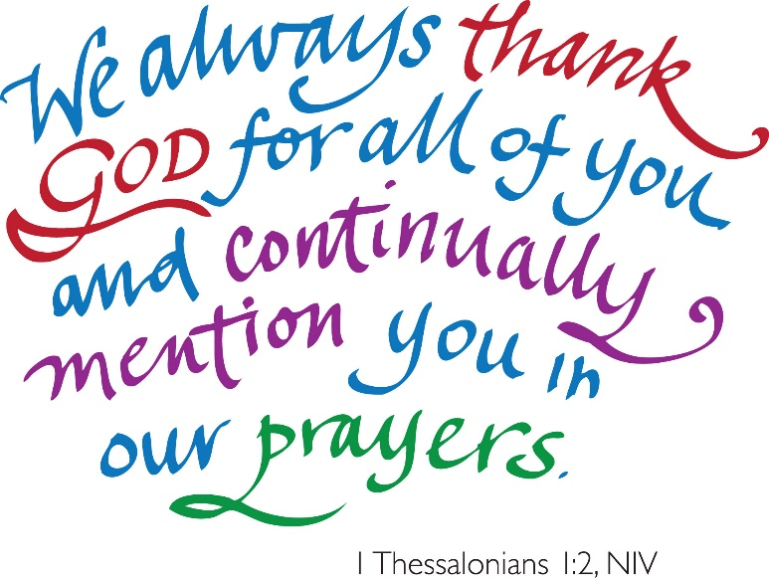
Meal
God feeds us with the presence of Jesus Christ.
OFFERING
Chancel Choir I Will Awaken the Dawn (Martin)

The assembly stands.

OFFERING RESPONSE #691 VS. 1-2
Text and Tune printed under OneLicense.net license A-708005

OFFERING PRAYER

Merciful God, as grains of wheat scattered upon the hills
were gathered together to become on bread,
so let your church be gathered together
from the ends of the earth into your kingdom,
for yours is the glory through Jesus Christ, now and forever.
Amen.

Great Thanksgiving

Dialogue
The Lord be with you.
And also with you.
Lift up your hearts.
We lift them to the Lord.
Let us give thanks to the Lord our God.
It is right to give our thanks and praise.

Preface
It is indeed right, our duty and our joy,
that we should at all times and in all places
give thanks and praise to you, almighty and merciful God,
through our Savior Jesus Christ;
who on this day overcame death and the grave,
and by his glorious resurrection opened to us the way of everlasting life.
And so, with all the choirs of angels,
with the church on earth and the hosts of heaven,
we praise your name and join their unending hymn:

Holy, Holy, Holy
Thanksgiving at the Table

Holy God, our Bread of life, our Table, and our Food, you created a world in which all might be satisfied by your abundance.

You dined with Abraham and Sarah, promising them life, and fed your people Israel with manna from heaven. You sent your Son to eat with sinners and to become food for the world.

In the night in which he was betrayed, our Lord Jesus took bread, and gave thanks; broke it, and gave it to his disciples, saying:
Take and eat; this is my body, given for you. Do this for the remembrance of me.

Again, after supper, he took the cup, gave thanks, and gave it for all to drink, saying: This cup is the new covenant in my blood,
shed for you and for all people for the forgiveness of sin. Do this for the remembrance of me.

Remembering, therefore, his life given for us and his rising from the grave, we await his coming again to share with us the everlasting feast.

By your Spirit nurture and sustain us with this meal: strengthen us to serve all in hunger and want, and by this bread and cup make of us the body of your Son.

Through him all glory and honor is yours, Almighty Father, with the Holy Spirit, in your holy Church, both now and forever.
Amen
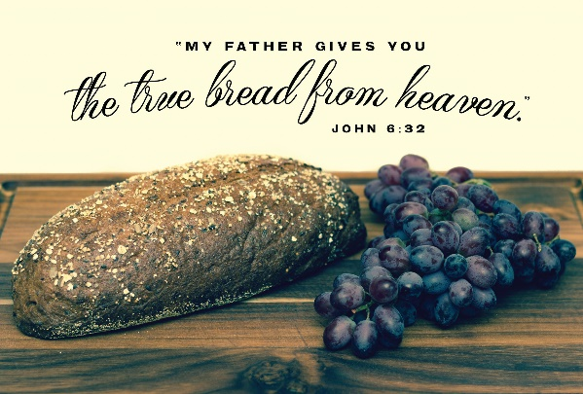

Lord’s Prayer

Gathered into one by the Holy Spirit,
let us pray as Jesus taught us.
Our Father in heaven,
hallowed be your name,
your kingdom come,
your will be done,
on earth as in heaven.
Give us today our daily bread.
Forgive us our sins
as we forgive those
who sin against us.
Save us from the time of trial
and deliver us from evil.
For the kingdom, the power,
and the glory are yours,
now and forever. Amen.

Invitation to Communion

Take hold of the life that really is life.
Come, take your place at the table.

The assembly is seated.

Communion
When giving the bread and cup, the communion ministers say
The body of Christ, given for you.
The blood of Christ, shed for you.
and each person may respond
Amen.

Communion Song

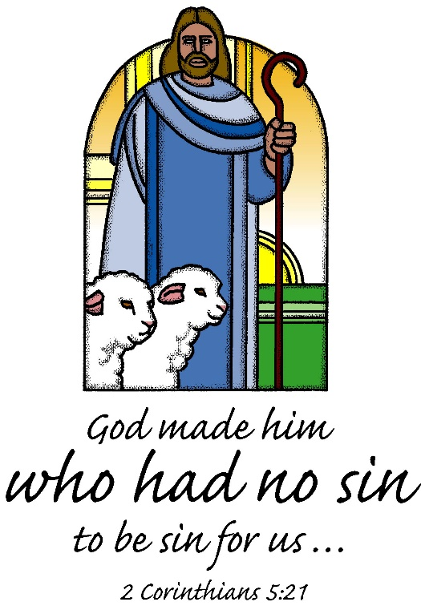

congregational song #617
Text printed under OneLicense.net license A-708005

congregational sonG
Text and music printed under OneLicense.net license A-708005

The assembly stands

The body and blood of our Lord Jesus Christ
strengthen you and keep you in his grace.
Amen

Prayer after Communion

Let us pray.

We come again to you, O God,
giving you thanks that in this feast of mercy
you have embraced us and healed us,
making us one in the body of Christ.

Go with us on our way.
Equip us for every good work,
that we may continue to give you thanks
by embracing others with mercy and healing;
through Jesus Christ, our Savior and Lord.
Amen.

Sending
God blesses us and sends us in mission to the world.

Blessing

God Almighty send you light and truth
to keep you all the days of your life.
The hand of God protect you;
the holy angels accompany you;
and the blessing of almighty God,
the Father, the ☩ Son, and the Holy Spirit,
be with you now and forever.

Amen.

Sending Song #860
Arrangement printed under OneLicense.net license A-708005
Dismissal
Go in peace. Remember the poor.
Thanks be to God.

POSTLUDE
“Concerto 13, Allegro,” G.F. Handel, ed. Rollin Smith

Copyright © 2016 Augsburg Fortress. All rights reserved. Reprinted by permission under Augsburg Fortress Liturgies Annual License #SAS000803. New Revised Standard Version Bible, copyright © 1989, Division of Christian Education of the National Council of the Churches of Christ in the United States of America. Used by permission. All rights reserved. Clipart copyright © 2016 by Communication Resources. All rights reserved. Used by permission.

Welcome to worship at Faith Lutheran Church. We’re blessed by the presence of each person here today!

Pastor Ellen Schoepf prellen@faithlutheranokemos.org
Secretary Katie Love klove@faithlutheranokemos.org
Director of Christian Education Melinda Schultz
Director of Music Debra Borton-McDonough
Organist/Pianist Bruce Williams
October 2nd Attendance: 114

Serving Faith Today October 16th

Acolyte Clayton Wenzel Sami Ransom
Altar Care Rich Weingartner & Melinda Schultz
Communion Assistants Clayton Wenzel Sami Ransom
Doug Hirt Dane Webb
Jack Dingledine David Baker
Greeters Harold Sollenberger Bill & Pam Williams
Lay Assistants Doug Hirt Dane Webb
Readers Jack Dingledine David Baker
Ushers Doug & Linda Hirt Doug & Linda Hirt
Nursery Connie Nelson Jennifer Coe

