Welcome to
Faith Lutheran Church
August 28, 2016

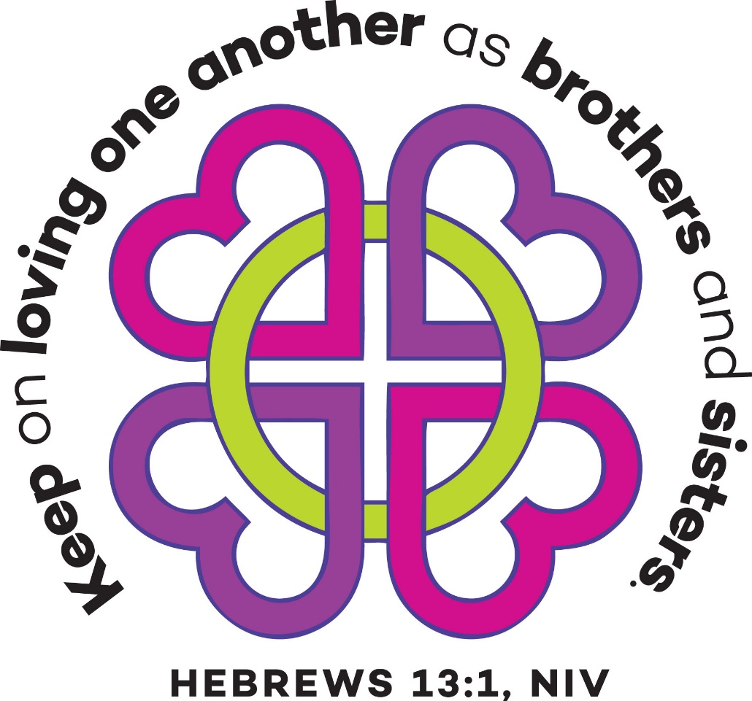

4515 Dobie Road
Okemos MI 48864-2203
517-349-0620

Pastor Ellen Schoepf
prellen@faithlutheranokemos.org

Come, Lord Jesus, Be Our Guest
Jesus knew his place. So, on the occasion of being invited to a sabbath meal, realizing he was being paid attention to and noticing the behavior of the guests, he graciously invited others to find their own blessed places too. He, of course, was asking the guests to sit and dine with him!
In Palestine, Jesus’ world, an invitation to share a meal was an honor reserved most always for family and closest friends. So it is among honored guests that Jesus begins this beautiful meal parable as he eyes them craving and calculating a route to the best places around the table. Listen carefully to Jesus. Pay attention to his words. If you hear only good-hearted encouragement to be charitable to the poor, you miss the lavish blessing Jesus extends to the host and guests.
You will be blessed in the company of the blind and the lame and the crippled and the poor, he says, not because they can repay you as friends and neighbors and relatives might, but because that is precisely where you will find and be with Jesus.
Mary’s song, the Magnificat, found in the first pages of this very gospel that Luke passes on to us, foretells Jesus’ blessings in her voice: “. . . he has lifted up the lowly . . . he has filled the hungry with good things, and sent the rich away empty.” Jesus comes not only among the poor and for the poor, he comes as the poor one—and the lame one and the blind one and the crippled one. And thus, with tender compassion looks to the host saying, “When you make your guest list, continue to invite me.”
At the table of the Lord we are served bread and wine from the poor one himself, whose blessing is the gift of life. Come, Lord Jesus, be our guest. Let these gifts to us be blessed.

Sunday, August 28, 2016
15th Sunday after Pentecost
Holy Communion
INTRODUCTION TO THE DAY

Invited and inviting—that is the nature of the church. By God’s grace in holy baptism we have a place at the banquet table of the Lord. When, by the power of that same Spirit, humility and mutual love continue among us, the church can be more inviting still.

If hearing assistance is needed, please ask an usher for a personal PA receiver.

The ushers also have large print copies of today’s worship folder available.

If it will be difficult for you to stand along with the congregation during
any part of the worship service, please feel free to remain seated.

There is a nursery available during the worship service for those who wish
to use it. It is located at the end of the hall beyond the coat racks.

WELCOME AND ANNOUNCEMENTS

We cordially greet all who have come to worship today.
Please register your attendance and join us in fellowship after the service.

Prayer Requests

PRELUDE

The pre-service music signals the beginning of the worship service. Silence during the
pre-service music enables worshipers to prepare for worship through quiet meditation.

“We Come to the Hungry Feast” arr. David Cherwien

Reference ELW hymn # 479

Gathering
The Holy Spirit calls us together as the people of God.
The assembly stands.
gATHERING song # 531
Text: Graham Kendrick, b. 1950 Music: Graham Kendrick Text & Music printed under CCLI 720217
Text and music © 1989 Make Way Music, admin. Music Servies in the Wetern Hemisphere

Greeting
The grace of our Lord Jesus Christ, the love of God,
and the communion of the Holy Spirit be with you all.
And also with you.

Kyrie

Canticle of Praise
⇒

Prayer of the Day

Let us pray.
Compassionate God, you have assured the human family of eternal life through Jesus Christ. Deliver us from the death of sin, and raise us to new life in your Son, Jesus Christ, our Savior and Lord.
Amen

The assembly is seated.

Word
God speaks to us in scripture reading, preaching, and song.

First Reading: Proverbs 25:6-7

The book of Proverbs is part of a collection of writings known as wisdom literature. Wisdom literature gave directions to Israel’s leaders and people for the conduct of daily life. Today’s reading is about humility.
A reading from Proverbs.

⁶Do not put yourself forward in the king’s presence
or stand in the place of the great;
⁷for it is better to be told, “Come up here,”
than to be put lower in the presence of a noble.

The word of the Lord.
Thanks be to God.

Psalm: Psalm 112

Read responsively

¹Hallelujah! Happy are they who fear the Lord
and have great delight in God’s commandments!
²Their descendants will be mighty in the land;
the generation of the upright will be blessed.
³Wealth and riches will be in their house,
and their righteousness will last forever.
⁴Light shines in the darkness for the upright;
the righteous are merciful and full of compassion.
⁵It is good for them to be generous in lending
and to manage their affairs with justice.
⁶For they will never be shaken;
the righteous will be kept in everlasting remembrance.

⁷They will not be afraid of any evil rumors;
their heart is steadfast, trusting in the Lord.
⁸Their heart is established and | will not shrink,
until they see their desire upon their enemies.
⁹They have given freely to the poor, and their righteousness
stands fast forever; they will hold up their head with honor.
¹⁰The wicked will see it and be angry; they will gnash their
teeth and pine away; the desires of the wicked will perish.

Second Reading: Hebrews 13:1-8, 15-16

The conclusion of the letter to the Hebrews contains suggestions for the conduct of a holy life, all of which are shaped by God’s love toward us in Jesus Christ.
A reading from Hebrews.

¹Let mutual love continue. ²Do not neglect to show hospitality to strangers, for by doing that some have entertained angels without knowing it. ³Remember those who are in prison, as though you were in prison with them; those who are being tortured, as though you yourselves were being tortured. ⁴Let marriage be held in honor by all, and let the marriage bed be kept undefiled; for God will judge fornicators and adulterers. ⁵Keep your lives free from the love of money, and be content with what you have; for he has said, “I will never leave you or forsake you.” ⁶So we can say with confidence,
“The Lord is my helper;
I will not be afraid.
What can anyone do to me?”
⁷Remember your leaders, those who spoke the word of God to you; consider the outcome of their way of life, and imitate their faith. ⁸Jesus Christ is the same yesterday and today and forever. ¹⁵Through him, then, let us continually offer a sacrifice of praise to God, that is, the fruit of lips that confess his name. ¹⁶Do not neglect to do good and to share what you have, for such sacrifices are pleasing to God.

The word of the Lord.
Thanks be to God.

Gospel Acclamation

Gospel: Luke 14:1, 7-14
Jesus observes guests jockeying for position at the table. He uses the opportunity to teach his hearers to choose humility rather than self-exaltation. Jesus also makes an appeal for hosts to mimic God’s gracious hospitality to the poor and the broken.

The holy gospel according to Luke.
Glory to you, O Lord.

¹On one occasion when Jesus was going to the house of a leader of the Pharisees to eat a meal on the sabbath, they were watching him closely.
⁷When he noticed how the guests chose the places of honor, he told them a parable. ⁸“When you are invited by someone to a wedding banquet, do not sit down at the place of honor, in case someone more distinguished than you has been invited by your host; ⁹and the host who invited both of you may come and say to you, ‘Give this person your place,’ and then in disgrace you would start to take the lowest place. ¹⁰But when you are invited, go and sit down at the lowest place, so that when your host comes, he may say to you, ‘Friend, move up higher’; then you will be honored in the presence of all who sit at the table with you. ¹¹For all who exalt themselves will be humbled, and those who humble themselves will be exalted.”
¹²He said also to the one who had invited him, “When you give a luncheon or a dinner, do not invite your friends or your brothers or your relatives or rich neighbors, in case they may invite you in return, and you would be repaid. ¹³But when you give a banquet, invite the poor, the crippled, the lame, and the blind. ¹⁴And you will be blessed, because they cannot repay you, for you will be repaid at the resurrection of the righteous.”

The gospel of the Lord.
Praise to you, O Christ.

The assembly is seated.

Children’s Message

Sermon

The assembly stands to proclaim the word of God in song

Hymn of the Day #523
Music and Text printed under OneLicense.net license A-708005
Creed
I believe in God, the Father almighty,
creator of heaven and earth.
I believe in Jesus Christ, God’s only Son, our Lord,
who was conceived by the Holy Spirit,
born of the virgin Mary,
suffered under Pontius Pilate,
was crucified, died, and was buried;
he descended to the dead.
On the third day he rose again;
he ascended into heaven,
he is seated at the right hand of the Father,
and he will come to judge the living and the dead.
I believe in the Holy Spirit,
the holy catholic church,
the communion of saints,
the forgiveness of sins,
the resurrection of the body,
and the life everlasting. Amen.

Prayers of Intercession

Rooted in Christ and rising to serve,
let us pray for the church, the world, and all in need.

Prayers of intercession are prayed.
To each petition, the assembly responds:

Hear us, O God.
Your mercy is great.

The presiding minister concludes the
prayers, and the assembly responds:

We lift our prayers to you, O God, trusting your
promise to hear us; through Jesus Christ our Lord.
Amen.

Peace

The peace of Christ be with you always.
And also with you.

The people may greet one another with a sign of Christ’s peace, and may say, “Peace be with you,” or similar words.
The assembly is seated.

Meal
God feeds us with the presence of Jesus Christ.
OFFERING

Debra Borton-McDonough “Precious Jesus” Althouse

The assembly stands

Offering Prayer

God of mercy and grace, the eyes of all wait upon you,
and you open your hand in blessing. Fill us with good
things at your table, that we may come to the help of
all in need, through Jesus Christ, our redeemer and Lord.
Amen.

Great Thanksgiving

Dialogue

The Lord be with you.
And also with you.

Lift up your hearts.
We lift them to the Lord.

Let us give thanks to the Lord our God.
It is right to give our thanks and praise.

Preface

It is indeed right, our duty and our joy,
that we should at all times and in all places
give thanks and praise to you, almighty and
merciful God, through our Savior Jesus Christ;
who on this day overcame death and the grave,
and by his glorious resurrection opened to us the
way of everlasting life.

And so, with all the choirs of angels,
with the church on earth and the hosts of heaven,
we praise your name and join their unending hymn:

Thanksgiving at the Table

Holy, mighty, and merciful Lord,
heaven and earth are full of your glory.

In great love you sent to us Jesus, your Son,
who reached out to heal the sick and suffering,
who preached good news to the poor,
and who, on the cross, opened his arms to all.

In the night in which he was betrayed,
our Lord Jesus took bread, and gave thanks;
broke it, and gave it to his disciples, saying:
Take and eat; this is my body, given for you.

Do this for the remembrance of me.
Again, after supper, he took the cup, gave thanks,
and gave it for all to drink, saying:
This cup is the new covenant in my blood,
shed for you and for all people for the forgiveness of sin.
Do this for the remembrance of me.

Remembering, therefore, his death, resurrection, and ascension,
we await his coming in glory.
Pour out upon us the Spirit of your love, O Lord,
and unite the wills of all who share this heavenly food,
the body and blood of Jesus Christ, our Lord;
to whom, with you and the Holy Spirit,
be all honor and glory, now and forever.

Amen.

Lord’s Prayer

Gathered into one by the Holy Spirit,
let us pray as Jesus taught us.
Our Father in heaven,
hallowed be your name,
your kingdom come,
your will be done,
on earth as in heaven.
Give us today our daily bread.
Forgive us our sins
as we forgive those
who sin against us.
Save us from the time of trial
and deliver us from evil.
For the kingdom, the power,
and the glory are yours,
now and forever. Amen.

Invitation to Communion

Come to the banquet, for all is now ready.
The assembly is seated.

Communion
When giving the bread and cup, the communion ministers say
The body of Christ, given for you.
The blood of Christ, shed for you.
and each person may respond
Amen.

Communion Song

Congregational Song

What Feast of Love #487
please use the hymnal next to your seat.

CONGREGATIONAL SONG #479
Text and Music printed under OneLicense.net license A-708005

The assembly stands.
The body and blood of our Lord Jesus Christ
Strengthen you and keep you in his grace.

Prayer after Communion

O God, as a mother comforts her child,
so you comfort your people,
carrying us in your arms
and satisfying us with this food and drink,
the body and blood of Christ.
Send us now as your disciples,
announcing peace and proclaiming
that the reign of God has come near;
through Jesus Christ, our Savior and Lord.
Amen.

Sending
God blesses us and sends us in mission to the world.

Blessing
The Lord bless you and keep you.
The Lord’s face shine upon you with grace and mercy.
The Lord look upon you with favor
and ☩ give you peace.
Amen.

Sending Song
Text and Arrangement printed under OneLicense.net license A-708005
Dismissal
Go in peace. Proclaim the good news.
Thanks be to God.

POSTLUDE
“Voluntary VI, Spiritoso” Samuel Wesley

Copyright © 2016 Augsburg Fortress. All rights reserved. Reprinted by permission under Augsburg Fortress Liturgies Annual License #SAS000803.New Revised Standard Version Bible, copyright © 1989, Division of Christian Education of the National Council of the Churches of Christ in the United States of America. Used by permission. All rights reserved.
Clipart copyright © 2016 by Communication Resources. All right reserved. Used by permission.

Psalms 81:1 (ESV) invites us, “Sing aloud to God our strength; shout for joy to the God of Jacob!” And so we will. Welcome to worship!

Pastor Ellen Schoepf prellen@faithlutheranokemos.org
Secretary Katie Love klove@faithlutheranokemos.org
Director of Christian Education Melinda Schultz
Director of Music Debra Borton-McDonough
Organist/Pianist Bruce Williams

Serving Faith Today September 4

Acolyte

Alter care Becky and Gretchen Bills Kay Showers
Gwynne Kadrofske
Communion assistants Harold Sollenberger Diane Wilke
John McCracken Karen Whitmeyer
Greeters Ken & Karen Whitmyer Mike Eschelbach
Lay Assistants Harold Sollenberger Diane Wilke
Readers John McCracken Karen Whitmeyer
Ushers Dingledine Family
Nursery Alexis Hereza Corey & Kim

