Welcome to Faith Lutheran Church

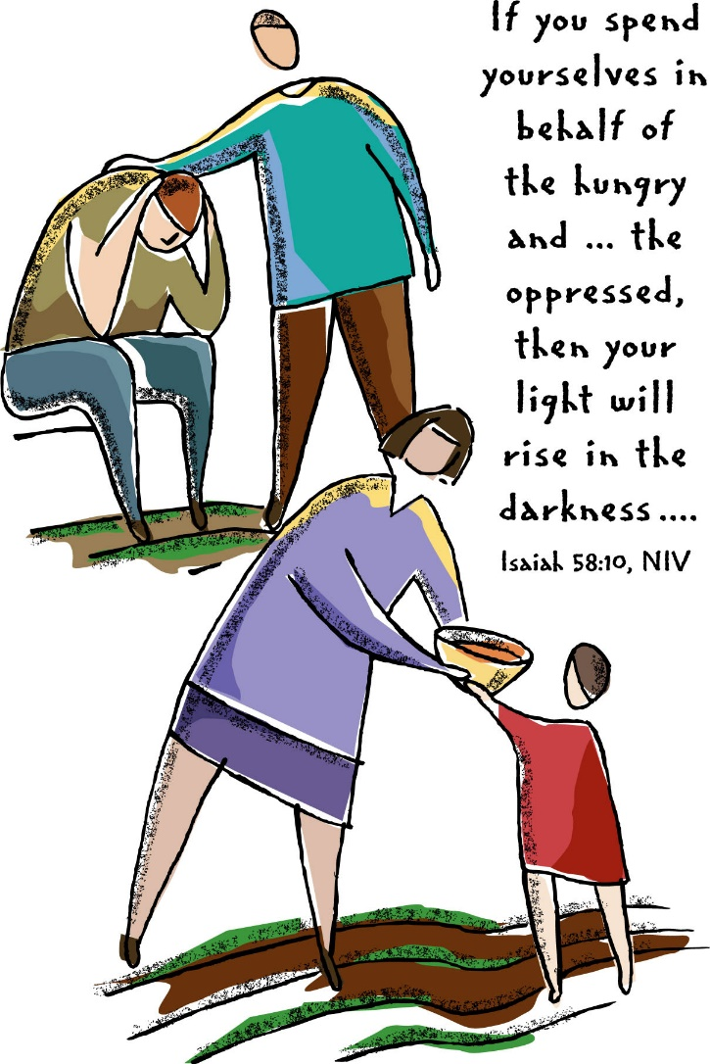
4515 Dobie Road
Okemos MI 48864-2203
517-349-0620

Pastor Ellen Schoepf
prellen@faithlutheranokemos.org

Now. Doing.
Look at the first word of today’ gospel reading. NOW. Notice the last word. DOING. These are fitting bookends for the collection of stories about the mercy of Jesus, the timing of his grace, and the occurrence of his compassion. Now. Doing.
This episode in the synagogue repeatedly draws attention to time. It was the sabbath, a set-aside time for unbinding the scrolls to set God’s word free from the wrapping of scriptures. Eighteen years, a long span of suffering time for a woman, bent low because of a crippling spirit, quite unable to stand up straight. And then the very present moment in time when Jesus’ eyes fell upon her. He called her to himself and immediately in time she was set free from bondage. Then comes time delay—six other days—another time for tending to crippling spirits and bent bodies.
But! But, but, but . . . in no time at all, indignant objections began to rise up against Jesus beside the rising frame of the woman so long wrapped in bondage. Protesting and praising contested with one another, and it seemed to be about timing.
At another time, recorded earlier in Luke (chapter 4), the time when Jesus began his ministry, he was in the synagogue in Nazareth on the sabbath day. There, then, he unbound the scroll and began to read from Isaiah: “The Spirit of the Lord is upon me . . . He has sent me to proclaim release . . . and recovery . . . to let the oppressed go free . . .” And then Jesus said, “Today . . .” NOW. DOING.
No well- or ill-intentioned indignation or objection will cripple Jesus’ mercy. In him, law is trumped by gospel. All the wrappings of bondage open a way to freedom, shame rises into joy, and all commandments submit to the one commandment of love.
Now. Doing.

Sunday, August 21, 2016
Fourteenth Sunday after Pentecost
Holy Communion

Introduction to the day
Remember the sabbath day. Call the sabbath a delight. This is the Lord’s day, and the Lord will do for us what the Lord does: feed us, forgive us, help and heal us. Rejoice at all the wonderful things God is doing.

If hearing assistance is needed, please ask an usher for a personal PA receiver.

The ushers also have large print copies of today’s worship folder available.

If it will be difficult for you to stand along with the congregation during
any part of the worship service, please feel free to remain seated.

There is a nursery available during the worship service for those who wish
to use it. It is located at the end of the hall beyond the coat racks.

WELCOME AND ANNOUNCEMENTS

We cordially greet all who have come to worship today.
Please register your attendance and join us in fellowship after the service.

Prayer Requests

PRELUDE

The pre-service music signals the beginning of the worship service. Silence during the
pre-service music enables worshipers to prepare for worship through quiet meditation.

“Thy Holy Wings” arr. Richard Webster

Reference ELW #613

Gathering
The Holy Spirit calls us together as the people of God.
The assembly stands.

Confession and Forgiveness

All may make the sign of the cross, the sign marked
at baptism, as the presiding minister begins.
Blessed be the holy Trinity, ☩ one God,
abounding in steadfast love toward us,
healing the sick and raising the dead,
showering us with every good gift.
Amen.

Let us confess our sin
in the presence of God and of one another.

Silence is kept for reflection.
Just and gracious God,
we come to you for healing and life.
Our sins hurt others and diminish us;
we confess them to you.
Our lives bear the scars of sin;
we bring these also to you.
Show us your mercy, O God.
Bind up our wounds,
forgive us our sins,
and free us to love,
for the sake of Jesus Christ, our Savior.
Amen.

The apostle Paul assures us:
“When we were dead in our trespasses,
God made us alive together with Christ,
nailing the record of our sins to the cross.”
Jesus says to you, ☩ “Your sins are forgiven.”
Be at peace, and tell everyone
how much God has done for you.
Amen.
Gathering Song #625

Greeting

The grace of our Lord Jesus Christ, the love of God,
and the communion of the Holy Spirit be with you all.
And also with you.

Canticle of Praise
Prayer of the Day

Let us pray.
O God, mighty and immortal, you know that as fragile creatures surrounded by great dangers, we cannot by ourselves stand upright. Give us strength of mind and body, so that even when we suffer because of human sin, we may rise victorious through your Son, Jesus Christ, our Savior and Lord.
Amen.

The assembly is seated.

Word
God speaks to us in scripture reading, preaching, and song.
First Reading: Isaiah 58:9b-14

The Lord promises those who have returned from exile that where justice and mercy prevail, the ruins will be rebuilt and light will rise in the darkness. It is a day for new beginnings.
A reading from Isaiah.

^{9b}If you remove the yoke from among you,
the pointing of the finger, the speaking of evil,
¹⁰if you offer your food to the hungry
and satisfy the needs of the afflicted,
then your light shall rise in the darkness
and your gloom be like the noonday.
¹¹The Lord will guide you continually,
and satisfy your needs in parched places,
and make your bones strong;
and you shall be like a watered garden,
like a spring of water,
whose waters never fail.
¹²Your ancient ruins shall be rebuilt;
you shall raise up the foundations of many generations;
you shall be called the repairer of the breach,
the restorer of streets to live in.
¹³If you refrain from trampling the sabbath,
from pursuing your own interests on my holy day;
if you call the sabbath a delight
and the holy day of the Lord honorable;
if you honor it, not going your own ways,
serving your own interests, or pursuing your own affairs;
¹⁴then you shall take delight in the Lord,
and I will make you ride upon the heights of the earth;
I will feed you with the heritage of your ancestor Jacob,
for the mouth of the Lord has spoken.

The word of the Lord.
Thanks be to God.

Second Reading: Hebrews 12:18-29

Using images of Moses from the Old Testament, the writer presents a striking vision of the new covenant of God made possible in Christ. There is no longer fear; only awe in the new promise in Christ into which we are invited.

A reading from Hebrews.

¹⁸You have not come to something that can be touched, a blazing fire, and darkness, and gloom, and a tempest, ¹⁹and the sound of a trumpet, and a voice whose words made the hearers beg that not another word be spoken to them. ²⁰(For they could not endure the order that was given, “If even an animal touches the mountain, it shall be stoned to death.” ²¹Indeed, so terrifying was the sight that Moses said, “I tremble with fear.”) ²²But you have come to Mount Zion and to the city of the living God, the heavenly Jerusalem, and to innumerable angels in festal gathering, ²³and to the assembly of the firstborn who are enrolled in heaven, and to God the judge of all, and to the spirits of the righteous made perfect, ²⁴and to Jesus, the mediator of a new covenant, and to the sprinkled blood that speaks a better word than the blood of Abel.
²⁵See that you do not refuse the one who is speaking; for if they did not escape when they refused the one who warned them on earth, how much less will we escape if we reject the one who warns from heaven! ²⁶At that time his voice shook the earth; but now he has promised, “Yet once more I will shake not only the earth but also the heaven.” ²⁷This phrase, “Yet once more,” indicates the removal of what is shaken—that is, created things—so that what cannot be shaken may remain. ²⁸Therefore, since we are receiving a kingdom that cannot be shaken, let us give thanks, by which we offer to God an acceptable worship with reverence and awe; ²⁹for indeed our God is a consuming fire.

The word of the Lord.
Thanks be to God.
The assembly stands to welcome the gospel.

GOSPEL ACCLAMATION
Gospel: Luke 13:10-17
Jesus heals a woman on the sabbath, offering her a new beginning for her life. When challenged by a narrow reading of the sabbath command, Jesus responds by expanding “sabbath work” to include setting people free from bondage.

The holy gospel according to Luke.
Glory to you, O Lord.

¹⁰Now [Jesus] was teaching in one of the synagogues on the sabbath. ¹¹And just then there appeared a woman with a spirit that had crippled her for eighteen years. She was bent over and was quite unable to stand up straight. ¹²When Jesus saw her, he called her over and said, “Woman, you are set free from your ailment.” ¹³When he laid his hands on her, immediately she stood up straight and began praising God. ¹⁴But the leader of the synagogue, indignant because Jesus had cured on the sabbath, kept saying to the crowd, “There are six days on which work ought to be done; come on those days and be cured, and not on the sabbath day.” ¹⁵But the Lord answered him and said, “You hypocrites! Does not each of you on the sabbath untie his ox or his donkey from the manger, and lead it away to give it water? ¹⁶And ought not this woman, a daughter of Abraham whom Satan bound for eighteen long years, be set free from this bondage on the sabbath day?” ¹⁷When he said this, all his opponents were put to shame; and the entire crowd was rejoicing at all the wonderful things that he was doing.

The gospel of the Lord.
Praise to you, O Christ.

The assembly is seated.

cHILDREN’S MESSAGE

Sermon

The assembly stands to proclaim the word of God in song.

Hymn of the Day
Text and arrangement printed under OneLicense.net license A-708005 ⇒

Creed
I believe in God, the Father almighty,
creator of heaven and earth.
I believe in Jesus Christ, God’s only Son, our Lord,
who was conceived by the Holy Spirit,
born of the virgin Mary,
suffered under Pontius Pilate,
was crucified, died, and was buried;
he descended to the dead.
On the third day he rose again;
he ascended into heaven,
he is seated at the right hand of the Father,
and he will come to judge the living and the dead.
I believe in the Holy Spirit,
the holy catholic church,
the communion of saints,
the forgiveness of sins,
the resurrection of the body,
and the life everlasting. Amen.
Prayers of Intercession

Rooted in Christ and rising to serve,
let us pray for the church, the world, and all in need.

Prayers of intercession are prayed.
To each petition, the assembly responds:

Hear us, O God.
Your mercy is great.

The presiding minister concludes the
prayers, and the assembly responds:

We lift our prayers to you, O God, trusting your promise to hear us; through Jesus Christ our Lord.
Amen.

Peace

The peace of Christ be with you always.
And also with you.

The people may greet one another with a sign of Christ’s peace, and may say, “Peace be with you,” or similar words.
The assembly is seated.

Meal
God feeds us with the presence of Jesus Christ.

OFFERING

Tammy Heilman, solo “His Eye Is On the Sparrow” Gabriel

The assembly stands.

Offering Prayer

Let us pray.
God of mercy and grace, the eyes of all wait upon you, and you open your hand in blessing. Fill us with good things at your table, that we may come to the help of all in need, through Jesus Christ, our redeemer and Lord.
Amen.

Great Thanksgiving

Dialogue

The Lord be with you.
And also with you.
Lift up your hearts.
We lift them to the Lord.
Let us give thanks to the Lord our God.
It is right to give our thanks and praise.

Preface

It is indeed right, our duty and our joy,
that we should at all times and in all places
give thanks and praise to you, almighty and merciful God,
through our Savior Jesus Christ;
who on this day overcame death and the grave,
and by his glorious resurrection opened to us the way of everlasting life.
And so, with all the choirs of angels,
with the church on earth and the hosts of heaven,
we praise your name and join their unending hymn:

Holy, Holy, Holy

Thanksgiving at the Table (ELW p. 173)

Holy, mighty, and merciful Lord,
heaven and earth are full of your glory.
In great love you sent to us Jesus, your Son,
who reached out to heal the sick and suffering,
who preached good news to the poor,
and who, on the cross, opened his arms to all.

In the night in which he was betrayed,
our Lord Jesus took bread, and gave thanks;
broke it, and gave it to his disciples, saying:
Take and eat; this is my body, given for you.
Do this for the remembrance of me.

Again, after supper, he took the cup, gave thanks,
and gave it for all to drink, saying:
This cup is the new covenant in my blood,
shed for you and for all people for the forgiveness of sin.
Do this for the remembrance of me.

Remembering, therefore, his death,
resurrection, and ascension,
we await his coming in glory.
Pour out upon us the Spirit of your love, O Lord,
and unite the wills of all who share this heavenly food,
the body and blood of Jesus Christ, our Lord;
to whom, with you and the Holy Spirit,
be all honor and glory, now and forever.
Amen.

Lord’s Prayer

Gathered into one by the Holy Spirit,
let us pray as Jesus taught us.
Our Father in heaven,
hallowed be your name,
your kingdom come,
your will be done,
on earth as in heaven.
Give us today our daily bread.
Forgive us our sins
as we forgive those
who sin against us.
Save us from the time of trial
and deliver us from evil.
For the kingdom, the power,
and the glory are yours,
now and forever. Amen.

Invitation to Communion

Christ invites you to a place of honor at this banquet.
Welcome to the feast.

The assembly is seated.

Communion
When giving the bread and cup, the communion ministers say
The body of Christ, given for you.
The blood of Christ, shed for you.
and each person may respond
Amen.

Communion Song

CONGREGATIONAL SONG #614
CONGREGATIONAL SONG #612
Text and music printed under OneLicesnse.net license A-708005

The assembly stands.

the body and blood of our Lord Jesus Christ strengthen you and keep you in his grace.
Amen.

PRAYER AFTER COMMUNION

Let us pray.
O God, as a mother comforts her child,
so you comfort your people, carrying us in your arms and satisfying us with this food and drink, the body and blood of Christ.

Send us now as your disciples,
Announcing peace and proclaiming
That the reign of God has come near;
Through Jesus Christ, our Savior and Lord.
Amen

Sending
God blesses us and sends us in mission to the world.

Sending of Communion

Blessing
The Lord bless you and keep you.
The Lord’s face shine upon you with grace and mercy.
The Lord look upon you with favor
and ☩ give you peace.
Amen.

Sending Song (vs. 1-4) #627
Text printed under OneLicese.net license A-708005

Dismissal
Go in peace. Proclaim the good news.
Thanks be to God.
POSTLUDE
“O Day Full of Grace” arr. Wayne Wold
Reference ELW Hymn #627

Copyright © 2016 Augsburg Fortress. All rights reserved. Reprinted by permission under Augsburg Fortress Liturgies Annual License #SAS000803.
New Revised Standard Version Bible, copyright © 1989, Division of Christian Education of the National Council of the Churches of Christ in the United States of America. Used by permission. All rights reserved.
Clipart copyright © 2016 by Communication Resources. All rights reserved. Used by permission.

We worship in the name of God, the Maker of heaven and earth; Jesus, the Messiah who teaches us how to serve others; and the Holy Spirit, counselor, comforter, cultivator of faith. Amen.

Pastor Ellen Schoepf prellen@faithlutheranokemos.org
Secretary Katie Love klove@faithlutheranokemos.org
Director of Christian Education Melinda Schultz
Director of Music Debra Borton-McDonough
Organist/Pianist Bruce Williams

July 14th worship attendance:79

Serving Faith Today August 28

Acolyte
Alter Care Becky Bills and Gretchen Bills
Communion Assistants Alyssa Magyar Harold Sollenberger Nathan Nelson John McCracken
Greeters Mark & Molly DeHate Ken & Karen Whitmyer
Lay Assistants Alyssa Magyar Harold Sollenberger
Readers Nathan Nelson John McCracken
Ushers
Nursery Jennifer & Maia Guenther Alexis Hereza

