**ANNOUNCEMENTS**

FaithFamily&Friends3

**August 7, 2016**

*Log onto Faith’s website www.faithlutheranokemos.org 24/7 for updates*

**DEADLINES**

Sunday worship folder announcements⎯Tuesday of each week

Submit to Katie at klove@faithlutheranokemos.org

***September Faith Family News newsletter*⎯Monday August 15th**

Submit to Taylor Belonga tay3394@yahoo.com

**PRAYERS OF INTERCESSION**

Please lift up in prayer this week:

🕆 Members—Max Ambs, Lowell Barricklow, Ellen Milne and Harry Nawrock

🕆 Friends and family—

Pat Belonga, Chris Cotter, Tim Drummond, Dick and Lil Jennings,

Terrie Becker; Christine, Izzy and Danny Loewen; Allie, Heather, Al,

Lilly, Sai Eshwar Lingamgunta, Jenn Leitch, Jeanne and Leonard,

Tom Brown, Susan Heft

🕆 Our mission partner congregation⎯Lansing Redeemer Lutheran Church

🕆 Those in military service⎯Jon Schoepf, Lani Yearicks

and Melody and Adam Wright

🕆 Lutheran Social Services of Michigan children who seek adoption—

Precious, Elijah, Emanuel and Isaiah. Pray for each to be adopted and

for Jesus to be their lifelong friend.

**NORTH/WEST LOWER MICHIGAN SYNOD PRAYER PARTNER**

As Jesus calls us to be one, even as he and the Father are one, please include

Pastor Karleen Kinker and the congregation of St. John’s Lutheran Church of Three Rivers in your prayers of intercession this week.

**ALTAR FLOWER DEDICATIONS**

Today’s altar flowers are given to the glory of God by. . .

Vase 1 Brenda, Becca, Katy, Austin and Ciara in celebration of Walter’s birthday.

Vase 2 Harry Nawrock, Kathy, Carl and Emily Richardson in memory of Rose Marie Nawrock

**FINANCIAL UPDATE**

Weekly Offering 07/31/16 Year-to-date as of 06/30/2016

General Fund $6,090.00 Income $144,728.34

Loose cash 52.00 Expenses 150,066.73

Loose checks 90.00

Flowers 75.00 Net Income $(5,338.39)

Capital Repairs 100.00

Youth 269.95

World Hunger 75.00

Facility Rental 50.00

Other 1065.00

Total $7,866.95

Simply Giving $ 0.00

THIS WEEK’S CHRONOLOGY OF EVENTS

Twelfth Sunday after Pentecost

**TODAY**

10:00 a.m. WORSHIP: VBS Celebration

11:30 a.m. Worship Committee Meeting

Deadline Today: Order your “God’s work. Our hands” t- shirt. Add your name to the sign-up sheet you will find in the narthex. Shirts will cost $7/person.

Tickets for 60th Anniversary Celebration are available today in the Narthex.

Monday, August 8

Tuesday, August 9

Worship folder announcements deadline

12:00 p.m. Lunch lectionary study group in Pastor Ellen’s office

Wednesday, August 10

7:30 a.m. Men’s study group in the library

9:30 a.m. Quilting and Samaritas ACTION

7:00 p.m. Evening of Conversation about RACE, ETHNICITY, RELIGION & CULTURE: LEARNING ABOUT ISLAM with Imam Schail Chaudhry from the East Lansing Islamic Center.

Thursday, August 11

11:30 a.m. Caregivers Support Group

2-8:30 p.m. Lifetouch Photos: By Appointment

Friday, August 12

2-8:30 p.m. Lifetouch Photos: By Appointment

Saturday, August 13

9:30 -4 p.m. Lifetouch Photos: By Appointment

**Picture Day Hosts**

Hosts are needed on August 11,12,13 and September 6 and 7.

Hosts will greet members when they arrive. The shifts are about 4 hrs.

Please call Linda Gerard to sign up.

517-349-9487 Thank you!

LOOKING AHEAD

AUGUST STEWARDSHIP FOCUS: ADOPT-A-SCHOOL

Watch for back-to-school sales and pick up items for the August Stewardship school supplies collection. We hope to supply items

needed by the Reo Elementary School near our synod mission partner church Redeemer Lutheran. Here are the items to watch for—dry erase markers, crayons, washable markers, colored pencils, Play Dough, scissors, water paints, shaving cream (to practice writing in), sidewalk chalk, bubbles and more bubbles and kinetic sand. . .and more listed on Faith@Work board.

**CARING COMMITTEE NEWS**

In one month children in our community will be go back to school. They will need to start their day with a healthy breakfast. You can help make sure that happens by joining the Caring Committee in the annual Back-to-School Breakfast Bag Food Drive. Individuals, families and committees are encouraged to shop for any or all of the following items:

* Oatmeal
* Cold Cereal
* Pancake Mix
* Syrup
* Canned Fruit
* Muffin Mix
* Juice
* Jelly
* Peanut Butter
* Breakfast Bars
* Instant Breakfast Drinks

Place your food donations in the grocery cart between now and September. With cash donations we will purchase milk, bread and eggs. There will also be a sign-up sheet hanging on the Committee Information board.

Thank you Faith Family for your care, concern and desire to help others in our community in HIS name.

CARE GIVING MEETING – UPCOMING DATES AND TOPICS

Join us at 11:30am for a light lunch and discussion. All are Welcome!

Thursday, August 11th at 11:30- Funeral Planning with Mike Lehman of Lehman Funeral Homes

Thursday, September 8th - Barb Mannino with Tri-County Office of Aging, speaking on “Residential Living outside of the Lansing Area.

Thursday October 13th: Kris Abbey, the Bereavement Coordinator at Hospice of Lansing will speak on Healthy Grieving.

SIXTY PLUS AND MINUS – SAVE THESE DATES!

Wednesday, August 17 at 11:30 a.m.

Come to Coral Gables for a bite of lunch! Sharing your summer adventures with friends from Faith can be fun and give new direction to wrapping up the carefree days of late summer and early fall.



**Wednesday, September 21 at 11:30 a.m.**

Join us for the first Fall gathering of the Sixty +/- group in the Fellowship Hall

Special Guest:

Roger Hoopengarner (from University Lutheran) is a retired

MSU professor who has spent his career studying the use of bees in pollinizing crops in the USA and around the world.  His power point presentation will challenge and inform us of current

concern re the deadly virus that has mysteriously affected the colonies of bees so vital to agricultural life.

This event will begin with one of Faith's famous Potlucks! Bring a favorite dish to pass and bring a friend!

COMMUNITY PICNIC AND CONCERT HERE AT FAITH

SATURDAY, AUGUST 27 – 4:00-7:30 P.M.

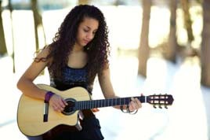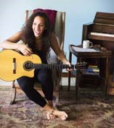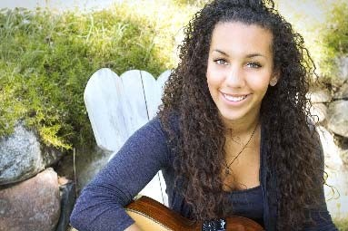

Bring your lawn chair

Join us for free picnic food

Enjoy the music of Taylor Taylor

Taylor is a 19-year-old native of Lansing with African American and Colombian roots. She has been cultivating her jazzy-pop style with classical guitar skills, warm, charismatic vocals and lyrical songwriting, which reveal her intelligence beyond her years. For Taylor’s complete bio, go to taylortaylormusic.com.

“GOD’S WORK. OUR HANDS.” SUNDAY September 11

On the afternoon of Sunday, September 11, ELCA churches all over the country will be participating in “God’s work. Our hands.” service projects.

We will be participating in this effort. At this point in time we are not certain what our service project will entail; however, we will be doing something that connects to make a difference in the lives of “first responders” in Meridian Township. Please mark your calendars for this event. And, if you wish to purchase a “God’s work. Our hands” shirt, add your name to the sign-up sheet you will find in the narthex. Shirts will cost $7/person. **Deadline to order is TODAY!**

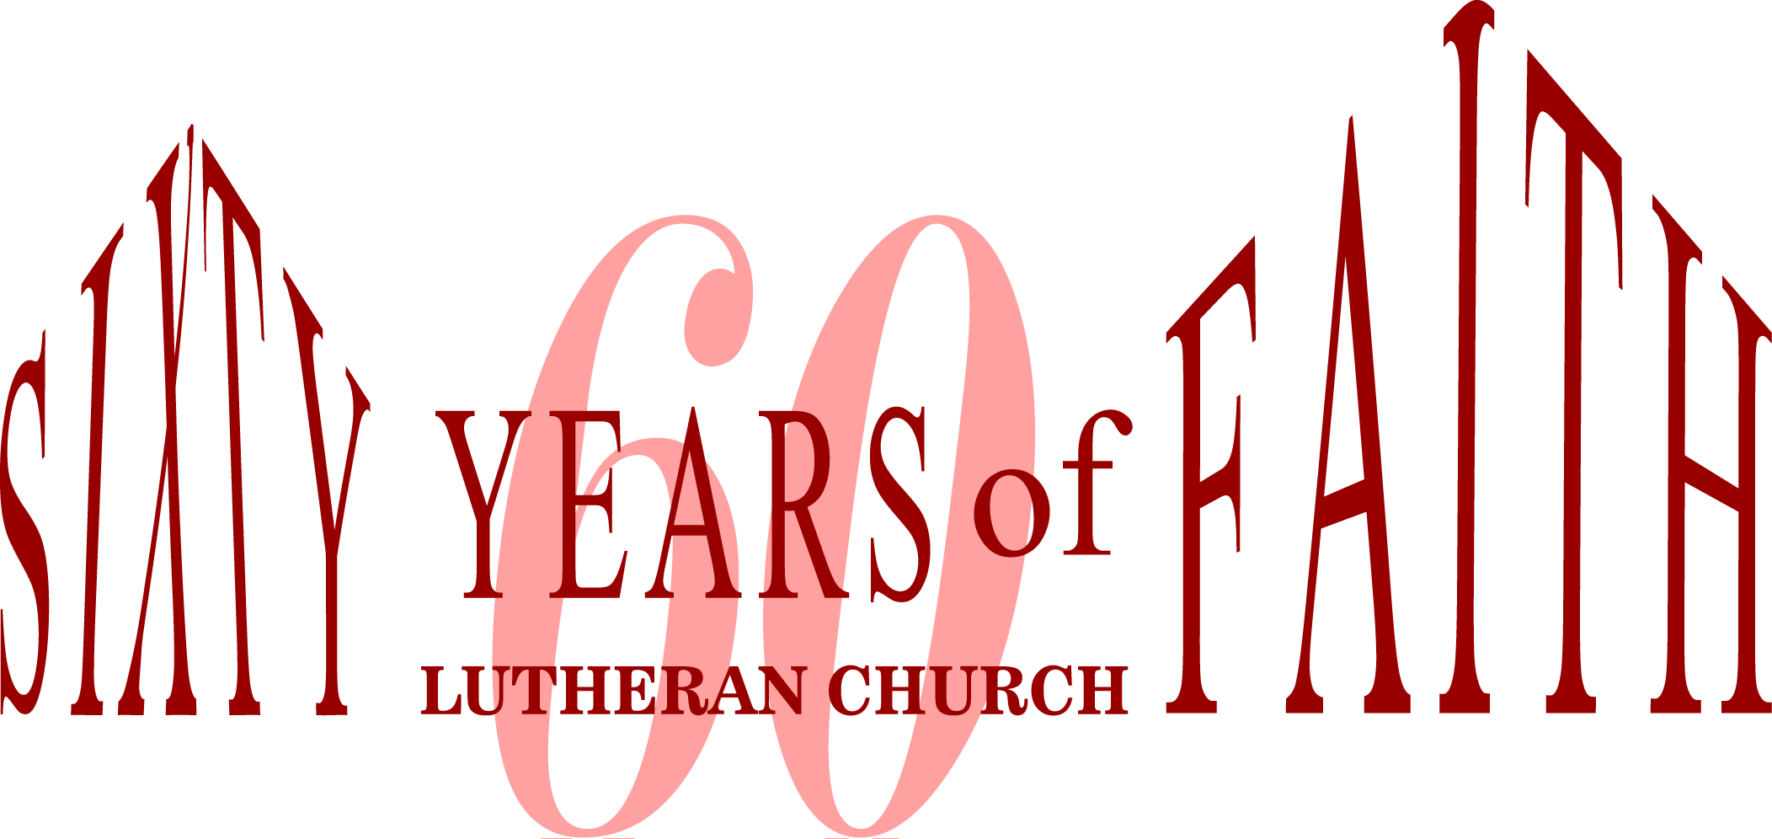

**September 18, 2016 Banquet**

The Good Lord has truly blessed us, and so we will gather to

give thanks and celebrate Faith Lutheran’s 60th anniversary!

We will enjoy a wonderful Italian Buffet, including a gluten-free entrée, to please both adult and children’s palates. There will be music, reminiscing and thoughts about the future of Faith Lutheran in Okemos.

DATE: Sunday, September 18, 2016

TIME: Welcome & Prayer 12:15 PM

Meal 12:30 PM

LOCATION: Big Ten Room C in the MSU Kellogg

Center on Harrison Road

TICKETS: $26.00 Adults

$18.25 Gluten Free/Vegetarian Meal

$12.25 Children 10 and under

Tickets are on sale NOW! Last day of ticket sales is Sunday September 11. Reserve your tickets during Sunday worship or call/stop by the church office. Parking will be Free.

*Please mark “60th Banquet” on your checks.*

We hope that you will be able to join us for this opportunity to celebrate together!

Anti-Racism Training: Sept 17, October 15 and November 5th 9:00-3:00



Dr. Freya A. Rivers and Angela Rivers will be offering Anti-Racism Training: Recognizing Seven Faces of Racism and Eradication from 9am-3pm on Saturday Sept 17, October 15 and November 5th.

Lunch will be provided. Please call the church office or sign up in the church narthex to register for these

training seminars.

**CHRISTIAN EDUCATION AND YOUTH ANNOUNCEMENTS**



**The Sunday School is in dire need of some faithful volunteers who can offer their time to teach our children one Sunday a month. Contact Melinda by calling the church office or emailing her at mrsjas305@sbcglobal.net**

**Tent Supervisors Needed**A new requirement for renting the church tent is for the renter to provide the installation crew. We would like to offer a member of the church as a supervisor in this process. We are hoping for approximately eight people to be on a rotational schedule. If you are able to help with this, please contact Melinda at the church.



Thank you to all the VBS

volunteers for your time,

effort and support!

VBS wouldn’t happen

without you! THANK YOU!!

NEWS FROM OUR SYNOD MISSION PARTNER CHURCH

25TH ANNIVERSARY OF ORDINATION AND MINISTRY

Please join us as we celebrate Pastor Jan Hite’s 25th anniversary of ordination and 25 years of faithful service at Redeemer Church. A special worship service will begin at 10:00am, followed by a picnic open house 12:00-2:00pm on Sunday, August 14. Redeemer Church is located at 2727 West Holmes Road in Lansing. No gifts please. For anyone interested, contributions toward a special gift to be used at Redeemer in Pastor Jan’s honor can be made at the open house.

RSVP Vickie, 517-267-0189 or email [vickie@LNRCP.com](mailto:vickie@LNRCP.com). Please join us even if you do not RSVP.

ICE CREAM SOCIAL

Each year, Redeemer Church, an active city church who cares for her local community, holds an ice cream social during the month of August. This year, the event will be held Saturday, August 17 from 3:00-6:00pm. FREE ice cream! FREE games! Join your friends and neighbors for the annual Ice Cream Social at Redeemer Church. This is an opportunity to share some FREE ice cream from Melting Moments. Also, there will be fun games, prizes and inflatables for kids, music for both young and old, great food, crafts, and our 50;/50 raffle. There is a nominal charge for hot dogs, chips and beverages. (Ice cream and toppings are free.) Everyone is invited. Share in the fun. Bring your family and friends. Redeemer Church is located at 2727 West Holmes Road in Lansing.





To make disciples for Jesus Christ. . .

. . .we **Gather** in faith for worship, prayer,

study and fellowship

. . .we **Equip** the people of God with a faith

that works in real life

. . .we **Serve** the world in the name of Jesus Christ

_______________

Email address

faith@faithlutheranokemos.org

Websites

Faith Lutheran Church ≈ www.faithlutheranokemos.org

North/West Lower Michigan Synod ≈ www.mittensynod.org

Evangelical Lutheran Church in America ≈ www.elca.org

Facebook

facebook.com/faithlutheranokemos

Podcasts

ITUNES

https://itunes.apple.com/us/podcast/your-faith-journey/id1085174663?mt=2

STITCHER

http://www.stitcher.com/podcast/dad-spotlight/your-faith-journey?refid=stpr

You also can find the audio available

on Faith’s website under worship

Sermons

http://faithlutheranokemos.org/sermons/

Special music

http://faithlutheranokemos.org/category/special-music/