**ANNOUNCEMENTS**

FaithFamily&Friends3

**July 31, 2016**

*Log onto Faith’s website www.faithlutheranokemos.org 24/7 for updates*

**DEADLINES**

Sunday worship folder announcements⎯Tuesday of each week

Submit to Katie at klove@faithlutheranokemos.org

***September Faith Family News newsletter*⎯Monday August 15th**

Submit to Taylor Belonga tay3394@yahoo.com

**PRAYERS OF INTERCESSION**

Please lift up in prayer this week:

🕆 Members—Max Ambs, Lowell Barricklow, Ellen Milne and Harry Nawrock

🕆 Friends and family—

Pat Belonga, Chris Cotter, Tim Drummond, Dick and Lil Jennings,

Terrie Becker; Christine, Izzy and Danny Loewen; Allie, Heather, Al,

Lilly, Sai Eshwar Lingamgunta, Jenn Leitch, Jeanne and Leonard,

Tom Brown

🕆 Our mission partner congregation⎯Lansing Redeemer Lutheran Church

🕆 Those in military service⎯Jon Schoepf, Lani Yearicks

and Melody and Adam Wright

🕆 Lutheran Social Services of Michigan children who seek adoption—

Aaron, Jeremiah, Sarah and David. Pray for each to be adopted and

for Jesus to be their lifelong friend.

**NORTH/WEST LOWER MICHIGAN SYNOD PRAYER PARTNER**

As Jesus calls us to be one, even as he and the Father are one, please include

Pastor Kent Lee and the congregation of Immanuel Lutheran Church of Suttons Bay in your prayers of intercession this week.

**ALTAR FLOWER DEDICATIONS**

Today’s altar flowers are given to the glory of God by. . .

Vase 1 Schulz family in loving remembrance of John and Marjorie Schulz

Vase 2 Virginia Taschner in celebration of her grandson’s wedding yesterday. Steven and Griffin Taschner.

The additional flower arrangement is given by Mike and Rita Barry in thanksgiving for our Faith family and for all the blessings you have given us.

**FINANCIAL UPDATE**

Weekly Offering 07/17/16 Year-to-date as of 06/30/2016

General Fund $3,675.00 Income $144,728.34

Loose cash 21.00 Expenses 150,066.73

Loose checks 58.00

Flowers 100.00

Facility Rental 100.00 Net Income $(5,338.39)

Other 120.00

Total $4,074.00

Simply Giving $2,826.00

THIS WEEK’S CHRONOLOGY OF EVENTS

TODAY Eleventh Sunday after Pentecost

**World Hunger Offering**

Today we will receive our monthly offering to help fight world hunger. The offering plate for this special offering is at the sanctuary entrance.

**Quarter Collection**

Today we are collecting quarters to give to the residents of Cedar Creek Apartments to help them cover the cost of their laundry.

**VBS** starts tomorrow and it’s not to late to sign up! Visit the VBS table in the lobby for a registration form. Sign up and bring friends. VBS will be packed with FUN as we explore the Mighty LOVE of God!

⇓ IMPORTANT ⇓

SCHEDULE YOUR PHOTO APPOINTMENT TODAY FOR

OUR 60TH ANNIVERSARY EDITION PICTORIAL DIRECTORY

**TODAY**

9:00 a.m. Tenor/Bass Choir Warm Up

10:00 a.m. WORSHIP

11:00 am. QUARTLY MEETING followed by a Catered Lunch in the large fellowship hall in honor of Rita’s retirement.

1:00 pm. VBS Set Up

Monday, August 1st :

9:00 am - 12 VBS

Tuesday, August 2nd

Worship folder announcements deadline

9:00 am - 12 VBS

12:00 p.m. NO Lunch lectionary study group this week due to VBS

Wednesday, August 3rd

7:30 a.m. Men’s study group in the library

9:00 am- 12 VBS

9:30 a.m. Quilting and Samaritas ACTION

6:30 pm. Member Development Committee Meeting

Thursday, August 4th

9:00 am- 12 VBS

Friday, August 5th

9:00 am- 12 VBS

LOOKING AHEAD

AUGUST STEWARDSHIP FOCUS: ADOPT-A-SCHOOL

Watch for back-to-school sales and pick up items for the August Stewardship school supplies collection. We hope to supply items

needed by the Reo Elementary School near our synod mission partner church Redeemer Lutheran. Here are the items to watch for—dry erase markers, crayons, washable markers, colored pencils, Play Dough, scissors, water paints, shaving cream (to practice writing in), sidewalk chalk, bubbles and more bubbles and kinetic sand. . .and more listed on Faith@Work board.

 RACE, ETHNICITY, RELIGION & CULTURE:

LEARNING ABOUT ISLAM

On Wednesday evening, August 10

from 7:00-9:00 p.m., we will be hosting

an evening of conversation with

Imam Schail Chaudhry from the East

Lansing Islamic Center. He will be joining us to talk about Islam and help us better understand Islam. We invite you to join us as we listen, learn and build bridges of understanding and peace. If you have any questions, please speak to Connie Nelson or Pastor Ellen.

CARE GIVING MEETING – UPCOMING DATES AND TOPICS

Join us at 11:30am for a light lunch and discussion. All are Welcome!

Thursday, August 11th at 11:30- Funeral Planning with Mike Lehman of Lehman Funeral Homes

Thursday, September 8th - Barb Mannino with Tri-County Office of Aging, speaking on “Residential Living outside of the Lansing Area.

Thursday October 13th: Kris Abbey, the Bereavement Coordinator at Hospice of Lansing will speak on Healthy Grieving.

SIXTY PLUS AND MINUS – SAVE THESE DATES!

Wednesday, August 17 at 11:30 a.m.

Come to Coral Gables for a bite of lunch! Sharing your summer adventures with friends from Faith can be fun and give new direction to wrapping up the carefree days of late summer and early fall.

Wednesday, September 21 at 11:30 a.m.

The first fall gathering of the Sixty Plus and Minus group. Program to be announced soon. Take part in an awesome potluck and reunite with good friends at 11:30 a.m.

COMMUNITY PICNIC AND CONCERT HERE AT FAITH

SATURDAY, AUGUST 27 – 4:00-7:30 P.M.

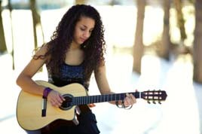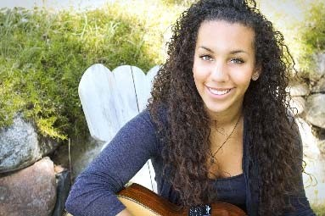

Bring your lawn chair

Join us for free picnic food

Enjoy the music of Taylor Taylor

Taylor is a 19-year-old native of Lansing with African American and Colombian roots. She has been cultivating her jazzy-pop style with classical guitar skills, warm, charismatic vocals and lyrical songwriting, which reveal her intelligence beyond her years. For Taylor’s complete bio, go to taylortaylormusic.com.

“GOD’S WORK. OUR HANDS.” SUNDAY September 11

On the afternoon of Sunday, September 11, ELCA churches all over the country will be participating in “God’s work. Our hands.” service projects.

We will be participating in this effort. At this point in time we are not certain what our service project will entail; however, we will be doing something that connects to make a difference in the lives of “first responders” in Meridian Township. Please mark your calendars for this event. And, if you wish to purchase a “God’s work. Our hands” shirt, add your name to the sign-up sheet you will find in the narthex. Shirts will cost $7/person. **Deadline to order: August 7.**

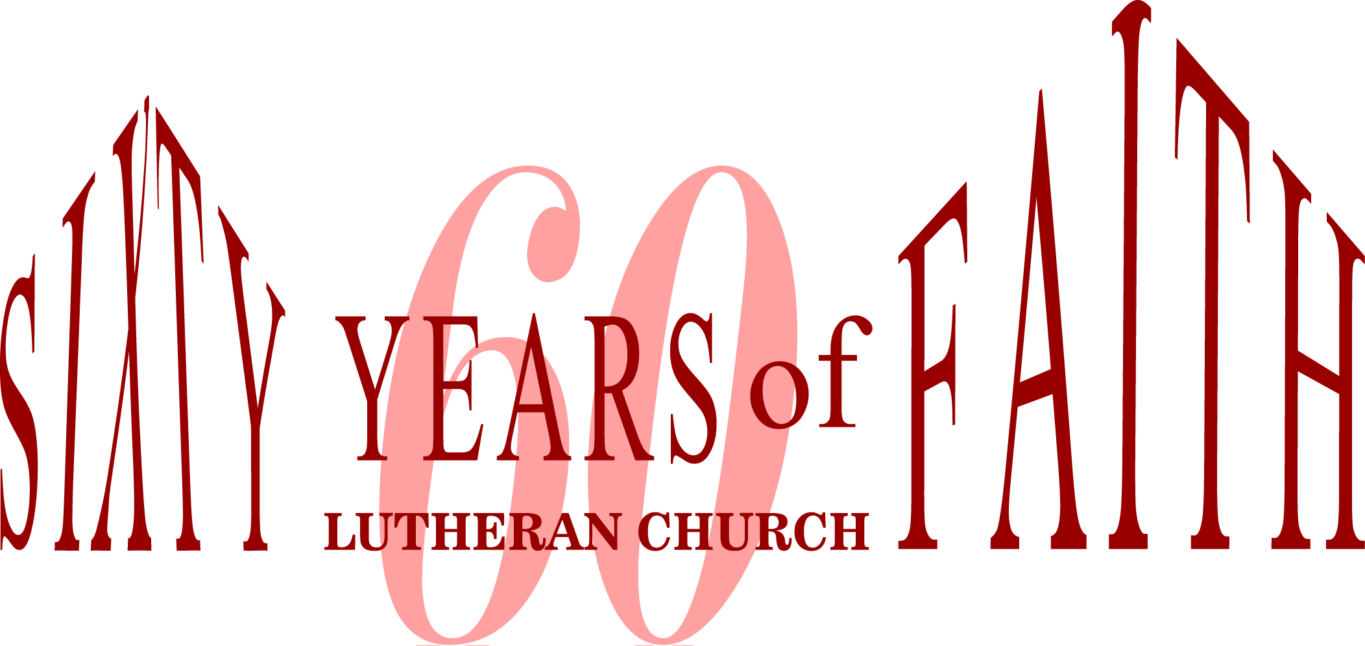

**September 18, 2016 Banquet**

The Good Lord has truly blessed us, and so we will gather to

give thanks and celebrate Faith Lutheran’s 60th anniversary!

We will enjoy a wonderful Italian Buffet, including a gluten-free entrée, to please both adult and children’s palates. There will

be music, reminiscing and thoughts about the future of Faith Lutheran in Okemos.

DATE: Sunday, September 18, 2016

TIME: 12:30 PM

LOCATION: Big Ten Room in the MSU Kellogg

Center on Harrison Road

TICKETS: $26.00 Adults

$13.00 Children 12 and under

Tickets will be available for purchase beginning Sunday morning, August 7, 2016. You may also call the church office at 349-0620 to reserve tickets. Please mark “60th Banquet” on your checks payable to Faith Lutheran Church.

We hope that you will be able to join us for this opportunity to celebrate together!

Anti-Racism Training: Sept 17, October 15 and November 5th 9:00-3:00

Dr. Freya A. Rivers and Angela Rivers will be offering Anti-Racism Training: Recognizing Seven Faces of Racism and Eradication from 9am-3pm on Saturday Sept 17, October 15 and November 5th. Lunch will be provided. Please call the church office or sign up in the church narthex to register for these training seminars.

**CHRISTIAN EDUCATION AND YOUTH ANNOUNCEMENTS**

**Tent Supervisors Needed**A new requirement for renting the church tent is for the renter to provide the installation crew. We would like to offer a member of the church as a supervisor in this process. We are hoping for approximately eight people to be on a rotational schedule. If you are able to help with this, please contact Melinda at the church.

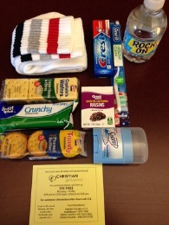**Blessing Bags**We were able to fill 49 bags (38 for men, 11 for women) for members to carry in their car to offer to any homeless people they come across in their travels. These bags are in the High School Room, which is located in the music room. We would like to continue to fill bags as we still have some product left and we would appreciate any items that can be donated: 27 men’s size 9-12 crew socks, 36 snack size raisins, 35 Ritz with cheese crackers in a bag, 59 travel size deodorants (Degree, if possible), 54 travel size toothpaste, and 27 toothbrushes. Any women’s hygiene products would be appreciated as well. You can place them in Melinda’s office, which is located across from the church secretary.

NEWS FROM OUR SYNOD MISSION PARTNER CHURCH

25TH ANNIVERSARY OF ORDINATION AND MINISTRY

Please join us as we celebrate Pastor Jan Hite’s 25th anniversary of ordination and 25 years of faithful service at Redeemer Church. A special worship service will begin at 10:00am, followed by a picnic open house 12:00-2:00pm on Sunday, August 14. Redeemer Church is located at 2727 West Holmes Road in Lansing. No gifts please. For anyone interested, contributions toward a special gift to be used at Redeemer in Pastor Jan’s honor can be made at the open house.

RSVP Vickie, 517-267-0189 or email [vickie@LNRCP.com](mailto:vickie@LNRCP.com). Please join us even if you do not RSVP.

ICE CREAM SOCIAL

Each year, Redeemer Church, an active city church who cares for her local community, holds an ice cream social during the month of August. This year, the event will be held Saturday, August 17 from 3:00-6:00pm. FREE ice cream! FREE games! Join your friends and neighbors for the annual Ice Cream Social at Redeemer Church. This is an opportunity to share some FREE ice cream from Melting Moments. Also, there will be fun games, prizes and inflatables for kids, music for both young and old, great food, crafts, and our 50;/50 raffle. There is a nominal charge for hot dogs, chips and beverages. (Ice cream and toppings are free.) Everyone is invited. Share in the fun. Bring your family and friends. Redeemer Church is located at 2727 West Holmes Road in Lansing.





To make disciples for Jesus Christ. . .

. . .we **Gather** in faith for worship, prayer,

study and fellowship

. . .we **Equip** the people of God with a faith

that works in real life

. . .we **Serve** the world in the name of Jesus Christ

_______________

Email address

faith@faithlutheranokemos.org

Websites

Faith Lutheran Church ≈ www.faithlutheranokemos.org

North/West Lower Michigan Synod ≈ www.mittensynod.org

Evangelical Lutheran Church in America ≈ www.elca.org

Facebook

facebook.com/faithlutheranokemos

Podcasts

ITUNES

https://itunes.apple.com/us/podcast/your-faith-journey/id1085174663?mt=2

STITCHER

http://www.stitcher.com/podcast/dad-spotlight/your-faith-journey?refid=stpr

You also can find the audio available

on Faith’s website under worship

Sermons

http://faithlutheranokemos.org/sermons/

Special music

http://faithlutheranokemos.org/category/special-music/