**ANNOUNCEMENTS**

FaithFamily&Friends3

**July 3, 2016**

*Log onto Faith’s website www.faithlutheranokemos.org 24/7 for updates*

**DEADLINES**

Sunday worship folder announcements⎯Tuesday of each week

Submit to Rita at rbarry@faithlutheranokemos.org

**August *Faith Family News* newsletter⎯July 18**

Submit to Taylor Belonga tay3394@yahoo.com

**PRAYERS OF INTERCESSION**

Please lift up in prayer this week:

🕆 Members—Max Ambs, Lowell Barricklow, Ellen Milne and Harry Nawrock

🕆 Friends and family—

Pat Belonga, Chris Cotter, Tim Drummond, Dick and Lil Jennings,

Terrie Becker; Christine, Izzy and Danny Loewen; Allie, Heather, Al,

Lilly, Sai Eshwar Lingamgunta, Jenn Leitch, Jeanne and Leonard

🕆 Our mission partner congregation⎯Lansing Redeemer Lutheran Church

🕆 Those in military service⎯Jon Schoepf, Lani Yearicks

and Melody and Adam Wright

🕆 Lutheran Social Services of Michigan children who seek adoption—

Aaron, Jeremiah, Sarah and David. Pray for each to be adopted and

for Jesus to be their lifelong friend.

**NORTH/WEST LOWER MICHIGAN SYNOD PRAYER PARTNER**

As Jesus calls us to be one, even as he and the Father are one, please include

Pastor Bryon Schneider-Thomas and the congregation of Sparta Peace Lutheran Church in your prayers of intercession this week.

**ALTAR FLOWER DEDICATIONS**

Today’s altar flowers are given to the glory of God by Bill and Pam Williams in celebration of their 29th wedding anniversary.

**FINANCIAL UPDATE**

Weekly Offering 06/26/16 Year-to-date as of 05/31/2016

General Fund $1,804.14 Income $117,595.75

Loose cash 20.00 Expenses 121,324.34

Loose checks 25.00 Net Income $ (3,728.59)

Flowers 25.00

Other 70.00

World Hunger 18.00

Total $1,962.14

THIS WEEK’S CHRONOLOGY OF EVENTS

TODAY Seventh Sunday after Pentecost

10:00 a.m. WORSHIP

Monday, July 4

Independence Day observed – Church office closed

Tuesday, June 5

Worship folder announcements deadline

12:00 p.m. Lunch lectionary study group in Pastor Ellen’s office

Wednesday, July 6

7:30 a.m. Men’s study group in the library

9:30 a.m. Quilting and Samaritas ACTION

6:00 p.m. Young adult BBQ book study at Pastor Ellen’s house

6:30 p.m. Membership Development Committee meeting

LOOKING AHEAD

Sunday, July 10

10:00 a.m. WORSHIP

3:00 p.m. The Willows at Okemos worship

Pastor Ellen facilitates a monthly worship service at The Willows at Okemos, 4830 Central Park Drive. This service takes place on the second Sunday of each month at 3:00pm. Everyone from Faith is invited to attend and participate as we worship with the Willows residents and staff.

⇓ IMPORTANT ⇓

PHOTOGRAPHY APPOINTMENTS ARE NOW BEING SCHEDULED FOR

OUR 60TH ANNIVERSARY EDITION CHURCH PHOTO DIRECTORY

We have had many changes in our church family and there are many new faces and families. To strengthen the bond within our church, we have made the commitment with Lifetouch Church Directories and Portraits to produce a 60th anniversary fellowship pictorial directory for

our church. A new church family album—

~ Preserves this special time in the

life and ministry of our church

~ Becomes a lasting record of

our current membership

~ Introduces our church to friends,

the community and new members

~ Becomes a communication

tool for our church family

Lifetouch is providing the directory at no cost to our church. Plus, every family photographed receives a directory and a complimentary 8x10 portrait! We are encouraging everyone to participate.

Sign up for your photo session on Sunday mornings at church,

OR go to our website faithlutheranokemos.org and click the homepage Lifetouch link which will take you to the appointment scheduler,

OR call the church office for assistance 349-0620.

Photography days are--

Thursday, Friday and Saturday August 11-13

Tuesday and Wednesday September 6 and 7

Hours of photography-- Weekdays 2pm-8:30pm

Saturday 9:30am-4pm

Church Photo Directory cont’d

For your convenience, all photography and portrait viewing will take place at our church where you will have a variety of poses taken, and Lifetouch never charges a sitting fee. One pose will be selected for the directory. You will have the opportunity to purchase additional portraits and portrait guides are available at the sign-up table that show the new portrait options offered by Lifetouch. Pets and meaningful items are welcome, too! If you donate a food item to our Caring Committee food drive, you will receive a $5 coupon from Lifetouch and, if you give us your email address, you will receive an email confirmation of your appointment. Lifetouch will also send you a reminder of your appointment time and give you an additional $10 coupon at your appointment session. Seniors age 60+ will receive a 20% discount.

You have the opportunity to invite your extended family and have portraits made with everyone together. Just schedule together and add additional time slots for each of your extended family units. Each family unit will be photographed and receive their own complimentary 8x10 portrait. Lifetouch will then photograph generational poses with everyone together, grandparents and grandkids, or any other special poses you would like to have. The additional families will count towards our program.

We are looking forward to seeing everyone take part and be photographed.

Our new directory will not be complete without you in it! There is NO obligation to purchase portraits; our only desire is for this special 60th anniversary edition to be as complete as possible to connect our families and tell our story.

CAREGIVER SUPPORT GROUP July 14

Our Caregiver Support Group continues to meet on the 2nd Thursday of every month. We meet from 11:30am-1:00pm and lunch is always served. This meeting provides a time of respite for caregivers as we share about our struggles and joys in a safe environment, enjoy lunch and fellowship and hear from a different speaker each month. The topics for July and August—

Thursday, July 14 - Keith Morris, President of Elder Law of Michigan, will share information regarding long distance caregiving.

Thursday, August 11 – A representative from one of the local funeral homes will share information regarding funeral planning.

All caregivers are welcome. If you have any questions about this group, please speak to Lois Neves, Kathy Richardson or Diane Hill.

RACE, ETHNICITY AND CULTURE: TABLE TALK CONVERSATIONS July 16

On Saturday, July 16, from 7:00-9:00 p.m., Faith Lutheran’s *Forum Planning Committee* will be hosting an evening of fellowship and conversation.



People of different backgrounds will be invited to share their stories. During this time of fellowship, we encourage those who are in attendance to speak, listen and learn from one another. There will be a chance for people to share their story and tell of the manner in which they have been impacted by racism. Attendees will have time to tell about their personal experiences. There will be an open mic. Individuals are encouraged to present his/her story in a safe environment with those who want to hear their stories. Everyone present will have a chance to share in small groups as attendees have time to learn from one another. One-on-one time in small groups is vitally important if we are to grow, change and become more hospitable as we live in relationship with those who are different from us. Please plan on coming to listen, learn and share.

Refreshments will be served. Plan on enjoying an ice cream sundae on a summer evening. If you have questions, please speak to Connie Nelson or Pastor Ellen.

LET’S TALK. . .LET’S LISTEN. . .LET’S SHARE

ANNOUNCING SPECIAL SUMMER CHOIR SUNDAY: JULY 31

Tenor/Bass Choir Sunday: July 31

Rehearse Wednesday, July 27, 7:00 p.m.

and then retire to Buddies for refreshments

Warm up Sunday, July 31, 9:00 a.m.

EVERYONE IS INVITED TO JOIN US FOR SINGING,

FUN AND FELLOWSHIP!!

JOINT WORSHIP SERVICE WITH UNIVERSITY LUTHERAN CHURCH AT ULC

Our 60th anniversary celebration continues. . .

On Sunday, July 24 at 10:00 a.m., we will worship AT

UNIVERSITY LUTHERAN CHURCH. University Lutheran

was the congregation that was instrumental in the

forming of Faith Lutheran Church in Okemos when

Faith began as a mission start congregation. This year, University

Lutheran Church celebrates its 75th anniversary as we celebrate our 60th. This service will be one of unity and celebration with a focus on creation. Please bring a lawn chair or blanket, a picnic lunch for you and your family

and join us as we worship under the trees on the north lawn at ULC, 1020 South Harrison Road, East Lansing. Drinks and an ice cream sundae bar

will be provided. Pastor John D. Schleicher will be preaching and presiding.

[](http://www.miipl.org/contact-us/)The offering received during this special worship service at University Lutheran Church will be designated for Michigan Interfaith Power & Light. MiPL’s mission

is to inspire and equip people of faith to exercise stewardship of and love for all creation. MiPL offers practical ways to

put faith into action by promoting energy efficiency, renewable energy and other

sustainable practices that lead to a

cleaner, healthier and more just world. Michigan IPL is part of national Interfaith Power & Light and was the fourth state to join. There are currently 40 state affiliates across the country. Pastor Schleicher serves on the MiPL board of directors.

How does this affect your regular Sunday offering to Faith Lutheran Church on July 24th? We suggest that you arrange to bring your offering to church with you on the Sunday before (July 17) or the Sunday after (July 31) we worship at ULC or mail it to or bring it to the church office at any time during the month. Thank you for your understanding and flexibility for this one unique Sunday.

Save the date



**Sunday ~ July 31 11:00 a.m.**

**followed by catered lunch**



Rita is retiring at the end of July, and she will be greatly missed. We want to celebrate her 19+ years of service to Faith Lutheran Church. Therefore, on Sunday,

July 31, following the quarterly meeting, a special catered luncheon will be held

downstairs to honor Rita and thank her for her service and commitment to this congregation. Please plan to join us for this celebration.

*If you are able to join us, please add your name to the sign-up sheet in the narthex. We need to know how many people are coming so we can notify the caterer.*

AUGUST STEWARDSHIP FOCUS: ADOPT-A-SCHOOL

Watch for back-to-school sales and pick up items for the August Stewardship school supplies collection. We hope to supply items needed by the Reo Elementary School near our synod mission partner church Redeemer Lutheran. Here are the items to watch for—dry erase markers, crayons, washable markers, colored pencils, Play Dough, scissors, water paints, shaving cream (to practice writing in), sidewalk chalk, bubbles and more bubbles and kinetic sand. . .and more listed on Faith@Work board.

 RACE, ETHNICITY, RELIGION & CULTURE:

LEARNING ABOUT ISLAM

On Wednesday evening, August 10

from 7:00-9:00 p.m., we will be hosting

an evening of conversation with

Imam Schail Chaudhry from the East

Lansing Islamic Center. He will be joining us to talk about Islam and help us better understand Islam. We invite you to join us as we listen, learn and build bridges of understanding and peace. If you have any questions, please speak to Connie Nelson or Pastor Ellen.

COMMUNITY PICNIC AND CONCERT HERE AT FAITH

SATURDAY, AUGUST 27 – 4:00-7:30 P.M.



Bring your lawn chair

Join us for free picnic food

Enjoy the music of Taylor Taylor

Taylor is a 19-year-old native of Lansing with African American and Colombian roots. She has been cultivating her jazzy-pop style with classical guitar skills, warm, charismatic vocals and lyrical songwriting, which reveal her intelligence beyond her years. For Taylor’s complete bio, go to taylortaylormusic.com.

“GOD’S WORK. OUR HANDS.” SUNDAY September 11

On the afternoon of Sunday, September 11, ELCA churches all over the country will be participating in “God’s work. Our hands.” service projects.

We will be participating in this effort. At this point in time we are not certain what our service project will entail; however, we will be doing something that connects to make a difference in the lives of “first responders” in Meridian Township. Please mark your calendars for this event. And, if you wish to purchase a “God’s work. Our hands” shirt, add your name to the sign-up sheet you will find in the narthex. Shirts will cost $7/person. Deadline to order: August 7.

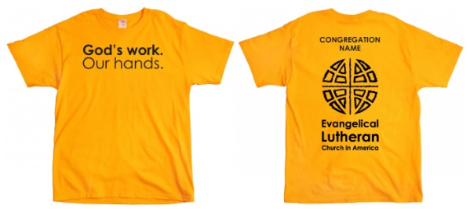

60TH ANNIVERSARY BANQUET

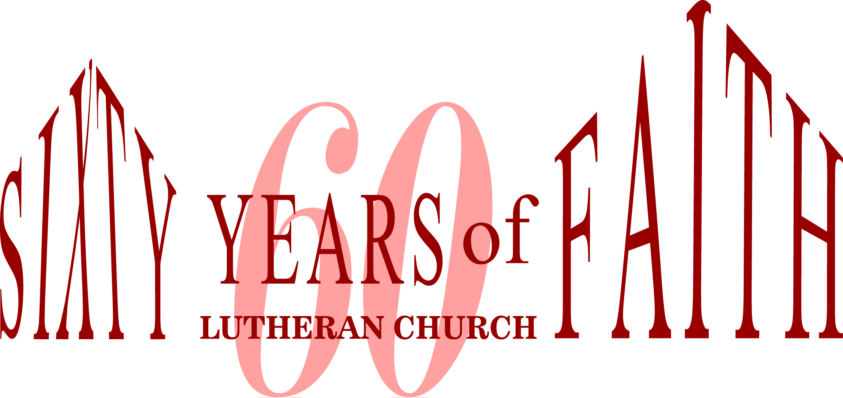

We will be holding a 60th anniversary banquet on Sunday, September 18

at the Kellogg Center shortly after noon. Tickets will be going on sale this summer. Be watching for more information regarding this celebratory event!

Looking for Pictures. . .

The 60th Anniversary Committee is asking for pictures you may have of events that have taken place over the past 60 years of ministry at Faith Lutheran Church. If you have any pictures you would like to share, please bring them in to the church office. We will scan them and include them in a PowerPoint loop we are creating for the September banquet.

**CHRISTIAN EDUCATION AND YOUTH ANNOUNCEMENTS**

**REGISTRATION CARDS AVAILABLE IN THE NARTHEX  
Vacation Bible School (VBS)** will be from August 1-5 from 9:00am – 12:00pm and is entitled “High Seas Expedition: Exploring the Mighty Love of God”. **VBS decorating and set-up will be on July 28th-30th from 1:00-6:00pm each day. The final set-up will be on Sunday, July 31st immediately following Rita’s Retirement Party.** Even ifyou cannot help during the VBS week, these decorating times are crucial and we would love to have as many helpers as possible. If you have any questions, please see Melinda. THANKS!!

**Tool Kits for Mission Trip**Please see the display in the Narthex of the items we will need to have when we travel to Hurricane, West Virginia. Every time we go on a mission trip we need supplies and we usually have to beg and borrow. With these supplies, we will have a supply to go to every time we are doing service. Thanks for your continued support.

**Mandatory Mission Meeting for Youth and Parents**At this meeting we will be completing all forms, discussing expectations, setting up departure times, and we will also have a mini-practice session with the tools and materials to assess the skill level of our participants. July 20th, 6:00-8:00pm.

**BINGO Fundraiser for the Youth – July 15th, 5:00-8:00pm**The Youth will be holding a Bingo Night Fundraiser for their mission trip for ages 1st Grade and above in the Large Fellowship Hall. The cost will be $10.00 for 8 cards and refreshments. All our games have prizes for the winners. There will also be a Jackpot Bingo game and that card will cost $5.00. We look forward to a fun night for all ages!!

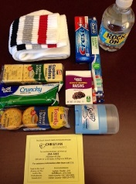**Blessing Bags are now available to pass out to the homeless!!!**The completed bags are available in the Youth Sunday School Room in a basket located by the Futon. Please take as many as you need to help those in need.





To make disciples for Jesus Christ. . .

. . .we **Gather** in faith for worship, prayer,

study and fellowship

. . .we **Equip** the people of God with a faith

that works in real life

. . .we **Serve** the world in the name of Jesus Christ

_______________

Email address

faith@faithlutheranokemos.org

Websites

Faith Lutheran Church ≈ www.faithlutheranokemos.org

North/West Lower Michigan Synod ≈ www.mittensynod.org

Evangelical Lutheran Church in America ≈ www.elca.org

Facebook

facebook.com/faithlutheranokemos

Podcasts

ITUNES

https://itunes.apple.com/us/podcast/your-faith-journey/id1085174663?mt=2

STITCHER

http://www.stitcher.com/podcast/dad-spotlight/your-faith-journey?refid=stpr

You also can find the audio available

on Faith’s website under worship

Sermons

http://faithlutheranokemos.org/sermons/

Special music

http://faithlutheranokemos.org/category/special-music/