Faith Lutheran Church

June 19, 2016

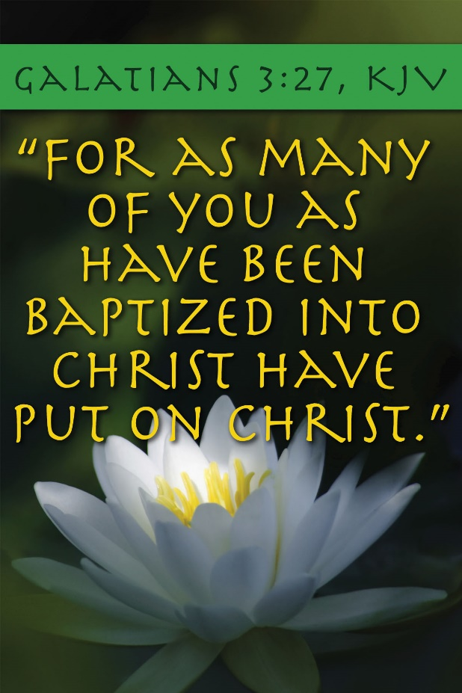

4515 Dobie Road
Okemos MI 48864-2203
517-349-0620

Pastor Ellen Schoepf
prellen@faithlutheranokemos.org

RELEASED TO PROCLAIM
Jesus encounters a man who lives naked among the tombs. The man convulsed with fits and seizures. Luke tells us he has an unclean spirit. We are told the demon who possesses the man is called “‘Legion’; for many demons had entered him” (Luke 8:30).
We can be plagued with many problems, enslaved to many vices. It is rarely one thing or another that holds us captive in life. Sometimes the forces of sin and evil that mount up against us are legion.
Earlier in Luke’s gospel, Jesus stood up in the synagogue and, echoing the prophet Isaiah, said he was sent “to proclaim release to the captives and recovery of sight to the blind, to let the oppressed go free” (Luke 4:18). Jesus’ ministry is not to those who have it all together, but to those whose struggles are many, whose resources are few, and whose prospects are dim.
By the end of the story, the now-clothed man is sitting calmly at the feet of Jesus. Ironically, the people respond to this healing with fear and actually ask Jesus to leave. Sometimes we grow comfortable with the demons—our own and others’. What is holding you captive today? What attitudes, addictions, or behaviors keep you chained? From what are you praying to be released today? When Christ comes to free you, will he be welcomed? Who benefits from this enslavement, whether ours or another’s?
As Jesus prepares to leave, he instructs the man, “Return to your home, and declare how much God has done for you” (Luke 8:39). From what have you been set free already? What do you celebrate today? Jesus came to free us from all that oppresses us, all that holds us captive, so that we might go out to declare how much God has done.

Sunday, June 19, 2016
Fifth Sunday after Pentecost
Holy Communion

INTRODUCTION TO THE DAY

This Sunday’s texts paint startling pictures of the horrific—the demonic—nature of sin. The church’s repeated celebration of the holy communion counters that tragic reality in a continued showing forth of the death of Jesus “until he comes.” It is a dramatic declaration of “how much God has done for you.”

If hearing assistance is needed, please ask an usher for a personal PA receiver.

The ushers also have large print copies of today’s worship folder available.

If it will be difficult for you to stand along with the congregation during
any part of the worship service, please feel free to remain seated.

There is a nursery available during the worship service for those who wish
to use it. It is located at the end of the hall beyond the coat racks.

WELCOME AND ANNOUNCEMENTS

We cordially greet all who have come to worship today.
Please register your attendance and join us in fellowship after the service.

Prayer Requests

PRELUDE

The pre-service music signals the beginning of the worship service. Silence during the
pre-service music enables worshipers to prepare for worship through quiet meditation.

“There Is a Balm in Gilead” arr. Carleton Inniss

Gathering
The Holy Spirit calls us together as the people of God
The assembly stands

Confession and Forgiveness

All may make the sign of the cross, the sign marked
at baptism, as the presiding minister begins
P Blessed be the holy Trinity, ☩ one God,
abounding in steadfast love toward us,
healing the sick and raising the dead,
showering us with every good gift.
C Amen

P Let us confess our sin in the
presence of God and of one another.

Silence is kept for reflection
P Just and gracious God,
C we come to you for healing and life.
Our sins hurt others and diminish us;
we confess them to you.
Our lives bear the scars of sin;
we bring these also to you.
Show us your mercy, O God.
Bind up our wounds, forgive
us our sins, and free us to love, for
the sake of Jesus Christ, our Savior.
Amen

P The apostle Paul assures us:
“When we were dead in our trespasses,
God made us alive together with Christ,
nailing the record of our sins to the cross.”
Jesus says to you, ☩ “Your sins are forgiven.”
Be at peace, and tell everyone how
much God has done for you.
C Amen

Gathering Song #314

Text printed under OneLicense.net license A-708005

Greeting

A The grace of our Lord Jesus Christ, the love of God,
and the communion of the Holy Spirit be with you all.
C And also with you.

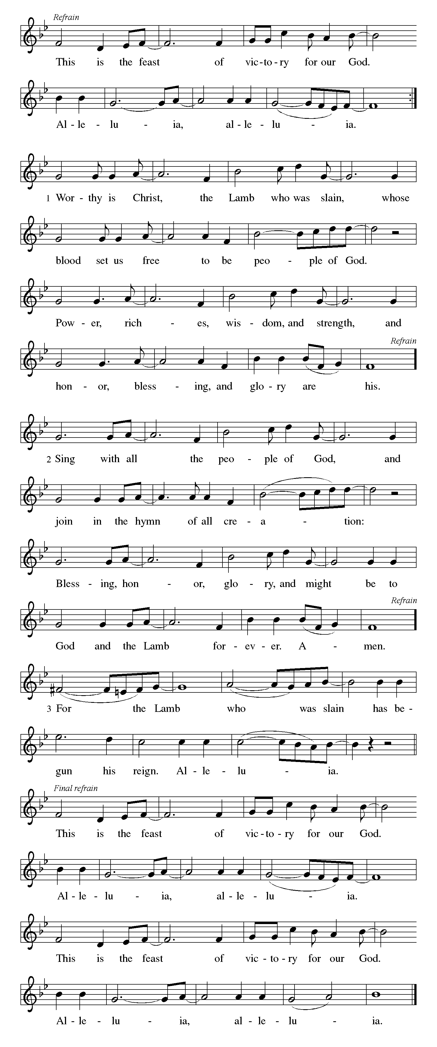
Canticle of Praise
⇒

Prayer of the Day
A Let us pray.
O Lord God, we bring before you the cries of a
sorrowing world. In your mercy set us free from
the chains that bind us, and defend us from everything
that is evil, through Jesus Christ, our Savior and Lord.
C Amen

The assembly is seated

Word
God speaks to us in scripture reading, preaching, and song

First Reading: Isaiah 65:1-9

The prophet announces God’s impatience. The people’s self-absorption is idolatry, and images from pagan worship fill this reading. Like a vintner who crushes the grape to release the wine, God will use Israel’s exile to establish a new community of the faithful.
A A reading from Isaiah.
¹I was ready to be sought out by those who did not ask,
to be found by those who did not seek me.
I said, “Here I am, here I am,”
to a nation that did not call on my name.
²I held out my hands all day long
to a rebellious people,
who walk in a way that is not good,
following their own devices;
³a people who provoke me
to my face continually,
sacrificing in gardens
and offering incense on bricks;
⁴who sit inside tombs,
and spend the night in secret places;
who eat swine’s flesh,
with broth of abominable things in their vessels;
⁵who say, “Keep to yourself,
do not come near me, for I am too holy for you.”
These are a smoke in my nostrils,
a fire that burns all day long.
⁶See, it is written before me:
I will not keep silent, but I will repay;
I will indeed repay into their laps
⁷their iniquities and their ancestors’ iniquities together,
says the Lord;
because they offered incense on the mountains
and reviled me on the hills,
I will measure into their laps
full payment for their actions.

⁸Thus says the Lord:
As the wine is found in the cluster,
and they say, “Do not destroy it,
for there is a blessing in it,”
so I will do for my servants’ sake,
and not destroy them all.
⁹I will bring forth descendants from Jacob,
and from Judah inheritors of my mountains;
my chosen shall inherit it,
and my servants shall settle there.

A The word of the Lord.
C Thanks be to God.

Second Reading: Galatians 3:23-29

For Paul, baptism is a powerful bond that unites people not only with God but with other believers. Those who call themselves children of God experience a transformation that removes prejudices of race, social class, or gender in favor of true unity in Christ.
A A reading from Galatians.
²³Now before faith came, we were imprisoned and guarded under the law until faith would be revealed. ²⁴Therefore the law was our disciplinarian until Christ came, so that we might be justified by faith. ²⁵But now that faith has come, we are no longer subject to a disciplinarian, ²⁶for in Christ Jesus you are all children of God through faith. ²⁷As many of you as were baptized into Christ have clothed yourselves with Christ. ²⁸There is no longer Jew or Greek, there is no longer slave or free, there is no longer male and female; for all of you are one in Christ Jesus. ²⁹And if you belong to Christ, then you are Abraham’s offspring, heirs according to the promise.

A The word of the Lord.
C Thanks be to God.

The assembly stands to welcome the gospel

Gospel Acclamation
Gospel: Luke 8:26-39
Jesus’ mission includes foreigners, and his authority extends to the casting out of demons. Some who witness Jesus’ work are seized with confusion and fear, but the man who was healed is commissioned to give testimony of God’s mercy and power.
P The holy gospel according to Luke.
C Glory to you, O Lord.

²⁶Then [Jesus and his disciples] arrived at the country of the Gerasenes, which is opposite Galilee. ²⁷As he stepped out on land, a man of the city who had demons met him. For a long time he had worn no clothes, and he did not live in a house but in the tombs. ²⁸When he saw Jesus, he fell down before him and shouted at the top of his voice, “What have you to do with me, Jesus, Son of the Most High God? I beg you, do not torment me”—²⁹for Jesus had commanded the unclean spirit to come out of the man. (For many times it had seized him; he was kept under guard and bound with chains and shackles, but he would break the bonds and be driven by the demon into the wilds.) ³⁰Jesus then asked him, “What is your name?” He said, “Legion”; for many demons had entered him. ³¹They begged him not to order them to go back into the abyss.
³²Now there on the hillside a large herd of swine was feeding; and the demons begged Jesus to let them enter these. So he gave them permission. ³³Then the demons came out of the man and entered the swine, and the herd rushed down the steep bank into the lake and was drowned.

³⁴When the swineherds saw what had happened, they ran off and told it in the city and in the country. ³⁵Then people came out to see what had happened, and when they came to Jesus, they found the man from whom the demons had gone sitting at the feet of Jesus, clothed and in his right mind. And they were afraid. ³⁶Those who had seen it told them how the one who had been possessed by demons had been healed. ³⁷Then all the people of the surrounding country of the Gerasenes asked Jesus to leave them; for they were seized with great fear. So he got into the boat and returned. ³⁸The man from whom the demons had gone begged that he might be with him; but Jesus sent him away, saying, ³⁹“Return to your home, and declare how much God has done for you.” So he went away, proclaiming throughout the city how much Jesus had done for him.

P The gospel of the Lord.
C Praise to you, O Christ.

The assembly is seated

CHILDREN’S MESSAGE

Trinity Seminary noisy offering

Sermon

The assembly stands to proclaim the word of God in song

Hymn of the Day #843
text printed under OneLicense.net license A-708005
APOSTLES’ Creed

C I believe in God, the Father almighty,
creator of heaven and earth.
I believe in Jesus Christ, God’s only Son, our Lord,
who was conceived by the Holy Spirit,
born of the virgin Mary,
suffered under Pontius Pilate,
was crucified, died, and was buried;
he descended to the dead.
On the third day he rose again;
he ascended into heaven,
he is seated at the right hand of the Father,
and he will come to judge the living and the dead.
I believe in the Holy Spirit,
the holy catholic church,
the communion of saints,
the forgiveness of sins,
the resurrection of the body,
and the life everlasting. Amen

Prayers of Intercession

A Let us pray for the church, those
in need, and all of God’s creation.

Prayers of intercession are prayed.
To each petition, the assembly responds:

A Lord, in your mercy,
C hear our prayer.

The presiding minister concludes the
prayers, and the assembly responds:
P We lift our prayers to you, O God, trusting your
promise to hear us; through Jesus Christ our Lord.
C Amen

Peace

P The peace of Christ be with you always.
C And also with you.

The people may greet one another with a sign of Christ’s peace,
and may say, “Peace be with you,” or similar words.

The assembly is seated

Meal
God feeds us with the presence of Jesus Christ

OFFERING

Drew Williams, violin “Canon in D” Pachelbel

The assembly stands

Offering Prayer

A Let us pray.
God of mercy and grace, the eyes of all wait upon you,
and you open your hand in blessing. Fill us with good
things at your table, that we may come to the help of all
in need, through Jesus Christ, our redeemer and Lord.
C Amen

Great Thanksgiving

Dialogue

P The Lord be with you.
C And also with you.

P Lift up your hearts.
C We lift them to the Lord.

P Let us give thanks to the Lord our God.
C It is right to give our thanks and praise.

Preface

P It is indeed right, our duty and our joy, that we should at all times and in all places give thanks and praise to you, almighty
and merciful God, through our Savior Jesus Christ; who on this day overcame death and the grave, and by his glorious resurrection opened to us the way of everlasting life. And so, with all the choirs of angels, with the church on earth and the hosts of heaven, we praise your name and join their unending hymn:

Holy, Holy, Holy
Thanksgiving at the Table

P In the night in which he was betrayed,
our Lord Jesus took bread, and gave thanks;
broke it, and gave it to his disciples, saying:
Take and eat; this is my body, given for you.
Do this for the remembrance of me.

Again, after supper, he took the cup, gave
thanks, and gave it for all to drink, saying:
This cup is the new covenant in my blood, shed for
you and for all people for the forgiveness of sin.
Do this for the remembrance of me.

Lord’s Prayer

P Gathered into one by the Holy Spirit,
let us pray as Jesus taught us.
C Our Father in heaven,
hallowed be your name,
your kingdom come,
your will be done,
on earth as in heaven.
Give us today our daily bread.
Forgive us our sins
as we forgive those
who sin against us.
Save us from the time of trial
and deliver us from evil.
For the kingdom, the power,
and the glory are yours,
now and forever. Amen

Invitation to Communion

P Christ invites you to a place of honor at this banquet.
Welcome to the feast.

Communion

When giving the bread and cup, the communion ministers say
The body of Christ, given for you.
The blood of Christ, shed for you.
and each person may respond
Amen

Communion Song

CONGREGATIONAL SONG

“here I Am, Lord” #574

CONGREGATIONAL SONG #592

The assembly stands

Prayer after Communion

A Let us pray.
O God, as a mother comforts her child, so you comfort
your people, carrying us in your arms and satisfying us
with this food and drink, the body and blood of Christ.
Send us now as your disciples, announcing peace and
Proclaiming that the reign of God has come near;
through Jesus Christ, our Savior and Lord.
C Amen

Sending
God blesses us and sends us in mission to the world

Blessing

P The Lord bless you and keep you.
The Lord’s face shine upon you with grace and mercy.
The Lord look upon you with favor
and ☩ give you peace.
C Amen

Sending Song #540
Text and music printed under CCLI license 720217

Dismissal

A Go in peace. Proclaim the good news.
C Thanks be to God.

POSTLUDE

“Didn’t the Lord Deliver Daniel” arr. Carleton Inniss

Copyright © 2016 Augsburg Fortress. All rights reserved. Reprinted by permission under Augsburg Fortress Liturgies Annual License #SAS000803.New Revised Standard Version Bible, copyright © 1989, Division of Christian Education of the National Council of the Churches of Christ in the United States of America. Used by permission. All rights reserved.
Clipart copyright © 2016 by Communication Resources. All rights reserved. Used by permission.

“This is the day that the Lord has made;
let us rejoice and be glad in it” (Psalm 118:24, ESV).
Welcome!

Preaching Harold Sollenberger
Presiding Pastor Ellen Schoepf
Secretary Rita Barry
Director of Christian Education Melinda Schultz
Director of Music Debra Borton-McDonough
Organist/Pianist Bruce Williams

June 12 worship attendance: 74

Serving Faith Today June 26 – 10:00 a.m.

Acolytes

Altar care Ledith Ambs and Jennifer Coe

Communion assistants Harold Sollenberger Deb Borton-McDonough
Dane Webb Brian Ransom
Griffin Ransom

Greeters Jack and Natalie Dingledine

Lay assistants Harold Sollenberger Deb Borton-McDonough

Readers Dane Webb Brian Ransom

Ushers Mike Barry Mike Barry

Nursery Corey and Kim O’Brien Lori Webb

