ANNOUNCEMENTS

MARCH 20, 2016

Log onto Faith’s website www.faithlutheranokemos.org 24/7 for updates

DEADLINES

Sunday worship folder announcements⎯Tuesday of each week
Submit to Rita at rbarry@faithlutheranokemos.org

April Faith Family News newsletter⎯Tomorrow the 21st
Submit to Rich at faith@mathwhiz.org

ALTAR FLOWER DEDICATIONS
Today’s altar flowers are given to the glory of God by Janice Taschner in celebration of Virginia Taschner’s 89th birthday.

PRAYERS OF INTERCESSION

Please lift up in prayer this week:

 Members—Max Ambs, Lowell Barricklow, Dale Halvorson,
Susan Heft, Ellen Milne and Harry Nawrock
 Friends and family—
Pat Belonga, Chris Cotter, Tim Drummond
Dick and Lil Jennings
Christine, Izzy and Danny Loewen
Larry Hinds and family
Annaliese, Heather, Bill, Al and Roger
 Our mission partner congregation⎯Lansing Redeemer Lutheran Church
 Those in military service⎯Jon Schoepf, Lani Yearicks
and Melody and Adam Wright
 Lutheran Social Services of Michigan children who seek adoption—
Thomas, Caprice, Philip and Thomas, Pray for each to be adopted and
for Jesus to be their lifelong friend.

NORTH/WEST LOWER MICHIGAN SYNOD PRAYER PARTNER
As Jesus calls us to be one, even as he and the Father are one, please include Pastor Dawn Pooley and the congregation of Reed City St. Paul Lutheran Church in your prayers of intercession this week.

FINANCIAL UPDATE

Weekly offering 03/13/2016
General fund $1,760.00
Loose cash 30.00
March 9 Lenten service 49.25
Flowers 60.00
Youth mission trip 132.00
Loaves & Fishes 211.10
Caring Comm Easter food 145.00
Parish Ed – Adult Ed 12.00
World Hunger 15.00
Total $2,414.35

THIS WEEK’S CHRONOLOGY OF EVENTS

TODAY Sunday of the Passion/Palm Sunday

9:00 a.m. Easter activities for kids during Sunday School time

10:00 a.m. WORSHIP – “The Cry of the Congregation”

As part of First Communion study, students create communion patens.
Lily O’Brien’s paten holds today’s communion bread.

Deliver Easter food to community families today
The Caring Committee Easter food is packed and ready to go. If you can make a delivery today, please speak with Sally Knoll who is stationed by the grocery bags.

11:30 a.m. Easter egg hunt for kids under fourth grade

11:30 a.m. Listening Post in the library

Today cont’d

4:00 p.m. Elliot Kadrofske Eagle project fundraiser music recital

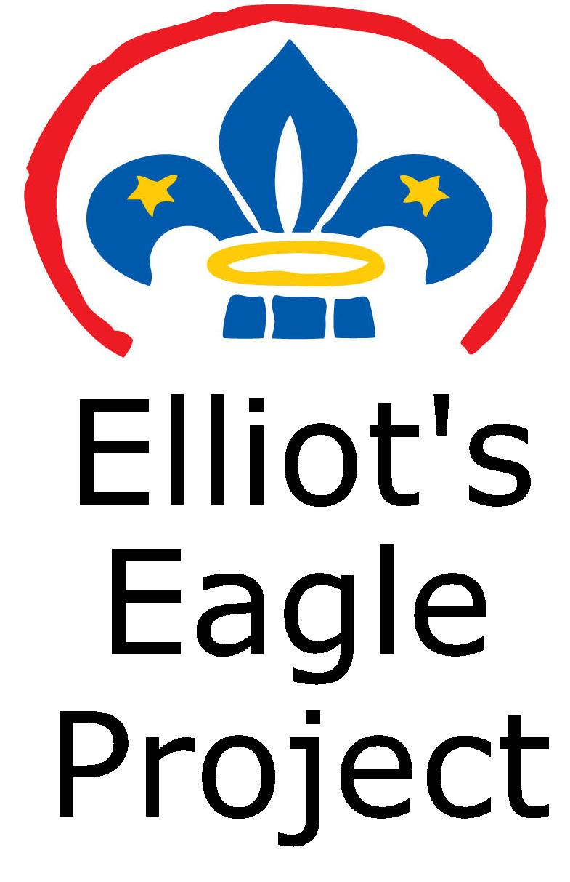
A fundraiser recital will be held here at Faith on
Sunday, March 20 from 4-5:00pm

Donations will be used to help offset the cost of
Elliot’s Eagle Scout project which is to construct
a fire pit area at Faith.

The concert will consist of a variety of music,
including classical selections from Okemos High
School musicians.

If you would like to donate to the project but are unable to attend, please contact Elliot or Gwynne Kadrofske

Monday, March 21 – Monday in Holy Week

7:00 p.m. Church Council meeting

April newsletter deadline – Email April articles to Rich Weingartner faith@mathwhiz.org . This is Rich’s last issue of the Faith Family News. We thank him for serving as newsletter editor for 14 years!

We are excited to announce that beginning with the May issue Taylor Belonga will be the newsletter editor. Taylor has been a Faith member for 14 years and is attending Lansing Community College studying graphic computer design.

Tuesday, March 22 – Tuesday in Holy Week

12:00 p.m. Lunch lectionary study group in Pastor Ellen’s office

6:30 p.m. Pub lectionary study group at Okemos Buddies Pub & Grill

Wednesday, March 23 – Wednesday in Holy Week

9:30 a.m. Quilting and LSSM ACTION

6:00 p.m. Trinity and Confirmation

6:15 p.m. Faith Bells

7:15 p.m. Gospel Mass Rehearsal

8:00 p.m. Chancel Choir

Thursday, March 24 – Maundy Thursday

7:00 p.m. WORSHIP

Friday, March 25 – Good Friday

12:00 p.m. Community Good Friday worship
at Okemos Community Church

7:00 p.m. GOOD FRIDAY WORSHIP HERE AT FAITH

LOOKING AHEAD

Sunday, March 27 Resurrection of Our Lord: Easter Day



RESURRECTION CELEBRATION WORSHIP

7:30 a.m. and 10:00 a.m.
_______________

Join Faith family and friends for our annual Easter breakfast between the worship services at 8:45 a.m.


8:45 a.m.

Breakfast will be served in the downstairs large fellowship hall. Sign up on the Faith at Work display board to bring a dish-to-pass. Please have your egg casserole, fruit, pastries, bagels, etc., cut and ready to be served. The Membership Development Committee will provide beverages.

STEWARDSHIP MARCH EMPHASIS: LOAVES AND FISHES MINISTRIES

We are collecting items for Loaves and Fishes Ministries as follows:

Toothbrushes w/travel covers, toilet paper, shaving cream (sample size), rubbing alcohol, razors, lip balm, tissues (pocket packs), bath soap, bath towels and cloths (preferably white), bath gel, black hair care products, laundry soap, bleach, window cleaner, dish soap, dish cloths, napkins, brooms, mops, shower curtain liners, mattress covers (twin), slippers, lunch meat, juice, coffee (decaf), coffee filters, breakfast meat, non-perishable snacks (individually packaged), bottled water, ponchos, baby crib sheets, board games.

L&F Guests receive starter kits when going into permanent housing.
Starter kits include broom, mop, dish soap, laundry soap and bath soap.

If you are able to donate any of these items, please place them in the narthex basket.

NEW MEMBER SUNDAY April 3
Reception of new members will take place Sunday, April 3. If you would like to join our Faith family, please speak with Pastor Ellen as soon as possible.

SOCIAL JUSTICE GATHERING Sunday, April 3

On Sunday, April 3, Angela Waters Austin will be joining us following worship. Angela is the founder, president and chief executive officer of One Love Global, Inc., a 501c3 non-profit corporation committed to peace, justice and opportunity. Angela leads One Love Global with over 20 years’ experience in promoting racial equity, public and community relations, fund development, marketing, special events, corporate sponsorships, program design and management. Angela’s professional positions have included director of women and youth services for the YWCA of Greater Lansing and associate director of Eureka Communities Detroit, a non—profit leadership development organization. Austin is an experienced media professional who has co-hosted and co-produced public affairs programming for Lansing’s WLAJ-TV53 and developed educational and cultural content for the Michigan Chronicle newspaper. Angela is also very involved in the Black Lives Matter movement as well as the work of My Brother’s Keeper.

THE HOMELESS ANGELS PROJECT WORKDAY
SATURDAY, APRIL 30, 10:00 A.M.
6501 South Pennsylvania Avenue, Lansing
We will be participating in The Homeless

Angels project. The Homeless Angels are a street-based outreach program in Lansing. Their mission is to rebuild and restore faith in humanity through innovative ideas, programs and events with the main goal of involving the community in real change for people who are homeless or at risk of homelessness. We will be adopting one of the hotel rooms at the Magnuson Hotel and fixing it up so it will be available for homeless families. Please be watching for more information regarding this effort and sign up to be part of this activity.

NORTH/WEST LOWER MICHIGAN SYNOD ANNOUNCEMENTS

FINDING YOUR INNER COMPASS: FROM THE EDGE TO THE CENTER - Sister Nancy Brousseau, Facilitator

On-Going Spiritual Formation Program: A Four-Part Series offered by Living Fire Ministries at Christ United Church, DeWitt, Wednesdays--10:30am-3:30pm--March 23, April 13, May 4 and May 25.

This series is about entering into a process where we do not find our Center; we let it find us, we welcome God who seeks us. Please join us for this community adventure into the God Center.

More detailed information and registration form posted on the community bulletin board in the hallway across from the coat racks.

UNDERSTANDING ISLAM EVENT Here at Faith Saturday, April 16

Join Dr. Mark Swanson and Bishop Satterlee for a day of conversation on Saturday, April 16 at Faith Lutheran Church in Okemos. The event will begin at 9 am and conclude at 3pm. Lunch will be provided. To register, contact Ann at the Synod Office (321-5066). There will be a modest fee for food.

An ordained pastor of the ELCA, Mark Swanson teaches in the areas of Christian-Muslim studies at the Lutheran School of Theology at Chicago. Before coming to the great ecumenical and interfaith meeting-place that is the city of Chicago, Dr. Swanson taught at Luther Seminary, St. Paul, Minn., and at the Evangelical Theological Seminary in Cairo, Egypt. His research interests
include the history of Christian-Muslim relations, medieval Egyptian church history, and early Arabic Christian literature.

CHRISTIAN EDUCATION AND YOUTH ANNOUNCEMENTS


Thrivent Action Teams are needed again!!!
Please apply to help your youth group in a one-time fundraiser, service activity or educational event that can be completed within 90 days. Here are some suggestions for your Thrivent Action Teams: Blessing Bags and Faith Vacation Bible School. Use this link to get started: https://www.thrivent.com/making-a-difference/living-generously/thrivent-action-teams/ Please see Melinda to get specific details or if you have any questions.


Easter Egg Hunt TODAY! We will be having special crafts and activities during the Sunday School hour and a special egg hunt after the worship service. This event is for any child under the age of 4th grade.


Vacation Bible School will be held on August 1st – 5th from 9:00-12:00. VBS Sunday will be on the 7th. We are looking for volunteers to help out with the various stations and with the groups. This year’s theme is “High Seas!”



To make disciples for Jesus Christ. . .
. . .we Gather in faith for worship, prayer,
study and fellowship
. . .we Equip the people of God with a faith
that works in real life
. . .we Serve the world in the name of Jesus Christ
_______________

Email address
faith@faithlutheranokemos.org

Websites
Faith Lutheran Church ≈ www.faithlutheranokemos.org
North/West Lower Michigan Synod ≈ www.mittensynod.org
Evangelical Lutheran Church in America ≈ www.elca.org

Facebook
facebook.com/faithlutheranokemos

Podcasts

ITUNES
https://itunes.apple.com/us/podcast/your-faith-journey/id1085174663?mt=2

STITCHER
http://www.stitcher.com/podcast/dad-spotlight/your-faith-journey?refid=stpr

You also can find the audio available
on Faith’s website under worship

Sermons
http://faithlutheranokemos.org/sermons/

Special music
http://faithlutheranokemos.org/category/special-music/

