ANNOUNCEMENTS

MARCH 13, 2016

Log onto Faith’s website www.faithlutheranokemos.org 24/7 for updates

DEADLINES

Sunday worship folder announcements⎯Tuesday of each week
Submit to Rita at rbarry@faithlutheranokemos.org

April newsletter articles⎯March 21
Submit to Rich at faith@mathwhiz.org

ALTAR FLOWER DEDICATIONS
Today’s altar flowers are given to the glory of God by Jim and Pat Fagan in celebration of their four grandchildren.

PRAYERS OF INTERCESSION

Please lift up in prayer this week:

 Members—Max Ambs, Lowell Barricklow, Dale Halvorson,
Susan Heft, Ellen Milne and Harry Nawrock
 Friends and family—
Pat Belonga, Chris Cotter, Tim Drummond
Dick and Lil Jennings
Christine, Izzy and Danny Loewen
Larry Hinds and family
Annaliese, Heather, Bill, Al and Roger
 Our mission partner congregation⎯Lansing Redeemer Lutheran Church
 Those in military service⎯Jon Schoepf, Lani Yearicks
and Melody and Adam Wright
 Lutheran Social Services of Michigan children who seek adoption—
Thomas, Caprice, Philip and Thomas, Pray for each to be adopted and
for Jesus to be their lifelong friend.

NORTH/WEST LOWER MICHIGAN SYNOD PRAYER PARTNER
As Jesus calls us to be one, even as he and the Father are one, please include Interim Pastor Jim Foster and the congregation of Portage Prince of Peace Lutheran Church in your prayers of intercession this week.

FINANCIAL UPDATE

Weekly offering 03/06/2016
General fund $5,870.00
Loose cash 82.00
Loose checks 25.00
Flowers 95.00
Capital repairs 85.00
World Hunger 76.65
Sunday School 25.27
Youth
Mission Trip 1,482.00
Babysitting 30.00
Pancake supper 433.00
Conf. retreat 118.00
Education 20.00
Caring Committee 70.00
Total $8,411.92
Simply Giving $2,081.00

Stewardship principle
We don’t give because we’re pretty well off and won’t miss a few bucks.
We don’t give because we somehow feel obligated.
We don’t give because we owe “dues to the church.”
We GIVE in JOYFUL response and often it’s a joy we haven’t known before. After all, it’s the least we can do.
Where is the joy in your stewardship journey?” –Salt Seasonings

THIS WEEK’S CHRONOLOGY OF EVENTS

TODAY Fifth Sunday in Lent

9:00 a.m. Sunday School

9:00 a.m. Adult book study group in the library
“CHOSEN? Reading the Bible Amid the Israeli-
Palestinian Conflict”

10:00 a.m. WORSHIP

Today cont’d

As part of First Communion study, students create communion patens.
Kate Magyar’s paten holds today’s communion bread.

Today Beth Young, the Volunteer Coordinator for Loaves and Fishes will be with us. She will be sharing a little bit of information with us at the beginning of the worship service, and she will lead an informational conversation after worship. We will be taking a “noisy” offering for Loaves and Fishes today. Over the next couple of months, we will also be collecting some of the items the organization needs, items we might be able to supply. We will be collecting the following items:

Toothbrushes w/travel covers, toilet paper, shaving cream (sample size), rubbing alcohol, razors, lip balm, tissues (pocket packs), bath soap, bath towels and cloths (preferably white), bath gel, black hair care products, laundry soap, bleach, window cleaner, dish soap, dish cloths, napkins, brooms, mops, shower curtain liners, mattress covers (twin), slippers, lunch meat, juice, coffee (decaf), coffee filters, breakfast meat, non-perishable snacks (individually packaged), bottled water, ponchos, baby crib sheets, board games.

Guests receive starter kits when going into permanent housing. Starter kits include: broom, mop, dish soap, laundry soap and bath soap.

If you are able to donate any of these items, please place them in the narthex basket.

11:30 a.m. Parish Education Committee meeting

3:00 p.m. The Willows at Okemos worship service

Pastor Ellen is facilitating worship at The Willows at Okemos residential care facility at 3:00 today. Everyone from Faith is invited to attend this special worship service. The address is 4830 Central Park Drive, Okemos.

_______________

CARING COMMITTEE
ANNUAL EASTER BASKET FOOD DRIVE ENDS TODAY
Cash donations help with the purchase of the hams, eggs and milk for the families. The delivery date is NEXT SUNDAY, March 20. Please see the sign-up sheet on the narthex Faith at Work board.

Thank you for your support, care for others and prayers as we do HIS work in our community.

Tuesday, March 15

12:00 p.m. Lunch lectionary study group in Pastor Ellen’s office

6:30 p.m. Evangelism and Outreach Committee meeting

Wednesday, March 16

9:30 a.m. Quilting and LSSM ACTION

1:00 p.m. MOVIE DAY FOR SIXTY PLUS OR MINUS
JOIN US FOR “WOMAN IN GOLD” AND SNACKS!

“Woman in Gold” is a 2015 British drama film based on the true story of the late Maria Altmann, an elderly Jewish refugee living in Los Angeles who together with her lawyer fought the Austrian government for almost a decade to reclaim Gustav Klimt’s iconic painting of her aunt which was stolen from her relatives by the Nazis in Vienna just prior to WWII. Altmann took her legal battle all the way to the Supreme Court of the United States. Stars Helen MIrren, Ryan Reynolds, Daniel Bruhl, Katie Holmes, Tatiana Maslany, Max Irons, Charles Dance, Elizabeth McGovern and Jonathan Pryce.
Friends—sixty plus or minus—are invited to attend!

6:00 p.m. Lent Supper
Trinity and Confirmation
Faith Bells

6:45 p.m. LENT WORSHIP

St. Paul , in his letter to the Romans, writes, “For creation waits with eager longing for the revealing of the children of God” (Romans 8:19). As we enter into our Lenten experience this year, we are going to enter into a deeper reflection on our place and role in creation and how we might participate in the reconciliation of all things, something the Bible calls shalom. Each week, we will focus on a different aspect of our response as stewards of creation. We will be using parts of Holden Evening Prayer for our Wednesday Lenten Service liturgy and ending each service with a prayer For the Healing of Creation. This week’s Lenten theme is RECOMMITMENT – Creation waits with eager longing: How will you respond?

7:15 p.m. Gospel Mass Rehearsal

8:00 p.m. Chancel Choir

Thursday, March 17

7:00 p.m. Mutual Ministry Committee meeting

Friday, March 18

6:00 p.m. Youth Group lock-in begins

Saturday, March 19

9:00 a.m. Youth Group lock-in ends

LOOKING AHEAD

Sunday, March 20 Sunday of the Passion/Palm Sunday
Deliver Caring Committee Easter food
to community families

9:00 a.m. Easter activities for kids

10:00 a.m. WORSHIP

11:30 a.m. Easter egg hunt for kids under fourth grade

11:30 a.m. Listening Post in the library

4:00 p.m. Elliot Kadrofske Eagle project fundraiser music recital

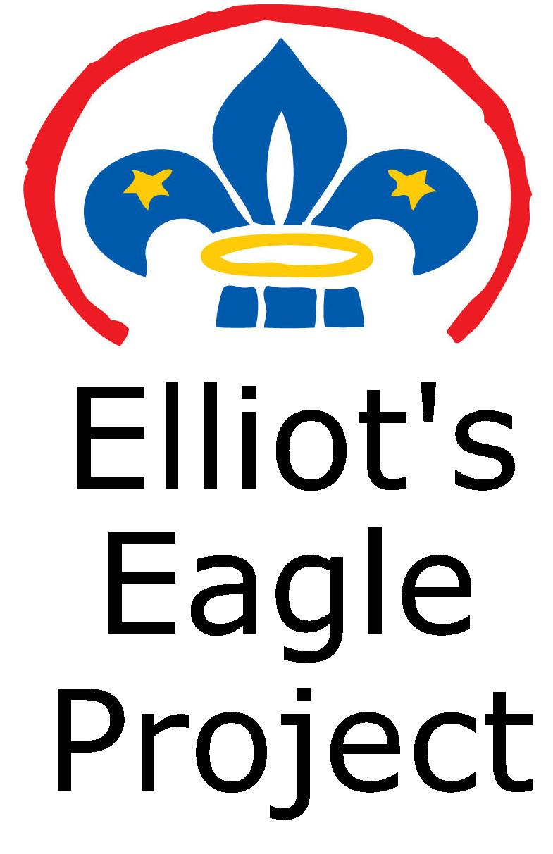
A fundraiser recital will be held here at Faith on
Sunday, March 20 from 4-5:00pm

Donations will be used to help offset the cost of
Elliot’s Eagle Scout project which is to construct
a fire pit area at Faith.

The concert will consist of a variety of music,
including classical selections from Okemos High
School musicians.

If you would like to donate to the project but are unable to attend, please contact Elliot or Gwynne Kadrofske



EASTER FLOWER DEDICATIONS DUE THIS WEDNESDAY, MARCH 16


We will soon be ordering tulips and daffodils that will be placed in the
sanctuary for our Easter morning worship
services. Plants cost $10 each. Order
daffodils or purple, pink, yellow or red
tulips. An order form is included in today’s
worship folder or can be found on the
narthex counter.

PALM SUNDAY, March 20
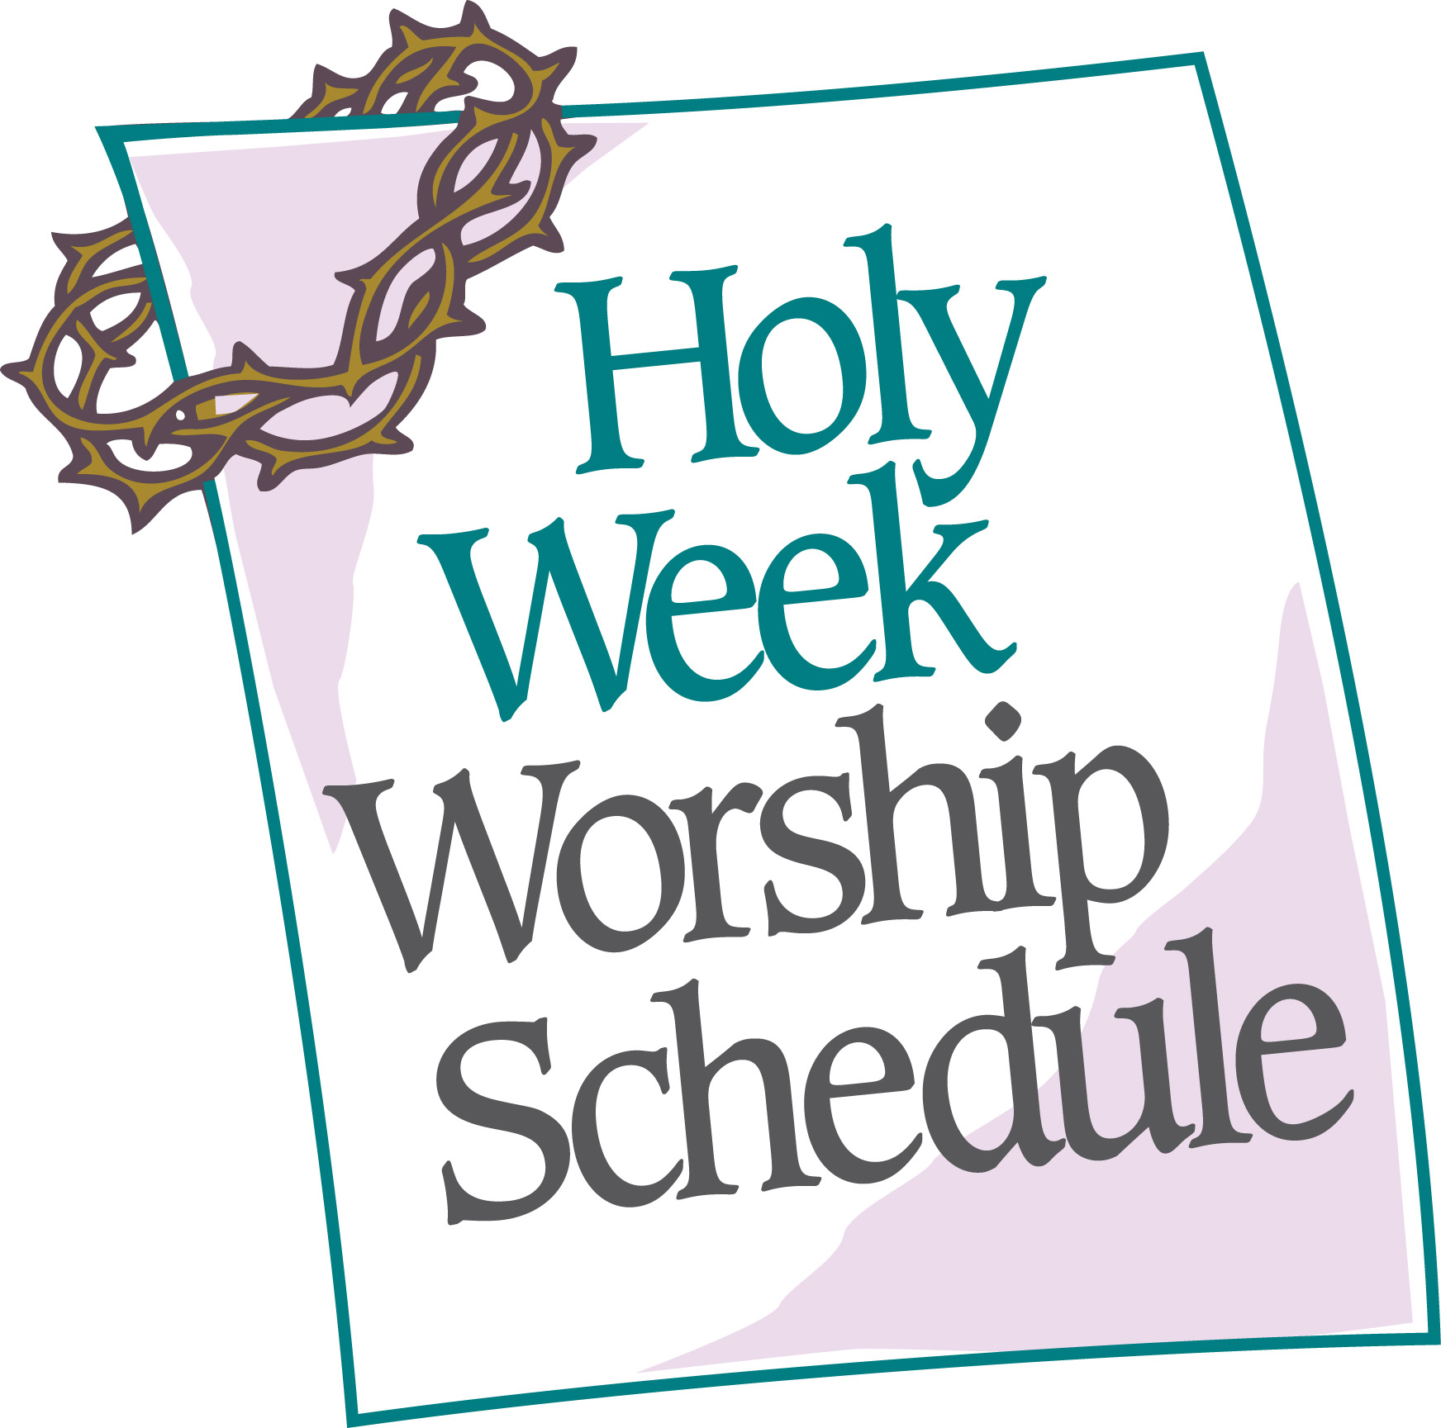
9:00am Easter activities for kids
10:00am WORSHIP: “The Cry of
the Congregation”
11:30am Easter egg hunt for kids under 4th grade

MAUNDY THURSDAY, March 24

7:00pm WORSHIP

GOOD FRIDAY, March 25

12:00pm Community worship at
Okemos Community
Church

7:00pm WORSHIP AT FAITH

EASTER SUNDAY, MARCH 27



RESURRECTION CELEBRATION WORSHIP

7:30 a.m. and 10:00 a.m.
_______________

Join Faith family and friends for our annual Easter breakfast between the worship services at 8:45 a.m.


8:45 a.m.

Breakfast will be served in the downstairs large fellowship hall. Sign up on the Faith at Work display board to bring a dish-to-pass. Please have your egg casserole, fruit, pastries, bagels, etc., cut and ready to be served. The Membership Development Committee will provide beverages.

NEW MEMBER SUNDAY April 3rd
Reception of new members will take place Sunday, April 3. If you would like to join our Faith family, please speak with Pastor Ellen as soon as possible.

_______________



Did you know that you can now subscribe to the Faith Lutheran – Your Faith Journey Podcast?

Did you miss the weekly sermon or special music or just need a quick pick me up for your own spiritual journey? Now you can subscribe to have new episodes brought right to you.

ITUNES
https://itunes.apple.com/us/podcast/your-faith-journey/id1085174663?mt=2

STITCHER
http://www.stitcher.com/podcast/dad-spotlight/your-faith-journey?refid=stpr

You also can find the audio available on Faith’s website under worship—

Sermons –
http://faithlutheranokemos.org/sermons/

Special music –
http://faithlutheranokemos.org/category/special-music/

FAITH—Is this a place where everybody knows your name??

Would it seem a more friendly place if we COULD call each other by name?

The Evangelism and Outreach Committee would like to encourage members to get back to the habit of wearing their permanent nametags each Sunday morning to encourage greeting each other by name!

If you don’t have your nametag on right now, it may well be in your church family mailbox in the south hallway. Not too convenient? Well, we’re trying out a new more convenient place to store those nametags that may help you remember to wear them. Committee member Bob Nelson has installed storage lines on the end of the coat racks where you can clip your nametag as you pick up your coat when you leave. Don’t worry about alphabetical order—just clip it on the line close to where you usually hang your coat, then pick it up fro there next time you arrive. Will you help us try out this system?

If your nametag is permanently missing in action, contact Rita; she’ll make you a replacement.
_______________

SOCIAL JUSTICE GATHERING Sunday, April 3

On Sunday, April 3, Angela Waters Austin will be joining us following worship. Angela is the founder, president and chief executive officer of One Love Global, Inc., a 501c3 non-profit corporation committed to peace, justice and opportunity. Angela leads One Love Global with over 20 years’ experience in promoting racial equity, public and community relations, fund development, marketing, special events, corporate sponsorships, program design and management. Angela’s professional positions have included director of women and youth services for the YWCA of Greater Lansing and associate director of Eureka Communities Detroit, a non—profit leadership development organization. Austin is an experienced media professional who has co-hosted and co-produced public affairs programming for Lansing’s WLAJ-TV53 and developed educational and cultural content for the Michigan Chronicle newspaper. Angela is also very involved in the Black Lives Matter movement as well as the work of My Brother’s Keeper.

THE HOMELESS ANGELS WORKDAY
SATURDAY, APRIL 30, 10:00 A.M.
6501 South Pennsylvania Avenue, Lansing
We will be participating in The Homeless

Angels project. The Homeless Angels are a street-based outreach program in Lansing. Their mission is to rebuild and restore faith in humanity through innovative ideas, programs and events with the main goal of involving the community in real change for people who are homeless or at risk of homelessness. We will be adopting one of the hotel rooms at the Magnuson Hotel and fixing it up so it will be available for homeless families. Please be watching for more information regarding this effort and sign up to be part of this activity.

NORTH/WEST LOWER MICHIGAN SYNOD ANNOUNCEMENT

On-Going Spiritual Formation Program: A Four-Part Series offered by Living Fire Ministries at Christ United Church, DeWitt, Wednesdays--10:30am-3:30pm--March 23, April 13, May 4 and May 25
Finding Your Inner Compass: From the Edge to the Center
Facilitator – Sister Nancy Brousseau
This series is about entering into a process where we do not find our Center; we let it find us, we welcome God who seeks us. Please join us for this community adventure into the God Center.

More detailed information and registration form posted on the community bulletin board in the hallway across from the coat racks.

FROM OUR MISSION PARTNER CHURCH

Easter Egg Hunt, Saturday, March 19. . .

Join us for a fun-filled Easter egg hunt at no cost. Fun will be had by all, and treats will be found by everyone. This is open to our entire community, and all are invited. Crafts and fun begin at 10am. Egg hunt begins at 11am on Saturday, March 10. (In case of rain, event will be held iside.)

Redeemer Church is located at 2727 West Holmes Road in Lansing (south of Mt. Hope, between Pleasant Grove and Catherie).

For more information, please contact the church office at 882-8000 or janhite@sbcglobal.net or online at redeemerlansing.com.

COMMUNITY ANNOUNCEMENTS

88.1 SMILE FM MORNING ESPRESSO HOMETOWN TOUR
IN MASON MARCH 18

Smile FM is a non-profit, Michigan based ministry with 25 non-commercial Christian radio stations throughout Michigan. Their mission is Building Families Touching Hearts and Changing Lives.

Once a month the morning team travels to a community and broadcasts the “Morning Espresso with Jenn & Brian” radio program from a local coffee shop to the entire State of Michigan. The tour offers a way to connect with listeners in that area and show the rest of the state what makes that hometown special.

Their next Hometown Tour stop is Friday, March 18, 7-10:00am at Bestsellers Books & Coffee Company, 360 South Jefferson Street, Mason.

THE LIVING DRAMATIZATION OF DaVINCI’S THE LAST SUPPER

St. Luke Lutheran Church is sponsoring a drama based on Leonardo DaVinci’s famous painting featuring soliloquies by the twelve Apostles on Saturday, March 19 at 3:00pm and 7:00pm. St. Luke is located at 5589 Van Atta Road, Haslett. Children’s nursery will be available during both performances. There is no charge. Q’s? Call 339-9119.

CHRISTIAN EDUCATION AND YOUTH ANNOUNCEMENTS

Parish Education Committee Meeting on Sunday, March 13th immediately following the worship service; after you grab coffee and treats, of course!


Thrivent Action Teams are needed again!!!
Please apply to help your youth group in a one-time fundraiser, service activity or educational event that can be completed within 90 days. Here are some suggestions for your Thrivent Action Teams: Blessing Bags and Faith Vacation Bible School. Use this link to get started: https://www.thrivent.com/making-a-difference/living-generously/thrivent-action-teams/ Please see Melinda to get specific details or if you have any questions.


Easter Egg Hunt is on March 20th. We will be having special crafts and activities during the Sunday School hour and a special egg hunt after the worship service. This event is for any child under the age of 4th grade.


Vacation Bible School will be held on August 1st – 5th from 9:00-12:00. VBS Sunday will be on the 7th. We are looking for volunteers to help out with the various stations and with the groups. This year’s theme is “High Seas!”



To make disciples for Jesus Christ. . .
. . .we Gather in faith for worship, prayer,
study and fellowship
. . .we Equip the people of God with a faith
that works in real life
. . .we Serve the world in the name of Jesus Christ
_______________

Email address
faith@faithlutheranokemos.org

Websites
Faith Lutheran Church ≈ www.faithlutheranokemos.org
North/West Lower Michigan Synod ≈ www.mittensynod.org
Evangelical Lutheran Church in America ≈ www.elca.org

Facebook
facebook.com/faithlutheranokemos

Podcasts

ITUNES
https://itunes.apple.com/us/podcast/your-faith-journey/id1085174663?mt=2

STITCHER
http://www.stitcher.com/podcast/dad-spotlight/your-faith-journey?refid=stpr

You also can find the audio available
on Faith’s website under worship

Sermons
http://faithlutheranokemos.org/sermons/

Special music
http://faithlutheranokemos.org/category/special-music/

2016 EASTER FLOWER DEDICATION
Order deadline: March 16

I would like to order the following flower(s) to
be placed in the sanctuary on Easter Sunday:

QUANTITY FLOWER(S) ORDER TOTAL

________ Daffodil(s) $10 ea. _____________

________ Tulip(s)* $10 ea. _____________

*Color selection for tulips: Purple Pink Yellow Red

Please PRINT your dedication(s) below:

Name person(s) dedicating:

In memory of:

In honor of:

In celebration of:

Make checks payable to Faith Lutheran Church
Place this dedication form in Connie Nelson’s church mailbox
Please pick up your flower(s)
after the late worship service Easter Sunday

