ANNOUNCEMENTS

DECEMBER 27, 2015

Log onto Faith’s website www.faithlutheranokemos.org 24/7 for updates

DEADLINES

Weekly worship folder announcements⎯Tuesday of each week
Submit to Rita at rbarry@faithlutheranokemos.org

February newsletter articles⎯January 18
Submit to Rich at faith@mathwhiz.org

2015 Annual Reports⎯January 3

ALTAR FLOWER DEDICATIONS

Today’s altar flowers are given to the glory of God by. . .
Vase 1 Mike and Rita Barry in celebration of Sammy’s baptism
Vase 2 Jon and Elaine Harrison in celebration of Dan’s birthday

PRAYERS OF INTERCESSION

Please lift up in prayer this week:

 Members—Max Ambs, Lowell Barricklow, Dale Halvorson,
Susan Heft, Ellen Milne and Harry Nawrock
 Friends and family—
Pat Belonga
Chris Cotter
Tim Drummond
Dick and Lil Jennings
Christine, Izzy and Danny Loewen
Annaliese, Heather, Bill, Al and Ron
 Our mission partner congregation⎯Lansing Redeemer Lutheran Church
 Those in military service⎯Jon Schoepf, Melody and Adam Wright
and Lani Yearicks
 Lutheran Social Services of Michigan children who seek adoption—
James, Devon, Gregory and Antoinette.

NORTH/WEST LOWER MICHIGAN SYNOD PRAYER PARTNER
As Jesus calls us to be one, even as he and the Father are one, please include Pastor Marcille Miller and the congregation of Muskegon Samuel Lutheran Church in your prayers of intercession this week.

FINANCIAL UPDATE

Weekly offering 12/13/2015: Year-to-date as of 11/30/15:
General Fund $ 9,360.00 Income $238,549.46
Loose cash 46.25 Expenses 256,331.38
Loose checks 75.00 Net Income $(17,781.92)
Flowers 125.00
Sunday School 16.00
World Hunger 46.00
Capital Repairs 1,700.00
Youth 64.20
Women’s Retreat 500.00
Operation Shoebox 21.00
Choir Music 400.00
Staff Gifts 1,320.00
Total $13,673.45
Simply Giving $ 2,690.00



IMPORTANT ANNOUNCEMENT
REGARDING POINTS OF ENTRY INTO
THE CHURCH ON SUNDAY MORNINGS

On Sunday mornings, once the worship service has begun, the two south entry doors into the church building (Dobie Road and south parking lot entrances) will be locked. If you arrive for church after 10:00 a.m., please expect to enter through the north doors.

THIS WEEK’S CHRONOLOGY OF EVENTS

TODAY First Sunday of Christmas

SERVICE OF HOLY BAPTISM

Today we celebrate the Sacrament of Holy Baptism as Samantha Ann Barry becomes a member of God’s Kingdom. Samantha is the infant daughter of Zac and Kristen Barry. Serving as sponsor for Samantha is Wynne Barry.

The Property Committee thanks all the volunteers who helped move the chairs and hymnals for the light-bulb changing on December 13 and 19. The sanctuary carpet was cleaned professionally as well. A special thanks to those who were here on Tuesday and Wednesday to help change the bulbs, to the members who helped defray the cost for the projects and to Bill Bailey, our bulb changer up on the lift.

The 2016 offering envelopes are on a table in the fellowship area. Please pick up yours today and begin using them next Sunday the 3rd. Your 2016 envelope number may have changed!

WORLD HUNGER OFFERING

Today we will receive our monthly offering to help fight world hunger.
The offering place for this special offering is at the sanctuary entrance.

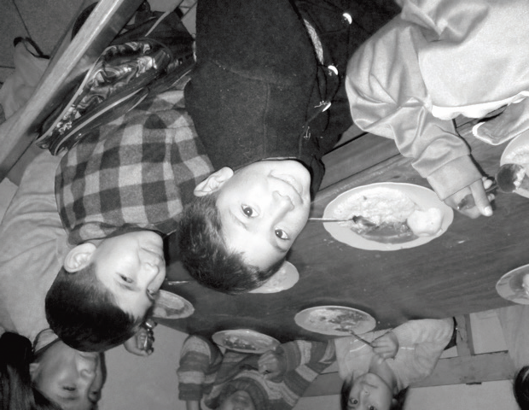
Huch׳ uy Runa in Peru

Every weekday, 120 elementary
school children gather at the Help
the Children Association School.
While each child has a different
backstory, they each share a
common denominator: They all
come from areas of extreme
poverty around and in the ancient
Incan capital city of Cusco, Peru.

The school, commonly known as “Huch׳ uy Runa,” opened more than 30 years ago to attend to the most basic needs of homeless children in Cusco. In Quechua, “Runa” means a whole, integral, important well-rounded peson who contributes to the well-being of the community. “Huch׳ uy” means little, there, “Huch׳ uy” means little important person. The children carry the huch׳ uy runa identity with pride despite the socio-economic and family circumstances against them.

World Hunger offering cont’d

Not only is Huch׳ uy Runa a primary school, it also serves as a trade skill school for the children. For many of them, attending school past the sixty grade is not guaranteed because they may have to go to work to support their family. Huch׳ uy Runa has several apprentice-style workshops where all the children learn a trade skill, whether it is in carpentry, metalwork, pottery,

bakery, knitting-weaving, or art, in order to support themselves and their families and attempt to rise out of economic poverty.

One of the teachers said of the school, “[It] is like a family trying to equip the children to be able to survice and succeed in life, hoping to build a solid base on which they can stand.

LOOKING AHEAD

Next Sunday, January 3

2015 Annual Reports are due

9:00 a.m. NO Sunday School

10:00 a.m. WORSHIP

11:30 a.m. Worship Committee meeting

Tuesday, January 5

12:00 p.m. Lunch lectionary study group

Wednesday, January 6

7:30 a.m. Men’s lectionary study group

9:30 a.m. Quilting and LSSM ACTION

6:00 p.m. Trinity and Confirmation

6:30 p.m. Faith Bells

7:30 p.m. Chancel Choir

SUNDAY, JANUARY 10, 9:00 A.M.

UPDATED FLC CONSTITUTION AND BYLAWS REVIEW
In November, Church Council approved recommendations for an update church constitution and bylaws. Church Council will be asking for congregation approval at the annual January 31 congregational meeting (11:00 a.m.). The updated document is available on the narthex counter for perusal prior to the January 10 review and the January 31 annual meeting.

Help Decorate the Sharing Tree. . .Not with ornaments and tinsel. . .but with baby items!!!

Visit the fellowship area Sharing Tree and select a paper “ornament” or two. On each ornament, a specific layette item is indicated. So it can be a reminder of what to purchase, take the ornament home with you (only new baby items please). Bring your unwrapped layette items and tuck them into the Sharing Tree branches by Sunday, January 10th. Your gifts will be given to Shared Pregnancy of Lansing, an organization that offers emotional and spiritual support to new moms.

SIXTY PLUS/MINUS JANUARY LUNCH AND PROGRAM

On Wednesday, January 20 at 11:30 a.m., we plan to gather at the church for pizza and a program! We have rescheduled the physical therapy presentation that was cancelled due to the November 18 power outage. Come and learn about the NEW out-patient physical therapy program being offered to the community at the Dobie Road Ingham County Medical Care Rehabilitation Center. Watch for details in the January worship folder announcements.

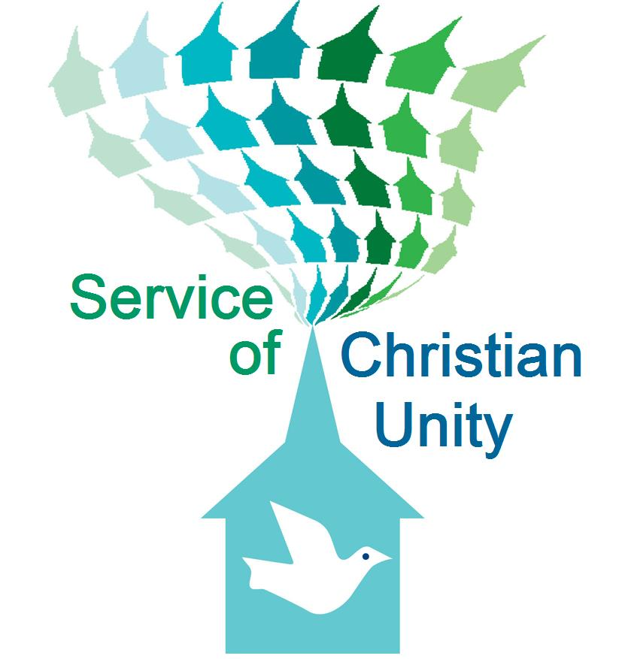
SERVICE OF CHRISTIAN UNITY – January 17 at 3:00 p.m.

On Sunday afternoon, January 17 at 3pm, we will be hosting a Service of Christian Unity here at Faith Lutheran Church. Members of The Church of Elohim will be joining us for this event. Pastors Derrick Knox and Linda Gardner serve The Church of Elohim. Linda was one of the panel members who participated in our fall Forum on Race, Ethnicity & Culture. This January worship service promises to be a very meaningful and enriching event. Please plan to join us and participate.

ANNUAL CONGREGATIONAL MEETING
Sunday, January 31 at 11:00 a.m.

OPEN HEARTS, OPEN CHURCH TASK FORCE – January 31 at 5:00 p.m.
On Sunday evening, January 31 at 5:00 p.m., members of the North/West Lower Michigan Synod’s Open, Hearts, Open Church Task Force will join us for an educational event. Members of this task force are going to various churches throughout the Synod to provide guidance, support and companionship as we journey together with regard to full inclusion of all sexual orientations and gender identities. All who are interested are invited to join us for this conversation. The event includes food! If you plan to attend, please sign the narthex sheet so we know how much food to prepare.

EASY WAYS TO FIGHT HUMAN TRAFFICKING – Feb. 21 following worship
On Sunday morning, February 21, following our morning worship service, Clarissa Grimes will be joining us to discuss issues of human trafficking. This is a growing problem in our community, in Michigan and throughout the world. Come to learn and become aware. Awareness is essential to enacting the personal and systemic changes that will free victims of human trafficking.

FAITH SIXTIETH ANNIVERSARY SAVE THE DATES
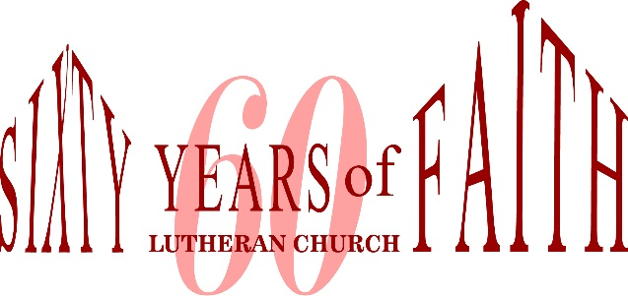
February 28, 10:00 a.m. – Special morning worship service and reception to commemorate the chartering of FLC.
September 18 – Luncheon banquet at MSU Kellogg Center

MARRIAGE RETREAT – March 11-13 in Grand Rapids
Interested members of Faith Lutheran Church will be joining with members of Muskegon First Lutheran Church to hold a marriage retreat in the Grand Rapids area. Any interested couples are invited to attend this event. More information to come!

CHRISTIAN EDUCATION AND YOUTH ANNOUNCEMENT

Winter break schedule
There are no Sunday School classes scheduled for January 3. Classes resume at 9:00 a.m. on Sunday, January 10.

Trinity and Confirmation resumes at 6:00 p.m. on Wednesday, Jan. 6.




To make disciples for Jesus Christ. . .
. . .we Gather in faith for worship, prayer,
study and fellowship
. . .we Equip the people of God with a faith
that works in real life
. . .we Serve the world in the name of Jesus Christ

