**ANNOUNCEMENTS**

FaithFamily&Friends3

**August 14, 2016**

*Log onto Faith’s website www.faithlutheranokemos.org 24/7 for updates*

**DEADLINES**

Sunday worship folder announcements⎯Tuesday of each week

Submit to Katie at klove@faithlutheranokemos.org

***September Faith Family News newsletter*⎯Monday August 15th**

Submit to Katie at klove@faithlutheranokemos.org

**PRAYERS OF INTERCESSION**

Please lift up in prayer this week:

🕆 Members—Max Ambs, Lowell Barricklow, Ellen Milne and Harry Nawrock

🕆 Friends and family—

Pat Belonga, Chris Cotter, Tim Drummond, Dick and Lil Jennings,

Terrie Becker; Christine, Izzy and Danny Loewen; Allie, Heather, Al,

Lilly, Sai Eshwar Lingamgunta, Jenn Leitch, Jeanne and Leonard,

Tom Brown, Susan Heft

🕆 Our mission partner congregation⎯Lansing Redeemer Lutheran Church

🕆 Those in military service⎯Jon Schoepf, Lani Yearicks

and Melody and Adam Wright

🕆 Lutheran Social Services of Michigan children who seek adoption—

Precious, Elijah, Emanuel and Isaiah. Pray for each to be adopted and

for Jesus to be their lifelong friend.

**NORTH/WEST LOWER MICHIGAN SYNOD PRAYER PARTNER**

As Jesus calls us to be one, even as he and the Father are one, please include

Pastor Paul Busekist, Diaconal Minister Julia Nelson and the congregation of Bethlehem Lutheran Church of Traverse City in your prayers of intercession this week.

**ALTAR FLOWER DEDICATIONS**

Today’s altar flowers are given to the glory of God by. . .

Vase 1 Bob Scholle in memory of his wife Diane Scholle.

Vase 2 Jennings family in celebration of their daughter Susan’s birthday.

The additional flower arrangement is in celebration of Max & Ledith Ambs 60th wedding anniversary.

**FINANCIAL UPDATE**

Weekly Offering 08/07/16 Year-to-date as of 06/30/2016

General Fund $3165.00 Income $144,728.34

Loose cash 73.00 Expenses 150,066.73

Loose checks 75.00

Capital Repairs 25.00 Net Income $(5,338.39)

Youth 20.00

Total $ 3358.00

Simply Giving $2081.00

THIS WEEK’S CHRONOLOGY OF EVENTS

Thirteenth Sunday after Pentecost

**TODAY**

10:00 a.m. WORSHIP

3:00 p.m. Worship at the Willows of Okemos: All are welcome to join.

**Tickets for 60th Anniversary Celebration**

**are on Sale NOW in the narthex.**

Monday, August 15

September Newsletter announcements due to Katie Love.

7:00 p.m. Church Council Meeting

Tuesday, August 16

Worship folder announcements deadline

12:00 p.m. Lunch lectionary study group in Pastor Ellen’s office

*Tuesday cont.*

6:30 p.m. Evangelism and Outreach Committee Meeting

Wednesday, August 17

7:30 a.m. Men’s study group in the library

9:30 a.m. Quilting and Samaritas ACTION

11:30 a.m. 60 +/- Meeting at Coral Gables

7:00 p.m. 60th Anniversary Committee Meeting

Thursday, August 18

7:00 p.m. RIC Team Meeting

Friday, August 19

Saturday, August 20

**Picture Day Hosts**

****Picture hosts are still needed for some dates.

Hosts will greet members when they arrive. The shifts are about 4 hrs.

Please call Linda Gerard to sign up.

517-349-9487 Thank you!

UPCOMING MEETINGS & STUDIES

***CARE GIVING***

Join us at 11:30am for a light lunch and discussion. All are Welcome!

Thursday, September 8th - Barb Mannino with Tri-County Office of Aging, speaking on “Residential Living outside of the Lansing Area.

Thursday October 13th: Kris Abbey, the Bereavement Coordinator at Hospice of Lansing will speak on Healthy Grieving.

***SIXTY PLUS AND MINUS – SAVE THESE DATES!***

Wednesday, August 17 at 11:30 a.m.

Come to Coral Gables for a bite of lunch! Sharing your summer adventures with friends from Faith can be fun and give new direction to wrapping up the carefree days of late summer and early fall.



**Wednesday, September 21 at 11:30 a.m.**

Join us for the first Fall gathering of the Sixty +/- group in the Fellowship Hall

Special Guest:

Roger Hoopengarner (from University Lutheran) is a retired

MSU professor who has spent his career studying the use of bees in pollinizing crops in the USA and around the world.  His power point presentation will challenge and inform us of current

concern re the deadly virus that has mysteriously affected the colonies of bees so vital to agricultural life.

This event will begin with one of Faith's famous Potlucks! Bring a favorite dish to pass and bring a friend!

UPCOMING MEETINGS & STUDIES CONT…

***NEW BOOK CLUB***

**BOOK GROUP CONVERSATION** –

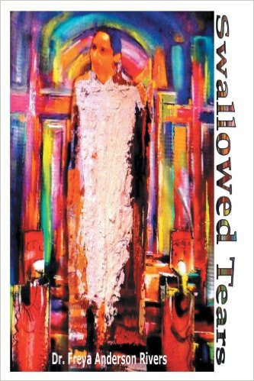 This fall Dr. Freya Anderson Rivers will be facilitating three consecutive anti-racism sessions here at Faith Lutheran Church. Dr. Rivers is the author of ***Swallowed Tears***, the story of an African American family’s courage and perseverance. This story is about one family but there were thousands of unknown individuals and families who daily put their lives on the line to end segregation. Dr. Dupuy H. Anderson was one of these individuals who persisted in spite of numerous threats to his life to change the city of Baton Rouge, Louisiana. He was one of the many in Baton Rouge who fought for change. When the movement began in Baton Rouge, no one knew that the impact of the 1953 bus boycott would create universal hope for the rights of equality, justice and freedom. The leaders did not know that Martin Luther King, Jr. would use their model as a catalyst for the Civil Rights Movement. Yet, challenging oppression in the struggle for truth, justice and righteousness, Dr. Dupuy H. Anderson, one man, made a difference.

As we host a series of anti-racism events facilitated by Dr. Rivers during the fall season, Pam Williams will also be leading a book group conversation based on Dr. Freya Rivers’ book, *Swallowed Tears*.

This gathering will take place at 7:00 PM on the following Wednesday nights this fall:

**Wednesday, September 28**

**&**

**Wednesday, October 26**

If you are able to participate, please add your name to the sign-up sheet in the Narthex. If you would like us to order your book, please indicate that on the sign-up sheet.

LOOKING AHEAD

**Invite your Friends and Neighbors!**

COMMUNITY PICNIC AND CONCERT HERE AT FAITH

SATURDAY, AUGUST 27 – 4:00-7:30 P.M.

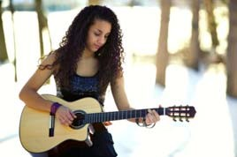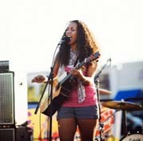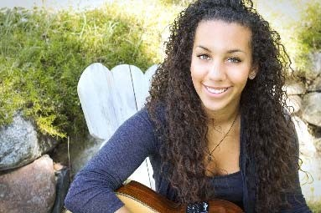

Bring your lawn chair

Join us for free picnic food

Enjoy the music of Taylor Taylor

Taylor is a 19-year-old native of Lansing with African American and Colombian roots. She has been cultivating her jazzy-pop style with classical guitar skills, warm, charismatic vocals and lyrical songwriting, which reveal her intelligence beyond her years. For Taylor’s complete bio, go to taylortaylormusic.com.

“GOD’S WORK. OUR HANDS.” SUNDAY September 11

On the afternoon of Sunday, September 11, ELCA churches all over the country will be participating in “God’s work. Our hands.” service projects.

We will be participating in this effort. At this point in time we are not certain what our service project will entail; however, we will be doing something that connects to make a difference in the lives of “first responders” in Meridian Township. Please mark your calendars for this event.

Anti-Racism Training: Sept 17, October 15 and November 5th 9:00-3:00



Dr. Freya A. Rivers and Angela Rivers will be offering Anti-Racism Training: Recognizing Seven Faces of Racism and Eradication from 9am-3pm on Saturday Sept 17, October 15 and November 5th.

Lunch will be provided. Please call the church office or sign up in the church narthex to register for these

training seminars

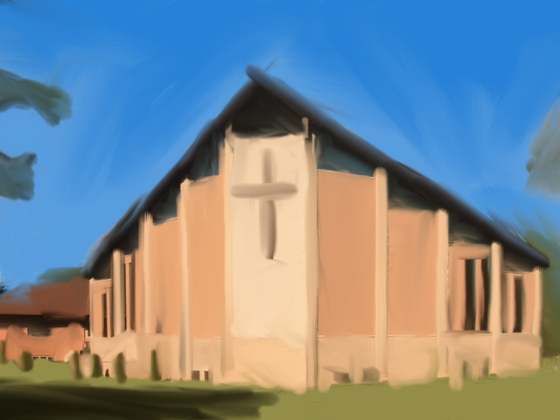

Painting of Faith Church by Taylor Belonga for 60th Anniversary

**Celebrate 60 years of Faith**

**September 18, 2016 Banquet**

The Good Lord has truly blessed us, and so we will gather to

give thanks and celebrate Faith Lutheran’s 60th anniversary!

We will enjoy a wonderful Italian Buffet, including a gluten-free entrée, to please both adult and children’s palates. There will be music, reminiscing and thoughts about the future of Faith Lutheran in Okemos.

DATE: Sunday, September 18, 2016

TIME: Welcome & Prayer 12:15 PM

Meal 12:30 PM

LOCATION: Big Ten Room C in the MSU Kellogg

Center on Harrison Road

TICKETS: $26.00 Adults

$18.25 Gluten Free/Vegetarian Meal

$12.25 Children 10 and under

Tickets are on sale NOW! Last day of ticket sales is Sunday September 11. Reserve your tickets during Sunday worship or call/stop by the church office. Parking will be Free.

*Please mark “60th Banquet” on your checks.*

WAYS TO GET INVOLVED

AUGUST STEWARDSHIP FOCUS: ADOPT-A-SCHOOL

Watch for back-to-school sales and pick up items for the August Stewardship school supplies collection. We hope to supply items

needed by the Reo Elementary School near our synod mission partner church Redeemer Lutheran. Here are the items to watch for—dry erase markers, crayons, washable markers, colored pencils, Play Dough, scissors, water paints, shaving cream (to practice writing in), sidewalk chalk, bubbles and more bubbles and kinetic sand. . .and more listed on Faith@Work board.

**CARING COMMITTEE NEWS**

In one month children in our community will be go back to school. They will need to start their day with a healthy breakfast. You can help make sure that happens by joining the Caring Committee in the annual Back-to-School Breakfast Bag Food Drive. Individuals, families and committees are encouraged to shop for any or all of the following items:

* Oatmeal
* Cold Cereal
* Pancake Mix
* Syrup
* Canned Fruit
* Muffin Mix
* Juice
* Jelly
* Peanut Butter
* Breakfast Bars
* Instant Breakfast Drinks

Place your food donations in the grocery cart between now and September. With cash donations we will purchase milk, bread and eggs. There will also be a sign-up sheet hanging on the Committee Information board.

Thank you Faith Family for your care, concern and desire to help others in our community in HIS name.

**CHRISTIAN EDUCATION AND YOUTH ANNOUNCEMENTS**

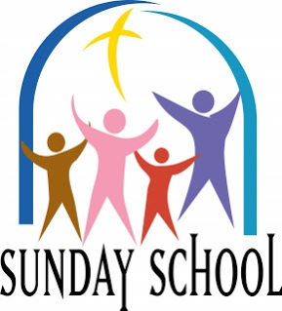

**\*Needed* 2016-17** **Sunday School Teachers-  
One Sunday a Month:**

We need teachers for one Sunday a month for ages Preschool (3-5 years) and Trinity (4th-6th grades). The lessons are planned for you and are very easy to follow and present. You do not have to have a teaching background, it does not require a weekly commitment, and it is a great way to become involved at the church. Please let Melinda Schultz know at [mrsjas305@sbcglobal.net](mailto:mrsjas305@sbcglobal.net).

**Parish Education Meetings**Parish Ed meetings will be held after church service on the second Sunday of each month.

**Rally Day**Rally Day will be on Sunday, September 11th. Sunday School classes will begin at 9:00 in the Small Fellowship Hall for grades Pre-K through 3rd. Fourth grade through eighth grade will begin in their classrooms. The High School Students will meet in their classroom.

**High School (Youth Group) Parent Meeting**  
On Rally Day, September 11th, there will be an informational meeting for the High School parents and youth at 12:00ish (directly following the picnic) in the Large Fellowship Hall. We will be discussing Calendars (for the year), possible Mission Trip destinations, Fundraising, etc.

**Trinity and Confirmation Parent Meeting**  
On the first T&C night on September 14th, there will be an informational meeting for parents and children regarding Calendars, Acolyting, and other important aspects of this program. Confirmation students will learn about all of the requirements for the program and we will discuss vital Calendar dates immediately following the Acolyte instruction. Dinner will be offered from 6:00-6:30 for everyone, with the meeting beginning directly afterwards.

NEWS FROM OUR SYNOD MISSION PARTNER CHURCH

ICE CREAM SOCIAL

Each year, Redeemer Church, an active city church who cares for her local community, holds an ice cream social during the month of August. This year, the event will be held Saturday, August 27 from 3:00-6:00pm. FREE ice cream! FREE games! Join your friends and neighbors for the annual Ice Cream Social at Redeemer Church. This is an opportunity to share some FREE ice cream from Melting Moments. Also, there will be fun games, prizes and inflatables for kids, music for both young and old, great food, crafts, and our 50;/50 raffle. There is a nominal charge for hot dogs, chips and beverages. (Ice cream and toppings are free.) Everyone is invited. Share in the fun. Bring your family and friends. Redeemer Church is located at 2727 West Holmes Road in Lansing.





To make disciples for Jesus Christ. . .

. . .we **Gather** in faith for worship, prayer,

study and fellowship

. . .we **Equip** the people of God with a faith

that works in real life

. . .we **Serve** the world in the name of Jesus Christ

_______________

Email address

faith@faithlutheranokemos.org

Websites

Faith Lutheran Church ≈ www.faithlutheranokemos.org

North/West Lower Michigan Synod ≈ www.mittensynod.org

Evangelical Lutheran Church in America ≈ www.elca.org

Facebook

facebook.com/faithlutheranokemos

Podcasts

ITUNES

https://itunes.apple.com/us/podcast/your-faith-journey/id1085174663?mt=2

STITCHER

http://www.stitcher.com/podcast/dad-spotlight/your-faith-journey?refid=stpr

You also can find the audio available

on Faith’s website under worship

Sermons

http://faithlutheranokemos.org/sermons/

Special music

http://faithlutheranokemos.org/category/special-music/